MCDA 5512 Assignment #1 - Git
Student Number: A00485185 – Md Chistia Chowdhury
(1) Repository Initialization and Status Check
- Commands Executed:
mkdir Git_Assignment1_A00485185
cd Git_Assignment1_A00485185
git init
git status
- Output (Terminal Snippet):
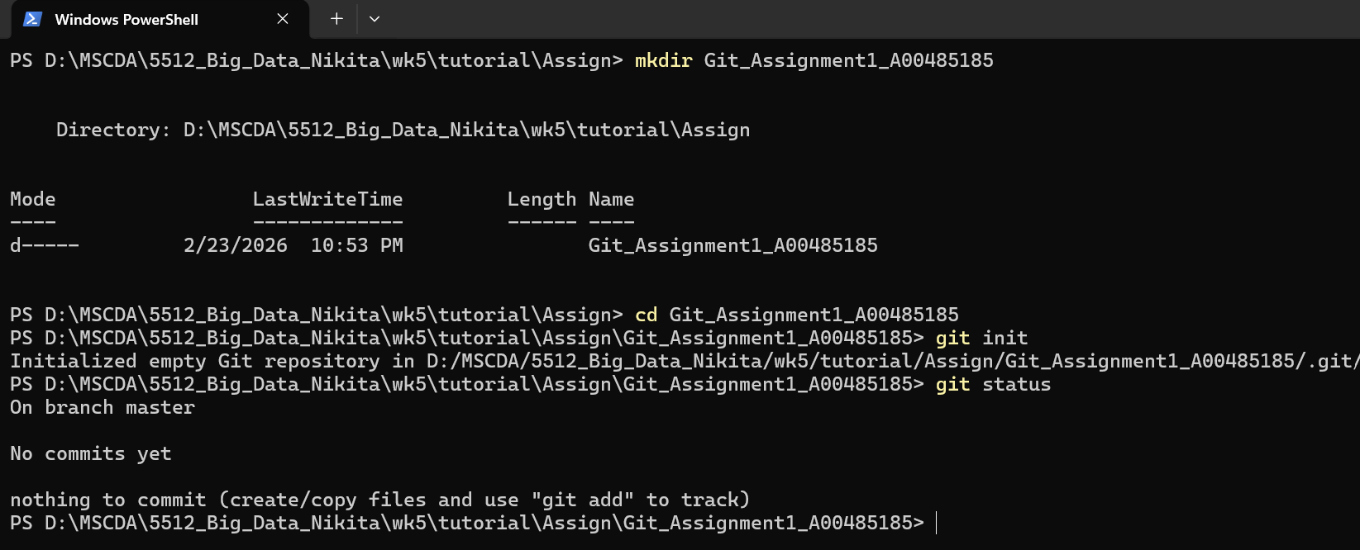

(2) File Creation and Version Control
- Commands Executed:
# Created countries.txt and shapes.txt
git status
git add countries.txt shapes.txt
git status
git commit -m "Adding Countries and Shapes"
# Created numbers.txt
git add numbers.txt
git commit -m "Adding numbers.txt"
git log --oneline
- Output (Terminal Snippet):
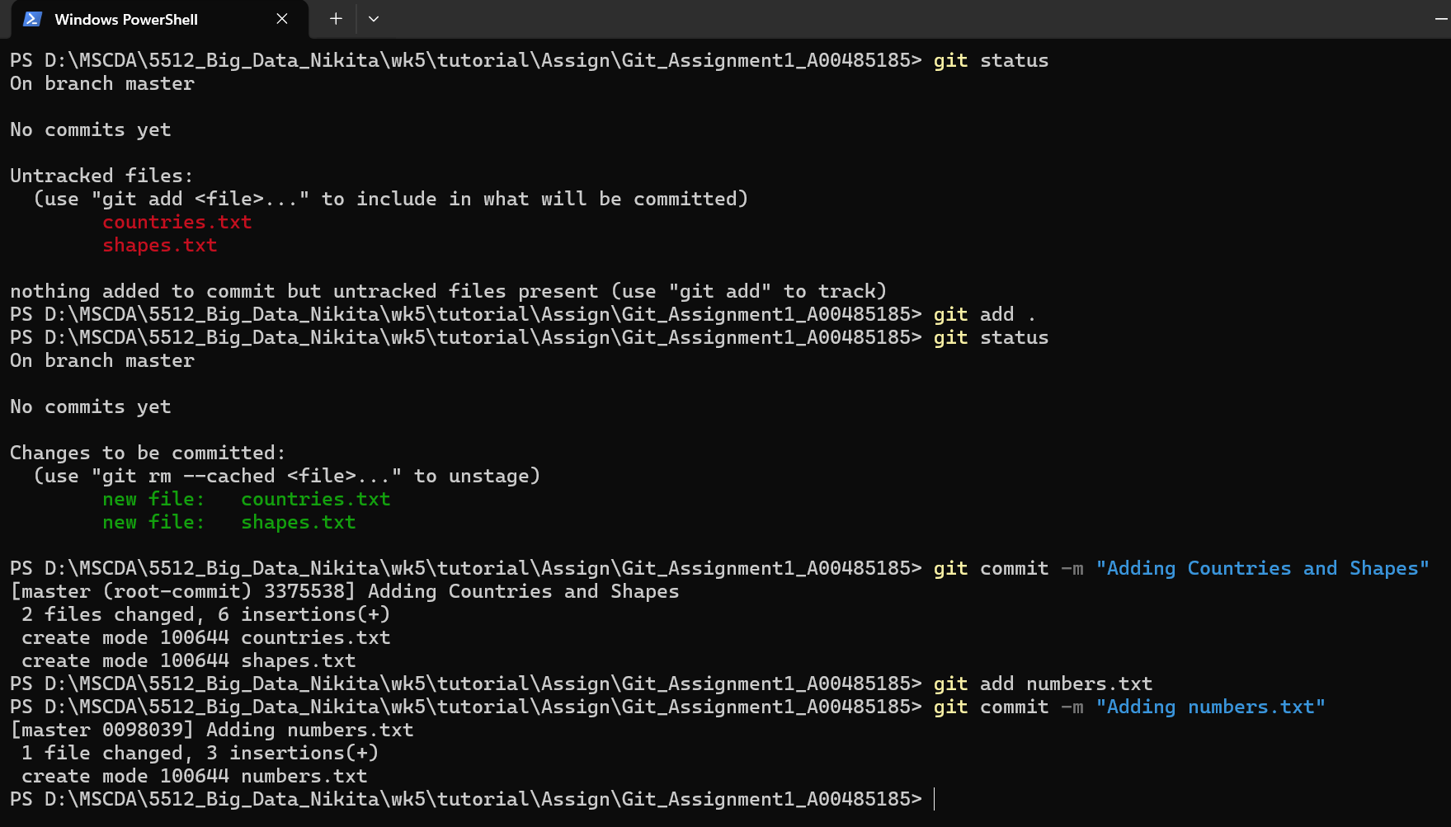
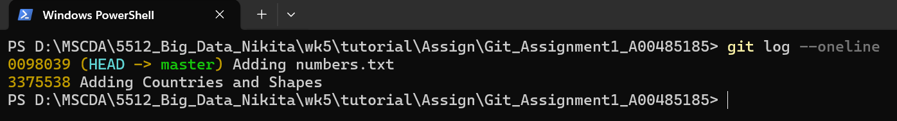

(3) Branch Creation and Commit
- Commands Executed:
git checkout -b LearnAnalytics
# Created languages.txt
git add languages.txt
git commit -m "Adding languages.txt"
git branch
- Output (Terminal Snippet):
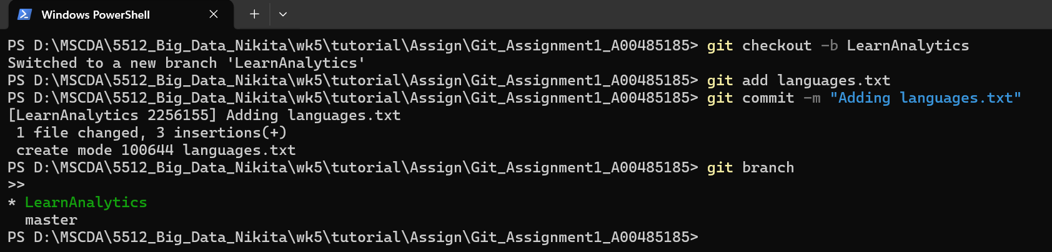

(4) Merging Conflicting Changes
- Commands Executed:
git checkout master
git branch user1
git branch user2
git checkout user1
# Replaced contents in countries.txt
git add countries.txt
git commit -m "user1 modifies countries"
git checkout user2
# Appended to countries.txt
git add countries.txt
git commit -m "user2 adds countries"
git checkout -b combine_countries
git merge user1
# Auto-merging failed. Kept changes from both in countries.txt
git add countries.txt
git commit -m "Resolved merge conflict by keeping all changes"
- Output (Terminal Snippet):
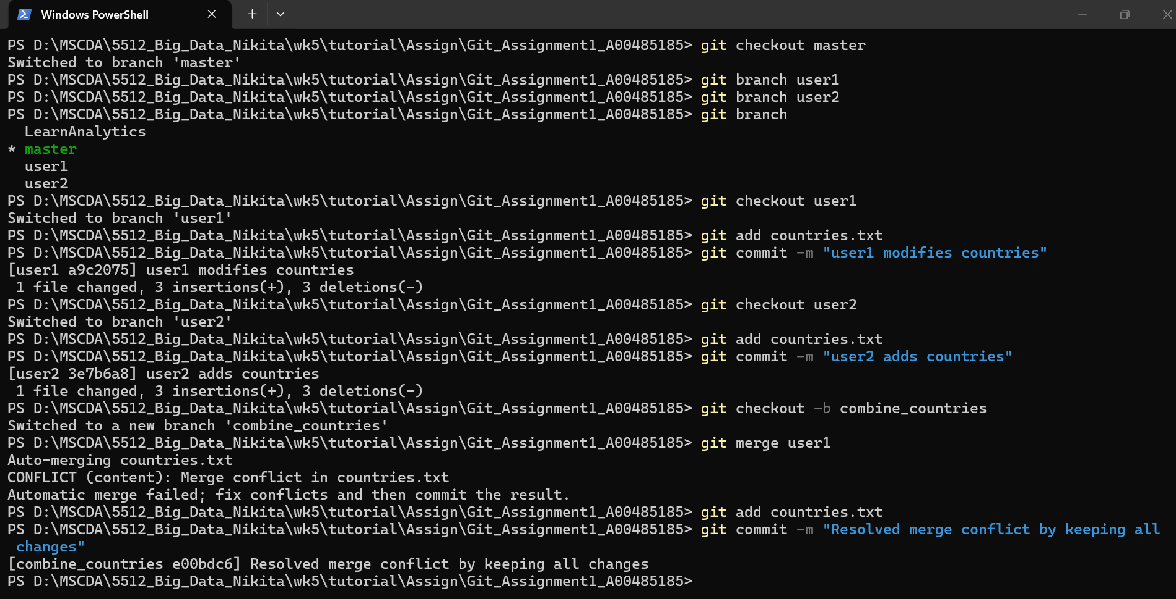

(5) Stashing and Applying Changes
- Commands Executed:
git checkout master
git checkout -b user3
# Appended to countries.txt
git stash
git checkout master
# Appended UK to countries.txt
git add countries.txt
git commit -m "master appends UK"
git checkout user3
git stash pop
git add countries.txt
git commit -m "user3 commits stashed changes"
- Output (Terminal Snippet):
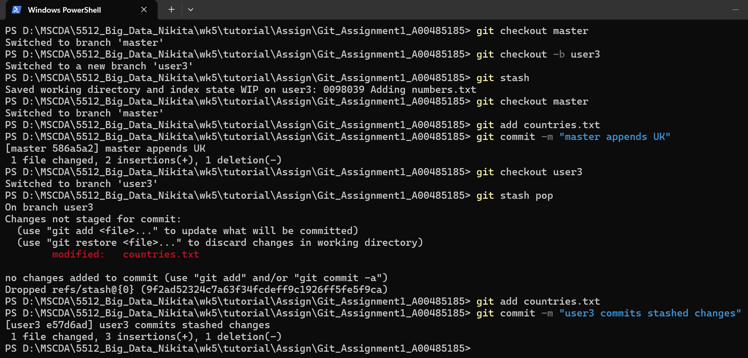

(6) Advanced git workflow
- Commands Executed:
git checkout master
git checkout -b bugfix
# Created bugfix.txt
git add bugfix.txt
git commit -m "Add bugfix.txt"
# Created random.txt
git add random.txt
git commit -m "Add random.txt"
git checkout master
git cherry-pick d78cb63
git status
- Output (Terminal Snippet):
Switched to branch 'master'
Switched to a new branch 'bugfix'
[bugfix d78cb63] Add bugfix.txt
1 file changed, 1 insertion(+)
create mode 100644 bugfix.txt
[bugfix 00cc3e4] Add random.txt
1 file changed, 1 insertion(+)
create mode 100644 random.txt
Switched to branch 'master'
[master a82842b] Add bugfix.txt
1 file changed, 1 insertion(+)
create mode 100644 bugfix.txt
On branch master
nothing to commit, working tree clean

