

Instituto Tecnológico y de Estudios
Superiores de Monterrey

5.2 Ejercicio de programación 2 y análisis estático

Anuar Olmos López A01092551

Profesores

Dr. Gerardo Padilla Zárate

Mtra. Viridiana Rodríguez González

Pruebas de software y aseguramiento de la calidad
Fecha: 15/02/2026

Ejecicio 5.2
Req 1. The program shall be invoked from a command line. The program shall receive two files as parameters. The first file will contain information in a JSON format about a catalogue of prices of products. The second file will contain a record for all sales in a company
Req 4. The name of the program shall be computeSales.py
Req 5. The minimum format to invoke the program shall be as follows:
python computeSales.py priceCatalogue.json salesRecord.json
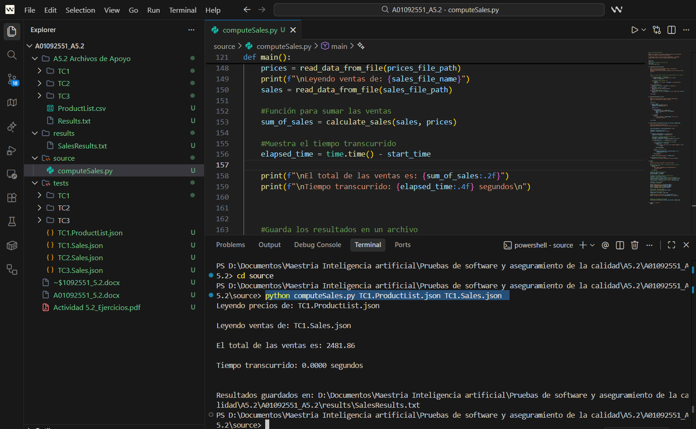
Req 2. The program shall compute the total cost for all sales included in the second JSON archive. The results shall be print on a screen and on a file named SalesResults.txt. The total cost should include all items in the sale considering the cost for every item in the first file.
The output must be human readable, so make it easy to read for the user.
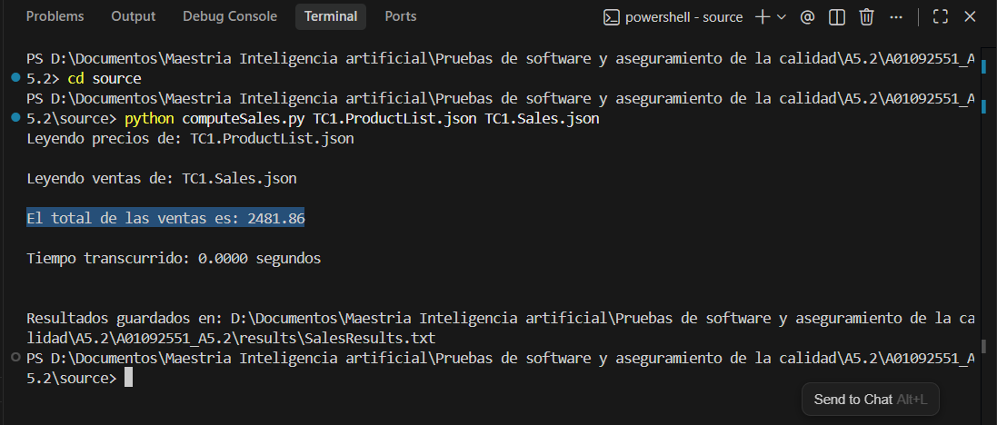

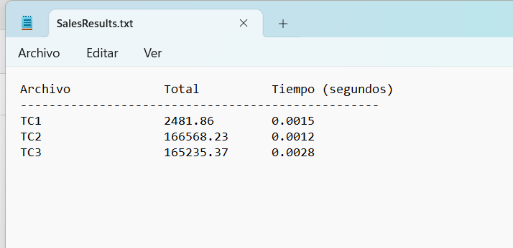

Req 3. The program shall include the mechanism to handle invalid data in the file. Errors should be displayed in the console and the execution must continue.
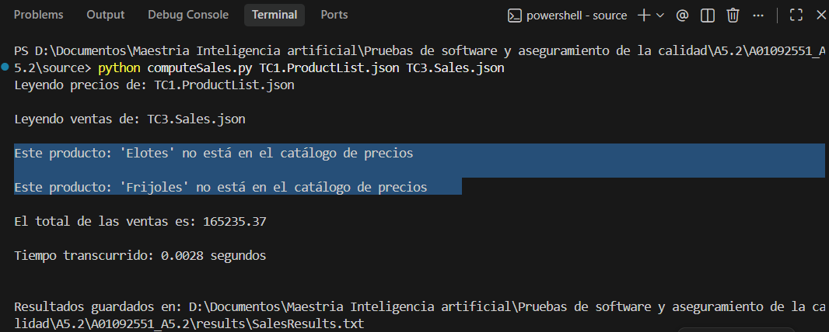
Req 6. The program shall manage files having from hundreds of items to thousands of items.
A test case with more than 1000 items was used to test the program
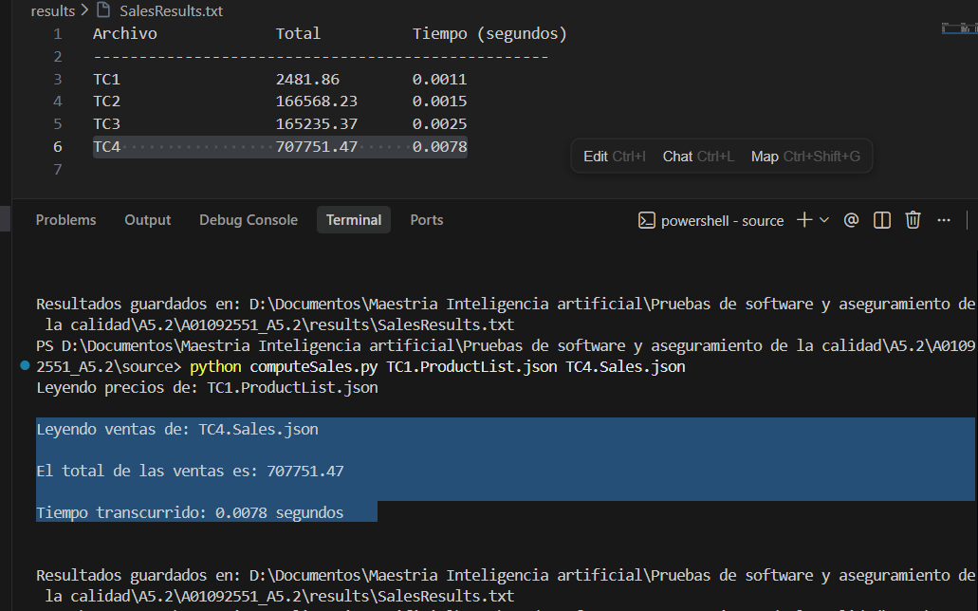

Req 7. The program should include at the end of the execution the time elapsed for the execution and calculus of the data. This number shall be included in the results file and on the screen.
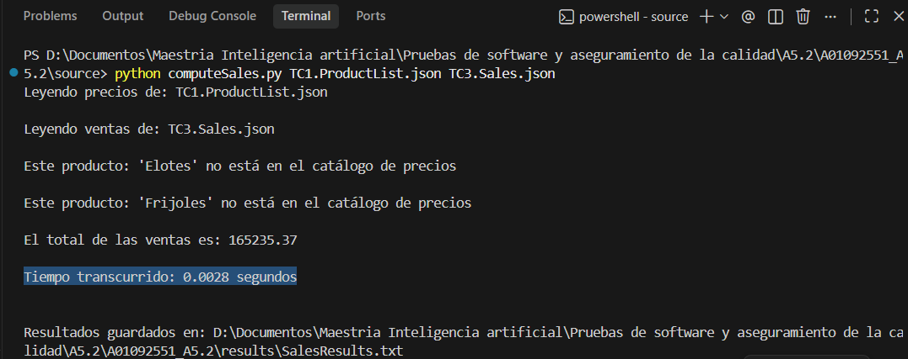

Req 8. Be compliant with PEP8.
Pylint
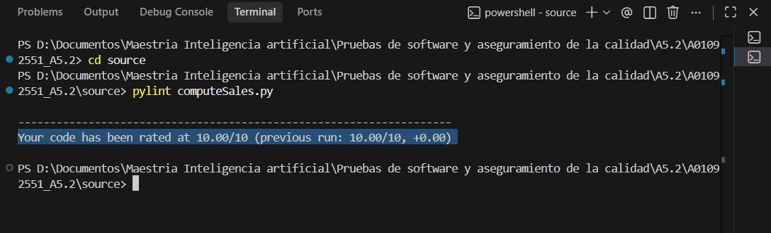

Flake8
