

**Mr. B-Man**

VIDEOGAMES FINAL PROJECT.

Esteban Azuara Aguirre A012201412.

Víctor Hugo Montiel Gómez A01411295.

Gustavo Arturo Pérez Santos A00511140.

Professor:

Ing. León Felipe Guevara Chavéz.

Date: 5/10/2018

Mr. B-Man

Game Design Document

Table of Contents

Game Description 3

Game Mechanics 3

Player Experience 3

Core Game Mechanics 3

Game Flow and Screens 4

Screen Mock-up 5

# Game Description

Mr. B-Man is a 2D platformer where the player must collect all the thunderbolt of the game for to access the next level and at the same time avoid enemies that it is too weak for attack them. Each time an enemy is touched, the player need to respond a question a specific them. In case of player answer wrong a will lose and is the game over. The arrows of the keyboard are used to move the character.

# Game Mechanics

## Player Experience

The game is displayed in 16:9.

## Core Game Mechanics

* Main character run in the platform and collects thunderbolt for advance to the next scene.
* The thunderbolt disappears when touched and gives the player points.
* The enemies are moving all around and cannot be touch for the player, if they are touched the player need to respond a question.
* When the player cannot respond of answer he loses and is game over.
* Score is displayed in the upper right of the screen and it show the final points.

## Game Flow and Screens

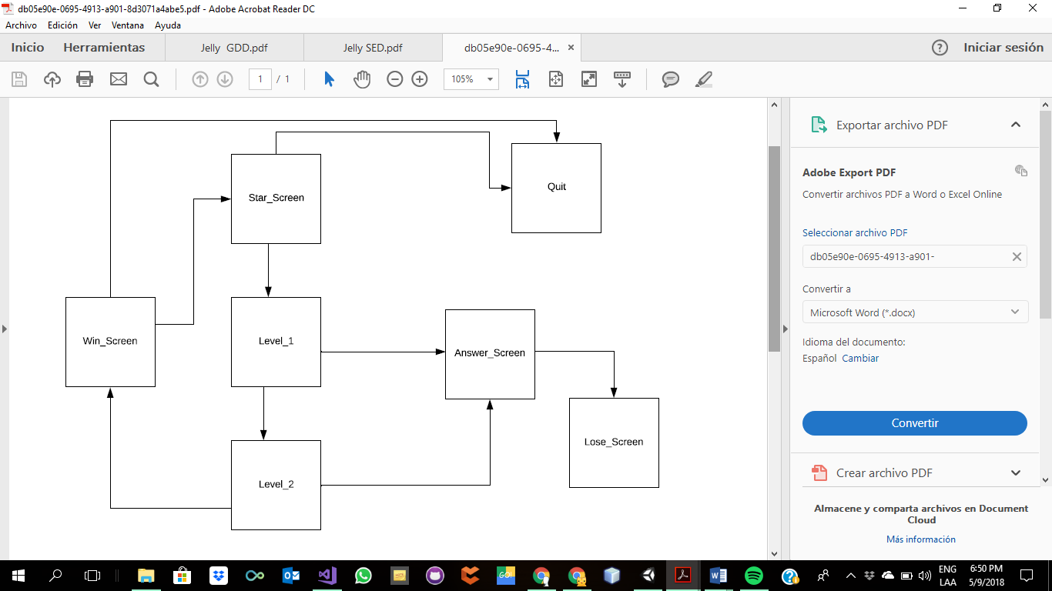

## Screen Mock-up

Start Screen

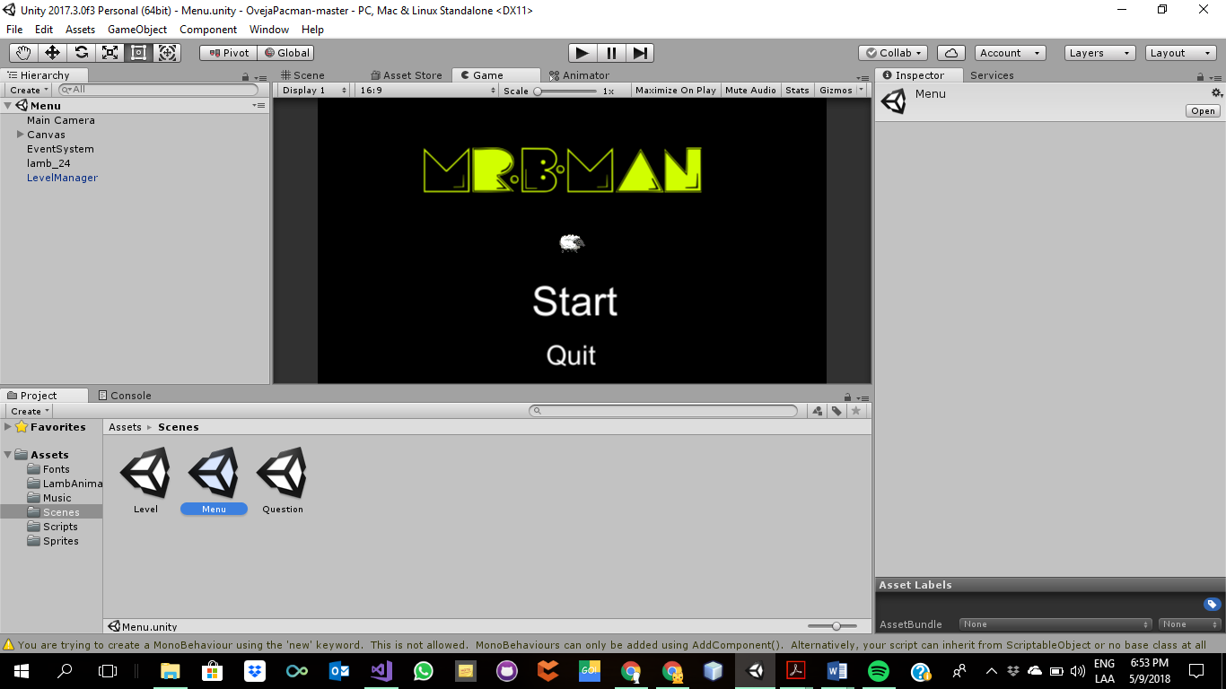

Level

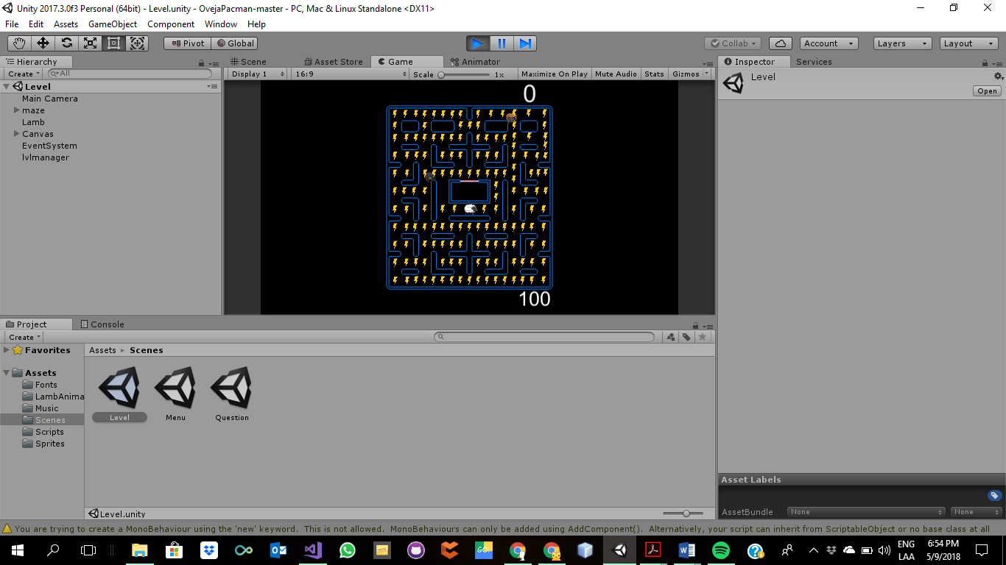

Answer Screen

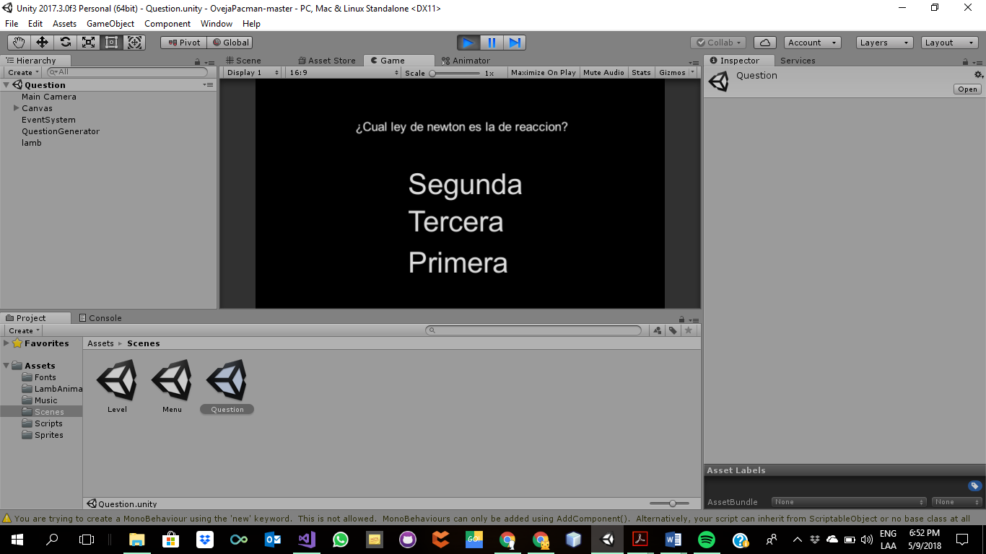

Win Screen

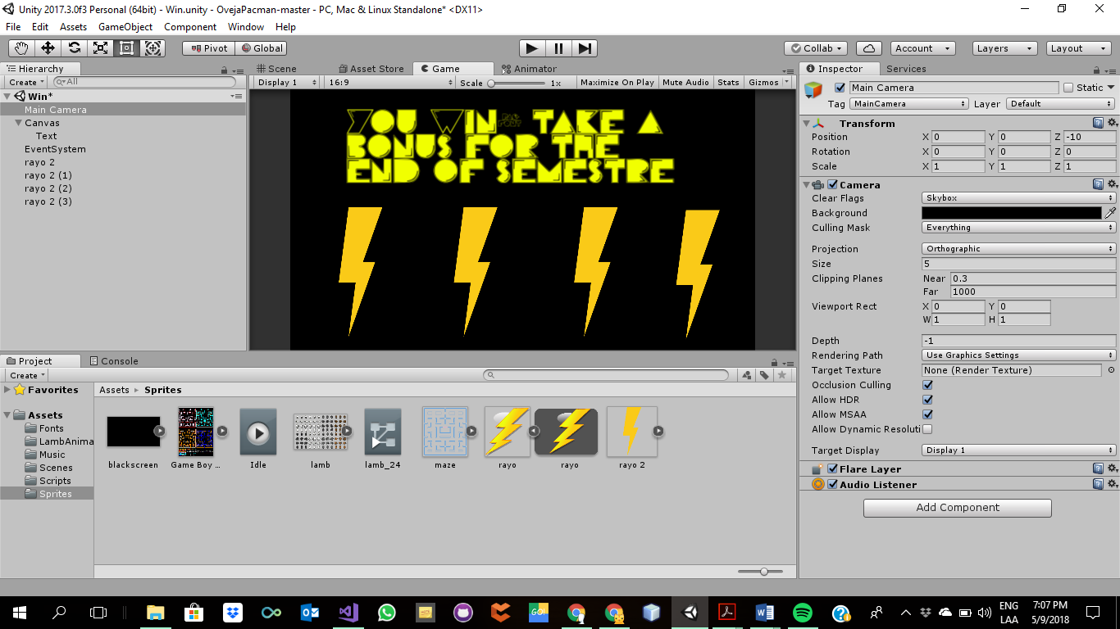

Lose Screen

