Mr. B-Man

Software Engineering Document

Table of Contents

Game Mechanics 2

Game Scenes 3

Game Flow 4

Classes and Scripts 5

# Game Mechanics

## Game Scenes

The game will have four basic scenes:

* A start scene, where we will allow the player to start from level 1 or to quit the game.
* The game has a two basic levels and simple scenes, each level more difficult that the other, for example the velocity of enemies is very fast each.
* The win scene, where the player will know his final score when completing all the game´s levels. This scene will have the option to return to restart scene or quit the game.
* A lose scene, where the player will land if his opportunities for respond wrong the question elected for the videogame.

## Game Flow

* Start scene will lead to level 1 game scene.
* Both win and lose scene will back start scene and will yet you quit the game.
* Game scene will lead to:

1. Next game scene, if the player has collected all thunderbolt and has not reach the final level.
2. Win scene, where the player collects all thunderbolt in the last scene.
3. Lose scene, when players health becomes 0.

# Classes and Scripts

Objects to handle in the game:

* Thunderbolt, that will be collected by the player and when he collects them all, he will advance to next level.
* LevelManager, that will allow us to move from one scene to another.
* LampMovement, that will allow us to move in the scene used the arrows of keyboard.
* QuestionGenerator, it will allow to ask the player questions to pass the levels and win the game.
* Fantasma, that will let our enemies move and make damage to our character.

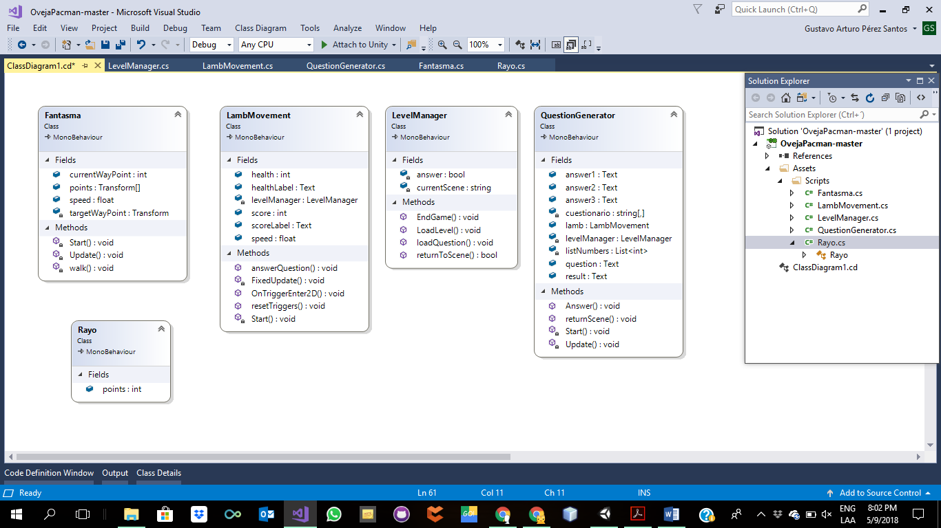 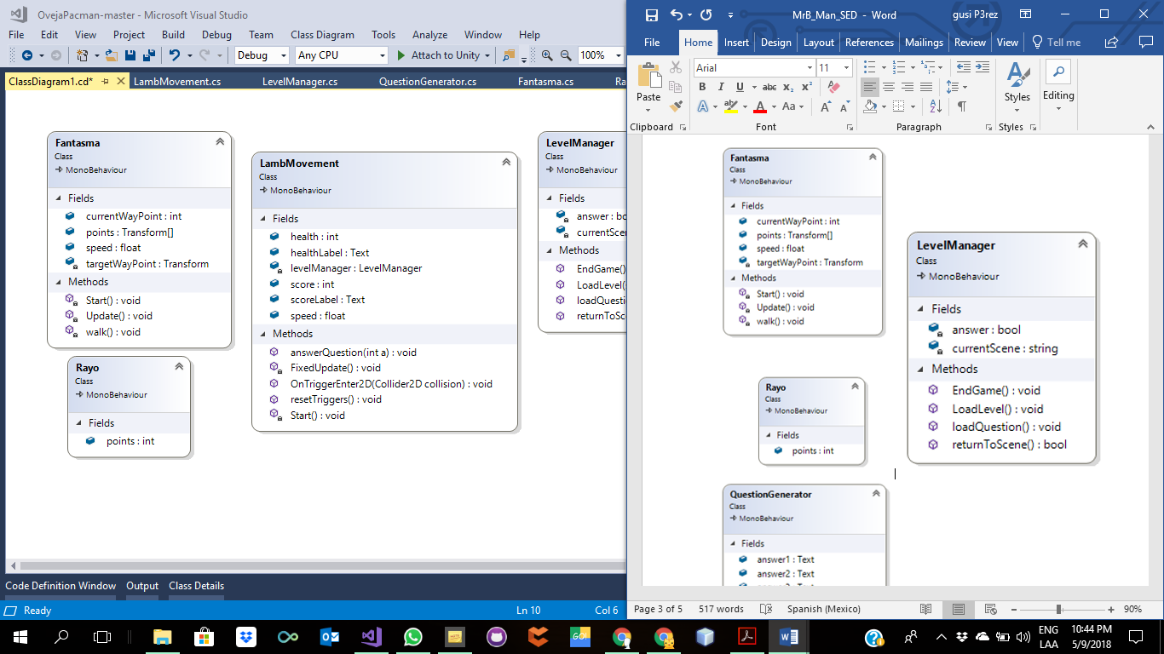  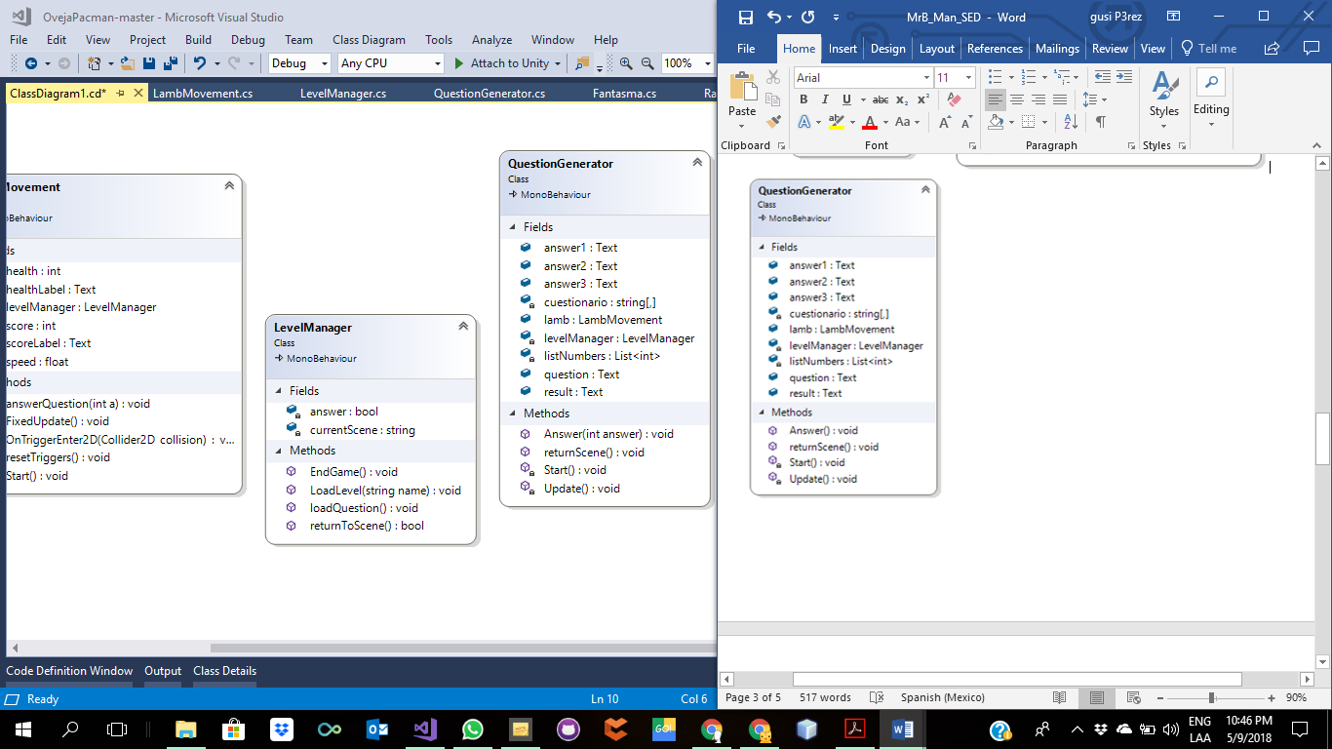

1. Fantasma

Attributes:

* currentWayPoint: It will show the current score as you progress through the game.
* points: Points obtained in the game.
* speed: Speed of the enemies.
* targetWayPoint: It will show the total score to be reached.

Methods:

* Start(): Use this for initializartion
* Update():check if we have somewhere to walk
* Walk():rotate towards the target

1. Rayo

Attributes:

* Points: it has a value of the one point

1. LambMovement

Attributes:

* Health: this is our characters help.
* healthLabel: it show in the label the health of the character.
* levelManager: a link to the level manager.
* score: the points achieved.
* scoreLabel: it show in the label the score.
* speed: it is the velocity of the character.

Methods:

* answerQuestions():it is the question for the player.
* FixedUpdate():it is the move it can do the character.
* OnTriggerEnter2D():it is accumulator of points for the lamb.
* resetTriggers():it is the move it can do the character when the player press the keyboard and It depends on the keypress change the moved.
* Start():this will initialize the character

1. LevelManager

Attributes:

* Answer: It function is show the question for the player.
* currentScene: In this part loaded the question for the player when: static bool answer = true;

Methods:

* EndGame():that will terminate the game in any platform but web.
* LoadLevel():that will let us jump to any given next scene.
* loadQuestion():load a one random question.return
* returnToScene():it returns to the played scene.

1. QuestionGenerator

Attributes:

* Answer1: In a array saved the first question.
* Answer2: In a array saved the second question.
* Answer3: In a array saved the third question.In this
* Cuestionario: In this part is show the random question of the arrays.
* Lamb: In this part called the class of LambMovement.
* levelManager: In this part load the new question
* listNumbers: In this part it is classified the range of question depending of difficult
* questions: In this part show the question.
* result: In this part show the correct answer.

Methods:

* answer():When you choose one answer it show a message
* returnToScene():In this part the function is return back to the scene it came from.
* Start():Use this for initialization
* Update():Update is called once per frame