Test Report Template

Name | Carlo Moises Onassis Salgado Organista | Date | 8/12/2020
Project/Task | /Proyecto/PSP2_5a

Test Name/# | Test1
Test Objective | Using PSP2, write a program to numerically integrate a function using Simpson’s rule. Use the t distribution as the function.
Test Description | Thoroughly test the program. At a minimum, calculate the values for the t distribution integral for the values in Table 1. Expected values are also included in Table 1.
Test Conditions
Expected Results | 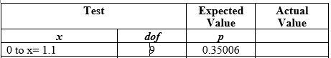
Actual Results | 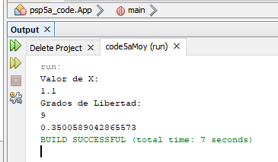

Test Name/# | Test2
Test Objective | Using PSP2, write a program to numerically integrate a function using Simpson’s rule. Use the t distribution as the function.
Test Description | Thoroughly test the program. At a minimum, calculate the values for the t distribution integral for the values in Table 1. Expected values are also included in Table 1.
Test Conditions
Expected Results | 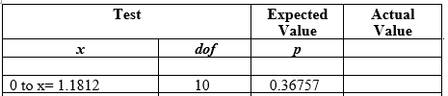
Actual Results | 