Interpretable multiclass classification of colorectal cancer progression using machine learning based on lipidomic biomarkers

María Virginia Mendizabal Miranda (1), Gianmel Joannelly Hernández Tosta (1), Sofía Ordaz López (1), Grettel Barceló Alonso (1)

(1) Tecnológico de Monterrey, School of Engineering and Sciences, Mexico

Corresponding author: María Virginia Mendizabal Miranda, mmvicky@hotmail.com,
+52 744 100 75 96

Abstract
Background and Objectives: Colorectal cancer (CRC) is one of the most prevalent neoplasms worldwide and constitutes a leading cause of cancer-related mortality. Current screening tests, such as the fecal immunochemical test (FIT), exhibit limited sensitivity for the detection of advanced adenomas (AA), precancerous lesions whose timely removal prevents progression to carcinoma. Conventional chemometric methods (PLS-DA) applied to lipidomic data have shown limitations in discriminating the AA class in multiclass settings. The aim of this study was to develop and evaluate a machine learning pipeline based on decision tree ensembles for tripartite classification (Control/AA/CRC) using fecal lipidomic biomarkers.
Methods: A cohort of 211 patients (78 controls, 58 AA, 75 CRC) whose fecal lipidomic profiles were obtained by ultra-high-performance liquid chromatography coupled to mass spectrometry (UHPLC-MS), with 127 lipids quantified, was used. The preprocessing pipeline included group-median imputation (validated against MICE using the Frobenius norm), Box-Cox transformation, and feature selection by intersection of Mutual Information and ANOVA (16 final variables). Fourteen models were compared: 6 individual classifiers and 8 ensembles (5 homogeneous, 2 heterogeneous, 1 individual baseline). Evaluation was conducted using stratified 5-fold cross-validation and an independent held-out set (n=43). Model interpretability was assessed using SHAP (SHapley Additive exPlanations) with TreeExplainer.
Results: The Bagging Tree model achieved F1 macro = 0.855 and AUC macro = 0.945 on the held-out set. Identification of advanced adenomas posed the greatest difficulty due to the similarity of their lipidomic profiles with those of the confirmed colorectal cancer (CRC) group. Despite this, the model attained F1 = 0.78 and recall = 0.75 for the AA class. Precision for healthy controls was 1.00, minimizing false positives. SHAP analysis revealed that CE(20:5) is the biomarker with the highest global contribution (mean |SHAP| = 0.070), with class-differentiated roles: PC(O-16:0/16:0) is the primary predictor for AA, FIT for CRC, and CE(20:5) for CTRL. A complementary analysis demonstrated that 15 variables from the full feature set retain the same AA recall (0.833), reducing dimensionality by 89%.
Conclusions: Lipidomic profiles analyzed using decision tree ensembles enable effective classification of the three CRC progression states, including the detection of advanced adenomas where conventional chemometric methods showed limited performance. SHAP analysis provides patient-level interpretability and improves model transparency, which may facilitate future clinical evaluation. The results suggest that a reduced lipidomic panel could complement FIT for non-invasive CRC screening, although external multicenter validation is required before clinical implementation can be considered.

Keywords: colorectal cancer; lipidomics; machine learning; ensemble methods; biomarker discovery; adenoma detection; SHAP; decision trees

1. Introduction
Colorectal cancer (CRC) represents a major global cancer burden, with high incidence and mortality reported in the most recent GLOBOCAN estimates [1]. CRC development is commonly described through the adenoma-carcinoma sequence, in which progressive molecular and phenotypic alterations favor transition from normal mucosa to adenoma, advanced adenoma (AA), and invasive carcinoma [2]. This progression provides a critical window for intervention: detection and removal of precursor lesions through endoscopic polypectomy has been shown to reduce CRC incidence [3].
Current population-based screening strategies rely primarily on stool-based tests and colonoscopy. The fecal immunochemical test (FIT) detects human hemoglobin in stool and offers advantages over guaiac-based methods because of its quantitative and analytical specificity [4]. However, its performance for advanced adenomas is lower than for established CRC; positive FIT results therefore require confirmation by colonoscopy, an invasive procedure with limited availability in some healthcare settings [4,5].
In this context, metabolomics and lipidomics have emerged as promising strategies for non-invasive biomarker discovery. Metabolic alterations in CRC include changes in amino acids, acylcarnitines, fatty acids, glycerophospholipids, sphingolipids, and cholesteryl esters, although the evidence varies according to sample type and analytical platform [6-9]. In particular, studies using fecal samples and extracts derived from fecal occult blood screening kits have identified metabolomic profiles that may complement FIT and reflect alterations related to advanced colorectal neoplasia [10-12].
However, conventional chemometric approaches may present limitations in multiclass settings, especially when classes represent heterogeneous and partially overlapping biological states. Alboniga et al. [12] applied PLS-DA to fecal lipidomic data from a cohort of 211 patients at the Hospital of Ourense, achieving good discrimination between healthy controls and confirmed CRC, but without correctly classifying advanced adenomas (F1 = 0 for the AA class). This limitation is clinically relevant because AAs represent a preventive intervention window.
Machine learning methods, particularly decision tree ensembles, offer advantages for this type of data because they can capture nonlinear relationships and interaction patterns among variables, while reducing variance relative to individual trees through aggregation [13-16]. In biomedical studies using complex models, methodological traceability and interpretability are especially important; therefore, frameworks such as CRISP-ML(Q) and reproducible modeling tools support the development of verifiable pipelines [17,18].
The present study addresses this gap through the development of a machine learning pipeline, following the CRISP-ML(Q) methodological framework [17], for tripartite classification (Control/AA/CRC) based on fecal lipidomic biomarkers. The specific objectives are: (1) to build a multiclass classifier for colorectal cancer progression with particular emphasis on advanced adenoma detection; (2) to identify a reduced panel of lipidomic biomarkers with discriminatory capacity and biological plausibility; and (3) to evaluate the complementarity between lipidomic biomarkers and standard clinical tests (FIT, fecal occult blood).
2. Related Work
The application of computational techniques to CRC diagnosis has expanded across histopathological, genomic, transcriptomic, clinical, and omics data. In metabolomics and lipidomics, supervised classification faces specific challenges, including high dimensionality, correlation among metabolites, preanalytical heterogeneity, and the risk of overinterpreting associative differences as biological mechanisms [7,8,13,14].
In metabolomics applied to CRC, previous studies have shown that metabolic profiles can discriminate CRC patients from controls and reflect aspects of tumor progression. Nishiumi et al. [19] proposed a serum metabolomics-based diagnostic approach; Farshidfar et al. [20] analyzed serum profiles associated with CRC stage; and recent studies have explored amino acids and acylcarnitines as diagnostic signal sources [21]. However, much of this literature focuses on binary comparisons or established cancer, with less attention to multiclass classification including advanced adenomas.
In fecal metabolomics and lipidomics, Cubiella et al. [10] identified low-invasive candidates using UPLC-MS, and Alboniga et al. [11] demonstrated that samples obtained from fecal occult blood screening kits can be used for metabolomic analysis in CRC populations. The study by Alboniga et al. [12] extended this line by quantifying 127 fecal lipids in 211 participants (78 controls, 58 AA, 75 CRC) and showed that cholesteryl esters together with FIT improved some diagnostic comparisons, although the AA class remained difficult to separate. These findings support the value of lipidomics, but also highlight the need for models able to handle nonlinear boundaries and transitional classes.
This gap in multiclass AA detection constitutes the central motivation of the present work. Unlike previous studies, our approach: (a) explicitly formulates the problem as tripartite classification (CTRL/AA/CRC); (b) employs a systematic preprocessing pipeline with quantitative validation of each decision; (c) compares 14 models including 8 ensembles implemented in the scikit-learn ecosystem [18]; and (d) prioritizes AA detection as the primary clinical metric, complementing the evaluation with SHAP interpretability analysis.

3. Materials and Methods
3.1 Dataset
The lipidomic dataset published by Alboniga et al. [12] was used, comprising 211 fecal samples from participants in the CRC screening program at the Hospital of Ourense (Galicia, Spain). Samples were analyzed by ultra-high-performance liquid chromatography coupled to mass spectrometry (UHPLC-MS), quantifying 127 lipids belonging to the sphingolipid, sterol, glycerophospholipid, and glycerolipid families.
The class distribution was: 78 healthy controls (CTRL, 37.0%), 58 advanced adenomas (AA, 27.5%), and 75 confirmed colorectal cancer cases (CRC, 35.5%). Additionally, clinical variables were recorded: age, FIT result (fecal hemoglobin concentration in µg/g), fecal occult blood test (FOB, categorical: yes/no), and sex.
Table 1. Dataset variables.
Variable | Type | Description
127 lipids | Continuous | Fecal lipid concentrations by UHPLC-MS
Age | Continuous | Patient age in years
FIT (µg/g) | Continuous | Fecal immunochemical hemoglobin concentration
FOB | Categorical | Fecal occult blood (Yes/No)
Sex | Categorical | Male/Female
Group | Categorical (target) | CTRL / AA / CRC

3.2 Preprocessing
3.2.1 Missing data treatment
Missing data analysis revealed that 56 of 132 variables had no missing values, while 27 lipids contained more than 20% missing data. Five lipids with more than 40% missing values were removed (PC(33:0), PE(P-18:0/20:4), SM(36:2), TG(55:2), SM(d18:1/17:0)), retaining 122 lipids for analysis.
Analysis of the missing data mechanism through chi-squared tests revealed that 13 of 56 evaluated lipids exhibited significant dependence of the missingness pattern on the diagnostic group (p < 0.05), indicating a MAR/MNAR mechanism. Biologically, concentrations below the detection limit are more frequent in healthy controls, where certain lipids associated with tumor processes are present at minimal concentrations.
Group-median imputation (CTRL/AA/CRC) was selected over MICE, validating the decision using two metrics: the Frobenius norm (3.24 vs. 13.58) and the percentage of pairs with correlation change |Δr| > 0.10 (1.6% vs. 15.2%). Group-median imputation preserved the lipidomic correlation structure 4 times better than MICE, which is critical since co-regulation patterns among lipids contain biologically relevant information.
3.2.2 Transformation and scaling
Given that all 127 lipids exhibited severe positive skewness (median skewness = 5.47), four transformation strategies were evaluated: log1p, Yeo-Johnson, Box-Cox, and raw data. The Box-Cox transformation [22] achieved the highest normality rate according to the Shapiro-Wilk test (81.1% of variables with p > 0.05), compared to log1p (0.8%) and Yeo-Johnson (5.5%). Median skewness was reduced from 5.47 to 0.03 after Box-Cox transformation. Subsequently, StandardScaler (mean = 0, standard deviation = 1) was applied to continuous variables to homogenize scales prior to model training.
3.3 Feature selection
A filter-based feature selection strategy was implemented through the intersection of two independent criteria: Mutual Information (MI, nonlinear criterion) and ANOVA F-test (linear criterion). The top 30 variables according to each criterion were selected, and their intersection was retained. The Jaccard coefficient between both sets was 27.66%, indicating low redundancy and complementarity between the criteria.
The resulting matrix, termed X_intersect, contains 16 variables: 12 lipidomic biomarkers, 2 clinical variables (age, FIT), and 2 categorical indicators (sex, FOB). Table 2 lists the lipidomic biomarkers included.
Table 2. Lipidomic biomarkers in X_intersect (MI ∩ ANOVA filter selection).
Biomarker | Lipid family
CE(20:5) | Cholesteryl ester
GlcCer(d18:1/24:0) | Monohexosylceramide
PC(36:5) | Diacylglycerophosphocholine
PC(O-16:0/16:0) | Ether-glycerophosphocholine
PC(O-16:0/18:2) | Ether-glycerophosphocholine
PC(O-34:1) | Ether-glycerophosphocholine
SM(33:1) | Sphingomyelin
SM(42:3) | Sphingomyelin
SM(d18:1/22:0) | Sphingomyelin
SM(d18:1/23:0) | Sphingomyelin
SM(d18:1/24:1) + SM(d18:2/24:0) | Sphingomyelin
TG(51:4) | Triacylglycerol

3.4 Models evaluated
A total of 14 models organized in two phases were compared. In the first phase, 6 individual classifiers with hyperparameter optimization via GridSearchCV with stratified 5-fold cross-validation were evaluated: Logistic Regression, Decision Tree, Support Vector Machine (SVM), K-Nearest Neighbors (KNN), Gaussian Naive Bayes, and Linear Discriminant Analysis (LDA). All applicable models were configured with class_weight='balanced' to compensate for moderate class imbalance.
In the second phase, 8 ensemble models were evaluated: 5 homogeneous (Bagging Tree, Random Forest, Gradient Boosting, AdaBoost, Extra Trees) and 2 heterogeneous (Stacking with Logistic Regression meta-classifier, Soft Voting), in addition to the individual Decision Tree as a baseline.
3.5 Evaluation strategy
A two-level evaluation was implemented to prevent data leakage. The dataset was split into X_dev (80%, n=168) for training and optimization, and X_test (20%, n=43) as an independent held-out set, never used during model selection or hyperparameter optimization. Stratified 5-fold cross-validation was applied on X_dev.
The primary evaluation metric was F1 macro, which equally weights performance across all three classes, avoiding the bias toward majority classes introduced by accuracy. Secondary metrics included AUC-ROC macro (one-vs-rest), precision, and recall per class, with particular emphasis on AA class performance as the clinically relevant metric.
3.6 Interpretability analysis using SHAP
To quantify the individual contribution of each biomarker to the model's predictions, the SHAP (SHapley Additive exPlanations) framework [23] was applied, grounded in Shapley value theory from cooperative game theory. Unlike mean impurity importance (Gini), which provides a single global ranking, SHAP decomposes each prediction into the additive contribution of each variable, enabling analysis of both global patterns and patient-level explanations.
TreeExplainer [24] was applied to each of the 100 base trees of the Bagging Tree, averaging the resulting SHAP values to obtain the contributions of the full ensemble. SHAP values were computed on the held-out set (n=43) and disaggregated by class (AA, CRC, CTRL), enabling identification of which biomarkers are most relevant for each CRC progression state.
4. Results
4.1 Comparison of individual classifiers
Table 3 presents the results of the 6 individual classifiers after hyperparameter optimization. The Decision Tree was selected as the best individual model (F1 macro held-out = 0.681) due to its consistency between cross-validation and test set (gap = 0.026, compared to 0.062 for KNN) and its clinical interpretability.
Table 3. Individual classifier performance (X_intersect, 16 variables).
Model | F1 CV | F1 Held-out | Gap
KNN (k=7, Manhattan) | 0.729 | 0.667 | 0.062
Decision Tree (max_depth=5) | 0.707 | 0.681 | 0.026
Logistic Regression (C=0.001) | 0.632 | -- | --
SVM (C=100, RBF) | 0.619 | -- | --
LDA (shrinkage=auto) | 0.578 | -- | --
Gaussian Naive Bayes | 0.565 | -- | --

4.2 Comparison of ensemble models
Table 4 shows the results of the 8 ensemble models. The Bagging Tree achieved the highest F1 macro on the held-out set (0.855), outperforming Random Forest (0.810), Gradient Boosting (0.809), and heterogeneous ensembles (Stacking: 0.760, Voting: 0.710). The improvement over the individual Decision Tree was +0.174 F1 points (+25.5%).
Table 4. Ensemble model performance (X_intersect, 16 variables).
Model | Type | F1 CV | F1 Held-out
Bagging Tree | Homogeneous | 0.802 | 0.855
Random Forest | Homogeneous | 0.806 | 0.810
Gradient Boosting | Homogeneous | 0.820 | 0.809
AdaBoost | Homogeneous | 0.752 | 0.809
Stacking | Heterogeneous | 0.682 | 0.760
Extra Trees | Homogeneous | 0.738 | 0.710
Soft Voting | Heterogeneous | 0.633 | 0.710
Decision Tree (baseline) | Individual | 0.696 | 0.639

4.3 Final model: Bagging Tree
The Bagging Tree model was configured with the optimal hyperparameters identified through GridSearchCV (108 combinations): n_estimators=100, max_samples=0.8, max_features=0.6, with unconstrained base tree depth and class_weight='balanced'. Table 5 presents the detailed per-class performance on the held-out set.
Table 5. Bagging Tree per-class performance (held-out set, n=43).
Class | Precision | Recall | F1-Score | Support (n)
AA (Advanced Adenoma) | 0.82 | 0.75 | 0.78 | 12
CRC (Colorectal Cancer) | 0.78 | 0.93 | 0.85 | 15
CTRL (Healthy Control) | 1.00 | 0.88 | 0.93 | 16
Macro Average | 0.87 | 0.85 | 0.855 | 43

The macro AUC-ROC was 0.945 (AA: 0.902, CRC: 0.949, CTRL: 0.984). The confusion matrix (Table 6) reveals that no AA sample was misclassified as CTRL, which has direct clinical relevance: the model does not produce complete false negatives in the most dangerous direction (classifying a precancerous lesion as healthy).
Table 6. Bagging Tree confusion matrix (held-out set).
 | Predicted: AA | Predicted: CRC | Predicted: CTRL
Actual: AA | 9 | 3 | 0
Actual: CRC | 0 | 14 | 1
Actual: CTRL | 0 | 2 | 14
4.4 SHAP interpretability analysis
4.4.1 Global SHAP importance
Figure 1 presents the global SHAP importance ranking, computed as the mean absolute SHAP values averaged across the three classes. CE(20:5) is confirmed as the biomarker with the highest global contribution (mean |SHAP| = 0.070), followed by FIT (0.059), TG(51:4) (0.057), and PC(O-16:0/16:0) (0.051). The clinical variables sex and FOB exhibited minimal contributions (0.002 and 0.009, respectively), confirming that the discriminative signal predominantly originates from lipidomic biomarkers. Table 7 presents the complete ranking.
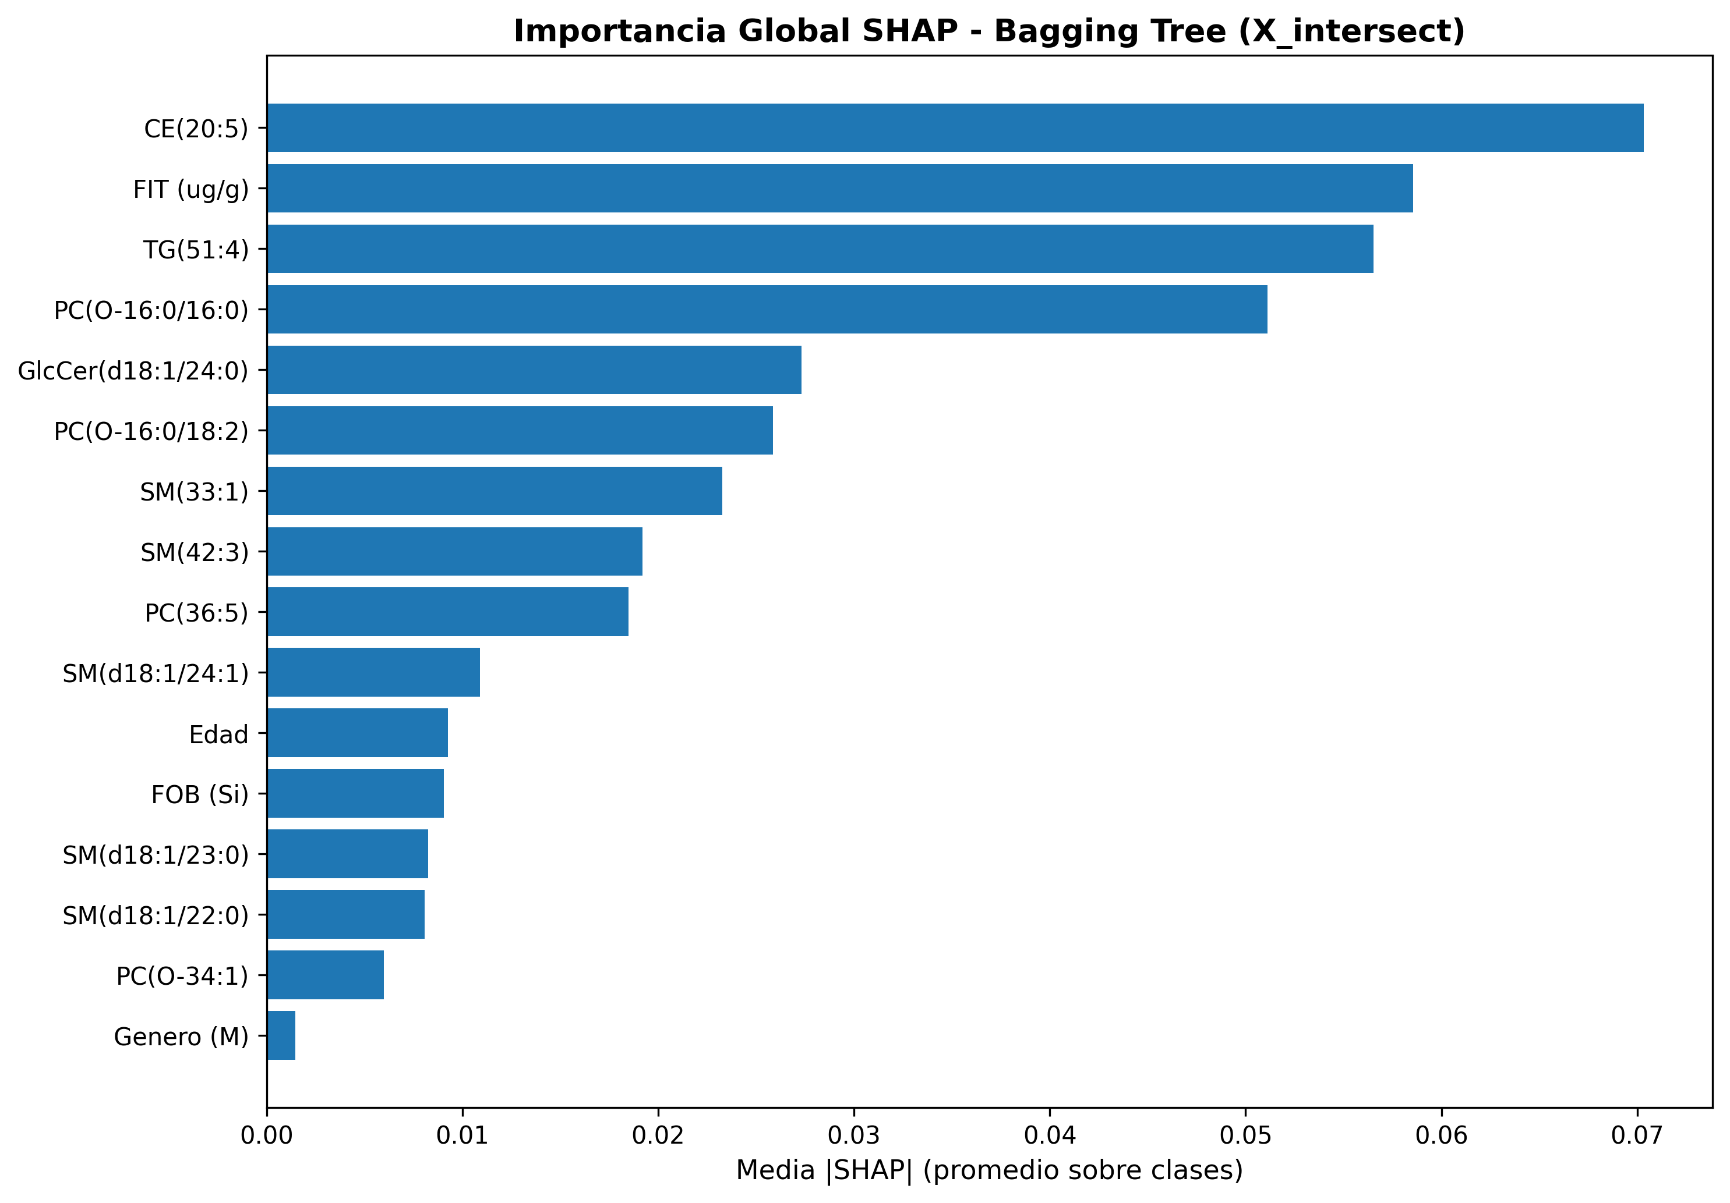
Figure 1. Global SHAP importance of the Bagging Tree (mean |SHAP| averaged across the three classes).

Table 7. Top 10 variables by SHAP importance (global mean |SHAP|).
Rank | Variable | Mean |SHAP| | Type
1 | CE(20:5) | 0.070 | Cholesteryl ester
2 | FIT (µg/g) | 0.059 | Clinical variable
3 | TG(51:4) | 0.057 | Triacylglycerol
4 | PC(O-16:0/16:0) | 0.051 | Ether-phosphatidylcholine
5 | GlcCer(d18:1/24:0) | 0.027 | Glucosylceramide
6 | PC(O-16:0/18:2) | 0.026 | Ether-phosphatidylcholine
7 | SM(33:1) | 0.023 | Sphingomyelin
8 | SM(42:3) | 0.019 | Sphingomyelin
9 | PC(36:5) | 0.019 | Phosphatidylcholine
10 | SM(d18:1/24:1)+SM(d18:2/24:0) | 0.011 | Sphingomyelin

4.4.2 Class-differentiated SHAP contributions
A key finding of the SHAP analysis is that biomarkers exhibit differentiated roles according to the diagnostic class (Figure 2, Table 8). For the AA class (advanced adenomas), PC(O-16:0/16:0) is the primary predictor (mean |SHAP| = 0.067), displacing CE(20:5) to the second position (0.054). This result suggests that ether-phospholipids capture metabolic alterations specific to the pre-malignant phase that are not detected by cholesteryl esters.
For the CRC class (confirmed cancer), the clinical variable FIT dominates the contributions (mean |SHAP| = 0.077), which is biologically coherent: fecal bleeding detectable by FIT is a hallmark of advanced colorectal tumors. The lipidomic biomarkers TG(51:4) and CE(20:5) occupy the second and third positions (0.058 and 0.057).
For the CTRL class (healthy controls), CE(20:5) is the dominant predictor (mean |SHAP| = 0.100), followed by TG(51:4) (0.078) and FIT (0.077). The magnitude of CE(20:5) for CTRL is the highest across all variable-class combinations, indicating that the levels of this cholesteryl ester are particularly informative for distinguishing healthy individuals from patients with colorectal pathology.
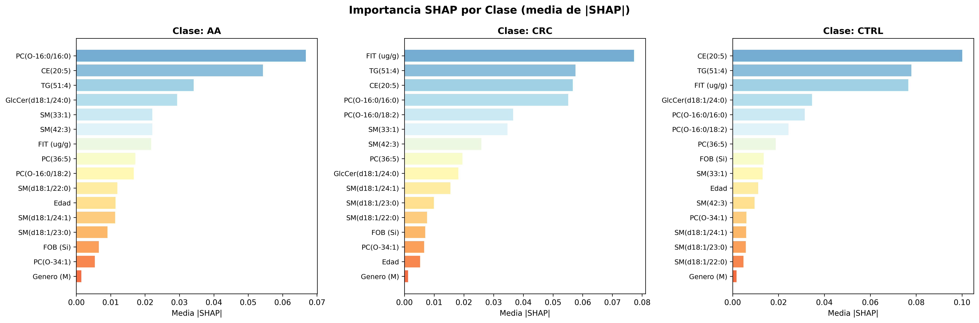
Figure 2. SHAP importance disaggregated by class (AA, CRC, CTRL). Biomarkers exhibit differentiated roles according to progression state.
Table 8. Top 5 biomarkers per class according to SHAP.
Rank | AA (Advanced Ad.) | |SHAP| | CRC (Cancer) | |SHAP| | CTRL (Control) | |SHAP|
1 | PC(O-16:0/16:0) | 0.067 | FIT (µg/g) | 0.077 | CE(20:5) | 0.100
2 | CE(20:5) | 0.054 | TG(51:4) | 0.058 | TG(51:4) | 0.078
3 | TG(51:4) | 0.034 | CE(20:5) | 0.057 | FIT (µg/g) | 0.077
4 | GlcCer(d18:1/24:0) | 0.029 | PC(O-16:0/16:0) | 0.055 | GlcCer(d18:1/24:0) | 0.035
5 | SM(33:1) | 0.022 | PC(O-16:0/18:2) | 0.037 | PC(O-16:0/16:0) | 0.031
4.4.3 Patient-level interpretability
Figures 3, 4, and 5 present SHAP contributions for representative individual patients from each class, correctly classified by the model. For the AA patient (Figure 3), GlcCer(d18:1/24:0) and PC(O-16:0/16:0) are the main positive contributors (increasing the probability of AA), while CE(20:5) contributes negatively (decreasing the probability of AA). This differential pattern enables the clinician to understand why the model classifies the patient as advanced adenoma rather than control or cancer.
For the CRC patient (Figure 4), FIT is the primary contributor, followed by TG(51:4) and CE(20:5), consistent with the pattern of elevated fecal bleeding and severe lipid alterations characteristic of confirmed cancer. The sphingomyelins SM(d18:1/22:0) and SM(d18:1/24:1) contribute negatively, suggesting that their levels in this patient are inconsistent with the typical CRC profile.
For the CTRL patient (Figure 5), all contributions are positive (increasing the probability of classification as healthy control), led by CE(20:5) and FIT with low values. The absence of negative contributions reflects a consistently normal metabolic profile.
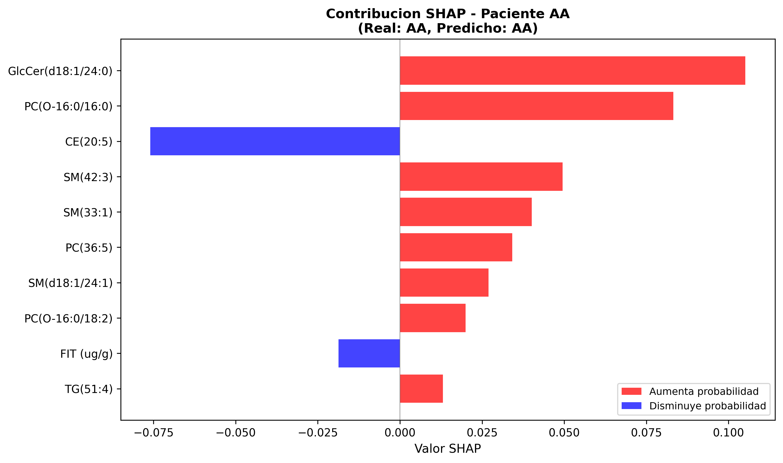
Figure 3. SHAP contributions for a correctly classified AA patient.
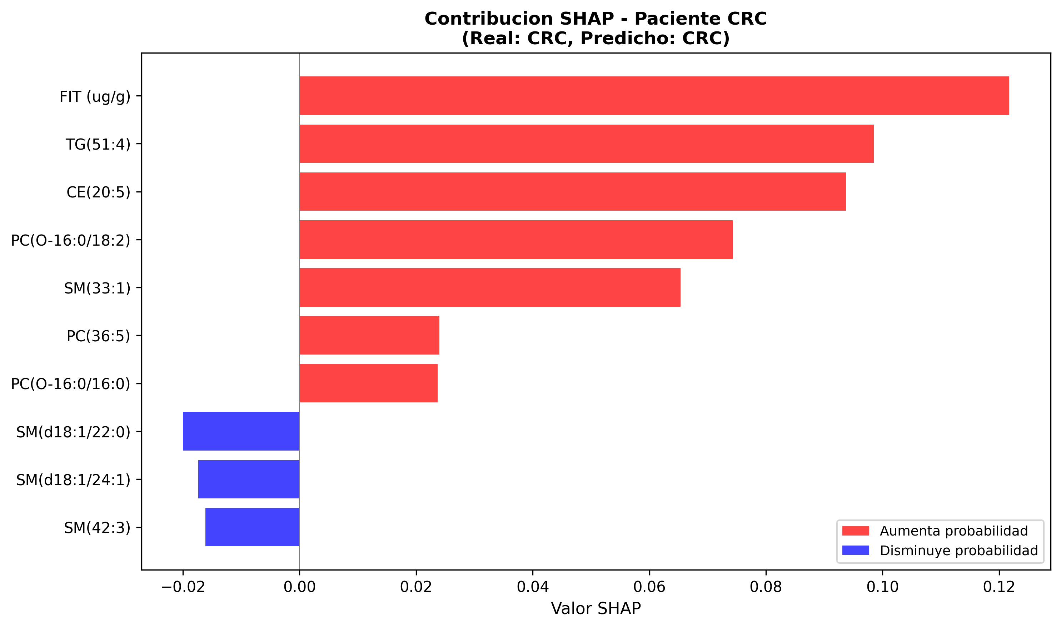
Figure 4. SHAP contributions for a correctly classified CRC patient.
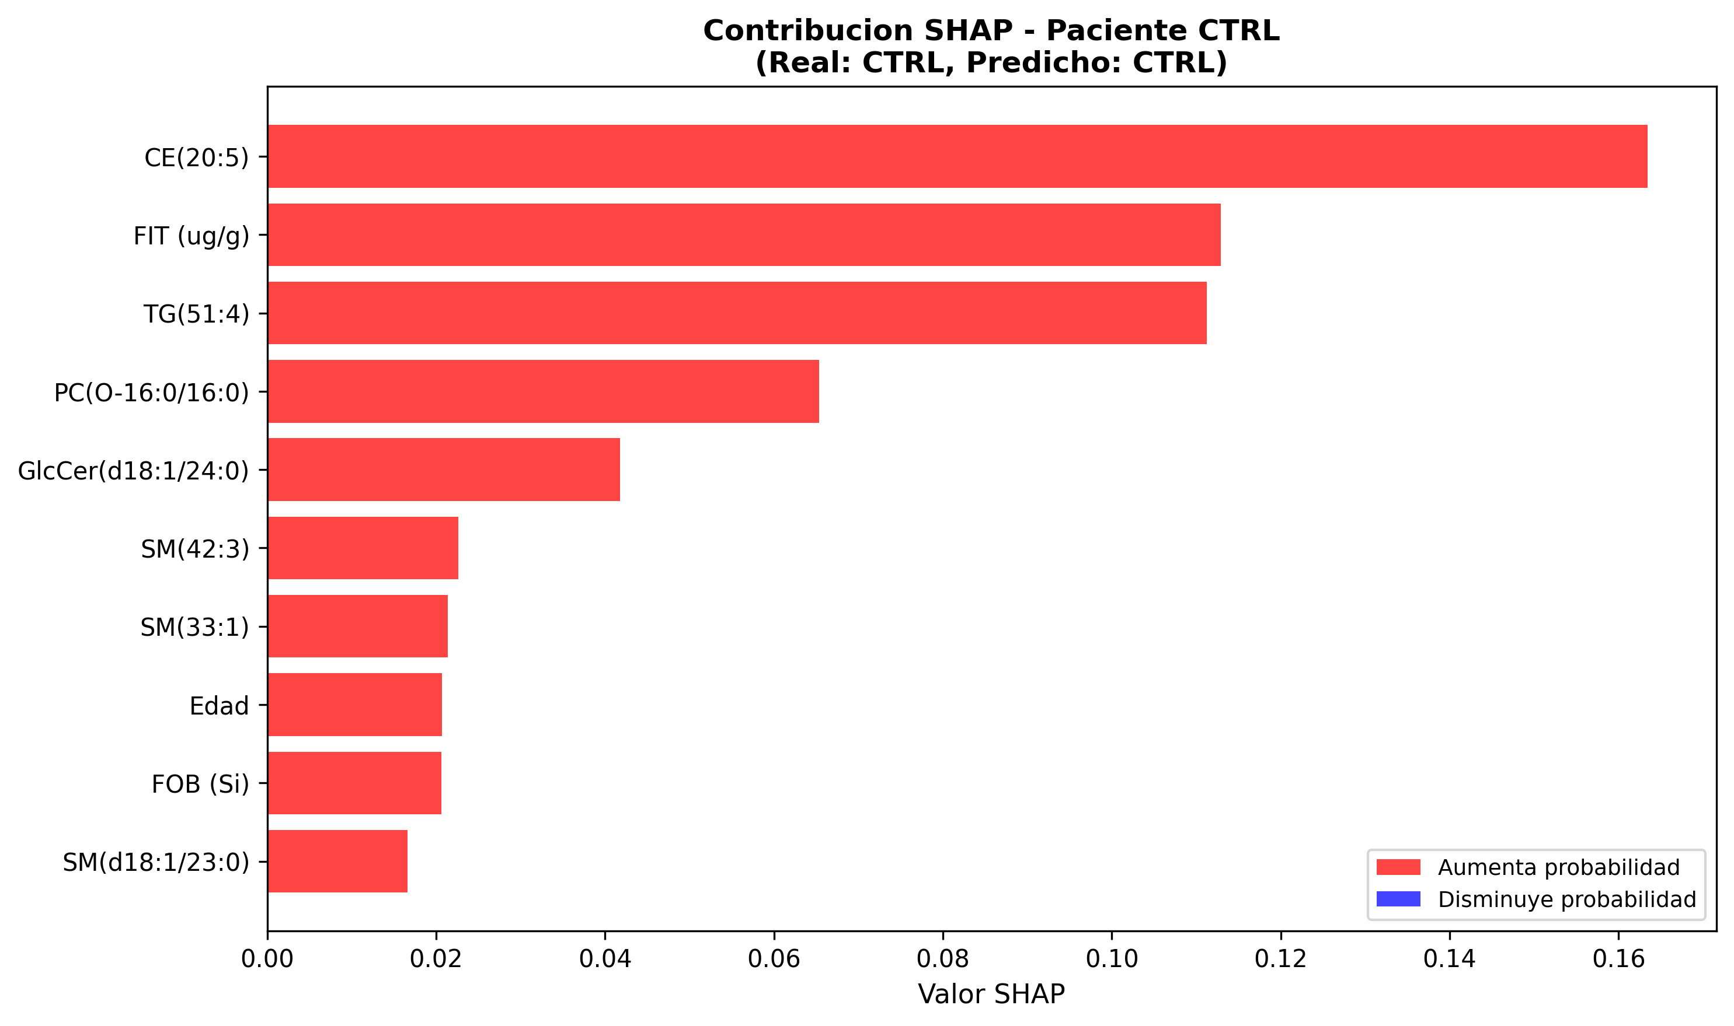
Figure 5. SHAP contributions for a correctly classified CTRL patient.
4.5 Performance evolution
Table 9 traces the performance evolution throughout the modeling pipeline, demonstrating consistent improvement from the linear baseline to the final ensemble.
Table 9. Performance evolution throughout the modeling pipeline.
Phase | Model | F1 Macro | F1 AA | Recall AA
Baseline | Logistic Regression | 0.628 | 0.45 | 0.47
Individual | Decision Tree | 0.681 | 0.55 | 0.50
Ensembles | Bagging Tree | 0.855 | 0.78 | 0.75

4.6 Top-K analysis: model-guided feature selection
As a complementary analysis, a strategy based on feature importance obtained from the model trained with all available features was evaluated. Unlike filter-based selection through Mutual Information and ANOVA (Section 3.3), this approach enables identification of the variables deemed most relevant by the model itself during the learning process. This strategy corresponds to a model-based feature selection approach, where the Bagging Tree's mean impurity importance determines the variable ranking.
The Bagging Tree model trained on X_full (131 variables) achieved an AA recall of 0.833, superior to the 0.750 obtained with X_intersect. To evaluate whether this improvement could be concentrated in a reduced subset, the Top-10, Top-15, Top-20, and Top-30 variables by model importance were selected and evaluated on the held-out set (Table 10).
Table 10. Top-K analysis: performance with model-selected feature subsets.
Configuration | n variables | F1 Macro | F1 AA | Recall AA
X_intersect (final model) | 16 | 0.855 | 0.783 | 0.750
X_full | 131 | 0.839 | 0.833 | 0.833
X_full Top-15 | 15 | 0.839 | 0.833 | 0.833
X_full Top-20 | 20 | 0.836 | 0.800 | 0.833
X_full Top-10 | 10 | 0.821 | 0.870 | 0.870

The Top-15 subset retained the same AA recall (0.833) and AA F1 (0.833) as the full X_full set, reducing dimensionality by 89%. The 9 variables common between X_intersect (filter selection) and Top-15 (model-guided selection) constitute the robust core of biomarkers validated by two independent selection strategies: CE(20:5), GlcCer(d18:1/24:0), PC(36:5), PC(O-16:0/16:0), PC(O-16:0/18:2), SM(33:1), SM(42:3), TG(51:4), and FIT.
5. Discussion
The results of this study show that decision tree ensembles, applied to fecal lipidomic biomarkers, achieve effective classification of the three CRC progression states in this cohort, including the detection of advanced adenomas where conventional chemometric methods had low performance. The main findings are discussed below in the context of the existing literature and their potential clinical implications.
5.1 Superiority of the ensemble approach over conventional methods
The most clinically significant result is the detection of advanced adenomas with F1 = 0.78 and recall = 0.75. Alboniga et al. [12] reported F1 = 0 for the AA class using PLS-DA on the same data. This difference is consistent with the ability of decision trees and their ensembles to model nonlinear relationships among variables and reduce variance through aggregation [15,16]. Biologically, the difficulty of AA also agrees with the source study's interpretation of this class as a heterogeneous transitional state between controls and CRC [12].
The precision of 1.00 for healthy controls on the held-out set indicates that, within this test partition, the model generated no false positives for healthy individuals. This result is relevant for screening programs, where unnecessary colonoscopies represent a clinical and operational burden, but it should be interpreted cautiously because of the small held-out set. The macro AUC of 0.945 confirms high discriminatory capacity across different decision thresholds in this cohort.
5.2 Identified lipidomic biomarkers and SHAP interpretability
CE(20:5) (cholesteryl ester with eicosapentaenoic acid) is confirmed as the biomarker with the highest global contribution by both Gini importance and SHAP. This result is consistent with the source study's emphasis on cholesteryl esters as relevant markers in fecal samples from advanced colorectal neoplasia [12]. The literature on lipidomics and cholesterol metabolism in cancer supports a cautious interpretation: cholesteryl ester alterations may reflect changes in cholesterol homeostasis, lipid-droplet storage, lipid availability for membranes, and proliferation-related signaling pathways [25-35]. In addition, hypotheses involving vesicular transport and signaling through cholesterol esterification provide general biological context, but do not by themselves validate CE(20:5) as a specific causal mechanism [37,38].
The SHAP analysis provides a dimension that Gini importance does not capture: differentiation of each biomarker's role according to diagnostic class. The finding that PC(O-16:0/16:0) is the primary predictor for advanced adenomas should be interpreted as a contribution to the model, not as direct mechanistic evidence. PC(O-) species belong to the ether-lipid class of phosphatidylcholines; given the available annotation level, it should not be assumed automatically that every PC(O-) species is a vinyl-ether plasmalogen. Its association with AA is compatible with the importance of glycerophospholipid and membrane remodeling described in CRC lipidomics literature [7,8,25], but requires specific analytical and biological validation.
The dominance of FIT as a predictor for CRC in the SHAP analysis is clinically coherent with the basis of the test, which quantifies fecal hemoglobin and tends to perform better for established cancer than for precursor lesions [4,12]. This result reinforces the complementarity between lipidomic biomarkers and standard clinical tests: in the model, lipids contribute signal for AA, while FIT remains highly relevant for confirmed CRC. SHAP, in this context, explains the model's prediction and does not establish biological causality or independent clinical validity.
Sphingomyelins (SM(42:3), SM(33:1)) and GlcCer(d18:1/24:0) rank among the model-relevant variables, which is compatible with studies reporting alterations of sphingolipids, glycerophospholipids, and other lipids in colorectal carcinogenesis [6-8,25,36]. Literature on ceramides and sphingolipids links these families to cell signaling, apoptosis, and tumor metabolism [36], but the evidence available here supports an interpretation as predictive biomarkers, not a causal conclusion about each molecular species. Similarly, TG(51:4) should be described conservatively as a predictive lipidomic feature; although triglycerides are part of lipidomic alterations reported in fecal CRC studies [12], no local evidence was identified that would justify assigning it a specific mechanism.
5.3 Clinical implications
The combination of lipidomic biomarkers with FIT has potential to improve future CRC screening protocols. With FIT as the sole tool, sensitivity for AA is generally lower than for CRC [4,12]. Our multimodal model (lipids + FIT) achieved AA recall of 75% on the held-out set. These results could motivate future evaluation of a targeted lipidomic panel (MRM/SRM) based on the identified biomarkers, but they do not by themselves demonstrate economic feasibility, clinical utility, or readiness for population-based screening.
5.4 Limitations
This study has several limitations that should be considered. First, the sample size is limited (n=211, test=43), which confers variance to the held-out metrics (estimated at ±0.02–0.05 F1). The most conservative estimate of external performance is the cross-validation F1 (0.802), not the held-out F1 (0.855). Second, the cohort originates from a single hospital center (Ourense, Spain), introducing potential population bias related to diet, genetics, and clinical protocols. Third, the model exhibits overfitting in training (Train F1 = 1.00), with a train-CV gap of ~0.20 that could be reduced through additional regularization (limiting max_depth, increasing min_samples_leaf). Fourth, the Top-K analysis was evaluated solely on the held-out set without nested cross-validation, and should therefore be interpreted as exploratory evidence.
6. Conclusions
This study demonstrates that a Bagging Tree-based machine learning pipeline, applied to 16 lipidomic biomarkers and clinical variables, enables effective tripartite classification of colorectal cancer progression (Control/AA/CRC) with F1 macro = 0.855 and AUC = 0.945. The most clinically relevant finding is the detection of advanced adenomas with F1 = 0.78, where the reference chemometric method (PLS-DA) yields F1 = 0 on the same data.
SHAP analysis reveals that biomarkers have differentiated roles according to the diagnostic class: PC(O-16:0/16:0) is the primary predictor for advanced adenomas, FIT for confirmed cancer, and CE(20:5) for healthy controls. This differentiation provides model interpretability and suggests plausible biological hypotheses, but it does not demonstrate causal metabolic mechanisms across CRC progression phases. Patient-level interpretability afforded by SHAP improves model transparency as a research tool.
The intersection of 9 biomarkers validated by two independent selection strategies (filter-based and model-guided) constitutes a candidate panel for future evaluation through targeted mass spectrometry assays (MRM/SRM). The results support that lipidomic profiles may complement, but not replace, standard screening tests. Clinical implementation requires external multicenter validation, ethical approval, and formal evaluation of clinical utility and cost-benefit.
Declarations
Ethics statement
The data used in this study originate from the dataset published by Alboniga et al. [12], collected at the Hospital of Ourense (Galicia, Spain) under approval from the corresponding institutional ethics committee. [NOTE: Complete with reference number and date of the original ethics approval, or statement of public data use as applicable.]
Data and code availability
The source code for the complete pipeline, including the SHAP analysis, is available at [NOTE: include GitHub repository URL]. [NOTE: State the accessibility of the data as applicable.]
Funding
[NOTE: Complete. If no funding: This research did not receive any specific grant from funding agencies in the public, commercial, or not-for-profit sectors.]
Declaration of competing interest
The authors declare that they have no known competing financial interests or personal relationships that could have appeared to influence the work reported in this paper.
Use of generative artificial intelligence
[NOTE: Declare any generative AI tools used in the preparation of the manuscript, including literature review, data analysis, text generation, or figure creation.]
Author contributions
[NOTE: Complete according to the CRediT taxonomy: Conceptualization, Methodology, Software, Validation, Formal analysis, Investigation, Resources, Data curation, Writing – original draft, Writing – review & editing, Visualization, Supervision, Project administration.]
References
[1] F. Bray, M. Laversanne, H. Sung, J. Ferlay, R.L. Siegel, I. Soerjomataram, A. Jemal, Global Cancer Statistics 2022: GLOBOCAN estimates of incidence and mortality worldwide for 36 cancers in 185 countries, CA Cancer J. Clin. 74 (2024) 229-263.
[2] E.R. Fearon, B. Vogelstein, A genetic model for colorectal tumorigenesis, Cell 61 (1990) 759-767.
[3] S.J. Winawer, A.G. Zauber, M.N. Ho, et al., Prevention of colorectal cancer by colonoscopic polypectomy, N. Engl. J. Med. 329 (1993) 1977-1981.
[4] H. Brenner, S. Tao, Superior diagnostic performance of faecal immunochemical tests for haemoglobin in a head-to-head comparison with guaiac based faecal occult blood test among 2235 participants of screening colonoscopy, Eur. J. Cancer 49 (2013) 3049-3054.
[5] R.E. Schoen, P.F. Pinsky, J.L. Weissfeld, et al., Colorectal-cancer incidence and mortality with screening flexible sigmoidoscopy, N. Engl. J. Med. 366 (2012) 2345-2357.
[6] S.H. Hoseini, P. Enayati, M. Nazari, E. Babakhanzadeh, M. Rastgoo, N.B. Sohrabi, Biomarker profile of colorectal cancer: current findings and future perspective, J. Gastrointest. Cancer 55 (2024) 497-510.
[7] A. Gold, F. Choueiry, N. Jin, X. Mo, J. Zhu, The application of metabolomics in recent colorectal cancer studies: a state-of-the-art review, Cancers 14 (2022) 725.
[8] F. Zhang, Y. Zhang, W. Zhao, K. Deng, Z. Wang, C. Yang, L. Ma, M.S. Openkova, Y. Hou, K. Li, Metabolomics for biomarker discovery in the diagnosis, prognosis, survival and recurrence of colorectal cancer: a systematic review, Oncotarget 8 (2017) 35460-35472.
[9] Y. Ni, G. Xie, W. Jia, Metabonomics of human colorectal cancer: new approaches for early diagnosis and biomarker discovery, J. Proteome Res. 13 (2014) 3857-3870.
[10] J. Cubiella, M. Clos-Garcia, C. Alonso, I. Martinez-Arranz, M. Perez-Cormenzana, Z. Barrenetxea, J. Berganza, I. Rodriguez-Llopis, M. D'Amato, L. Bujanda, et al., Targeted UPLC-MS metabolic analysis of human faeces reveals novel low-invasive candidate markers for colorectal cancer, Cancers 10 (2018) 300.
[11] O.E. Alboniga, J. Cubiella, L. Bujanda, M.E. Blanco, B. Lanza, C. Alonso, B. Nafria, J.M. Falcon-Perez, A novel approach on the use of samples from faecal occult blood screening kits for metabolomics analysis: application in colorectal cancer population, Metabolites 13 (2023) 321.
[12] O.E. Alboniga, J. Cubiella, L. Bujanda, P. Aspichueta, M.E. Blanco, B. Lanza, C. Alonso, J.M. Falcon-Perez, Metabolic signature in combination with fecal immunochemical test as a non-invasive tool for advanced colorectal neoplasia diagnosis, Cancers 17 (2025) 2339.
[13] E. Saccenti, H.C.J. Hoefsloot, A.K. Smilde, J.A. Westerhuis, M.M.W.B. Hendriks, Reflections on univariate and multivariate analysis of metabolomics data, Metabolomics 10 (2014) 361-374.
[14] A.M. Wheelock, C.E. Wheelock, Trials and tribulations of 'omics data analysis: assessing quality of SIMCA-based multivariate models using examples from pulmonary medicine, Mol. Biosyst. 9 (2013) 2589.
[15] L. Breiman, Bagging predictors, Mach. Learn. 24 (1996) 123-140.
[16] L. Breiman, Random forests, Mach. Learn. 45 (2001) 5-32.
[17] S. Studer, T.B. Bui, C. Drescher, A. Hanuschkin, L. Winkler, S. Peters, K.R. Mueller, Towards CRISP-ML(Q): a machine learning process model with quality assurance methodology, Mach. Learn. Knowl. Extr. 3 (2021) 392-413.
[18] F. Pedregosa, G. Varoquaux, A. Gramfort, et al., Scikit-learn: machine learning in Python, J. Mach. Learn. Res. 12 (2011) 2825-2830.
[19] S. Nishiumi, T. Kobayashi, A. Ikeda, et al., A novel serum metabolomics-based diagnostic approach for colorectal cancer, PLoS ONE 7 (2012) e40459.
[20] F. Farshidfar, A.M. Weljie, K. Kopciuk, et al., Serum metabolomic profile as a means to distinguish stage of colorectal cancer, Genome Med. 4 (2012) 42.
[21] L. Avram, D. Crisan, R.-C. Moldovan, L.-G. Bogos, C.-A. Iuga, D. Andras, S. Crisan, C. Bodolea, A. Nemes, V. Donca, Metabolomic exploration of colorectal cancer through amino acids and acylcarnitines profiling of serum samples, Cancers 17 (2025) 427.
[22] G.E.P. Box, D.R. Cox, An analysis of transformations, J. R. Stat. Soc. Ser. B Stat. Methodol. 26 (1964) 211-243.
[23] S.M. Lundberg, S.I. Lee, A unified approach to interpreting model predictions, Adv. Neural Inf. Process. Syst. 30 (2017) 4765-4774.
[24] S.M. Lundberg, G. Erion, H. Chen, A. DeGrave, J.M. Prutkin, B. Nair, R. Katz, J. Himmelfarb, N. Bansal, S.I. Lee, From local explanations to global understanding with explainable AI for trees, Nat. Mach. Intell. 2 (2020) 56-67.
[25] M.A. Fernandez-Garcia, M.L. Ruiz-Canela, M.A. Martinez-Gonzalez, Lipidomics in colorectal cancer biomarker research, J. Lipid Res. 62 (2021) 100090.
[26] Z. Liu, C.R. Gomez, I. Espinoza, T.P.T. Le, V. Shenoy, X. Zhou, Correlation of cholesteryl ester metabolism to pathogenesis, progression and disparities in colorectal cancer, Lipids Health Dis. 21 (2022) 22.
[27] W. Jiang, W.-L. Jin, A.-M. Xu, Cholesterol metabolism in tumor microenvironment: cancer hallmarks and therapeutic opportunities, Int. J. Biol. Sci. 20 (2024) 2044-2071.
[28] J.L. Goldstein, R.A. DeBose-Boyd, M.S. Brown, Protein sensors for membrane sterols, Cell 124 (2006) 35-46.
[29] T.-Y. Chang, B.-L. Li, C.C.Y. Chang, Y. Urano, Acyl-coenzyme A: cholesterol acyltransferases, Am. J. Physiol.-Endocrinol. Metab. 297 (2009) E1-E9.
[30] B. Huang, B. Song, C. Xu, Cholesterol metabolism in cancer: mechanisms and therapeutic opportunities, Nat. Metab. 2 (2020) 132-141.
[31] J. Kopecka, M. Godel, C. Riganti, Cholesterol metabolism: at the cross road between cancer cells and immune environment, Int. J. Biochem. Cell Biol. 129 (2020) 105876.
[32] X. Chen, H. Liang, Q. Song, X. Xu, D. Cao, Insulin promotes progression of colon cancer by upregulation of ACAT1, Lipids Health Dis. 17 (2018) 122.
[33] C. Wu, M. Wang, H. Shi, Cholesterol promotes colorectal cancer growth by activating the PI3K/AKT pathway, J. Oncol. 2022 (2022) 1515416.
[34] S. Yue, J. Li, S.-Y. Lee, H.J. Lee, T. Shao, B. Song, L. Cheng, T.A. Masterson, X. Liu, T.L. Ratliff, et al., Cholesteryl ester accumulation induced by PTEN loss and PI3K/AKT activation underlies human prostate cancer aggressiveness, Cell Metab. 19 (2014) 393-406.
[35] K. Ye, Y. Wu, Y. Sun, J. Lin, J. Xu, TLR4 siRNA inhibits proliferation and invasion in colorectal cancer cells by downregulating ACAT1 expression, Life Sci. 155 (2016) 133-139.
[36] N. Morad, M. Cabot, Ceramide-orchestrated signaling in cancer cells, Nat. Rev. Cancer 13 (2013) 51-65.
[37] M. Record, M. Poirot, S. Silvente-Poirot, Emerging concepts on the role of exosomes in lipid metabolic diseases, Biochimie 96 (2014) 67-74.
[38] M.R. Paillasse, P. de Medina, G. Amouroux, L. Mhamdi, M. Poirot, S. Silvente-Poirot, Signaling through cholesterol esterification: a new pathway for the cholecystokinin 2 receptor involved in cell growth and invasion, J. Lipid Res. 50 (2009) 2203-2211.

