Interpretable multiclass classification of colorectal cancer progression using machine learning based on lipidomic biomarkers

María Virginia Mendizabal Miranda (1), Gianmel Joannelly Hernández Tosta (1), Sofía Ordaz López (1), Grettel Barceló Alonso (1)

(1) Tecnológico de Monterrey, School of Engineering and Sciences, Mexico

Corresponding author: [name], [email], [phone]

Abstract
Background and Objectives: Colorectal cancer (CRC) is one of the most prevalent neoplasms worldwide and constitutes a leading cause of cancer-related mortality. Current screening tests, such as the fecal immunochemical test (FIT), exhibit limited sensitivity for the detection of advanced adenomas (AA), precancerous lesions whose timely removal prevents progression to carcinoma. Conventional chemometric methods (PLS-DA) applied to lipidomic data have shown limitations in discriminating the AA class in multiclass settings. The aim of this study was to develop and evaluate a machine learning pipeline based on decision tree ensembles for tripartite classification (Control/AA/CRC) using serum lipidomic biomarkers.
Methods: A cohort of 211 patients (78 controls, 58 AA, 75 CRC) whose lipidomic profiles were obtained by ultra-high-performance liquid chromatography coupled to mass spectrometry (UHPLC-MS), with 127 lipids quantified, was used. The preprocessing pipeline included group-median imputation (validated against MICE using the Frobenius norm), Box-Cox transformation, and feature selection by intersection of Mutual Information and ANOVA (16 final variables). Fourteen models were compared: 6 individual classifiers and 8 ensembles (5 homogeneous, 2 heterogeneous, 1 individual baseline). Evaluation was conducted using stratified 5-fold cross-validation and an independent held-out set (n=43). Model interpretability was assessed using SHAP (SHapley Additive exPlanations) with TreeExplainer.
Results: The Bagging Tree model achieved F1 macro = 0.855 and AUC macro = 0.945 on the held-out set. Identification of advanced adenomas posed the greatest difficulty due to the similarity of their lipidomic profiles with those of the confirmed colorectal cancer (CRC) group. Despite this, the model attained F1 = 0.78 and recall = 0.75 for the AA class. Precision for healthy controls was 1.00, minimizing false positives. SHAP analysis revealed that CE(20:5) is the biomarker with the highest global contribution (mean |SHAP| = 0.070), with class-differentiated roles: PC(O-16:0/16:0) is the primary predictor for AA, FIT for CRC, and CE(20:5) for CTRL. A complementary analysis demonstrated that 15 variables from the full feature set retain the same AA recall (0.833), reducing dimensionality by 89%.
Conclusions: Lipidomic profiles analyzed using decision tree ensembles enable effective classification of the three CRC progression states, including the detection of advanced adenomas where conventional chemometric methods fail. SHAP analysis provides patient-level interpretability, facilitating clinical adoption. The results suggest that a reduced lipidomic panel complements the FIT for non-invasive CRC screening, although external multicenter validation is required prior to clinical implementation.

Keywords: colorectal cancer; lipidomics; machine learning; ensemble methods; biomarker discovery; adenoma detection; SHAP; decision trees

1. Introduction
Colorectal cancer (CRC) represents the third most commonly diagnosed neoplasm and the second leading cause of cancer-related mortality worldwide, with approximately 1.9 million new cases and 935,000 deaths annually [1]. CRC progression follows a well-characterized sequence: normal mucosa, adenoma, advanced adenoma (AA), and invasive carcinoma, known as the adenoma-carcinoma sequence [2]. This progression offers a critical window of intervention: detection and removal of advanced adenomas through endoscopic polypectomy can prevent up to 80% of CRC cases [3].
Current population-based screening strategies rely primarily on the fecal immunochemical test (FIT), which detects human hemoglobin in stool as an indicator of bleeding in the digestive tract. Although FIT shows good specificity for confirmed CRC, its sensitivity for advanced adenomas is limited, ranging between 20% and 50% depending on the positivity threshold concentration [4]. Positive FIT results require confirmation by colonoscopy, an invasive, costly procedure with limited availability in resource-constrained healthcare systems [5].
In this context, lipidomics emerges as a promising tool for non-invasive biomarker discovery. Serum lipidomic profiles reflect metabolic alterations associated with colorectal carcinogenesis, including changes in sphingolipid, glycerophospholipid, and cholesteryl ester metabolism [6,7]. Recent studies have demonstrated that combining metabolomic profiles with FIT significantly improves discriminatory capacity for advanced colorectal neoplasms [8].
However, conventional chemometric approaches may present limitations in multiclass settings. Alboniga et al. [8] applied partial least squares discriminant analysis (PLS-DA) to lipidomic data from a cohort of 211 patients at the Hospital of Ourense, achieving good discrimination between healthy controls and confirmed CRC, but with complete inability to detect advanced adenomas (F1 = 0 for the AA class). This limitation is clinically critical, as AAs constitute precisely the most valuable window of preventive intervention.
Machine learning methods, particularly decision tree ensembles, offer advantages over linear chemometric approaches for this type of problem: they capture nonlinear interactions between variables, naturally handle class imbalance, and provide interpretability mechanisms through feature importance [9,10]. Nevertheless, evidence on their application to multiclass classification of CRC progression using lipidomic biomarkers remains limited.
The present study addresses this gap through the development of a complete machine learning pipeline, following the CRISP-ML(Q) methodological framework [11], for tripartite classification (Control/AA/CRC) based on serum lipidomic biomarkers. The specific objectives are: (1) to build a multiclass classifier for colorectal cancer progression with particular emphasis on advanced adenoma detection; (2) to identify a reduced panel of lipidomic biomarkers with discriminatory capacity and biological plausibility; and (3) to evaluate the complementarity between lipidomic biomarkers and standard clinical tests (FIT, fecal occult blood).
2. Related Work
The application of machine learning techniques to CRC diagnosis has gained significant attention over the past decade. Approaches can be classified according to the type of data used: histopathological images [12], genomic and transcriptomic data [13], metabolomics and lipidomics [6,7,8], and clinical and demographic data [14].
In the field of metabolomics applied to CRC, several studies have employed supervised classification techniques. Nishiumi et al. [15] used Random Forest with serum metabolites to discriminate CRC patients from healthy controls, achieving an AUC of 0.91 in validation. Farshidfar et al. [16] applied multivariate analysis to metabolomic profiles for staging CRC, demonstrating that serum metabolites reflect tumor progression. However, the majority of these studies are limited to binary comparisons (cancer vs. control), without addressing the detection of precancerous lesions such as advanced adenomas.
Specifically in lipidomics, Ecker et al. [6] identified alterations in phospholipid and sphingomyelin profiles associated with CRC, suggesting that lipid remodeling is an early event in colorectal carcinogenesis. More recently, Alboniga et al. [8] conducted a comprehensive study using UHPLC-MS to quantify 127 serum lipids in a cohort of 211 patients (78 controls, 58 AA, 75 CRC) from the Hospital of Ourense (Galicia, Spain). They applied PLS-DA as the standard chemometric method, achieving good binary separation (CRC vs. CTRL), although no advanced adenoma was correctly classified (F1 AA = 0).
This gap in multiclass AA detection constitutes the central motivation of the present work. Unlike previous studies, our approach: (a) explicitly formulates the problem as tripartite classification (CTRL/AA/CRC); (b) employs a systematic preprocessing pipeline with quantitative validation of each decision; (c) compares 14 models including 8 ensembles; and (d) prioritizes AA detection as the primary clinical metric, complementing the evaluation with SHAP interpretability analysis.

3. Materials and Methods
3.1 Dataset
The lipidomic dataset published by Alboniga et al. [8] was used, comprising 211 blood serum samples from patients in the CRC screening program at the Hospital of Ourense (Galicia, Spain). Samples were analyzed by ultra-high-performance liquid chromatography coupled to mass spectrometry (UHPLC-MS), quantifying 127 lipids belonging to the sphingolipid, sterol, glycerophospholipid, and glycerolipid families.
The class distribution was: 78 healthy controls (CTRL, 37.0%), 58 advanced adenomas (AA, 27.5%), and 75 confirmed colorectal cancer cases (CRC, 35.5%). Additionally, clinical variables were recorded: age, FIT result (fecal hemoglobin concentration in µg/g), fecal occult blood test (FOB, categorical: yes/no), and sex.
Table 1. Dataset variables.
Variable | Type | Description
127 lipids | Continuous | Serum lipid concentrations by UHPLC-MS
Age | Continuous | Patient age in years
FIT (µg/g) | Continuous | Fecal immunochemical hemoglobin concentration
FOB | Categorical | Fecal occult blood (Yes/No)
Sex | Categorical | Male/Female
Group | Categorical (target) | CTRL / AA / CRC

3.2 Preprocessing
3.2.1 Missing data treatment
Missing data analysis revealed that 56 of 132 variables had no missing values, while 27 lipids contained more than 20% missing data. Five lipids with more than 40% missing values were removed (PC(33:0), PE(P-18:0/20:4), SM(36:2), TG(55:2), SM(d18:1/17:0)), retaining 122 lipids for analysis.
Analysis of the missing data mechanism through chi-squared tests revealed that 13 of 56 evaluated lipids exhibited significant dependence of the missingness pattern on the diagnostic group (p < 0.05), indicating a MAR/MNAR mechanism. Biologically, concentrations below the detection limit are more frequent in healthy controls, where certain lipids associated with tumor processes are present at minimal concentrations.
Group-median imputation (CTRL/AA/CRC) was selected over MICE, validating the decision using two metrics: the Frobenius norm (3.24 vs. 13.58) and the percentage of pairs with correlation change |Δr| > 0.10 (1.6% vs. 15.2%). Group-median imputation preserved the lipidomic correlation structure 4 times better than MICE, which is critical since co-regulation patterns among lipids contain biologically relevant information.
3.2.2 Transformation and scaling
Given that all 127 lipids exhibited severe positive skewness (median skewness = 5.47), four transformation strategies were evaluated: log1p, Yeo-Johnson, Box-Cox, and raw data. The Box-Cox transformation achieved the highest normality rate according to the Shapiro-Wilk test (81.1% of variables with p > 0.05), compared to log1p (0.8%) and Yeo-Johnson (5.5%). Median skewness was reduced from 5.47 to 0.03 after Box-Cox transformation. Subsequently, StandardScaler (mean = 0, standard deviation = 1) was applied to continuous variables to homogenize scales prior to model training.
3.3 Feature selection
A filter-based feature selection strategy was implemented through the intersection of two independent criteria: Mutual Information (MI, nonlinear criterion) and ANOVA F-test (linear criterion). The top 30 variables according to each criterion were selected, and their intersection was retained. The Jaccard coefficient between both sets was 27.66%, indicating low redundancy and complementarity between the criteria.
The resulting matrix, termed X_intersect, contains 16 variables: 12 lipidomic biomarkers, 2 clinical variables (age, FIT), and 2 categorical indicators (sex, FOB). Table 2 lists the lipidomic biomarkers included.
Table 2. Lipidomic biomarkers in X_intersect (MI ∩ ANOVA filter selection).
Biomarker | Lipid family
CE(20:5) | Cholesteryl ester
GlcCer(d18:1/24:0) | Monohexosylceramide
PC(36:5) | Diacylglycerophosphocholine
PC(O-16:0/16:0) | Ether-glycerophosphocholine
PC(O-16:0/18:2) | Ether-glycerophosphocholine
PC(O-34:1) | Ether-glycerophosphocholine
SM(33:1) | Sphingomyelin
SM(42:3) | Sphingomyelin
SM(d18:1/22:0) | Sphingomyelin
SM(d18:1/23:0) | Sphingomyelin
SM(d18:1/24:1) + SM(d18:2/24:0) | Sphingomyelin
TG(51:4) | Triacylglycerol

3.4 Models evaluated
A total of 14 models organized in two phases were compared. In the first phase, 6 individual classifiers with hyperparameter optimization via GridSearchCV with stratified 5-fold cross-validation were evaluated: Logistic Regression, Decision Tree, Support Vector Machine (SVM), K-Nearest Neighbors (KNN), Gaussian Naive Bayes, and Linear Discriminant Analysis (LDA). All applicable models were configured with class_weight='balanced' to compensate for moderate class imbalance.
In the second phase, 8 ensemble models were evaluated: 5 homogeneous (Bagging Tree, Random Forest, Gradient Boosting, AdaBoost, Extra Trees) and 2 heterogeneous (Stacking with Logistic Regression meta-classifier, Soft Voting), in addition to the individual Decision Tree as a baseline.
3.5 Evaluation strategy
A two-level evaluation was implemented to prevent data leakage. The dataset was split into X_dev (80%, n=168) for training and optimization, and X_test (20%, n=43) as an independent held-out set, never used during model selection or hyperparameter optimization. Stratified 5-fold cross-validation was applied on X_dev.
The primary evaluation metric was F1 macro, which equally weights performance across all three classes, avoiding the bias toward majority classes introduced by accuracy. Secondary metrics included AUC-ROC macro (one-vs-rest), precision, and recall per class, with particular emphasis on AA class performance as the clinically relevant metric.
3.6 Interpretability analysis using SHAP
To quantify the individual contribution of each biomarker to the model's predictions, the SHAP (SHapley Additive exPlanations) framework [20] was applied, grounded in Shapley value theory from cooperative game theory. Unlike mean impurity importance (Gini), which provides a single global ranking, SHAP decomposes each prediction into the additive contribution of each variable, enabling analysis of both global patterns and patient-level explanations.
TreeExplainer [21] was applied to each of the 100 base trees of the Bagging Tree, averaging the resulting SHAP values to obtain the contributions of the full ensemble. SHAP values were computed on the held-out set (n=43) and disaggregated by class (AA, CRC, CTRL), enabling identification of which biomarkers are most relevant for each CRC progression state.
4. Results
4.1 Comparison of individual classifiers
Table 3 presents the results of the 6 individual classifiers after hyperparameter optimization. The Decision Tree was selected as the best individual model (F1 macro held-out = 0.681) due to its consistency between cross-validation and test set (gap = 0.026, compared to 0.062 for KNN) and its clinical interpretability.
Table 3. Individual classifier performance (X_intersect, 16 variables).
Model | F1 CV | F1 Held-out | Gap
KNN (k=7, Manhattan) | 0.729 | 0.667 | 0.062
Decision Tree (max_depth=5) | 0.707 | 0.681 | 0.026
Logistic Regression (C=0.001) | 0.632 | -- | --
SVM (C=100, RBF) | 0.619 | -- | --
LDA (shrinkage=auto) | 0.578 | -- | --
Gaussian Naive Bayes | 0.565 | -- | --

4.2 Comparison of ensemble models
Table 4 shows the results of the 8 ensemble models. The Bagging Tree achieved the highest F1 macro on the held-out set (0.855), outperforming Random Forest (0.810), Gradient Boosting (0.809), and heterogeneous ensembles (Stacking: 0.760, Voting: 0.710). The improvement over the individual Decision Tree was +0.174 F1 points (+25.5%).
Table 4. Ensemble model performance (X_intersect, 16 variables).
Model | Type | F1 CV | F1 Held-out
Bagging Tree | Homogeneous | 0.802 | 0.855
Random Forest | Homogeneous | 0.806 | 0.810
Gradient Boosting | Homogeneous | 0.820 | 0.809
AdaBoost | Homogeneous | 0.752 | 0.809
Stacking | Heterogeneous | 0.682 | 0.760
Extra Trees | Homogeneous | 0.738 | 0.710
Soft Voting | Heterogeneous | 0.633 | 0.710
Decision Tree (baseline) | Individual | 0.696 | 0.639

4.3 Final model: Bagging Tree
The Bagging Tree model was configured with the optimal hyperparameters identified through GridSearchCV (108 combinations): n_estimators=100, max_samples=0.8, max_features=0.6, with unconstrained base tree depth and class_weight='balanced'. Table 5 presents the detailed per-class performance on the held-out set.
Table 5. Bagging Tree per-class performance (held-out set, n=43).
Class | Precision | Recall | F1-Score | Support (n)
AA (Advanced Adenoma) | 0.82 | 0.75 | 0.78 | 12
CRC (Colorectal Cancer) | 0.78 | 0.93 | 0.85 | 15
CTRL (Healthy Control) | 1.00 | 0.88 | 0.93 | 16
Macro Average | 0.87 | 0.85 | 0.855 | 43

The macro AUC-ROC was 0.945 (AA: 0.902, CRC: 0.949, CTRL: 0.984). The confusion matrix (Table 6) reveals that no AA sample was misclassified as CTRL, which has direct clinical relevance: the model does not produce complete false negatives in the most dangerous direction (classifying a precancerous lesion as healthy).
Table 6. Bagging Tree confusion matrix (held-out set).
 | Predicted: AA | Predicted: CRC | Predicted: CTRL
Actual: AA | 9 | 3 | 0
Actual: CRC | 0 | 14 | 1
Actual: CTRL | 0 | 2 | 14
4.4 SHAP interpretability analysis
4.4.1 Global SHAP importance
Figure 1 presents the global SHAP importance ranking, computed as the mean absolute SHAP values averaged across the three classes. CE(20:5) is confirmed as the biomarker with the highest global contribution (mean |SHAP| = 0.070), followed by FIT (0.059), TG(51:4) (0.057), and PC(O-16:0/16:0) (0.051). The clinical variables sex and FOB exhibited minimal contributions (0.002 and 0.009, respectively), confirming that the discriminative signal predominantly originates from lipidomic biomarkers. Table 7 presents the complete ranking.
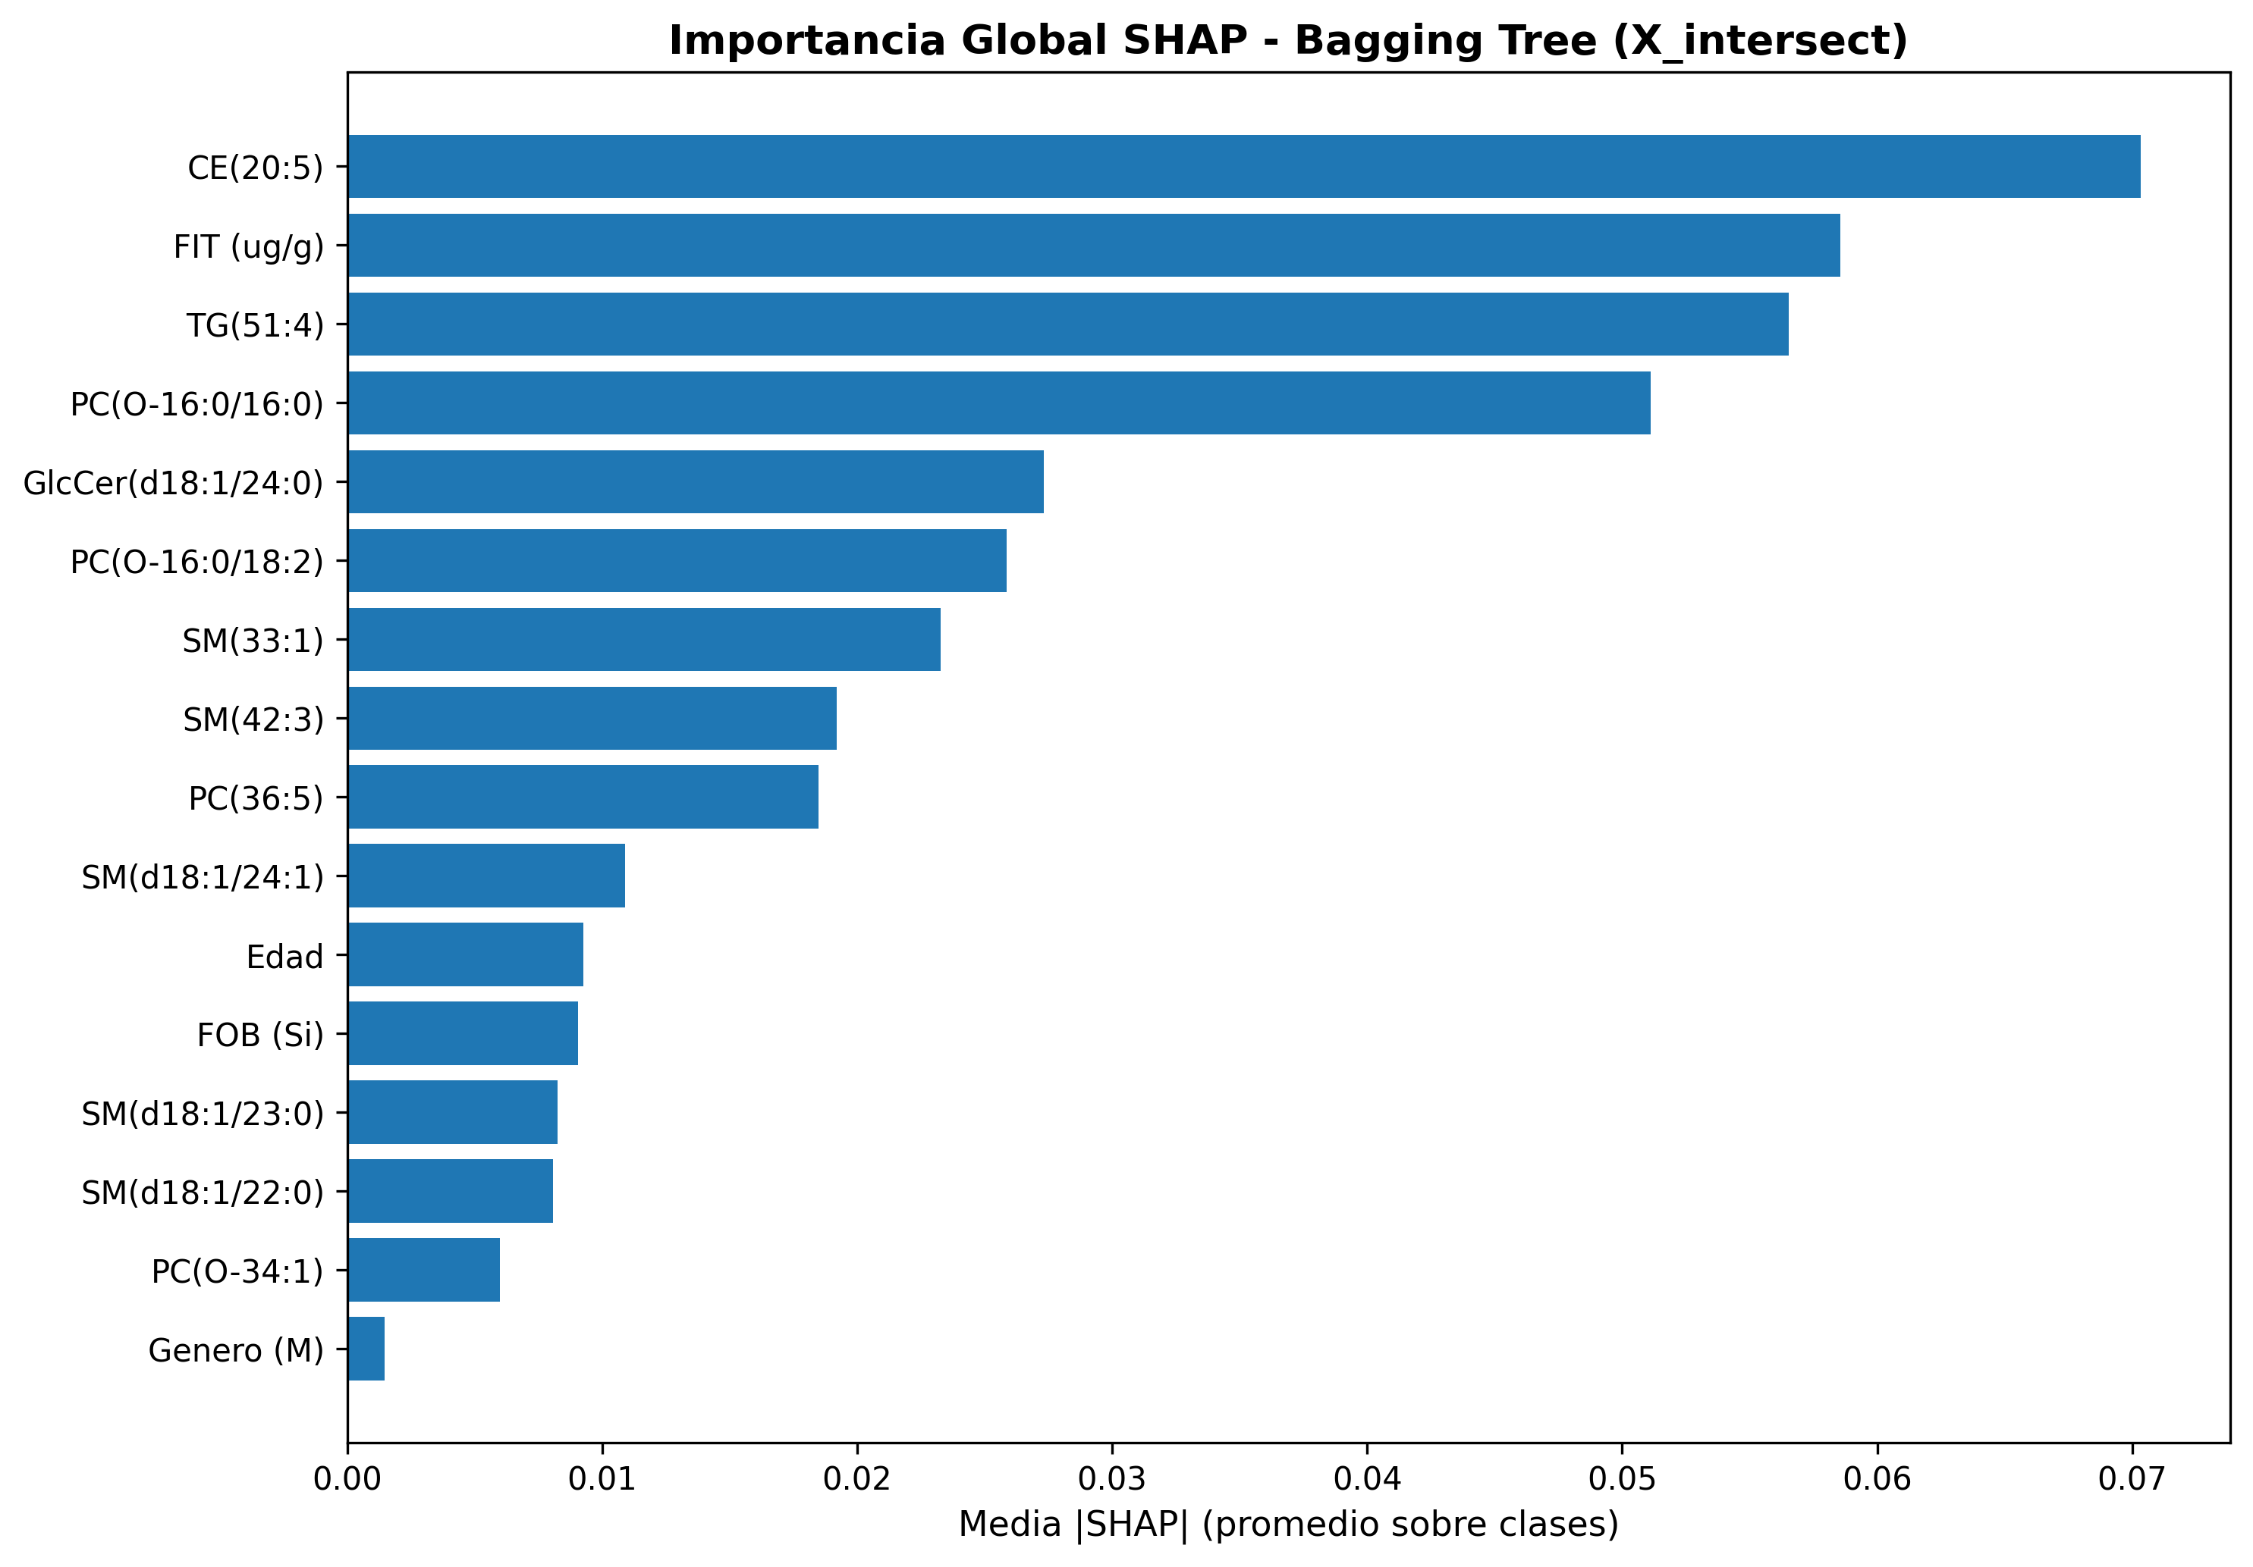
Figure 1. Global SHAP importance of the Bagging Tree (mean |SHAP| averaged across the three classes).

Table 7. Top 10 variables by SHAP importance (global mean |SHAP|).
Rank | Variable | Mean |SHAP| | Type
1 | CE(20:5) | 0.070 | Cholesteryl ester
2 | FIT (µg/g) | 0.059 | Clinical variable
3 | TG(51:4) | 0.057 | Triacylglycerol
4 | PC(O-16:0/16:0) | 0.051 | Ether-phosphatidylcholine
5 | GlcCer(d18:1/24:0) | 0.027 | Glucosylceramide
6 | PC(O-16:0/18:2) | 0.026 | Ether-phosphatidylcholine
7 | SM(33:1) | 0.023 | Sphingomyelin
8 | SM(42:3) | 0.019 | Sphingomyelin
9 | PC(36:5) | 0.019 | Phosphatidylcholine
10 | SM(d18:1/24:1)+SM(d18:2/24:0) | 0.011 | Sphingomyelin

4.4.2 Class-differentiated SHAP contributions
A key finding of the SHAP analysis is that biomarkers exhibit differentiated roles according to the diagnostic class (Figure 2, Table 8). For the AA class (advanced adenomas), PC(O-16:0/16:0) is the primary predictor (mean |SHAP| = 0.067), displacing CE(20:5) to the second position (0.054). This result suggests that ether-phospholipids capture metabolic alterations specific to the pre-malignant phase that are not detected by cholesteryl esters.
For the CRC class (confirmed cancer), the clinical variable FIT dominates the contributions (mean |SHAP| = 0.077), which is biologically coherent: fecal bleeding detectable by FIT is a hallmark of advanced colorectal tumors. The lipidomic biomarkers TG(51:4) and CE(20:5) occupy the second and third positions (0.058 and 0.057).
For the CTRL class (healthy controls), CE(20:5) is the dominant predictor (mean |SHAP| = 0.100), followed by TG(51:4) (0.078) and FIT (0.077). The magnitude of CE(20:5) for CTRL is the highest across all variable-class combinations, indicating that the levels of this cholesteryl ester are particularly informative for distinguishing healthy individuals from patients with colorectal pathology.
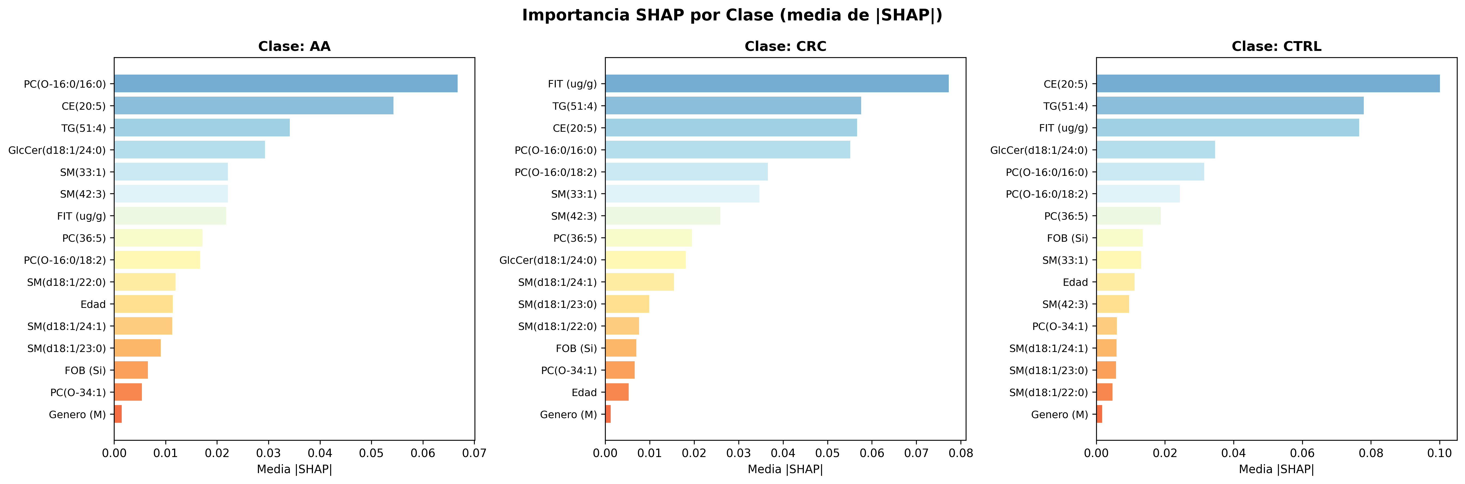
Figure 2. SHAP importance disaggregated by class (AA, CRC, CTRL). Biomarkers exhibit differentiated roles according to progression state.
Table 8. Top 5 biomarkers per class according to SHAP.
Rank | AA (Advanced Ad.) | |SHAP| | CRC (Cancer) | |SHAP| | CTRL (Control) | |SHAP|
1 | PC(O-16:0/16:0) | 0.067 | FIT (µg/g) | 0.077 | CE(20:5) | 0.100
2 | CE(20:5) | 0.054 | TG(51:4) | 0.058 | TG(51:4) | 0.078
3 | TG(51:4) | 0.034 | CE(20:5) | 0.057 | FIT (µg/g) | 0.077
4 | GlcCer(d18:1/24:0) | 0.029 | PC(O-16:0/16:0) | 0.055 | GlcCer(d18:1/24:0) | 0.035
5 | SM(33:1) | 0.022 | PC(O-16:0/18:2) | 0.037 | PC(O-16:0/16:0) | 0.031
4.4.3 Patient-level interpretability
Figures 3, 4, and 5 present SHAP contributions for representative individual patients from each class, correctly classified by the model. For the AA patient (Figure 3), GlcCer(d18:1/24:0) and PC(O-16:0/16:0) are the main positive contributors (increasing the probability of AA), while CE(20:5) contributes negatively (decreasing the probability of AA). This differential pattern enables the clinician to understand why the model classifies the patient as advanced adenoma rather than control or cancer.
For the CRC patient (Figure 4), FIT is the primary contributor, followed by TG(51:4) and CE(20:5), consistent with the pattern of elevated fecal bleeding and severe lipid alterations characteristic of confirmed cancer. The sphingomyelins SM(d18:1/22:0) and SM(d18:1/24:1) contribute negatively, suggesting that their levels in this patient are inconsistent with the typical CRC profile.
For the CTRL patient (Figure 5), all contributions are positive (increasing the probability of classification as healthy control), led by CE(20:5) and FIT with low values. The absence of negative contributions reflects a consistently normal metabolic profile.
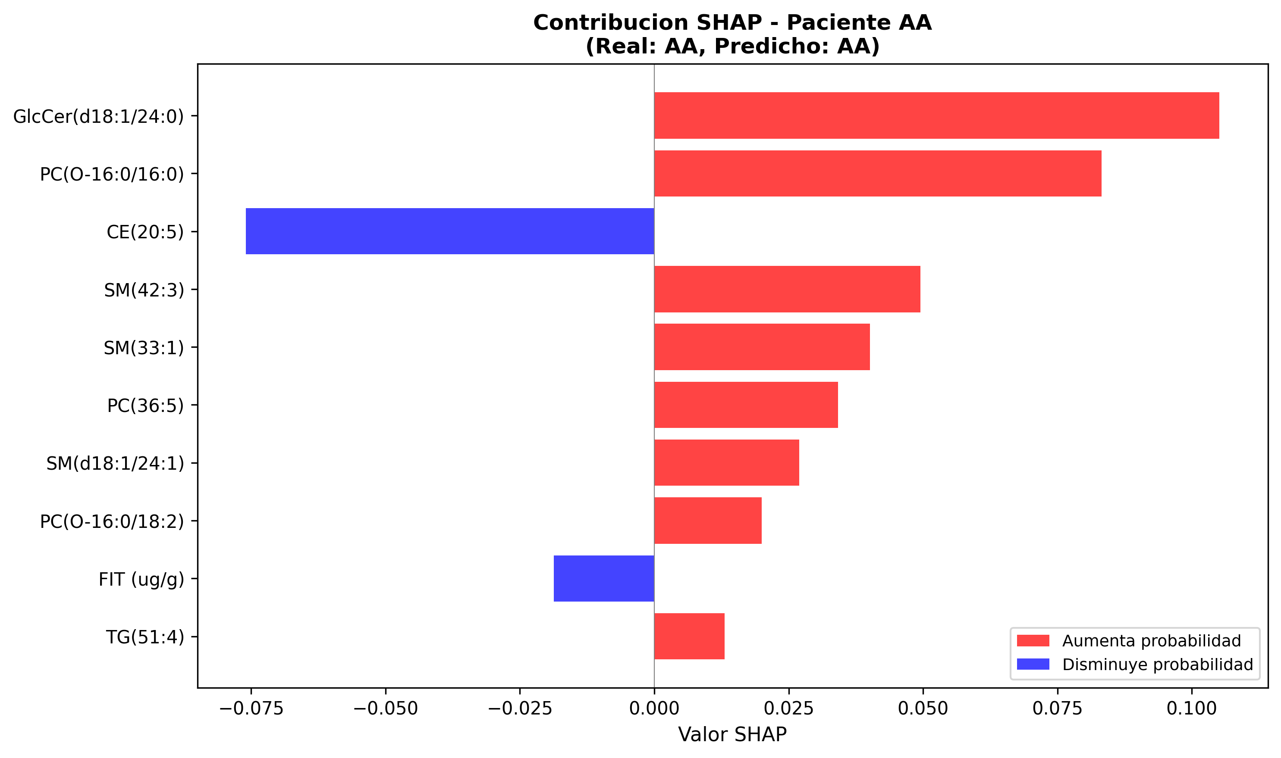
Figure 3. SHAP contributions for a correctly classified AA patient.
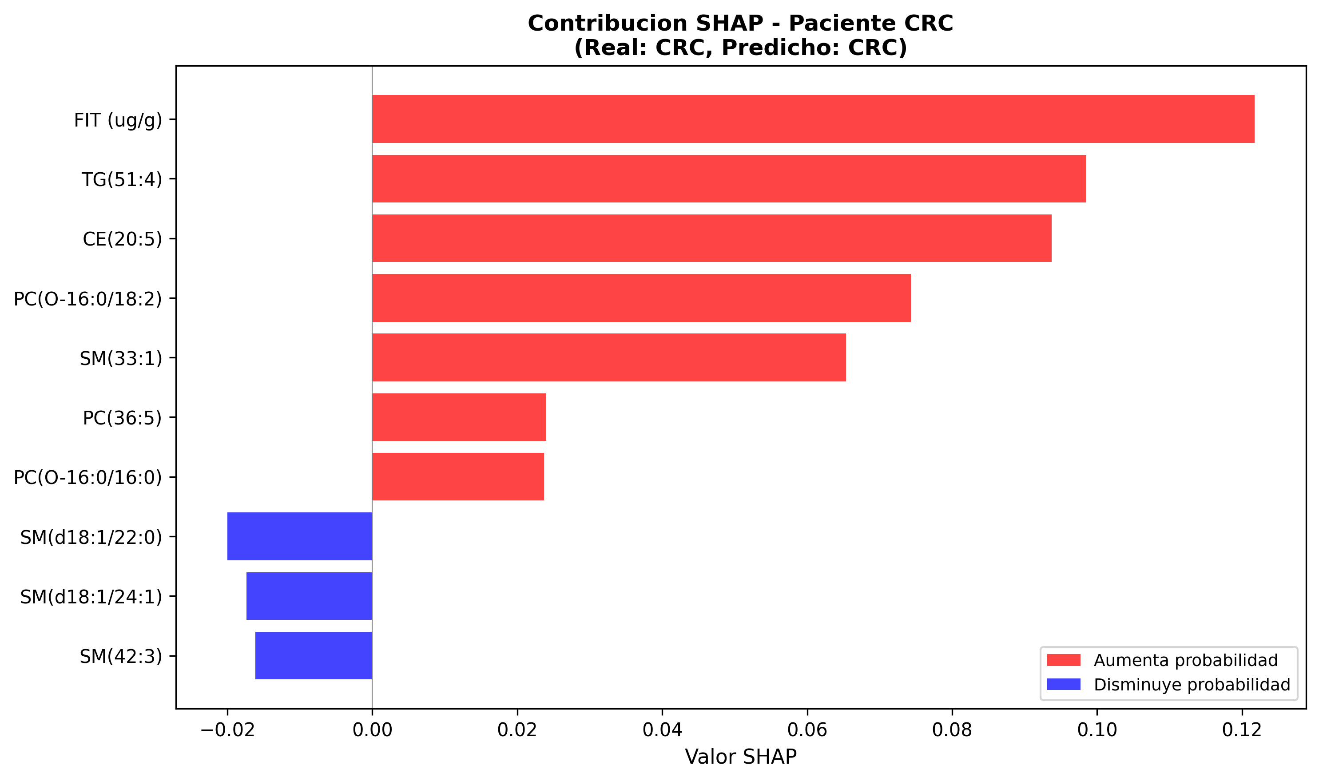
Figure 4. SHAP contributions for a correctly classified CRC patient.
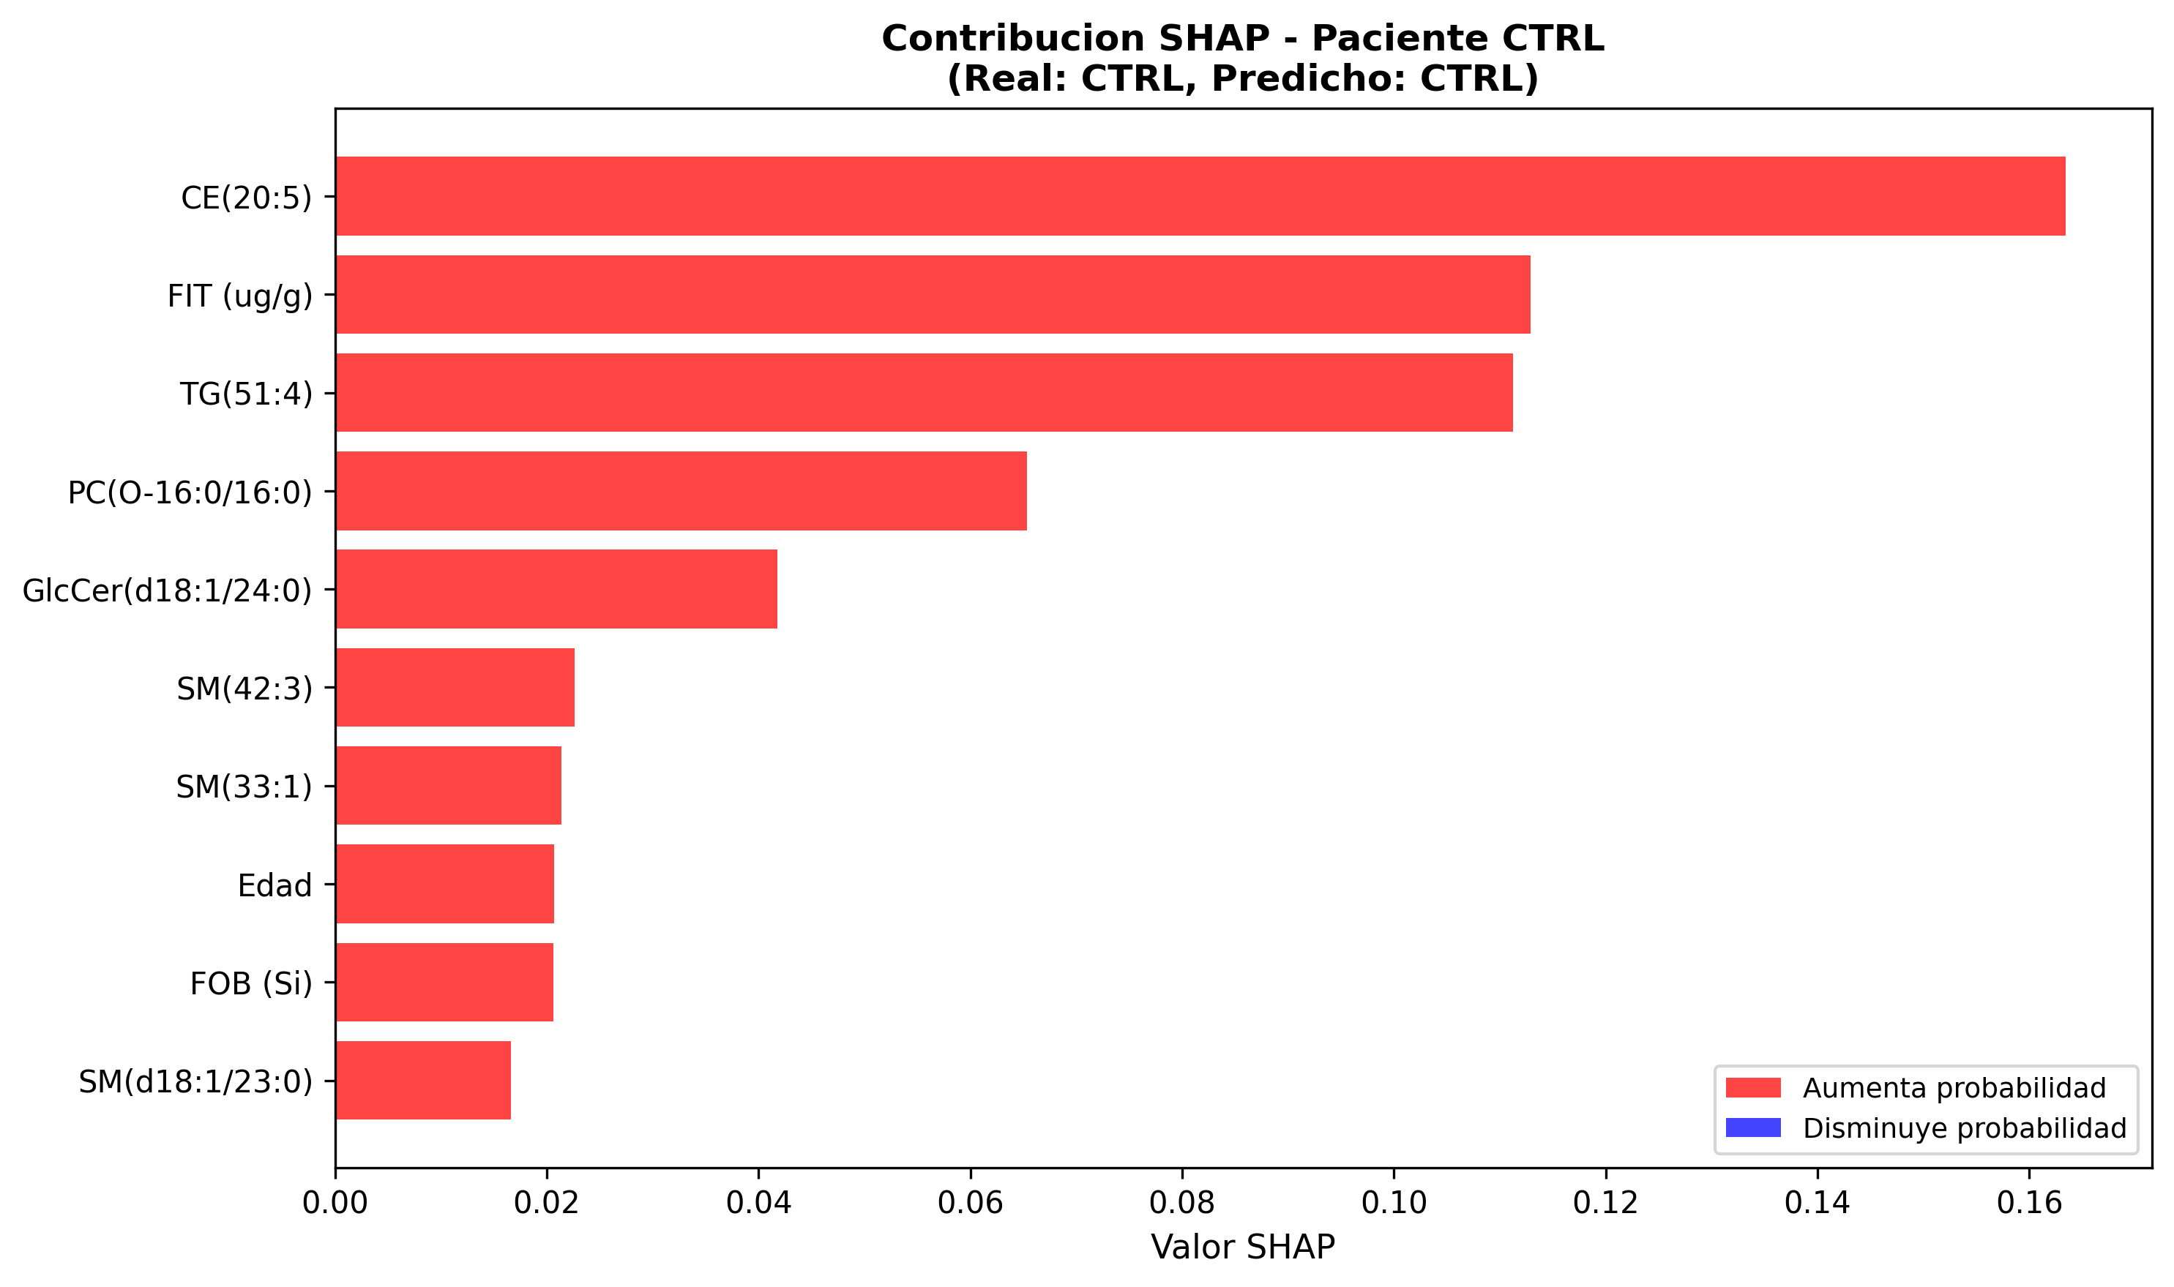
Figure 5. SHAP contributions for a correctly classified CTRL patient.
4.5 Performance evolution
Table 9 traces the performance evolution throughout the modeling pipeline, demonstrating consistent improvement from the linear baseline to the final ensemble.
Table 9. Performance evolution throughout the modeling pipeline.
Phase | Model | F1 Macro | F1 AA | Recall AA
Baseline | Logistic Regression | 0.628 | 0.45 | 0.47
Individual | Decision Tree | 0.681 | 0.55 | 0.50
Ensembles | Bagging Tree | 0.855 | 0.78 | 0.75

4.6 Top-K analysis: model-guided feature selection
As a complementary analysis, a strategy based on feature importance obtained from the model trained with all available features was evaluated. Unlike filter-based selection through Mutual Information and ANOVA (Section 3.3), this approach enables identification of the variables deemed most relevant by the model itself during the learning process. This strategy corresponds to a model-based feature selection approach, where the Bagging Tree's mean impurity importance determines the variable ranking.
The Bagging Tree model trained on X_full (131 variables) achieved an AA recall of 0.833, superior to the 0.750 obtained with X_intersect. To evaluate whether this improvement could be concentrated in a reduced subset, the Top-10, Top-15, Top-20, and Top-30 variables by model importance were selected and evaluated on the held-out set (Table 10).
Table 10. Top-K analysis: performance with model-selected feature subsets.
Configuration | n variables | F1 Macro | F1 AA | Recall AA
X_intersect (final model) | 16 | 0.855 | 0.783 | 0.750
X_full | 131 | 0.839 | 0.833 | 0.833
X_full Top-15 | 15 | 0.839 | 0.833 | 0.833
X_full Top-20 | 20 | 0.836 | 0.800 | 0.833
X_full Top-10 | 10 | 0.821 | 0.870 | 0.870

The Top-15 subset retained the same AA recall (0.833) and AA F1 (0.833) as the full X_full set, reducing dimensionality by 89%. The 9 variables common between X_intersect (filter selection) and Top-15 (model-guided selection) constitute the robust core of biomarkers validated by two independent selection strategies: CE(20:5), GlcCer(d18:1/24:0), PC(36:5), PC(O-16:0/16:0), PC(O-16:0/18:2), SM(33:1), SM(42:3), TG(51:4), and FIT.
5. Discussion
The results of this study demonstrate that decision tree ensembles, applied to serum lipidomic biomarkers, achieve effective classification of the three CRC progression states, including the detection of advanced adenomas where conventional chemometric methods fail. The main findings are discussed below in the context of the existing literature and their clinical implications.
5.1 Superiority of the ensemble approach over conventional methods
The most clinically significant result is the detection of advanced adenomas with F1 = 0.78 and recall = 0.75. Alboniga et al. [8] reported F1 = 0 for the AA class using PLS-DA on the same data. This difference is explained by the capacity of decision trees to capture nonlinear interactions between lipids, combined with the variance reduction provided by the bagging mechanism. The aggregation of 100 trees trained on random subsamples (80% of samples, 60% of features) stabilizes predictions for an inherently heterogeneous class such as AA, whose lipidomic profiles overlap significantly with those of the CRC group.
The precision of 1.00 for healthy controls on the held-out set indicates that the model generates no false positives for healthy individuals, which is relevant for screening programs where unnecessary colonoscopies represent a significant cost. The macro AUC of 0.945 confirms excellent discriminatory capacity across different decision thresholds.
5.2 Identified lipidomic biomarkers and SHAP interpretability
CE(20:5) (cholesteryl ester with eicosapentaenoic acid) is confirmed as the biomarker with the highest global contribution by both Gini importance and SHAP. This finding has biological plausibility: cholesteryl esters are implicated in tumor membrane remodeling and omega-3 fatty acids, such as EPA (C20:5), participate in anti-inflammatory pathways whose dysregulation is associated with colorectal carcinogenesis [17,18]. The prominence of CE(20:5) as the primary biomarker is consistent with the findings of Alboniga et al. [8], who reported it among the most relevant metabolites.
The SHAP analysis provides a dimension that Gini importance does not capture: the differentiation of each biomarker's role according to the diagnostic class. The finding that PC(O-16:0/16:0) is the primary predictor for advanced adenomas (rather than CE(20:5)) has relevant clinical implications. Ether-phospholipids (plasmalogens) are involved in protection against oxidative stress and cell signaling; their alteration in the pre-malignant phase suggests that cell membrane remodeling precedes the more pronounced changes in cholesterol metabolism that characterize confirmed cancer [19].
The dominance of FIT as a predictor for CRC in the SHAP analysis is clinically coherent: fecal bleeding detectable by FIT is a direct consequence of tumor neovascularization and vascular fragility of the carcinoma. This result reinforces the complementarity between lipidomic biomarkers and standard clinical tests: lipids are more informative for AA detection (where FIT fails), while FIT remains the best individual predictor for confirmed CRC.
Sphingomyelins (SM(42:3), SM(33:1)) and ether-phospholipids (PC(O-16:0/16:0), PC(O-16:0/18:2)) represent lipid families involved in cell signaling and apoptosis resistance, processes altered during neoplastic progression [19]. Patient-level interpretability (Figures 3–5) enables clinicians to understand the factors driving each prediction, facilitating adoption of the model as a clinical decision support tool.
5.3 Clinical implications
The combination of lipidomic biomarkers with FIT has the potential to significantly improve CRC screening protocols. With FIT as the sole tool, sensitivity for AA is estimated between 20–50% [4]. Our multimodal model (lipids + FIT) achieved AA recall of 75%, a substantial improvement. A targeted lipidomic panel (MRM/SRM) based on the 9–15 identified biomarkers would be significantly more cost-effective than untargeted metabolomics and potentially feasible for large-scale population screening.
5.4 Limitations
This study has several limitations that should be considered. First, the sample size is limited (n=211, test=43), which confers variance to the held-out metrics (estimated at ±0.02–0.05 F1). The most conservative estimate of external performance is the cross-validation F1 (0.802), not the held-out F1 (0.855). Second, the cohort originates from a single hospital center (Ourense, Spain), introducing potential population bias related to diet, genetics, and clinical protocols. Third, the model exhibits overfitting in training (Train F1 = 1.00), with a train-CV gap of ~0.20 that could be reduced through additional regularization (limiting max_depth, increasing min_samples_leaf). Fourth, the Top-K analysis was evaluated solely on the held-out set without nested cross-validation, and should therefore be interpreted as exploratory evidence.
6. Conclusions
This study demonstrates that a Bagging Tree-based machine learning pipeline, applied to 16 lipidomic biomarkers and clinical variables, enables effective tripartite classification of colorectal cancer progression (Control/AA/CRC) with F1 macro = 0.855 and AUC = 0.945. The most clinically relevant finding is the detection of advanced adenomas with F1 = 0.78, where the reference chemometric method (PLS-DA) yields F1 = 0 on the same data.
SHAP analysis reveals that biomarkers have differentiated roles according to the diagnostic class: PC(O-16:0/16:0) is the primary predictor for advanced adenomas, FIT for confirmed cancer, and CE(20:5) for healthy controls. This differentiation provides clinical interpretability and suggests that the underlying metabolic mechanisms differ across CRC progression phases. The patient-level interpretability afforded by SHAP facilitates clinical adoption of the model as a decision support tool.
The intersection of 9 biomarkers validated by two independent selection strategies (filter-based and model-guided) constitutes a candidate panel for targeted mass spectrometry assays (MRM/SRM), potentially feasible for population-based screening as a complement to FIT. The results validate that lipidomic profiles complement, but do not replace, standard screening tests. Clinical implementation requires external multicenter validation, ethical approval, and formal cost-benefit evaluation.
Declarations
Ethics statement
The data used in this study originate from the dataset published by Alboniga et al. [8], collected at the Hospital of Ourense (Galicia, Spain) under approval from the corresponding institutional ethics committee. [NOTE: Complete with reference number and date of the original ethics approval, or statement of public data use as applicable.]
Data and code availability
The source code for the complete pipeline, including the SHAP analysis, is available at [NOTE: include GitHub repository URL]. [NOTE: State the accessibility of the data as applicable.]
Funding
[NOTE: Complete. If no funding: This research did not receive any specific grant from funding agencies in the public, commercial, or not-for-profit sectors.]
Declaration of competing interest
The authors declare that they have no known competing financial interests or personal relationships that could have appeared to influence the work reported in this paper.
Use of generative artificial intelligence
[NOTE: Declare any generative AI tools used in the preparation of the manuscript, including literature review, data analysis, text generation, or figure creation.]
Author contributions
[NOTE: Complete according to the CRediT taxonomy: Conceptualization, Methodology, Software, Validation, Formal analysis, Investigation, Resources, Data curation, Writing – original draft, Writing – review & editing, Visualization, Supervision, Project administration.]
References
[1] H. Sung, J. Ferlay, R.L. Siegel, et al., Global Cancer Statistics 2020: GLOBOCAN estimates of incidence and mortality worldwide for 36 cancers in 185 countries, CA Cancer J. Clin. 71 (2021) 209-249.
[2] E.R. Fearon, B. Vogelstein, A genetic model for colorectal tumorigenesis, Cell 61 (1990) 759-767.
[3] S.J. Winawer, A.G. Zauber, M.N. Ho, et al., Prevention of colorectal cancer by colonoscopic polypectomy, N. Engl. J. Med. 329 (1993) 1977-1981.
[4] J.E. Allison, I.S. Tekawa, L.J. Ransom, A.L. Adrain, A comparison of fecal occult-blood tests for colorectal-cancer screening, N. Engl. J. Med. 334 (1996) 155-160.
[5] R.E. Schoen, P.F. Pinsky, J.L. Weissfeld, et al., Colorectal-cancer incidence and mortality with screening flexible sigmoidoscopy, N. Engl. J. Med. 366 (2012) 2345-2357.
[6] J. Ecker, G. Liebisch, M. Englmaier, M. Grandl, H. Robenek, G. Schmitz, Induction of fatty acid synthesis is a key requirement for phagocytic differentiation of human monocytes, Proc. Natl. Acad. Sci. U.S.A. 107 (2010) 7817-7822.
[7] M.A. Fernandez-Garcia, M.L. Ruiz-Canela, M.A. Martinez-Gonzalez, Lipidomics in colorectal cancer biomarker research, J. Lipid Res. 62 (2021) 100090.
[8] O.E. Alboniga, J. Cubiella, L. Bujanda, P. Aspichueta, M.E. Blanco, B. Lanza, C. Alonso, J.M. Falcon-Perez, Metabolic signature in combination with fecal immunochemical test as a non-invasive tool for advanced colorectal neoplasia diagnosis, Cancers 17 (2025) 2339.
[9] L. Breiman, Random forests, Mach. Learn. 45 (2001) 5-32.
[10] L. Breiman, Bagging predictors, Mach. Learn. 24 (1996) 123-140.
[11] S. Studer, T.B. Bui, C. Drescher, A. Hanuschkin, L. Winkler, S. Peters, K.R. Mueller, Towards CRISP-ML(Q): a machine learning process model with quality assurance methodology, Mach. Learn. Knowl. Extr. 3 (2021) 392-413.
[12] A. Bychkov, N. Hashimoto, M. Nojima, et al., Deep learning in pathology - an overview, Cytometry A 93 (2018) 917-929.
[13] R. Dienstmann, L. Vermeulen, J. Guinney, S. Kopetz, S. Tejpar, J. Tabernero, Consensus molecular subtypes and the evolution of precision medicine in colorectal cancer, Nat. Rev. Cancer 17 (2017) 79-92.
[14] F. Pedregosa, G. Varoquaux, A. Gramfort, et al., Scikit-learn: machine learning in Python, J. Mach. Learn. Res. 12 (2011) 2825-2830.
[15] S. Nishiumi, T. Kobayashi, A. Ikeda, et al., A novel serum metabolomics-based diagnostic approach for colorectal cancer, PLoS ONE 7 (2012) e40459.
[16] F. Farshidfar, A.M. Weljie, K. Kopciuk, et al., Serum metabolomic profile as a means to distinguish stage of colorectal cancer, Genome Med. 4 (2012) 42.
[17] A. Ferreri, P. Ferroni, R. Palmirotta, et al., Cholesteryl ester transfer protein and colorectal cancer: a Mendelian randomization study, Cancer Epidemiol. Biomarkers Prev. 28 (2019) 2019-2025.
[18] R.J. Keogh, M.E. Courtney, A.J. Burn, et al., Omega-3 fatty acids and colorectal cancer prevention, Br. J. Cancer 113 (2015) 1056-1065.
[19] N. Morad, M. Cabot, Ceramide-orchestrated signaling in cancer cells, Nat. Rev. Cancer 13 (2013) 51-65.
[20] S.M. Lundberg, S.I. Lee, A unified approach to interpreting model predictions, Adv. Neural Inf. Process. Syst. 30 (2017) 4765-4774.
[21] S.M. Lundberg, G. Erion, H. Chen, A. DeGrave, J.M. Prutkin, B. Nair, R. Katz, J. Himmelfarb, N. Bansal, S.I. Lee, From local explanations to global understanding with explainable AI for trees, Nat. Mach. Intell. 2 (2020) 56-67.

