Neutron host plug-in for Virtual Edge Firewall appliance with NETCONF interface for configuring policies

Overview

This blueprint aims to provide a host-plugin for supporting orchestration and configuration of a virtual edge firewall appliance in an Openstack cloud. Neutron service plug-in with integrated NETCONF client will be built. The solution aims to provide a YANG standard based NETCONF interface for configuring virtual applicances over SSH using NETCONF. The needed YANG model can be generated and same can be used by both client and server.

FWaaS from Havana release is considered as base for the implementation.

Architecture

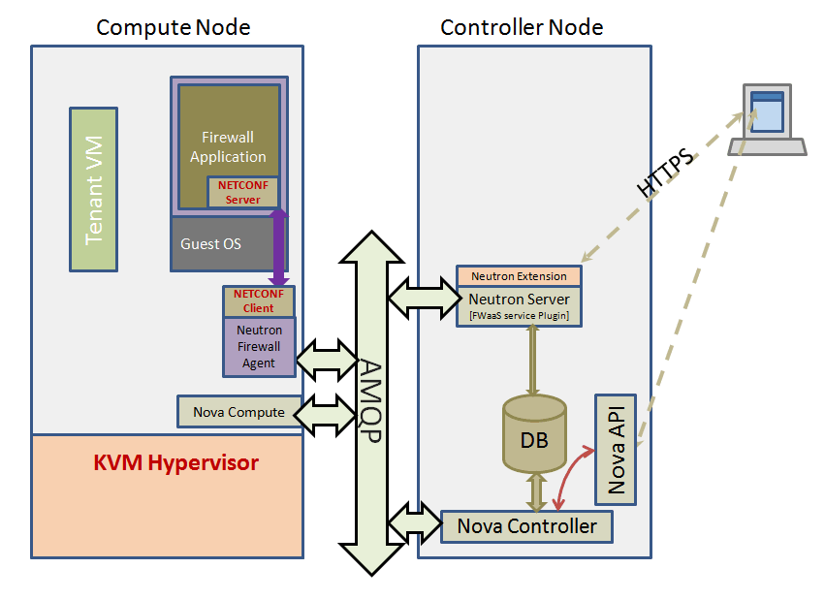

Following components are introduced - FWaaS Service plugin, Firewall Agent, Driver with Netconf client.

Netconf_FWaaS_Plugin

In the new design, the Virtual edge firewall appliance is realized by launching a Virtual machine.

Hence the new plugin will launch a VM when create_firewall is invoked. The required parameters like image, firewall credentials, virtual networks to connect to Firewall VM shall be configured in neutron.conf.

Other functionalities of the plugin will remain same as default FWaaS plugin implementation.

Firewall Agent

In current design, firewall agent is tightly coupled with neutron-l3-agent. A new agent netconf_firewall-agent have been introduced that invokes the driver based on the configuration specified in firewall_driver.ini. The agent is responsible for sending the API requests from the plugin to the driver.

Firewall Driver

Firewall Driver acts as NETCONF client and will configure the Firewall device by communicating with the netconfd server running on Firewall VM image. Driver maps the user defined firewall actions with YANG based NETCONF commands.

YANG model needs to be predefined that can be used by both Driver and Netconfd modules on the Firewall VM. In the current implementation, the plan is to support Vyatta firewall and define a YANG model for Vyatta commands.

SSH communciation between driver and NETCONFD server is realized by Yangcli binary. This is an enhanced version of yangcli from Opensource Yuma project.

Workflow

The following diagram show the workflow:

