Lab 2 part 1

Alamin Ahmed

1265293

ECE 5440

1. Number Matching Game
   1. This game requires 2 players. Before playing, a password (SW9) need to be entered to give players full access to the full board and using push button (Key3) to enter one bit at a time. After that, each player will take turn to input a single (4 bits) number. The first player will start out with the switches SW0 – SW3 (for input B, SW0 is LSB) and SW14 – SW17 (for input A, SW14 is the LSB). After the player “A” input the first number and press the enter button (same), the number will show up in the 7 segments display HEX6. After this, it is player “B”s turn. The player B will input another number using switches SW0 – SW3. After the second player input the number and press the enter button (same), the number will show up in the 7 segments display HEX3. Each time the player input a number, the sum of both number from player A and player B will show up in 7 segments display HEX5. All the number show up in the 7 segments display will be in base 16. Upon pressing Reset button (Key0), the display will clear to zeros.
2. Module Presentations
   1. Access Control Module: a 6-bit password will be hard coded (010011) into the module. Before playing, one of the players have to enter each bit using SW9 then press enter(KEY3) to save the bit, repeat till the input password is matched with the hardcoded one. If enter wrong password, the reset button (KEY0) can be used to reenter password

Reset

Enter

Password

AccessControl

clock

Enable

* 1. Button Shaper Module: this module’s purpose is to make sure the board will take in only one pulse when a button is pressed.

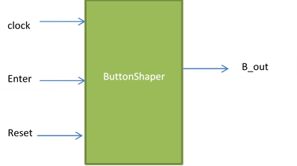

* 1. Input Register Module: this module is used to lock all the players input and the sum output until the enter key (KEY3) is pressed before displaying them to the 7 segment di

reset

Input A/B

enter

InputRegister

clock

Output

Enable

1. The Architecture

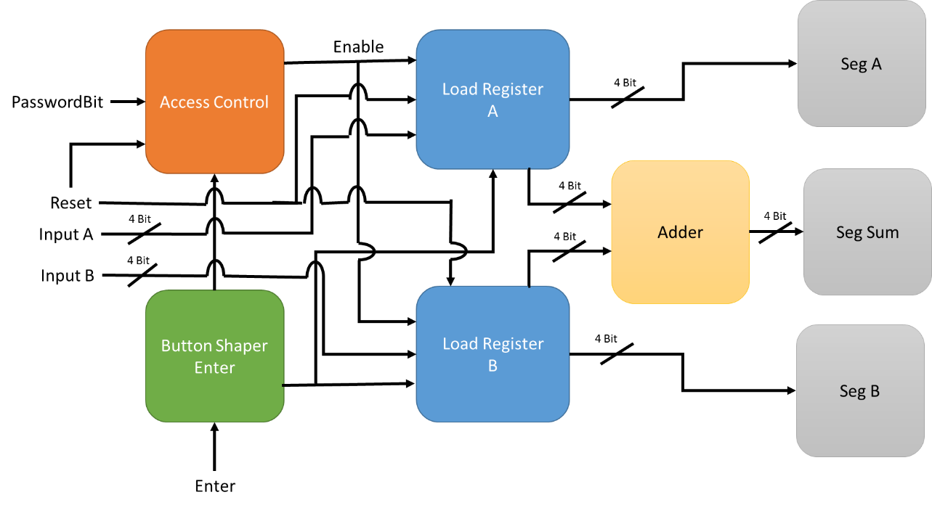

1. Finite State Machine.
2. ButtonShaper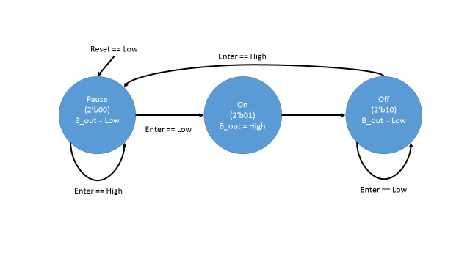
   1. AccessControl

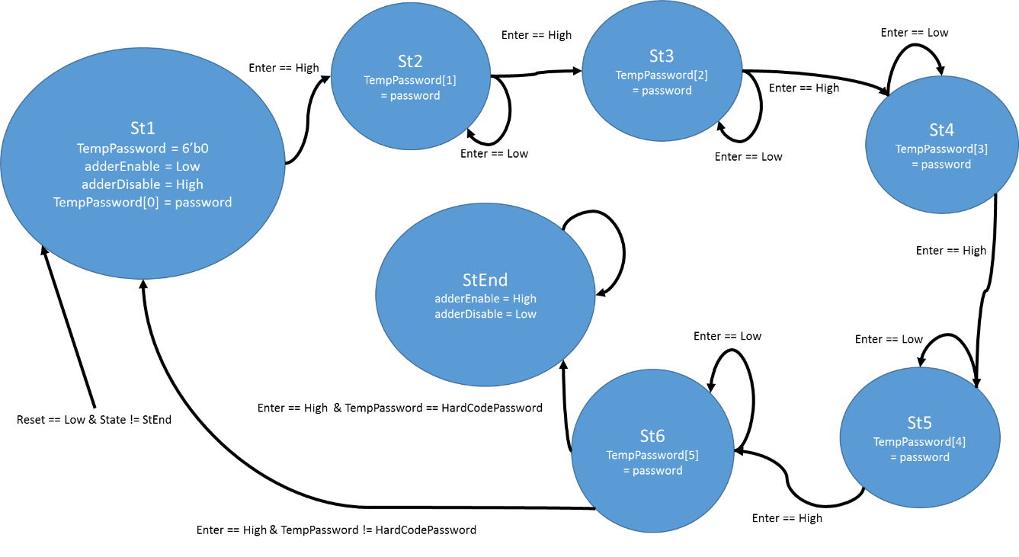

1. WaveForm
   1. Button shaper (expected and real results)

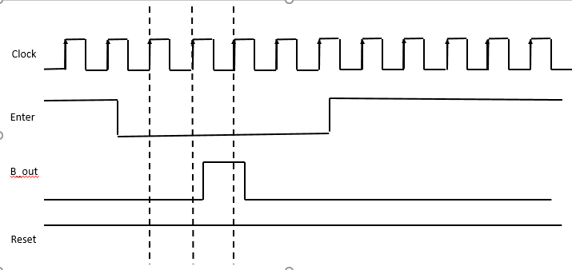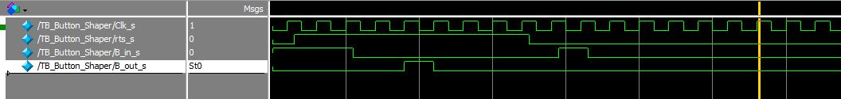

* 1. Access Control (expected and real results) 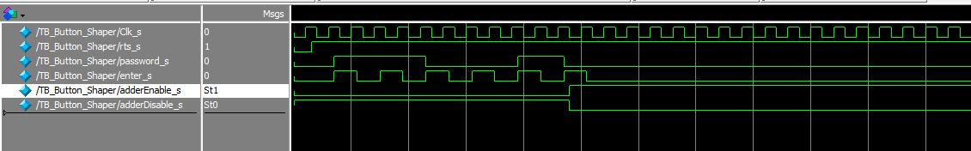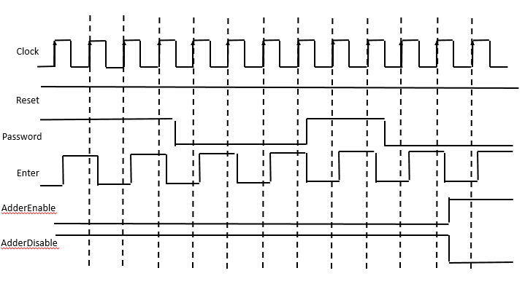

1. Board Result in Access Control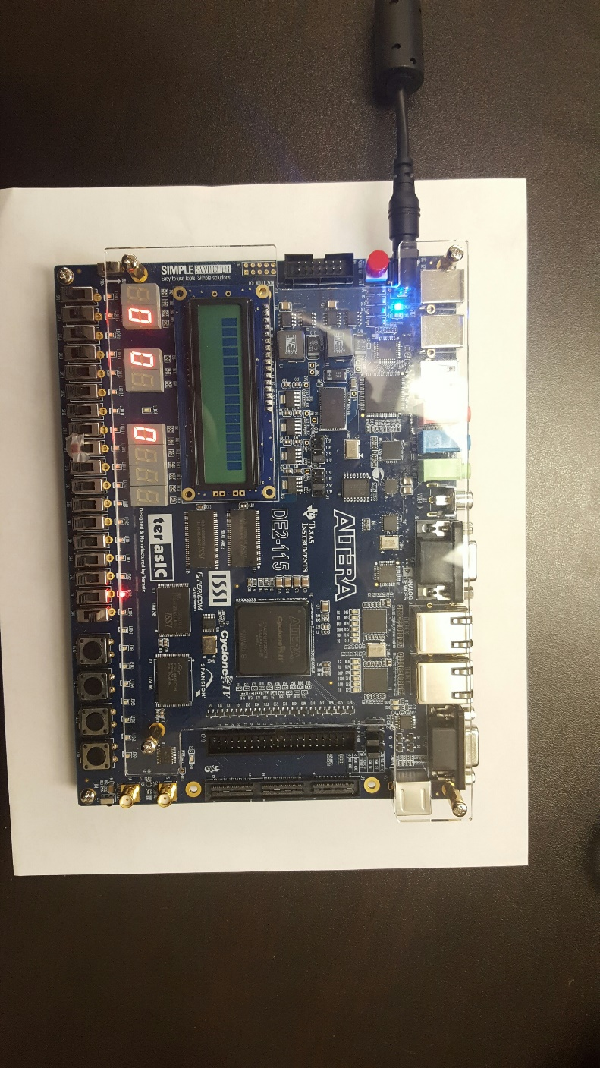
2. After Access Control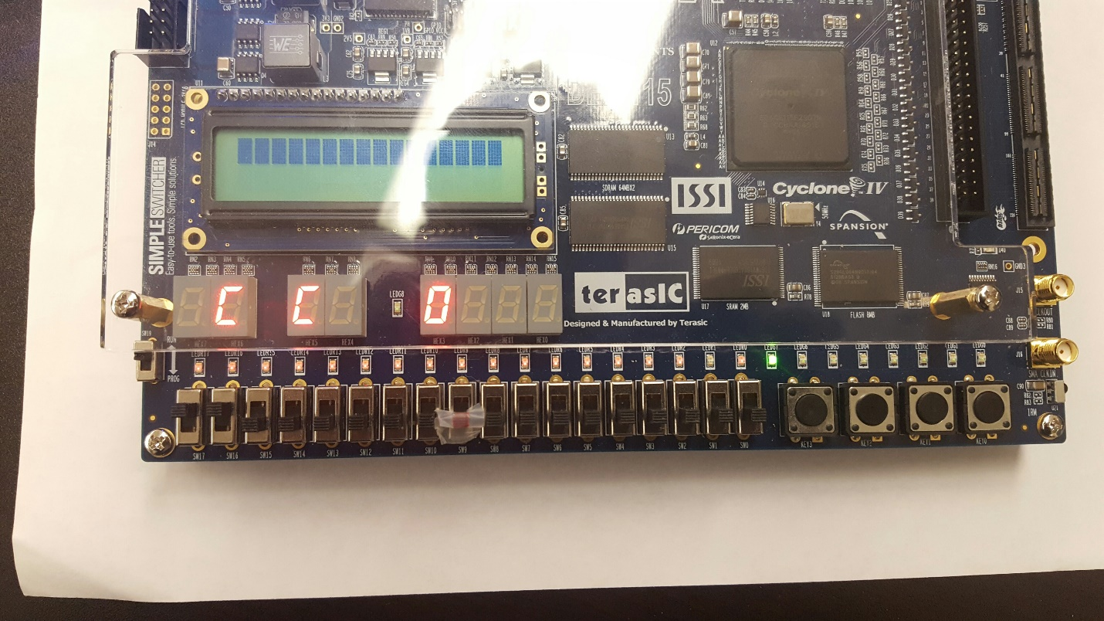
3. Conclusion

The system is tested and work as intended. The input takes in the password before giving the players access to the board. After the players input their number, the system should add 2 numbers and display them along with the input numbers after the enter button is pressed. After this project, I have learned a lot about Verilog and how to program with FPGA. The status of this project is Complete.

1. Appendix
   1. 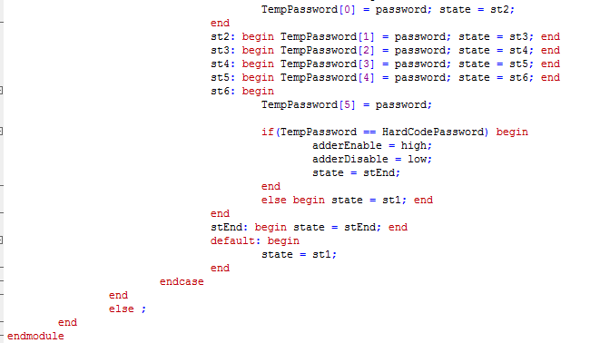Access Control Code

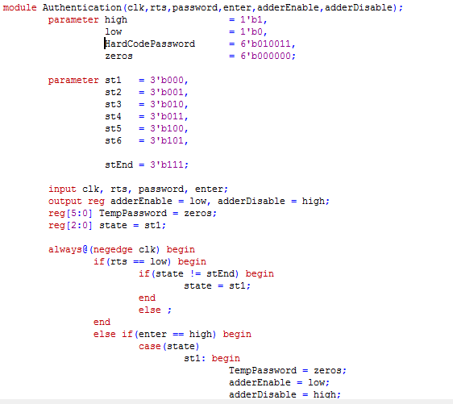

* 1. Button Shaper Code

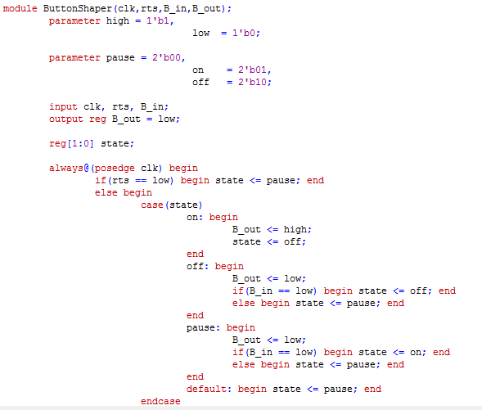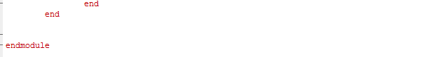

* 1. Input Register Code