**Client Server Architecture**

***Client:*** *Consumer who wants to consume a specific information. Also, called as Client in Client-Server context.*

***Server:*** *Provider who provides the information. Also, called as Server in Client-Server context.*

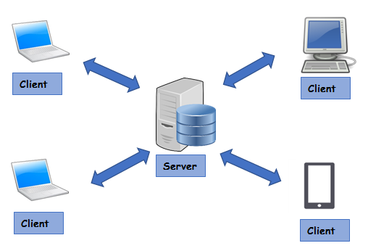

HTTP Protocol between Client and Server

1. *A medium for communication, specifically a protocol for two systems to interact. Also called HTTP communication protocol*.
2. *A protocol to ask for the required details from the server. This could be in any form of formatted data. Most commonly used formats are XML and Json.*
3. *Server responds by sending a Response in any form of formatted data, here also it could be XML or JSON.*

***To Summarize:*** A Client and a Server establishes a connection using HTTP protocol. Once the connection is established, Client sends across the request to the Server in the form of XML or JSON which both entities (Client and Server) understand. After understanding the request Server responds with appropriate data by sending back a Response.

A screenshot of a cell phone

Description generated with high confidence