經濟一甲 林諭辰

A109260041

#user enter the passcode “Python”

## if matches the settings

Then output “welcome”

Else if! Matches the setting

Output “try again”

Then jump back to the enter section

If{

!matches the setting three times

Else if{

Matches the settings

Output “welcome”

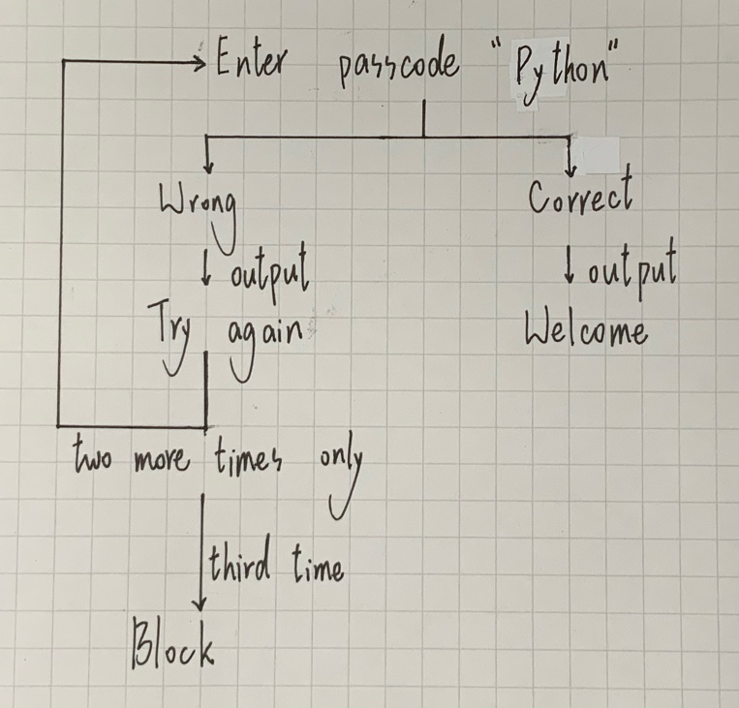Then block the entering system.