**Cryptoverse: A Cryptocurrency Dashboard**

# Introduction

The introduction serves as the opening statement of the Cryptoverse project, designed to attract users and convey its purpose. Cryptoverse is a comprehensive platform created to help users navigate the world of cryptocurrencies. It offers tools to track cryptocurrency prices, access blockchain insights, and learn about decentralized finance (DeFi). A strong introduction is engaging, clear, and informative, providing users with context and encouraging them to explore further.

## Example Content:

* What is Cryptoverse?
* Why should you care about cryptocurrencies?
* How can Cryptoverse help you keep up with the crypto world?



# Description

The description elaborates on the functionality, benefits, and features of Cryptoverse. This section highlights why Cryptoverse stands out as a platform:

## Core Features:

1. **Real-Time Cryptocurrency Prices:** Track prices of major cryptocurrencies like Bitcoin and Ethereum.
2. **Educational Content:** Access resources on blockchain technology, cryptocurrency mining, smart contracts, and DeFi.
3. **Market Insights:** Analyze market trends, price volatility, and expert opinions for informed decision-making.
4. **User Profiles or Portfolio Management:** Track investments and monitor cryptocurrency portfolios.

## Example Content:

* + Detailed descriptions of features like live price tracking and educational articles.
  + Explanation of how these features benefit both new and experienced users.



# Scenario

The scenario section illustrates typical user journeys, showcasing how users interact with the platform and derive value from it:

1. **Beginner Investors:** Learn cryptocurrency basics, track prices, and explore beginner- friendly guides.
2. **Experienced Traders:** Monitor market trends, analyze data, and stay updated with blockchain news.
3. **Researchers and Learners:** Dive into educational content and detailed reports on the crypto market.

**Example Scenario:** "John, a beginner, visits Cryptoverse to learn about Bitcoin and tracks its price while exploring guides on blockchain technology."



# Prerequisites

Outline the skills, knowledge, and tools users need to benefit fully from Cryptoverse:

## For General Users:

* + Basic crypto knowledge for a more enriching experience.
  + Familiarity with web browsing.

## For Developers:

* + Knowledge of HTML, CSS, JavaScript, and APIs for contributing or customizing the platform.
  + Familiarity with tools like Node.js or React.

## Example Content:

* + "Basic understanding of cryptocurrencies like Bitcoin or Ethereum."
  + "Familiarity with blockchain technology is helpful but not required."



# Project Structure

The project structure ensures maintainability, scalability, and ease of navigation:

## File Organization:

1. **HTML Files:** Core content for pages (e.g., index.html for the homepage).
2. **CSS Files:** Styling (e.g., style.css).
3. **JavaScript Files:** Dynamic functionalities (e.g., fetching live prices).
4. **Assets:** Images, icons, and resources.
5. **Documentation:** README files explaining setup and contribution.

## Example Structure:

* + index.html (Main homepage)
  + css/ (Styling files)
  + js/ (JavaScript functionalities)
  + assets/ (Logos, images, fonts)
  + README.md (Project documentation)



# Project Flow

The project flow maps user experience, ensuring intuitive navigation:

1. **Homepage Visit:** Introduction to Cryptoverse’s features.
2. **Cryptocurrency Data:** Navigate to live prices, market data, and trends.
3. **Learning Resources:** Explore blockchain, DeFi, and smart contracts.
4. **Portfolio Management:** Sign up to track investments and set price alerts.
5. **Support and Communities:** Access help and join forums.



# Key Components

## Cryptocurrency Component:

* + Fetch real-time data from providers like CoinMarketCap or CoinGecko.
  + Display prices, market caps, trading volumes, and historical data in charts or tables.
  + Interactive features like sorting, filtering, and alerts.

## Example Content:

* + A card showing Bitcoin’s price and 24-hour changes.
  + A chart of Ethereum’s historical price trends.

## Homepage Design:

* + **Navigation:** Access to major sections like price tracking and educational resources.
  + **Introduction:** Tagline, call-to-action (CTA), and summary of offerings.
  + **Visual Appeal:** Clean, modern design reflecting blockchain and cryptocurrency themes.
  + **Featured Sections:** Highlight key features in an easy-to-digest format.

**Coding:**

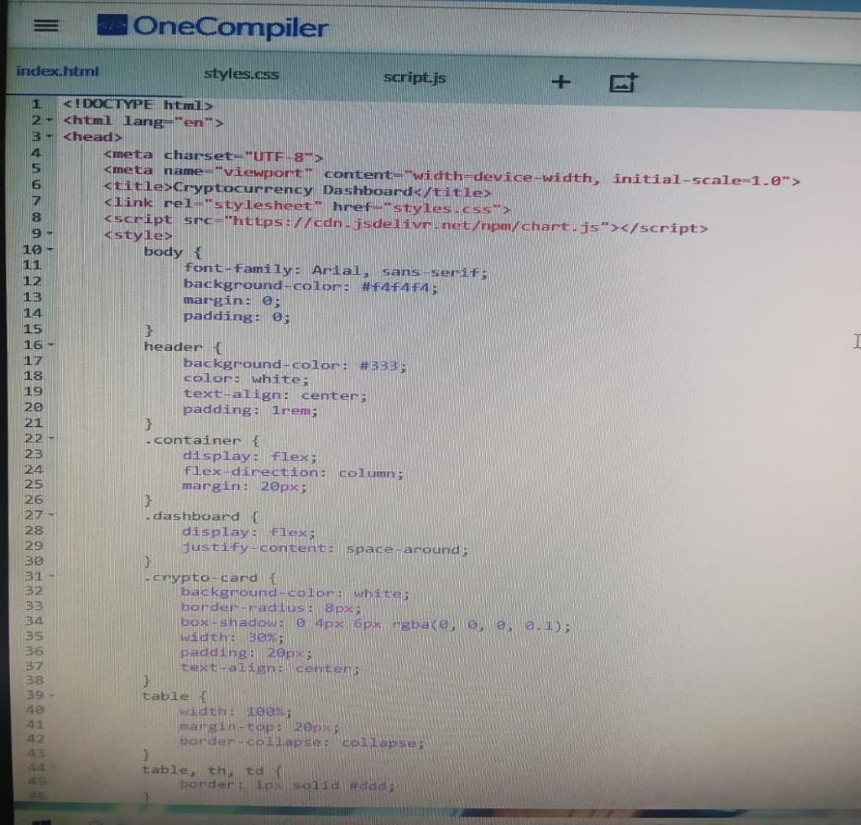

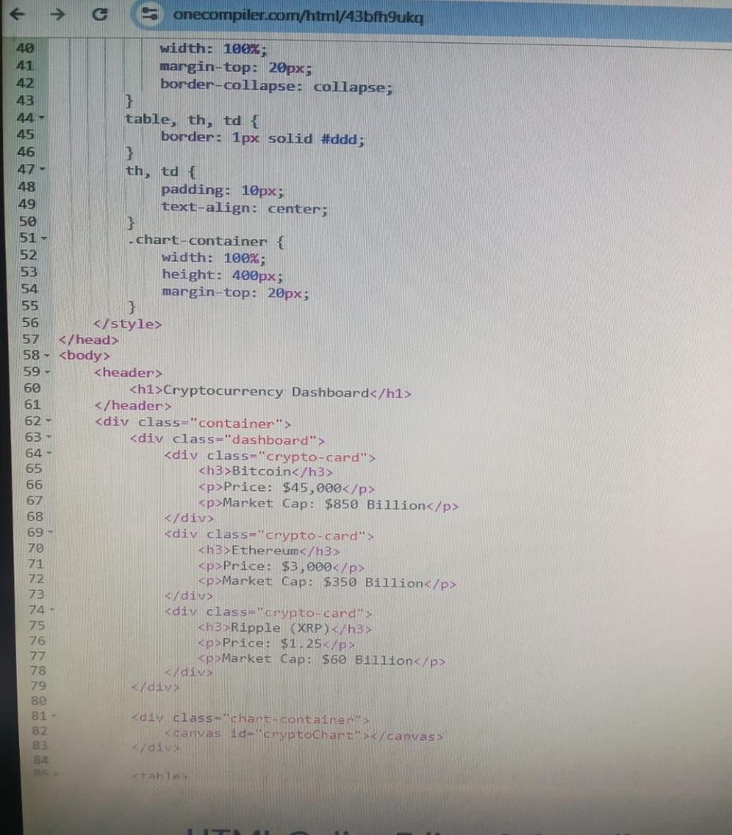

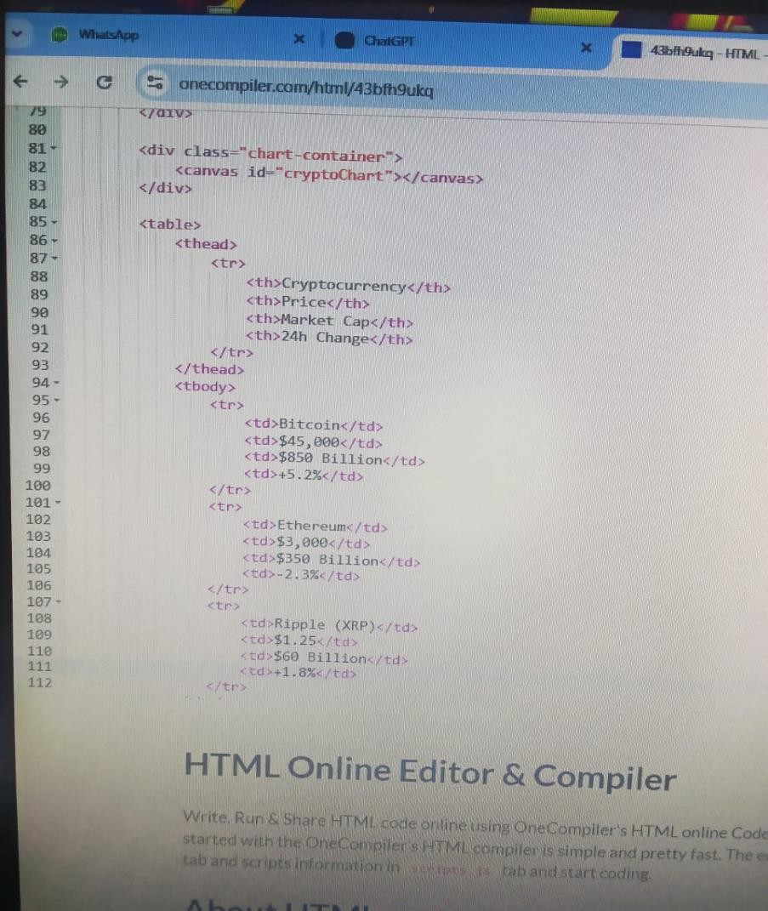

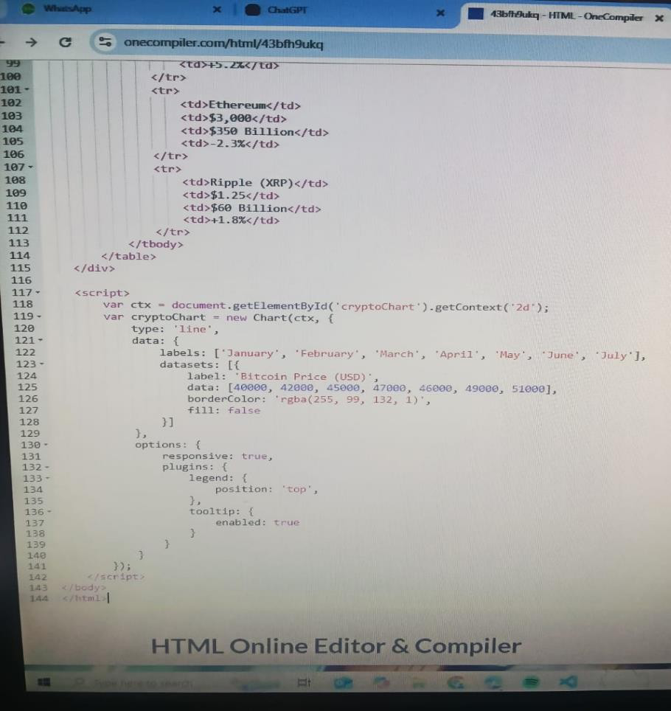

**Output:**

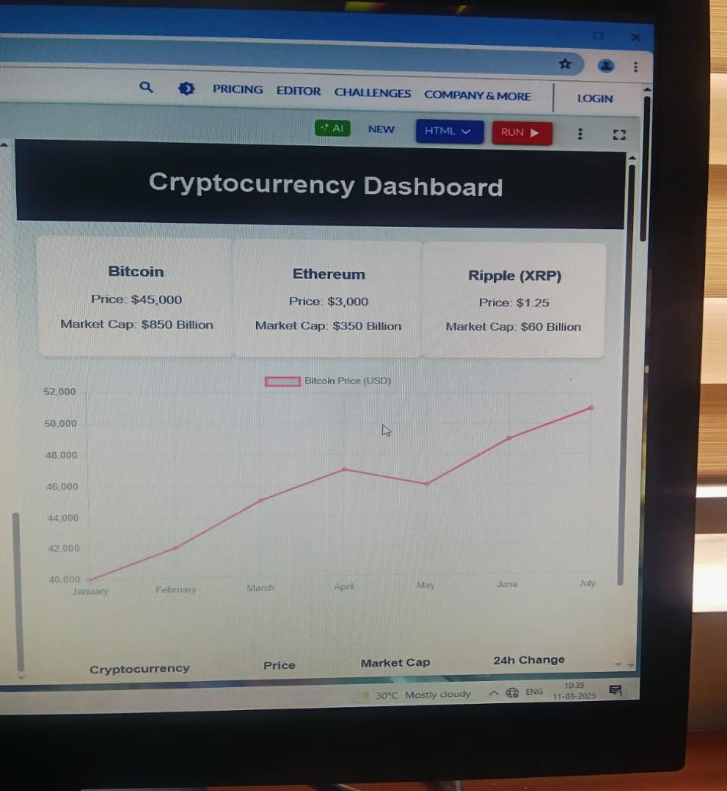

**Conclusion:**

Cryptoverse provides an integrated platform for all cryptocurrency needs, catering to both beginners and experts. By offering live price tracking, educational resources, and portfolio management, Cryptoverse empowers users to navigate the dynamic world of cryptocurrencies with ease. Its user-friendly design and robust functionalities ensure a seamless experience for everyone involved.

Team Leader – Anusiya V - irapranith[@gmail.com](mailto:abiramya65@gmail.com)

Team Member 1 – Swetha S – Swethaarun2005[@gmail.com](mailto:narmatharn1331@gmail.com)

Team Member 2 – Udhayakumari N – uk1942813[@gmail.com](mailto:k.mohanapriya1904@gmail.com)

Team Member 3 – Satha S – sathasathasaravanan[@gmail.com](mailto:p.preethi2904@gmail.com)