Configure azure via JSON template

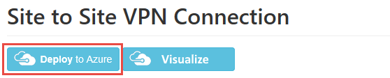

<https://github.com/Azure/azure-quickstart-templates/tree/master/201-site-to-site-vpn>

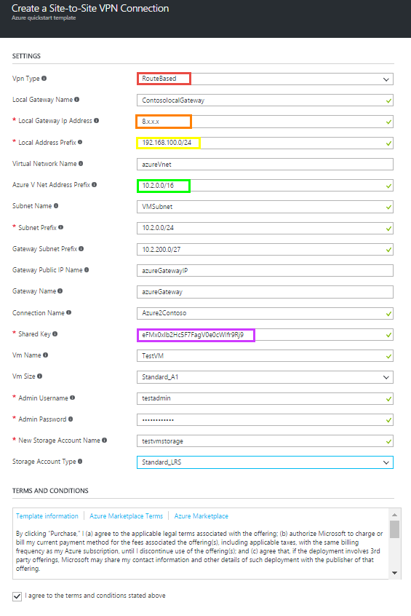

After Site 2 Site connection is deployed review your Azure gateway address and your Local gateway IP address

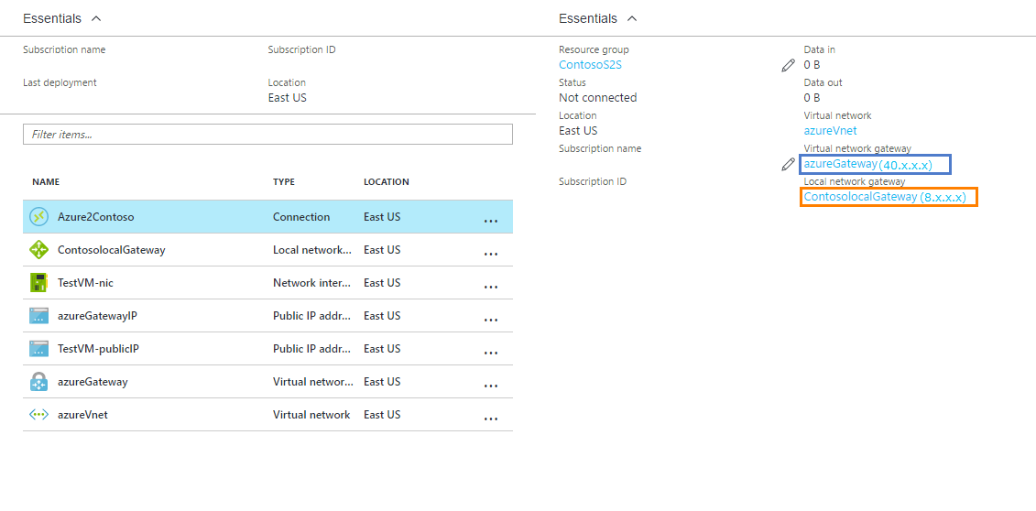

**Configure the Fortigate**

Login into the forgate mangament

Under **VPN => IPsecWizard**

Select Custom

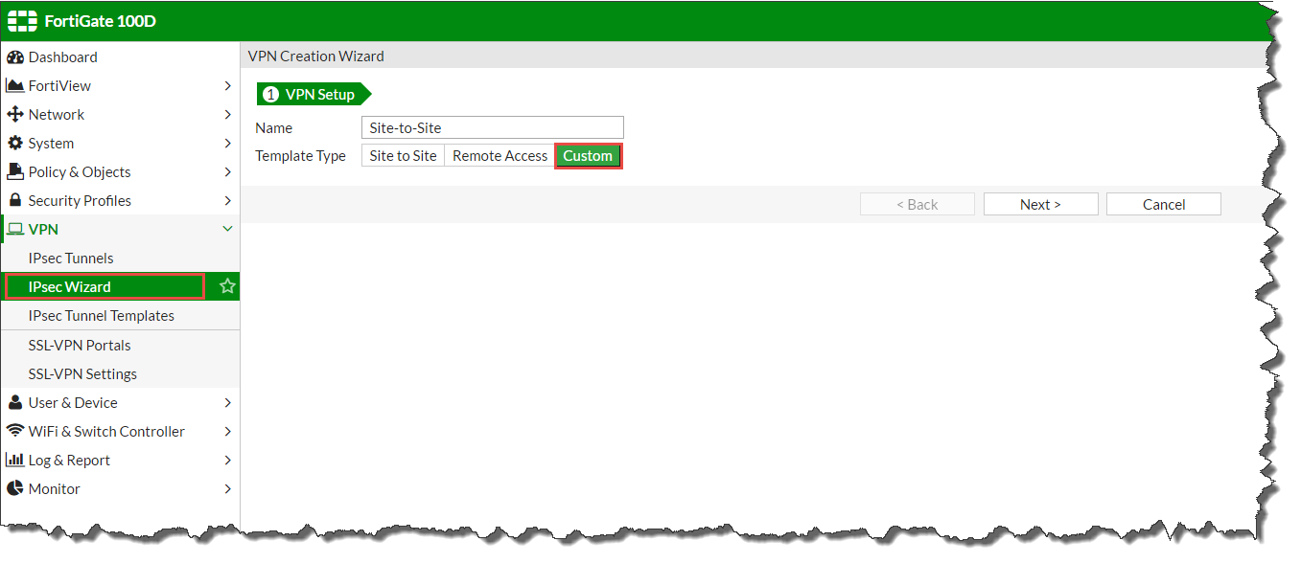

Configure the VPN tunnel as outlined below

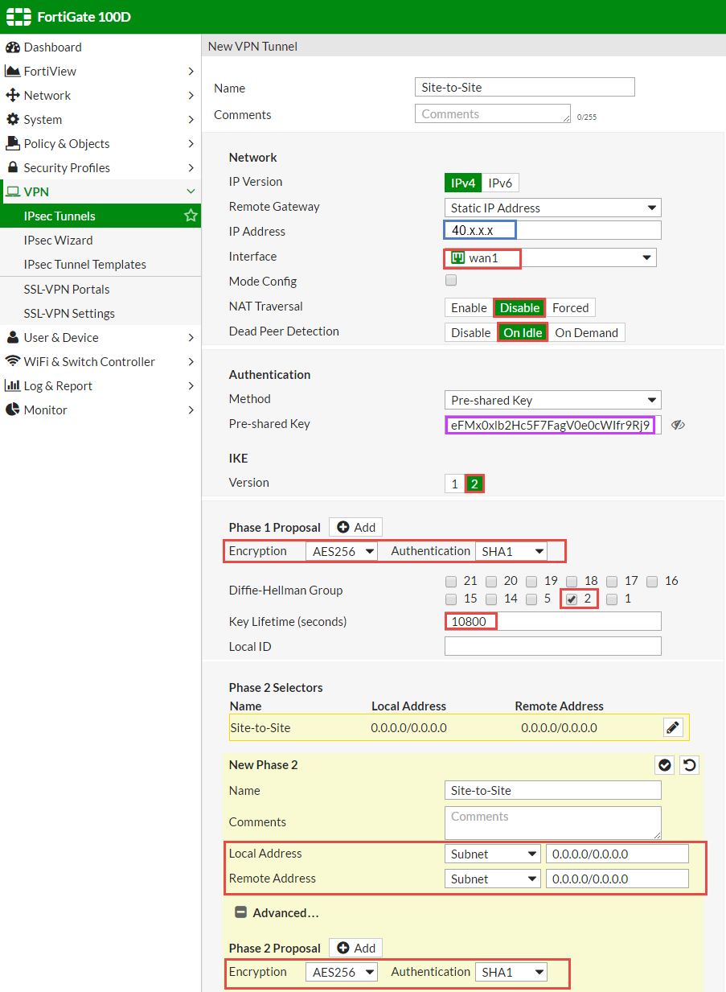

Under **Network => Static Routes**   
Create a new static route to the Azure vnet address space

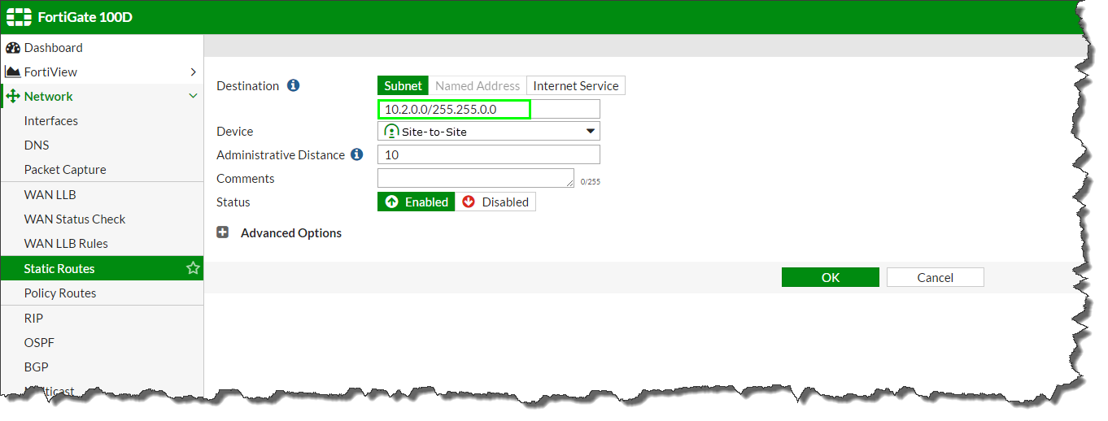

Under **Policy & Objects => Addresses**

Add the Azure vnet address space

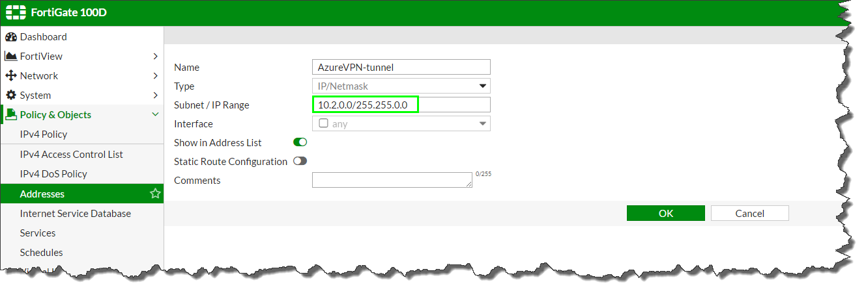

Add the Local Address space for the FortiGate

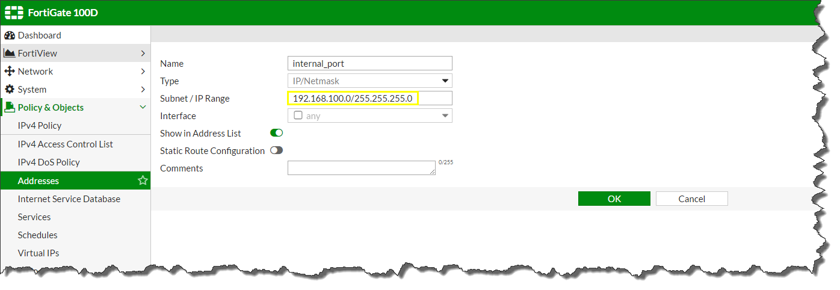

Under **Policy & Objects => IPV4 Policy**

Allow the firewall to accept incoming traffic from the Azure vnet

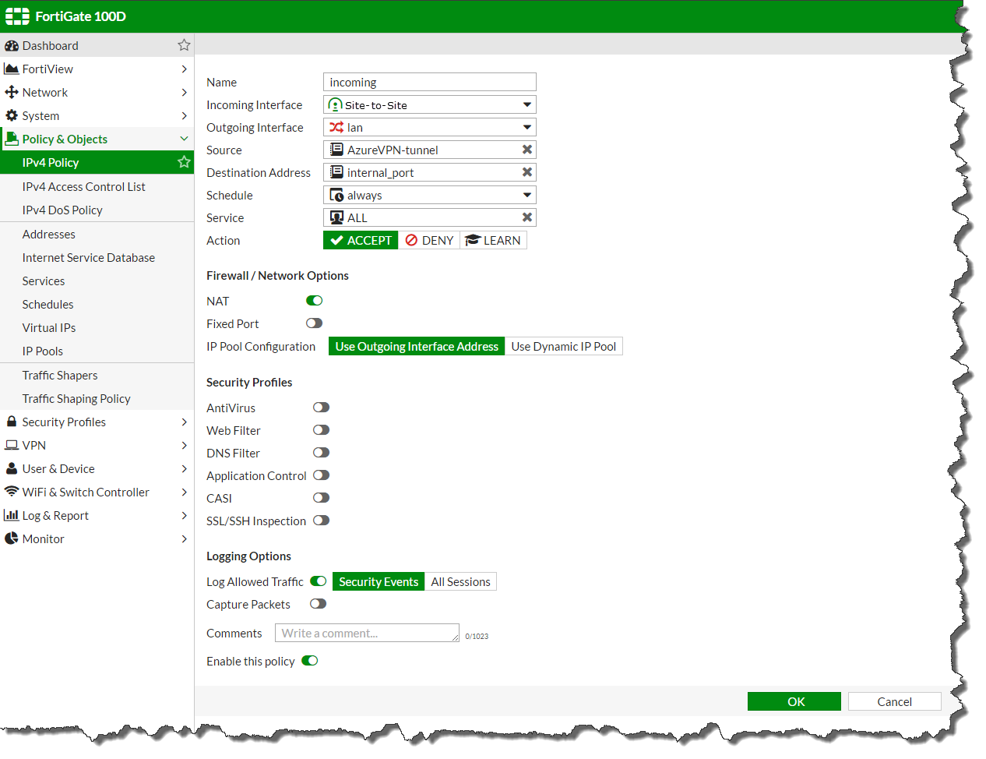

Create a 2nd firewall policy to allow outgoing traffic from the FortiGate to the Azure vnet

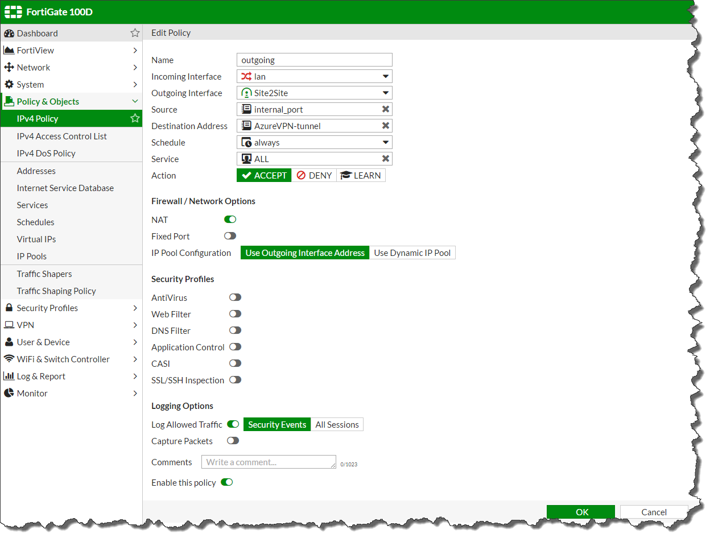

Under **Monitor => IPSec Monitor**

Right click to bring up the gateway

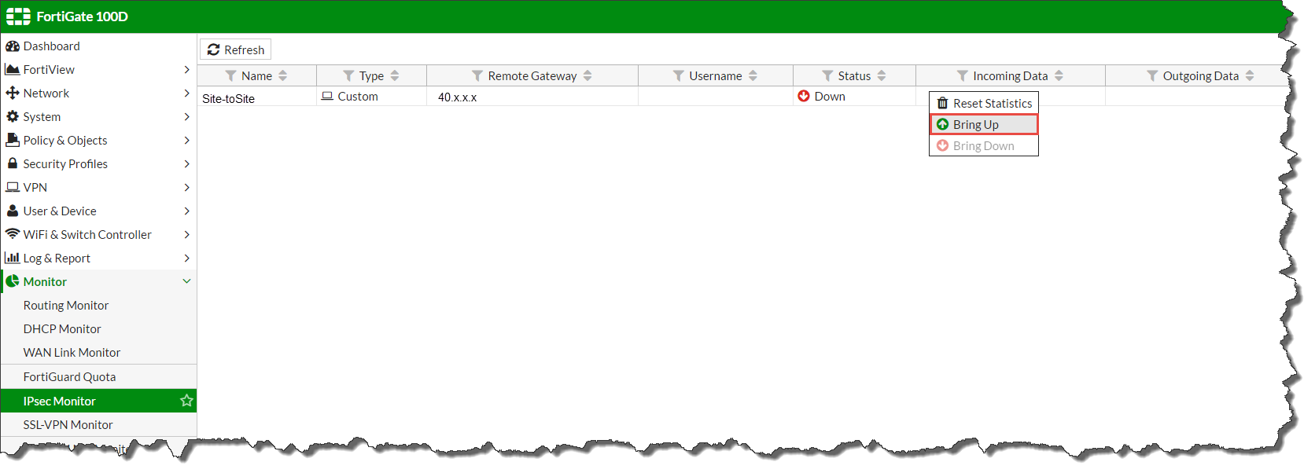

Ensure the VPN tunnel comes up on the Fortinet:

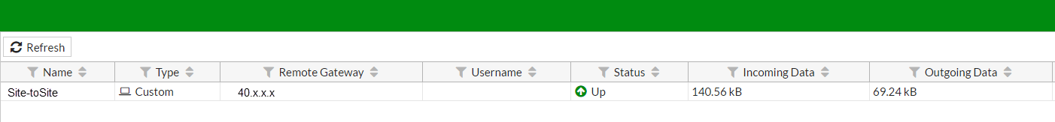

The Azure portal will update within a few moments

