Deploy a **Dynamic** ARM Site to Site VPN Connection from <https://github.com/Azure/azure-quickstart-templates/tree/master/201-site-to-site-vpn>

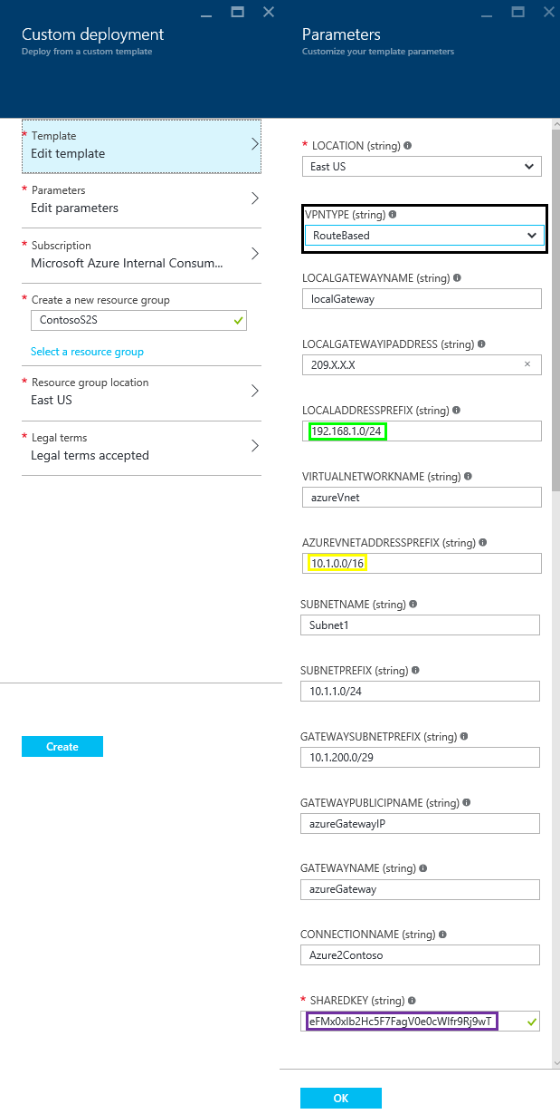

After Site 2 Site connection is deployed review your Azure Public IP Address

Machine generated alternative text:
azureGatewaylP 
Public IP 
S *tings 
Essentials 
Resource group 
ContosoS2S 
Location 
East US 
Subscription name 
Subscription ID 
IP address 
.x.x.x 
Associated to 
azureGateway 
PR 
All settings 

Now we need to configure the SRX. If you log in to the device as the root user, you enter the UNIX shell, which is indicated by the percent sign (%) as the prompt.

To access the Junos CLI, enter the cli command at the shell prompt:

Machine generated alternative text:
root e * cli 
root n •ure SR_» 

After logging in, you enter operational mode, which is indicated by the right angle bracket (>) From operational mode, use the configure command to enter configuration mode, which is indicated by the pound sign (#):

Machine generated alternative text:
root Azure SR_» configure 
Entering configuration mode 
(edit) 
root Azure SRX# 

One we have logged into Junos CLI we need to see what route can reach the Dynamic Azure Gateway

The Junos command is **run show route**

Machine generated alternative text:
root Azure SRX# run show route 
inet.O: S destinations, S routes (S active, 
ho I ddown , 
hidden) 
Active Route, 
o.o.o.o/o 
192.168 .1.0/24 
192.168.1.1/32 
Last Active, 
Both 
• (Static,'sl 
to 206.165.220.1 via fe-O/O/O.O 
• (Direct,'ol 
via vIan.I 
• (Local ,'01 
Local via VI an. I 
206.x.x.x/24 
206.x.x.x/32 
• (Direct,'ol 
via fe—O/O/O 
• (Local ,'01 
Local via fe— 
0/0/0 0 

In this example **fe-0/0/0.0** is the name of the External interface, **vlan.1** is the name of the Internal interface

We will need to show zone(s) with interface **fe-0/0/0.0**

The Junos command is **show security zones | display set | match fe-0/0/0.0**

Machine generated alternative text:
(edit) 
root"zure SRX# show security zones dis lay set I match fe—O/O/O.O 
set security zones security—zone Internet interfaces fe—O/O/O .0 

In this example Zone **Internet** is associated with interface **fe-0/0/0.0**

We will need to show zone(s) with interface **vlan.1**

The Junos command is **show security zones | display set | match vlan.1**

Machine generated alternative text:
root@Äzure SRX# show security zones I display set I match 
Vlan. I 
host — inbound —t raffi c 
host — inbound —t raffi c 
host — inbound —t raffi c 
host — inbound —t raffi c 
host — inbound —t raffi c 
host — inbound —t raf f i c 
system 
system 
system 
system 
system 
system 
— se ces 
p 1 ng 
https 
s sh 
te I net 
set 
set 
set 
set 
set 
security 
security 
security 
security 
security 
security 
zone s 
zone s 
zone s 
zone s 
zone s 
zone s 
security 
security 
security 
security 
security 
security 
— zone 
— zone 
— zone 
— zone 
— zone 
— zone 
Internal 
Inte rna I 
Inte rna I 
Inte rna I 
Inte rna I 
Inte rna I 
interfaces 
interfaces 
interfaces 
interfaces 
interfaces 
interfaces 
vIan . 
vIan . 
vIan . 
vIan . 
vIan . 

In this example Zone **Internal** is associated with interface **vlan.1**

The follow script may need to be modified to suit your device

*###Script Begin###*

*set security ike proposal azure-proposal authentication-method pre-shared-keys*

*set security ike proposal azure-proposal authentication-algorithm sha1*

*set security ike proposal azure-proposal encryption-algorithm aes-256-cbc*

*set security ike proposal azure-proposal lifetime-seconds 28800*

*set security ike proposal azure-proposal dh-group group2*

*set security ike policy azure-policy mode main*

*set security ike policy azure-policy proposals azure-proposal*

*set security ike policy azure-policy pre-shared-key ascii-text* ***eFMx0xlb2Hc5F7FagV0e0cWIfr9Rj9wT***

*set security ike gateway azure-gateway ike-policy azure-policy*

*set security ike gateway azure-gateway address* ***40.X.X.X***

*set security ike gateway azure-gateway external-interface* ***fe-0/0/0.0***

*set security ike gateway azure-gateway version v2-only*

*set security ipsec proposal azure-ipsec-proposal protocol esp*

*set security ipsec proposal azure-ipsec-proposal authentication-algorithm hmac-sha1-96*

*set security ipsec proposal azure-ipsec-proposal encryption-algorithm aes-256-cbc*

*set security ipsec proposal azure-ipsec-proposal lifetime-seconds 3600*

*set security ipsec policy azure-vpn-policy proposals azure-ipsec-proposal*

*set security ipsec vpn azure-ipsec-vpn ike gateway azure-gateway*

*set security ipsec vpn azure-ipsec-vpn ike ipsec-policy azure-vpn-policy*

*set security zones security-zone* ***Internal*** *interfaces* ***vlan.1***

*set security zones security-zone* ***Internal*** *host-inbound-traffic system-services ike*

*set security zones security-zone* ***Internal*** *address-book address onprem-networks-1* ***192.168.1.0/24***

*set security zones security-zone* ***Internet*** *interfaces* ***fe-0/0/0.0***

*set security zones security-zone* ***Internet*** *host-inbound-traffic system-services ike*

*set security zones security-zone* ***Internet*** *address-book address azure-networks-1* ***10.1.0.0/16***

*set security policies from-zone* ***Internal*** *to-zone* ***Internet*** *policy azure-security-****Internal****-to-****Internet****-0 match source-address onprem-networks-1*

*set security policies from-zone* ***Internal*** *to-zone* ***Internet*** *policy azure-security-****Internal****-to-****Internet****-0 match destination-address azure-networks-1*

*set security policies from-zone* ***Internal*** *to-zone* ***Internet*** *policy azure-security-****Internal****-to-****Internet****-0 match application any*

*set security policies from-zone* ***Internal*** *to-zone* ***Internet*** *policy azure-security-****Internal****-to-****Internet****-0 then permit*

*set security policies from-zone* ***Internet*** *to-zone* ***Internal*** *policy azure-security-****Internet****-to-****Internal****-0 match source-address azure-networks-1*

*set security policies from-zone* ***Internet*** *to-zone* ***Internal*** *policy azure-security-****Internet****-to-****Internal****-0 match destination-address onprem-networks-1*

*set security policies from-zone* ***Internet*** *to-zone* ***Internal*** *policy azure-security-****Internet****-to-****Internal****-0 match application any*

*set security policies from-zone* ***Internet*** *to-zone* ***Internal*** *policy azure-security-****Internet****-to-****Internal****-0 then permit*

*set interfaces st0 unit 0 family inet*

*set security zones security-zone* ***Internet*** *interfaces st0.0*

*set security ipsec vpn azure-ipsec-vpn bind-interface st0.0*

*set routing-options static route* ***10.1.0.0/16*** *next-hop st0.0*

*set security flow tcp-mss ipsec-vpn mss 1350*

*###Script End###*

###Script Key###

***eFMx0xlb2Hc5F7FagV0e0cWIfr9Rj9wT is the Azure Gateway preshared key******40.X.X.X is the IP address of the Dynamic Azure gateway***

***fe-0/0/0.0 in the external interface***

***vlan.1 the name of the internal interface***

***Internal is the zone is associated with interface vlan.1***

***Internet is the zone is associated with interface fe-0/0/0.0***

***192.168.1.0/24 this is IP address range of the onprem-networks***

***10.1.0.0/16 this is the IP address rage of the azure-networks***

We will need to use the text typed at the terminal as input to the configuration

The Junos command is **load set terminal**

Machine generated alternative text:
root Azure SRX# load set terminal 
L Type AD at a new line to end input I 

Copy and paste the edited script into the Juniper console window when completed press "Control D" to end input

The Junos command is **commit full**

Machine generated alternative text:
root Azure SRX# comit 
t comple te 

We need to show the default security policy

The Junos command is **show security policies from-zone Internal to-zone Internet**

Machine generated alternative text:
root"zure SRX# show security policies 
policy All Internal Internet 
mat ch 
source—address any ; 
destination—address any ; 
appl cat ion any ; 
then 
pe rmi t ; 
policy 
f rom— z one 
Internal 
to— zone 
Int e t 
mat ch 
source—address ; 
destination—address azure—networks—I, 
appl cat ion any ; 
then 
pe rmi t ; 

The default policy name in this example is **azure-security-Internal-to-Internet-0**

\*\*If your default policy does not match **azure-security-Internal-to-Internet-0**

Run Command **insert security policies from-zone Internal to-zone Internet policy azure-security-Internal-to-Internet-0 before policy <NameOfYourDefaultTrustToUntrustPolicy>**

**commit**

How to check to see main mode is connected

The Junos command is **run show security ike security-associations**

Machine generated alternative text:
root"zure SRX# run show security ike security—associations 
Remot e 
Add re s s 
go.x.x.x 
Index State Initiator cookie 
Re sponder cookie 
1369b1d61d0260B2 
Mode 
IKEv2 
6852022 UP 
9abdB7c7bea9BB63 

How to check to see Quick Mode is connected

The Junos command is **run show security ipsec security-associations**

Machine generated alternative text:
root"zure SRX# run show security ipsec security 
Total active tunnels : I 
—associations 
Life : sec/ kb Mon 
SPI 
I sys Port 
root S 00 
root S 00 
Gat e way 
40. x. x. x 
40. x. x. x 
U 31073 ESP:aes-2S6/sha1 37eb99ba 2083/ unlim 
M 31073 ESP:aes-2S6/sha1 4649682c 2083/ unlim 

To exit configuration mode and go back to operational mode, enter exit at the prompt:

Machine generated alternative text:
root Azure SRX# exit 
Exiting configuration mode 