Deploy an **Dynamic** ARM Site to Site VPN Connection from <<https://github.com/Azure/azure-quickstart-templates/tree/master/101-create-site-to-site-vpn>>

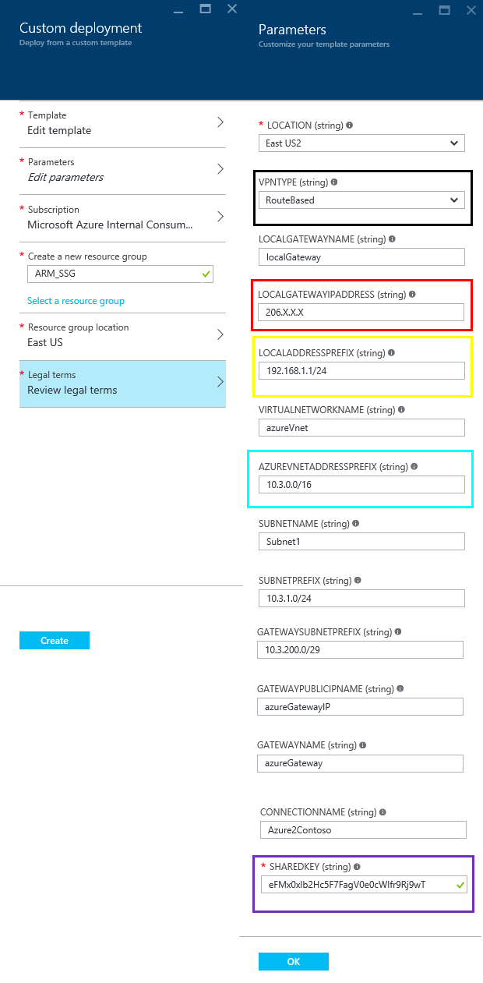

After Site 2 Site connection is deployed review your **Azure Public IP Address**

Machine generated alternative text:
azureGatewaylP 
Public IP 
S *tings 
Dissociate 
Essentials 
Resource group 
ARM SSG 
Location 
East US 
Subscription name 
Subscription ID 
IP address 
104.x.x.x 
Associatecl to 
azureGateway 
PR 

Now we need to configure the SSG. Log into the ScreenOS. One we have logged into ScreenOS CLI we need to see what route can reach the Dynamic Azure Gateway

The ScreenOS command is **Get Interface**

Machine generated alternative text:
. c0c0 . becb 
. c0c0 . beca 
ssgS—seriaI—» get interface 
D 
Down, 
R 
Re ady 
Z one 
Null 
Unt rus t 
Trust 
Null 
Null 
Null 
Null 
001b 
001b 
001b 
001b 
001b 
001b 
001b 
. c0c0 
. c0c0 
. c0c0 
. c0c0 
. c0c0 
VIAN 
be co 
be c 5 
be c c 
be ce 
be Cf 
state VSD 
ve , 
Inte r fa ce s 
serial 0/0 
ethO O 
e thO/I 
b graupO 
ethO/ 2 
ethO/ 3 
ethO/ 4 
ethO/5 
ethO/ 6 
bg roup2 
v lanl 
nul I 
Inact i ve, U 
in vsys Root : 
IP Address 
o. 0/0 
0.0 
206. x. x. x 
o. 0/0 
0.0 
192.168.1 
0 0.0. 0/0 
0 0.0. 0/0 
0 0.0. 0/0 
0 0.0. 0/0 
o.o.o.o/o 
24 
1/24 

In this example **eth0/0** is the name of the outgoing-interface, **bgroup0** is the name of the bridge group interface

The follow script may need to be modified to suit your device

*###Script Begin###*

*set interface tunnel.1 zone untrust*

*set interface tunnel.1 ip unnumbered interface* ***bgroup0***

*set route* ***10.3.0.0/16*** *interface tunnel.1*

*set ike gateway ikev2 azure-gateway address* ***104.X.X.X*** *outgoing-interface* ***eth0/0*** *preshare* ***eFMx0xlb2Hc5F7FagV0e0cWIfr9Rj9wT*** *sec-level compatible*

*set ike gateway azure-gateway dpd-liveness interval 10*

*set vpn azure-ipsec-vpn gateway azure-gateway tunnel idletime 0 sec-level compatible*

*set vpn azure-ipsec-vpn bind interface tunnel.1*

*set address trust onprem-networks-1* ***192.168.1.0/24***

*set address untrust azure-networks-1* ***10.3.0.0/16***

*set policy top from trust to untrust onprem-networks-1 azure-networks-1 any permit*

*set policy top from untrust to trust azure-networks-1 onprem-networks-1 any permit*

*set flow vpn-tcp-mss 1350*

*save*

*###Script End###*

###Script Key###

**bgroup0 is the name of the bridge group interface**

**eth0/0 is the name of the outgoing-interface**

**40.X.X.X is the IP address of the Dynamic Azure gateway**

**eFMx0xlb2Hc5F7FagV0e0cWIfr9Rj9wT is the Azure Gateway preshared key**

10.1.0.0/16 this is the IP address rage of the azure-networks

**192.168.1.0/24 this is IP address range of the onprem-networks**

We will need to use the text typed at the terminal as input to the configuration

How to check to see main mode is connected

The ScreenOS command is **Get SA**

Machine generated alternative text:
ssgS—seriaIO Get SA 
total configured sa: I 
SPI 
f39aB604 
Ocde6d9B 
Life: sec kb 
2693 unlim 
2693 unlim 
Sta 
PID vsys 
HEX ID 
Gat e way 
104. x. x. x 
ooooooo» 104. x. x. x 
soo 
soo 
esp : 3des/ shal 
esp : 3des/ shal 

([Both A/- and A/U are positive states that your tunnel is up](http://kb.juniper.net/InfoCenter/index?page=content&id=KB6134&actp=search))

We can also check the Azure Gateway to view connection

Machine generated alternative text:
Azure2Contoso 
Co 
S *tings 
Essentials 
Resource group 
ARM SSG 
Connected 
Location 
East US 
Subscription name 
Subscription ID 
Data in 
Data out 
360 B 
Virtual network 
Virtual network gateway 
Local network gateway 
localGatewav (206.X.X.X) 
PR 