**Jenkins Pipeline for Java Application with Docker**

**Title: Creating a Jenkins Pipeline for Java Code to Generate a JAR File**

Objective

The objective of this assignment is to create a Docker container for a Java application such that executing the container results in the generation of a `.jar` file. This JAR file can then be easily shared as the output of the build process.

---

(A) Project Structure

The project should be structured as follows:

- Java File: The Java source file, `HelloWorld.java`, should be located in the directory `src/main/java/com/example`. Ensure that the file is saved in this specific directory and that the necessary folder structure is created.

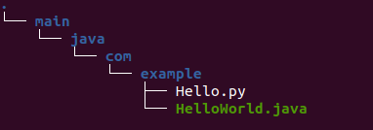

- POM File: A `pom.xml` file must be created to specify all dependencies and their respective versions required for the Java application.

- Dockerfile: This file will utilise OpenJDK as the base image. The application will be set up in the working directory, and the `pom.xml` and source files will be copied into this directory. The Dockerfile will also contain instructions to run the Java application when the container starts.

---

(B) Creating the Docker Container

Docker Host and Docker Daemon

Docker facilitates the separation of applications from infrastructure, providing a platform to run containers efficiently. The relationship between the Docker host and the Docker daemon is akin to a client-server model; these components can reside on the same machine or be installed on different machines. The processes of creating Docker images and running containers are managed by the Docker daemon.

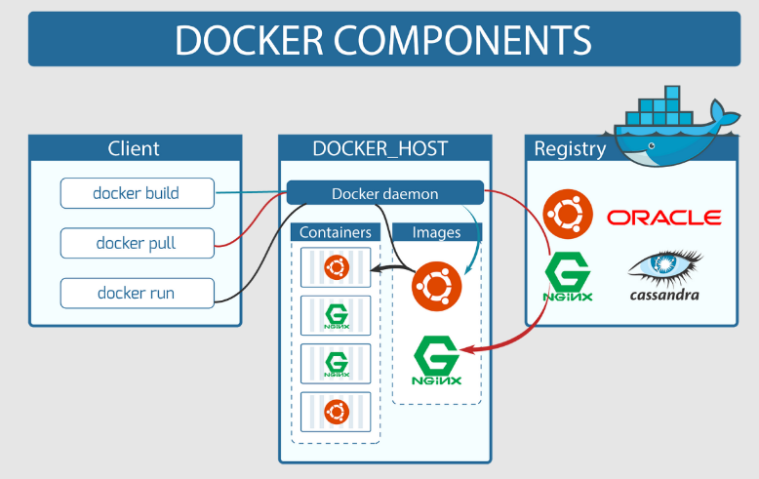

Steps to Create a Docker Image

To create a Docker image using the Dockerfile, execute the following command:

<<

docker build -t image_name .

>>

You can view all Docker images on your system using the following commands:

<<

docker images

>>>

Or

<<<

docker image ls

>>>

Steps to Create a Docker Container

To create and run a Docker container, use the command:

<<<

docker run -d -p host_port:container_port docker_image_name

>>>

The `-d` flag enables the container to run in detached mode; without this flag, the container will run in interactive mode.

To view running containers, use:

<<<

docker ps

>>>

To see all containers, including those that are stopped, use:

<<<

docker ps -a

>>>

Accessing the Docker Container

To access the shell of a running Docker container, use the command:

<<<

docker exec -it container_name sh

>>>

This command opens a shell session inside the container, allowing you to view and modify files as necessary.

---

(C) Creating the Jenkins Pipeline

Jenkins is an open-source tool designed to facilitate the creation of Continuous Integration and Continuous Deployment (CI/CD) pipelines. By establishing a pipeline, we can automate various tasks associated with the build and deployment processes.

Steps to Create a Jenkins Pipeline

1. Create a Jenkins Account: After running the Docker container, create an account on Jenkins.

2. Create a New Item: Navigate to "New Item" in the Jenkins dashboard and provide a name for the pipeline, such as `docker-CICD`.

3. Job Description: Enter a relevant description for the job to clarify its purpose.

4. GitHub Project URL: In the "GitHub Project URL" field, provide the URL of your GitHub repository containing the Java application.

5. Pipeline Section:

- Definition: Select "Pipeline script from SCM."

- Repository URL: Enter the URL of your GitHub repository.

- Ensure that you have established GitHub credentials before running the job.

- Branch: Specify the branch where all content is saved.

- Script Path: Enter `Jenkinsfile` (the name must match exactly as it appears in your GitHub repository).

6. Save and Run Job: Save the configuration and execute the job.

7. Expected Outcome: The end result should reflect a successful pipeline execution. If you encounter any issues, please review the instructions carefully and ensure that you are following the repository guidelines.

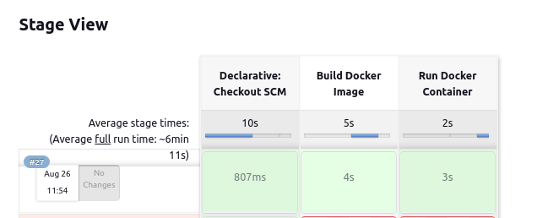

---

This documentation serves as a comprehensive guide for setting up a Jenkins pipeline for a Java application using Docker. It is intended to assist anyone navigating through the repository to understand the process and achieve the desired outcomes effectively.