Table of Contents

Table Tag with markers 6

Vertical extension 6

Horizontal extension 6

Discard if empty 7

8

8

8

Discard if 8

9

9

9

Discard row if 9

Nested Tables 10

Conditions in tables 11

|  |  |  |  |
| --- | --- | --- | --- |
| **NAME** | **PRICE** | **QUANTITY** | **AMOUNT** |
| {{**subscriptions.name**}} | {{**subscriptions.price**}} | {{**subscriptions.quantity**}} | {{**subscriptions.amount**}} |

|  |  |  |  |
| --- | --- | --- | --- |
| **NAME** | **PRICE** | **QUANTITY** | **AMOUNT** |
| **Adobe Document API** | **99** | **1** | **99** |
| **Adobe Marketing API** | **199** | **2** | **398** |

|  |  |  |  |
| --- | --- | --- | --- |
| **Description** | **Amount** | **Quantity** | **Total** |
| {{**subscription.name**}} | {{**subscription.name**}} | {{**subscription.name**}} | {{**subscription.name**}} |
| product2 | 499 | 1 | 998 |

|  |  |  |  |
| --- | --- | --- | --- |
| **NAME** | **PRICE** | **QUANTITY** | **AMOUNT** |
| {{**subscription.name**}} | {{subscriptions.price}} | {{subscriptions.quantity}} | {{subscriptions.amount}} |

Hello, **{{accountName}}**, your account number Hello, **Kane Miller**, your account number

is **{{accountNumber}}**. is **8324e015-6400**.

Hello, Kane your account manager is Hello, Kane your account manager is

**{{accountManager:default-val(“John Bert”)}}**. **John Bert**.

Hello, Kane your registered address is Hello, Kane your registered address is

123 ABC Street**, **LA**

**{{address.country:optional(true)}}**

Hello, Kane your assigned physician is Hello, Kane your assigned physician is

**{{doctor:prefix(“Dr. ”)}}**. **Dr. John Doe**.

* Hi hello
* Hi hello

The total profit for the financial year 2020-21 The total profit for the financial year 2020-21

is $**{{expr(revenue – expenditure)}})**. is $**350**.

The total subscriptions sold for the whole  The total subscriptions sold for the whole

day is **{{expr($sum(subscriptions.licenses))}}**. day is **4**.

**{% conditional-section expr(state = “CA”)%}**This is a clause for California **{% end-section %}**. We are committed to protecting your privacy. Authorized employees within the company on a need to know basis  only use any information collected from individual customers. We constantly review our systems and data to ensure the best possible service to our customers. Parliament has created specific offences for unauthorized actions against computer systems and data. We will investigate any such actions with a view to prosecuting and/or taking civil proceedings to recover damages against those responsible

The total quantity of product sold for the whole month is {{expr($sum(products.quantity))}}

**{% conditional-section expr(state = “CA”)%}** **Washington State Disclosure**  **Washington State Disclosure**

As your company in Washington State, you

understand that your company will comply understand that your company will comply

with Washington State Privacy Laws defined with Washington State Privacy Laws defined

by law 6372.  by law 6372.

**{% end-section %}**

**{**

**Washington State Disclosure**  **Washington State Disclosure**

As your company in Washington State,

you understand that your company will comply you understand that your company will comply

with **{% conditional-section expr(state = “CA”)%}** with Washington State Privacy Laws defined

Washington State Privacy Laws defined by law 6372.

**{% end-section %}** by law 6372.

{{Sig1_es_:signer1:signature}}

______________________________

${accountManager}

{{Sig2_es_:signer2:signature}}

______________________________

${customerName}

Please find the Product List below : Please find the Product List below :

{% repeating-section products %} 1. **Adobe Photoshop**

2. **Adobe Premiere Pro**

{% end-section %}3. **Adobe InDesign**

Please find the Product List below : Please find the Product List below :

**Adobe Photoshop**

Adobe Premiere Pro**



**Adobe InDesign**

|  |  |
| --- | --- |
| **NAME** | **PRICE** |
| {{**subscriptions.name:cell-extension(vertical)**}} | {{**subscriptions.price**} |
|  |  |

|  |  |
| --- | --- |
| **NAME** | **PRICE** |
| **Adobe Document API** | **99** |
| **Adobe Marketing API** | **199** |

## 

## Table Tag with markers

### Simple Table

Document template Formatted Output

|  |  |  |
| --- | --- | --- |
| **SCHOOL** | **STRENGTH** | **ADDRESS** |
| ABC Public School | 128 | New Delhi |
| DEF Public School | 83 | Hyderabad |
| XYZ Public School | 165 | Mumbai |

|  |  |  |
| --- | --- | --- |
| **SCHOOL** | **STRENGTH** | **ADDRESS** |
| {% table-start school %}  {{name}} | {{strength}} | {{address}}  {% table-end %} |

### 

### Vertical extension

Document template Formatted Output

|  |  |
| --- | --- |
| **NAME** | **PRICE** |
| Adobe Document  API | 99 |
| Adobe Marketing  API | 199 |
| Adobe Design  API | 299 |

|  |  |
| --- | --- |
| **NAME** | **PRICE** |
| {% table-start subscriptions %}  {{name:cell-extension(vertical)}} | {{price}}  {% table-end %} |

### Horizontal extension

Document template Formatted Output

|  |  |
| --- | --- |
| **NAME** | {% table-start subscriptions %}  {{name:cell-extension(horizontal)}} |
| **PRICE** | {{price}}  {% table-end %} |

|  |  |  |  |
| --- | --- | --- | --- |
| **NAME** | Adobe Document  API | Adobe Marketing  API | Adobe Design  API |
| **PRICE** | 99 | 199 | 299 |

### 

### 

### Discard if empty

Document template Formatted Output

|  |  |  |
| --- | --- | --- |
| **PROJECT** | **MILESTONE** | **DATE COMPLETE** |
| ABC Infra | First Milestone | 24/06/2021 |
| ABC Infra | Second Milestone | 24/06/2022 |
| DEF Computer Labs | First Milestone | 12/12/2021 |
| DEF Computer Labs | Second Milestone | 12/12/2021 |

|  |  |  |  |
| --- | --- | --- | --- |
| **PROJECT** | **MILESTONE** | **DATE COMPLETE** | **NOTES** |
| {% table-start project %}  {{name}} | {{milestone}} | {{dateComplete}} | {{notes:discard-if-empty(true)}}  {% table-end %} |

### Discard if

Document template Formatted Output

|  |
| --- |
| **Month** |
| July, 2021 |
| September, 2021 |
| Dec, 2021 |
| April, 2022 |
| Dec, 2022 |

|  |  |  |
| --- | --- | --- |
| **Month** | **Customer Conversion** | **Via** |
| {% table-start conversion %}  {{month}} | {{rate:discard-if(expr( $sum(conversion.rate)!=100),$)}} | {{method:discard-if(expr($sum(conversion.rate)!=100),$)}}  {% table-end %} |

### 

### Discard row if

Document template Formatted Output

|  |  |  |
| --- | --- | --- |
| **Month** | **Customer Conversion** | **Via** |
| Dec, 2022 | 40 | Payout by Cheque |
| Dec, 2021 | 80 | Payout by Cheque |
| Dec, 2022 | 45 | Payout by Cheque |

|  |  |  |
| --- | --- | --- |
| **Month** | **Customer Conversion** | **Via** |
| {% table-start Conversion %}  {{month}} | {{rate:discard-row-if(expr(rate<=20))}} | {{method:discard-row-if(expr(method!="Payout by Cheque"))}}  {% table-end %} |

### 

### Nested Tables

Document template Formatted Output

|  |  |
| --- | --- |
| **SCHOOL** | **CLASSES** |
| ABC Public  School | |  |  |  | | --- | --- | --- | | **CLASS** | **STRENGTH** | **CONTACT** | | XI | 65 | 9XXXXXXXX8 | | XII | 40 | 9XXXXXXXX8 | |
| XYZ Public  School | |  |  |  | | --- | --- | --- | | **CLASS** | **STRENGTH** | **CONTACT** | | X | 45 | 7XXXXXXXX5 | | XI | 38 | 7XXXXXXXX5 | | XII | 82 | 7XXXXXXXX5 | |
|  |  |

|  |  |
| --- | --- |
| **SCHOOL** | **CLASSES** |
| {% table-start school %}  {{name}} | |  |  |  | | --- | --- | --- | | **CLASS** | **STRENGTH** | **CONTACT** | | {% table-start class %}  {{name}} | {{strength}} | {{contact:eval(school)}}  {% table-end %} |   {% table-end %} |

### Context in Table Markers

|  |  |  |
| --- | --- | --- |
| **SCHOOL** | **BOARD** | **CLASSES** |
| {% table-start school %}  {{name}} | {{board:eval($)}} | |  |  |  | | --- | --- | --- | | **CLASS** | **STRENGTH** | **SPORTS** | | {% table-start class %}  {{name}} | {{strength}} | {% conditional-section expr(details.sportsAvailable = "Yes"):eval(school) %}  Sports facility is available for this class  {% end-section %}  {% conditional-section expr(details.sportsAvailable = "No" ):eval(school) %}  Sports facility is not available for this class  {% end-section %}  {% table-end %} |   {% table-end %} |
|  |  |  |

|  |  |  |
| --- | --- | --- |
| **SCHOOL** | **BOARD** | **CLASSES** |
| ABC Public  School | CBSE | |  |  |  | | --- | --- | --- | | **CLASS** | **STRENGTH** | **SPORTS** | | XI | 65 | Sports facility is not available for this class | | XII | 40 | Sports facility is not available for this class | |
| XYZ Public  School | CBSE | |  |  |  | | --- | --- | --- | | **CLASS** | **STRENGTH** | **SPORTS** | | X | 45 | Sports facility is available for this class | | XI | 38 | Sports facility is available for this class | | XII | 82 | Sports facility is available for this class | |
|  |  |  |

Document template Formatted Output

Representation of JSON data 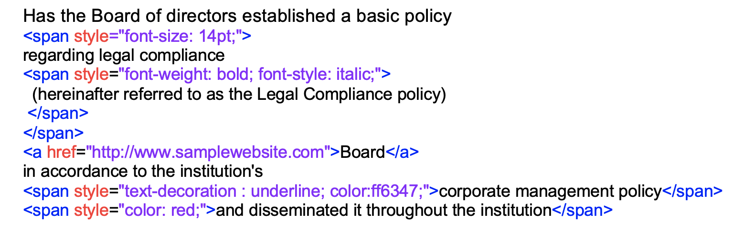

Document template

{{Notes Section}}

Document template Formatted output

Representation of JSON data

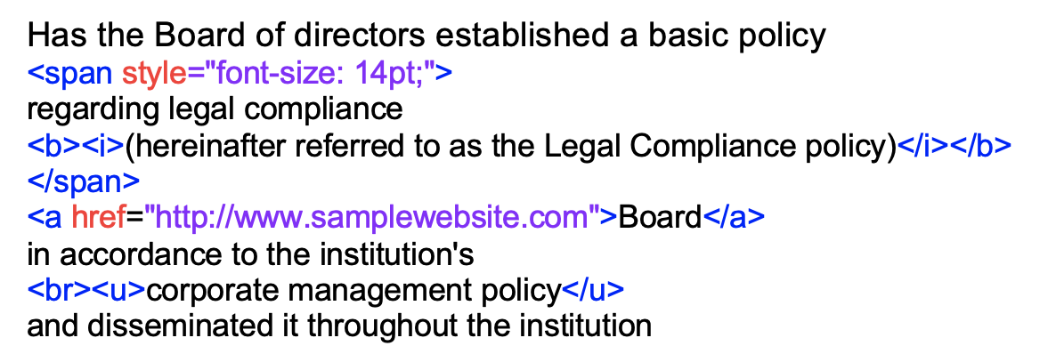

Document template Formatted output

{{Notes Section}}

Sample for anchor tag

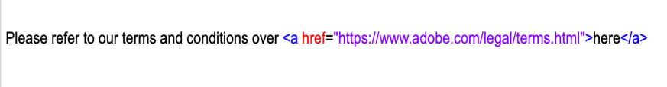

Document template Formatted output

Representation of JSON data



Document template

This is a {{ContentBlock}}

Formatted output

* A picture containing shape

  Description automatically generated

