Московский государственный технический университет
им. Н.Э. Баумана
Факультет “Информатика и системы управления”
Кафедра “Системы обработки информации и управления”



Дисциплина «Парадигмы и конструкции языков программирования»

Отчет по лабораторной работе №1
«Основные конструкции языка Python»

Выполнил:
студент группы ИУ5-36Б
Галенко Алексей Владимирович
Проверил:
Гапанюк Юрий Евгеньевич

Москва, 2025
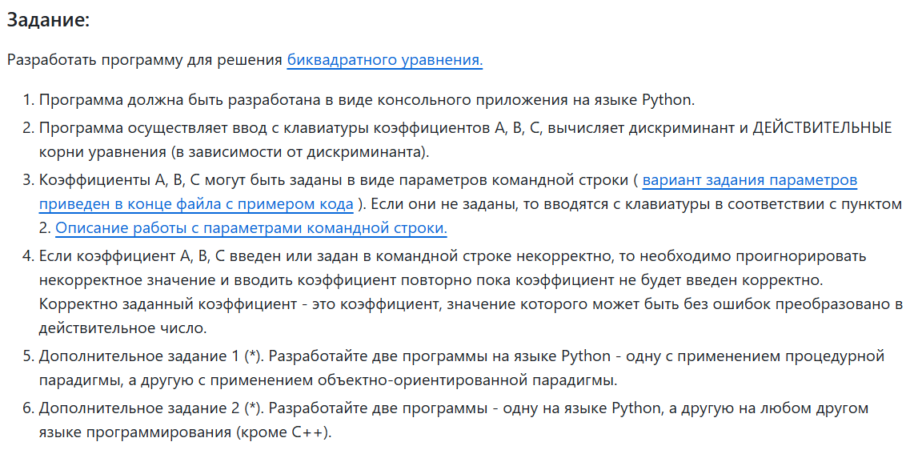

Code procedural.py
import sys
import math
def get_input_coefficient(args, index):
try:
return float(args[index])
except (IndexError, ValueError):
return None
def prompt_coefficient(name):
while True:
try:
value = float(input(f"write coefficient {name}: "))
return value
except ValueError:
print("error: coefficient must be float")
def solve_biquadratic(a, b, c):
discriminant = b ** 2 - 4 * a * c
if discriminant < 0:
return []
roots = set()
y_first = (-b + math.sqrt(discriminant)) / (2 * a)
y_second = (-b - math.sqrt(discriminant)) / (2 * a)
if y_first >= 0:
x_first = math.sqrt(y_first)
roots.add(x_first)
roots.add(-x_first)
if y_second >= 0:
x_second = math.sqrt(y_second)
roots.add(x_second)
roots.add(-x_second)
return sorted(list(roots))
def main():
args = sys.argv[1:]
a = get_input_coefficient(args, 0)
if a is None:
a = prompt_coefficient('A')
b = get_input_coefficient(args, 1)
if b is None:
b = prompt_coefficient('B')
c = get_input_coefficient(args, 2)
if c is None:
c = prompt_coefficient('C')
print(f"equation: {a}x^4 + {b}x^2 + {c} = 0")
roots_real = solve_biquadratic(a, b, c)
if not roots_real:
print("no real roots")
else:
print(f"real roots: {roots_real}")
if __name__ == "__main__":
main()

Code object.py
import sys
import math
class BiquadraticEquationInRealSolution:
def __init__(self, a, b, c):
self.a = a
self.b = b
self.c = c
self.roots = []
def solve(self):
discriminant = self.b ** 2 - 4 * self.a * self.c
if discriminant < 0:
return
temp_roots = set()
y1 = (-self.b + math.sqrt(discriminant)) / (2 * self.a)
y2 = (-self.b - math.sqrt(discriminant)) / (2 * self.a)
if y1 >= 0:
x1 = math.sqrt(y1)
temp_roots.add(x1)
temp_roots.add(-x1)
if y2 >= 0:
x2 = math.sqrt(y2)
temp_roots.add(x2)
temp_roots.add(-x2)
self.roots = sorted(list(temp_roots))
def display_results(self):
print(
f"equation: {self.a}x^4 + {self.b}x^2 + {self.c} = 0")
if not self.roots:
print("no real roots")
else:
print(f"real roots: {self.roots}")
def get_input_coefficient(args, index):
try:
return float(args[index])
except (IndexError, ValueError):
return None
def prompt_coefficient(name):
while True:
try:
return float(input(f"write coefficient {name}: "))
except ValueError:
print("error: coefficient must be float")
def main():
args = sys.argv[1:]
a = get_input_coefficient(args, 0) or prompt_coefficient('A')
b = get_input_coefficient(args, 1) or prompt_coefficient('B')
c = get_input_coefficient(args, 2) or prompt_coefficient('C')
equation = BiquadraticEquationInRealSolution(a, b, c)
equation.solve()
equation.display_results()
if __name__ == "__main__":
main()

Code procedural.c
#include <stdio.h> // For input/output functions like printf and scanf
#include <stdlib.h> // For string to number conversion (atof)
#include <math.h> // For math functions, specifically sqrt (square root)
// Function to prompt the user for a coefficient
// &coeff is a "pointer", it allows the function to modify the variable in main
void prompt_input_coefficient(const char* name, double* coeff) {
printf("Enter coefficient %s: ", name);
// Infinite loop until a valid number is entered
while (scanf("%lf", coeff) != 1) {
printf("Error: Invalid input. Please try again: ");
// Clear the input buffer to prevent the program from getting stuck on invalid input
while (getchar() != '\n');
}
}
int main(int argc, char *argv[]) {
double a, b, c;
if (argc == 4) {
printf("Coefficients taken from command-line arguments.\n");
a = atof(argv[1]);
b = atof(argv[2]);
c = atof(argv[3]);
} else {
printf("No coefficients were passed, please enter them manually.\n");
prompt_input_coefficient("A", &a);
prompt_input_coefficient("B", &b);
prompt_input_coefficient("C", &c);
}
printf("\nSolving equation: %.2fx^4 + %.2fx^2 + %.2f = 0\n", a, b, c);
// --- Solving Logic ---
double discriminant = b * b - 4 * a * c;
if (discriminant < 0) {
printf("No real roots because the discriminant is negative.\n");
return 0;
}
double yFirst = (-b + sqrt(discriminant)) / (2 * a);
double ySecond = (-b - sqrt(discriminant)) / (2 * a);
double roots[4];
int count = 0;
if (yFirst >= 0) {
double xFirst = sqrt(yFirst);
if (xFirst == 0) {
roots[count++] = 0;
} else {
roots[count++] = xFirst;
roots[count++] = -xFirst;
}
}
if (ySecond >= 0) {
double xSecond = sqrt(ySecond);
if (yFirst != ySecond) {
if (xSecond == 0) {
if (yFirst != 0) {
roots[count++] = 0;
}
} else {
roots[count++] = xSecond;
roots[count++] = -xSecond;
}
}
}
// --- Solving Logic ---

// --- Output Result ---
if (count == 0) {
printf("No real roots found.\n");
} else {
printf("Found real roots:\n");
for (int i = 0; i < count; i++) {
printf("%.2f ", roots[i]);
}
printf("\n");
}
// --- Output Result ---

return 0;
}

Test procedural.py
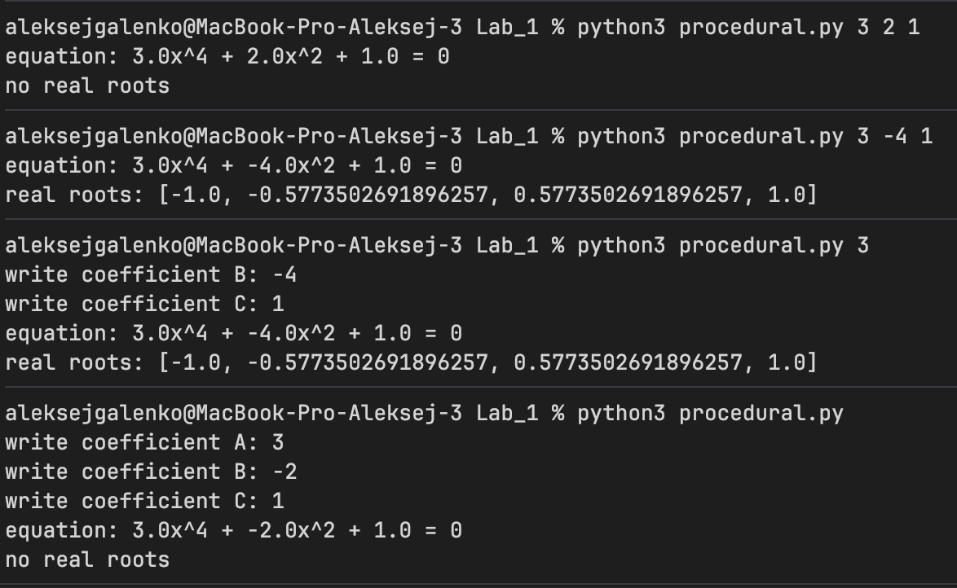
Test object.c
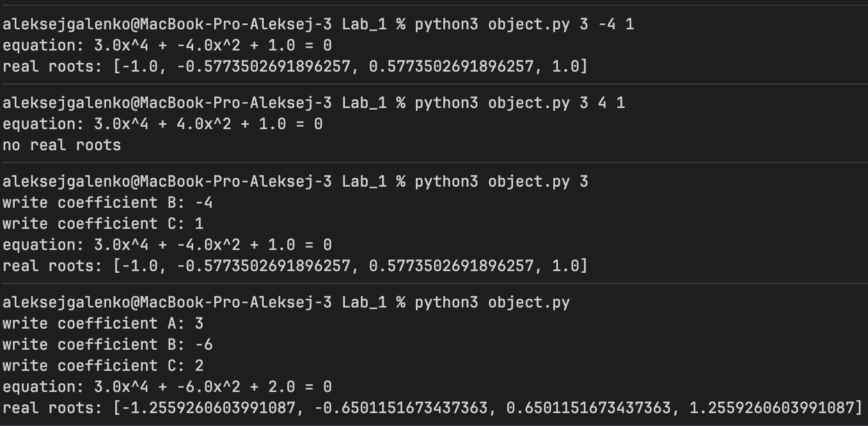
Test procedural.c
