Spot test figures and captions
Phage Φ8 and the expressed CDS_0012-family proteins on seven Pseudomonas strains
Prepared 21 Oct 2026 for the funding application · iGEM 2026
Source data: spot test spotted 12 Oct 2026, plates photographed 16 Oct 2026. Figures generated by code/1016_spot_test_result.ipynb (Figures 1–3, S1) and code/1015_spot_test_dilution.ipynb (Figure S2). Plate photographs are archived in data/assays/1016_spot_test/.
How to use this document: each figure below carries a caption written for direct use. The shared methods paragraph is given once, under Methods. Everything the figures cannot yet show is collected at the end under Limitations — please read that section before any of these panels is used in an application.

Methods (applies to Figures 1–3 and S1)
Seven Pseudomonas strains were each grown as a double-layer lawn (200 µL overnight culture in 3 mL soft agar). Every plate received five 7 µL drops: phage Φ8 stock (positive control), sterile 1× PBS (negative control), purified e1, and crude lysates of e40 and e281. All protein samples were diluted 1:10 in sterile PBS. Drops were spotted on 12 Oct 2026 and the plates photographed on 16 Oct 2026. “R1” denotes a Φ8-resistant isolate picked from the sensitive parent strain. Colonies inside each drop were counted by automated image segmentation; touching colonies are counted as one, so all counts are lower bounds. n = 1 plate per strain at a single concentration.

Figure 1 — Spot test drops and colony counts
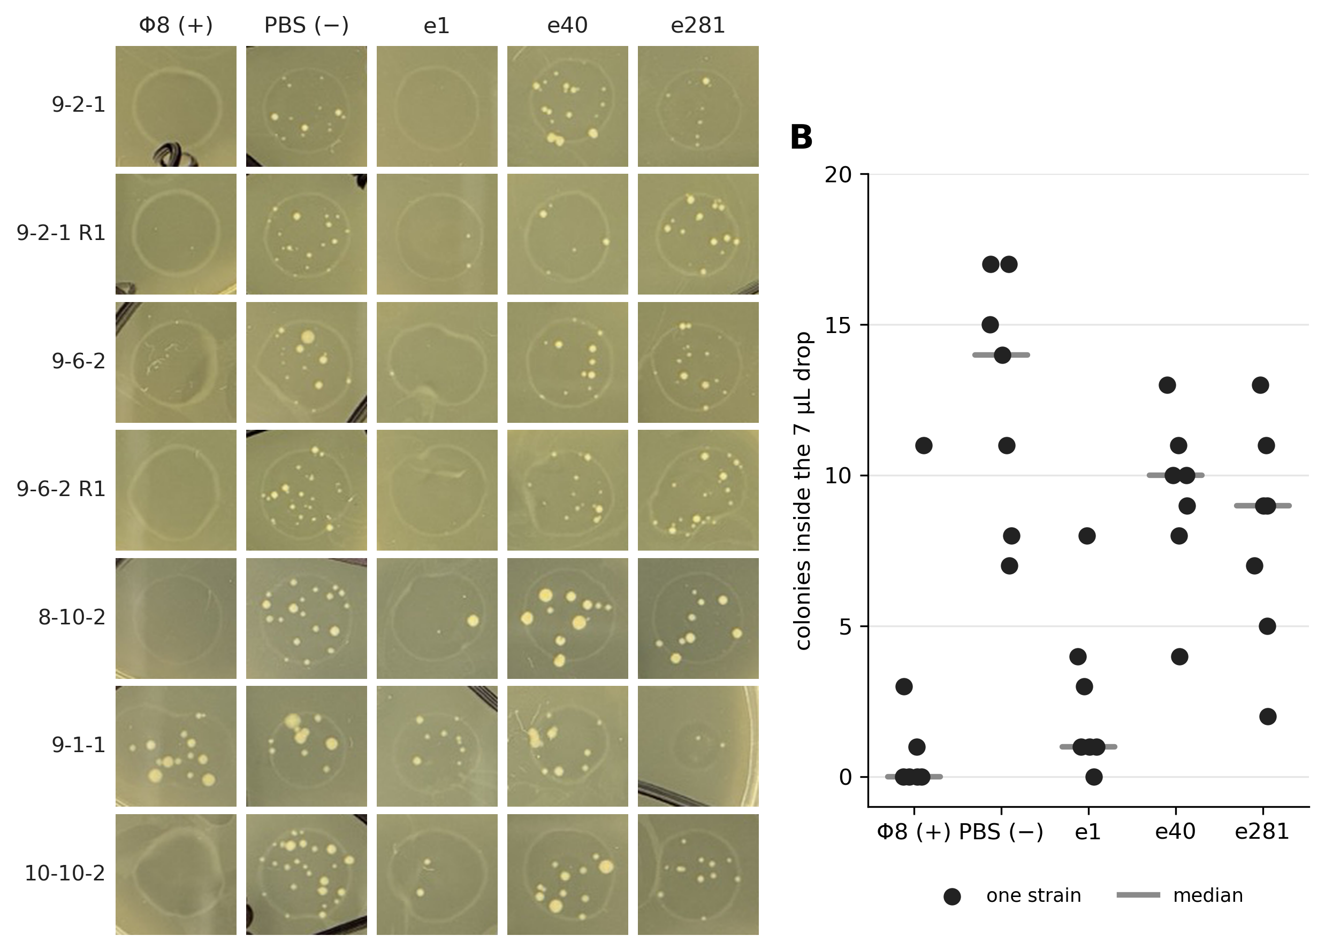
Figure 1. Proof-of-concept spot test of three expressed CDS_0012-family proteins on seven Pseudomonas lawns. (A) Each 7 µL drop, cropped from the plate photograph without colour correction; rows are strains, columns treatments. (B) Colonies counted inside each drop; one point per strain, bars show medians. The lawns grew well, but no clear zone is visible in the photographs. The readable signal is colony growth inside the drop. Sterile PBS drops consistently developed discrete colonies (median 14 per drop), which sets the baseline for a liquid drop landing on these lawns. Both the Φ8 drops (median 0) and the purified e1 drops (median 1) almost completely suppressed that growth on six of the seven strains. Because the e1 drop was 90 % PBS, the difference from the PBS control comes from the e1 preparation itself, and its effect was comparable to that of the phage. The crude e40 and e281 lysates reduced colony numbers only slightly (medians 10 and 9); in those lysates the target protein is not enriched, so this does not show that e40 and e281 lack activity.
File: Figure 1 - Spot test drops and colony counts.png / .pdf

Figure 2 — Spot test grouped by phage host range
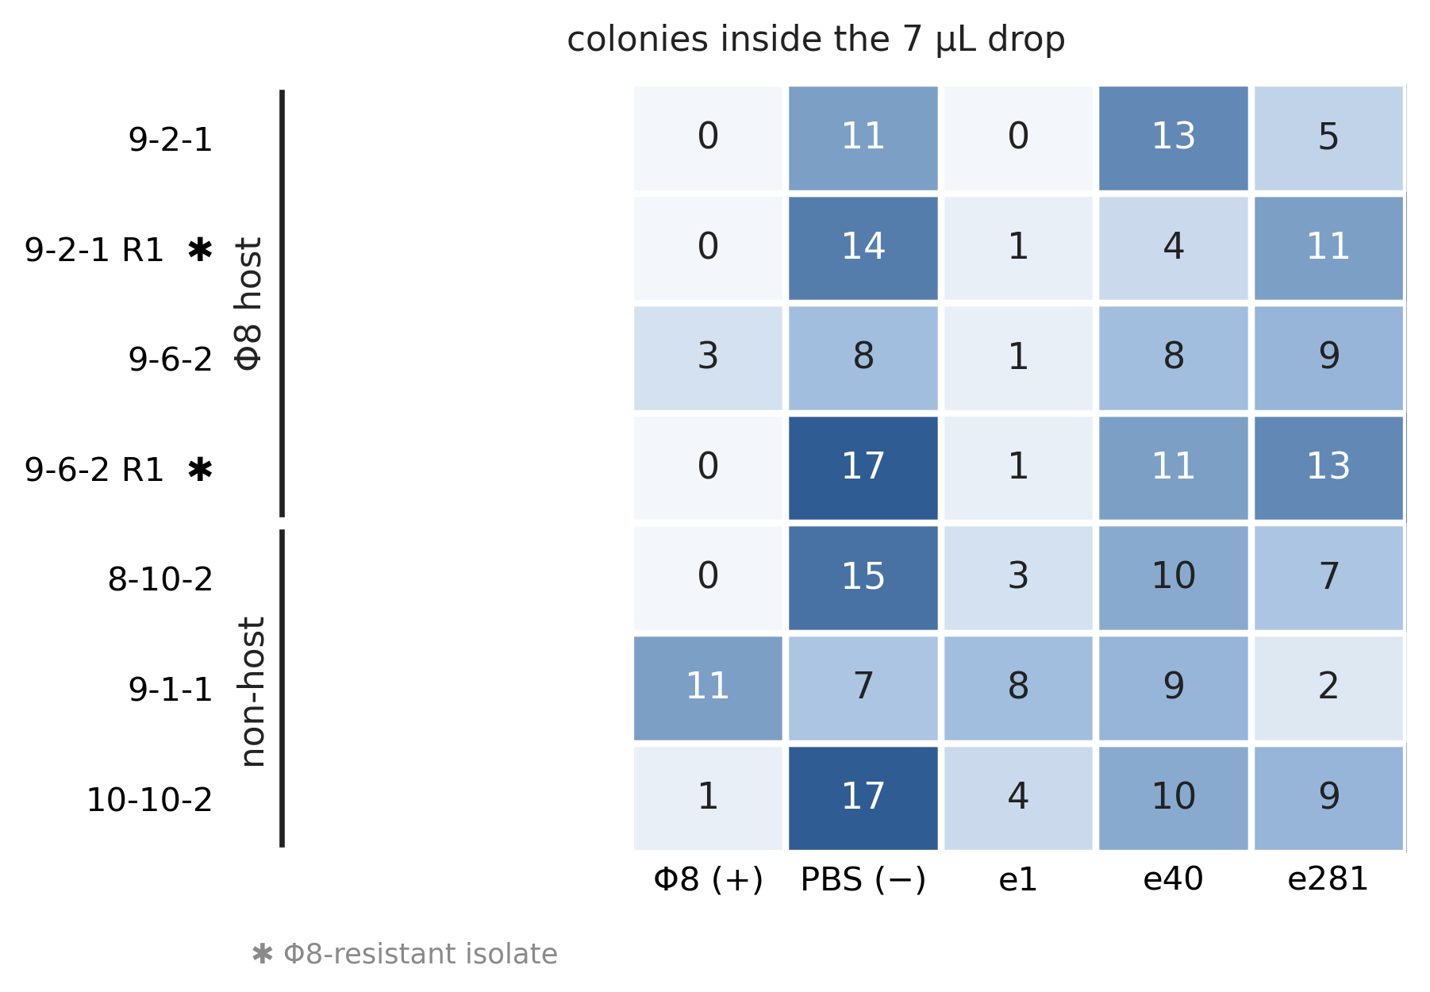
Figure 2. The same spot test, arranged by whether phage Φ8 can infect the strain. Each cell is one 7 µL drop; the number is the colony count inside it and the shading follows that number. Rows are grouped by the host range of Φ8, scored independently in a plaque assay of 18 strains against two Φ8 lysates: 9-2-1 and 9-6-2 are the strains Φ8 was isolated on, while 8-10-2, 9-1-1 and 10-10-2 gave no plaques with either lysate. ✿ marks the two Φ8-resistant isolates picked from the sensitive parents. Sterile PBS gave a high colony count in every row, host and non-host alike (group medians 12.5 and 15), so the baseline does not depend on host range. The e1 preparation suppressed colony growth in every row (group medians 1 and 4), including on strains Φ8 cannot infect and on both resistant isolates. Host range does not separate this data set and the figure should not be read as if it did: Φ8 itself suppressed colonies on two of the three non-hosts, so suppression in this assay does not require infection, and the activity of e1 on non-hosts therefore does not rule out phage carried over into the preparation. Two cells should not be over-read: the 3 counted in the 9-6-2 Φ8 drop are reflections at the drop edge, not colonies, and 9-1-1 is the one strain where the Φ8 drop did not suppress growth (11 colonies), consistent with it being a non-host.
File: Figure 2 - Spot test grouped by phage host range.png / .pdf

Figure 3 — Colony suppression normalised to the PBS control
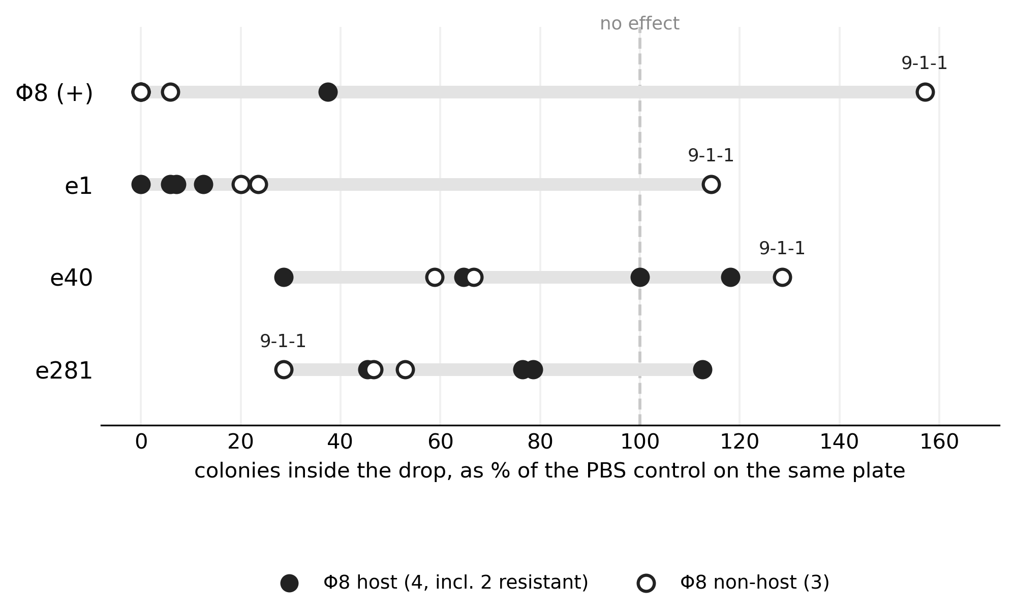
Figure 3. Colony suppression in the spot test, normalised to the sterile-PBS control on the same plate. Every plate carried its own 7 µL sterile-PBS drop, and the colony count in that drop varied between plates (7–17). Each point is one strain, expressed as the colonies in that treatment’s drop as a percentage of the PBS drop on the same plate; 100 % is no effect. Filled points are the four strains Φ8 can infect, two of which are Φ8-resistant isolates; open points are the three strains that gave no plaques with either Φ8 lysate. Phage Φ8 (median 0 %) and the e1 preparation (median 12 %) both suppressed colony growth almost completely, while the crude e40 and e281 lysates stayed near the no-effect line (medians 67 % and 53 %). e1 tracks the phage strain by strain: on six of the seven strains both fall below 40 %, and the single strain where the phage failed — 9-1-1, at 157 % — is also the one strain where e1 failed, at 114 %. That agreement is the strongest signal in this experiment, and it is also the strongest remaining confound, because an activity carried over from the phage stock would behave the same way (see Limitations). This is the figure to show if only one can be shown.
File: Figure 3 - Colony suppression normalised to the PBS control.png / .pdf

Figure S1 — Plate overview with all drops
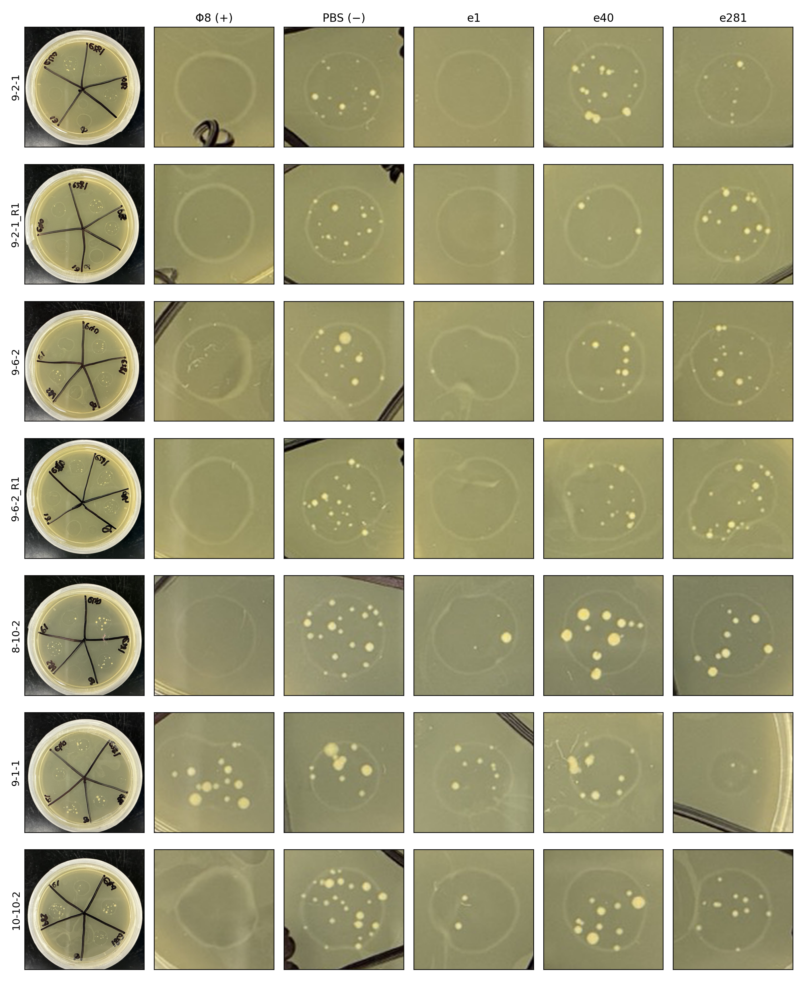
Figure S1. The raw plate photographs behind Figures 1–3. One row per strain: the leftmost panel is the whole plate as photographed on 16 Oct 2026, followed by the five drop regions (Φ8, PBS, e1, e40, e281) cropped and enlarged without colour correction. This panel is the provenance record — every number in Figures 1–3 is counted from these images — and is intended for a supplement rather than the main text.
File: Figure S1 - Plate overview with all drops.png

Figure S2 — Bradford standard curve for the spot-test dilutions
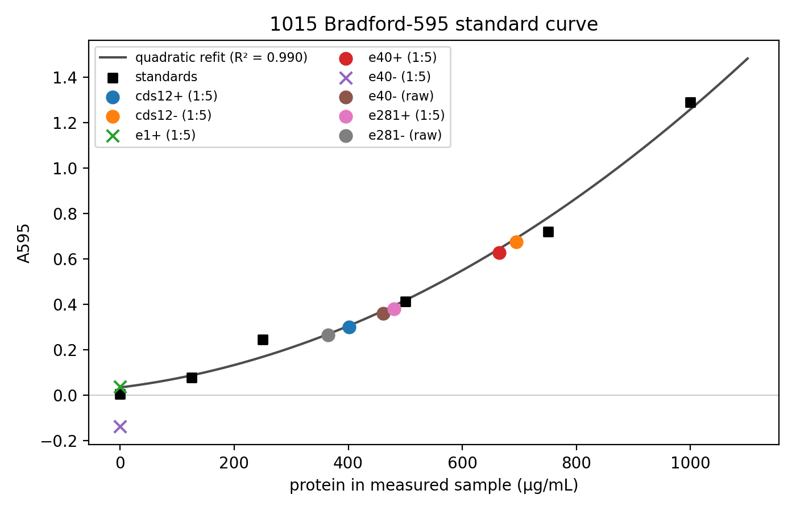
Figure S2. Protein quantification of the samples prepared for the spot test (15 Oct 2026). Bradford assay read at A595; black squares are the BSA standards and the line is a quadratic refit (R² = 0.990), against which the coloured sample points are placed. The curve is shown because it sets what the spot test could and could not control: the induced lysates CDS12+, e40+ and e281+ fell in the usable range of the standard curve (0.36–3.5 mg/mL in the stock), whereas the e1 preparation read at essentially zero protein (green ✕, at the origin), i.e. below the detection limit of this assay. The purified e1 fraction is therefore the sample with the strongest effect in Figures 1–3 and the least measurable protein, which is why its identity and provenance have to be established before any claim rests on it (see Limitations).
File: Figure S2 - Bradford standard curve for the spot-test dilutions.png

Limitations — read before these figures are used
The one thing this data set cannot do is separate a protein activity in the e1 preparation from infectious phage carried over into it. e1 tracks Φ8 strain by strain, including the shared failure on 9-1-1, which is exactly what carried-over phage would look like. The remaining points are secondary to that one.
- No clearing was seen anywhere on these plates, not even for Φ8 on its own parental hosts. The assay therefore reports colony growth inside the drop, not lysis, and says nothing yet about resistance in the R1 isolates.
- No buffer-only control. The e1 drop was 90 % sterile PBS and 10 % preparation, and that 10 % carries its purification buffer, imidazole included. Buffer toxicity remains a live alternative explanation.
- Protein amounts were not equalised between samples, and by Bradford the e1 preparation was at or below the detection floor (Figure S2).
- The 10/19 His-tag dot blot puts all four 1:10 spot-test dilutions at or below background, so the spot test was run with material at or below that blot’s detection floor. In the same blot the e1 rough lysate was one of only two His-positive samples (2.4× the negative control), which is consistent but not independent confirmation.
- No successful purification of e1 is recorded in the notebooks (10/01 purified CDS10 and e40; the 10/10 e281 Ni-NTA run failed). The provenance of that tube has to be established, and ideally the protein confirmed by anti-His western or intact-mass MS, before this figure is published.
- Still no BL21 empty-vector control in any protein assay of this series, so nothing here distinguishes a construct-specific effect from host background.
- CDS12_WT was not spotted on this plate, so the ancestor-versus-modern comparison the design is built on has not yet been made.
- n = 1 plate per strain, one concentration, colonies counted by automated image segmentation. 9-1-1 is a single plate and is labelled in the figures rather than treated as an established exception.
- No written notebook page exists for the spotting day or the photography day (notebook 2 p.09+ has not been photographed); the record is the plate photographs and the analysis notebook.

What would make these figures publishable
Ranked by how much each moves the carryover question.
- Plaque assay on the e1 preparation itself. One plate, one day. Spot an e1 dilution series on a lawn of the sensitive parent 9-2-1 and look for countable plaques. Plaques mean infectious phage and the activity cannot be attributed to the protein; no plaques at a dilution where the Φ8 stock gives a clear titre means the suppression needs another explanation. This gates the interpretation of everything above.
- Elution-buffer drop, diluted 1:10 in the same PBS, to remove buffer toxicity as an alternative.
- Dilution series of e1 (1:10, 1:100, 1:1000). A protein activity should fade in a graded way; a fixed contaminant may not. Also gives a crude potency figure.
- CDS12_WT on the same plate, to make the ancestor-versus-modern comparison the project is designed around.
- Confirm what e1 is — provenance of the tube, then anti-His western or intact-mass MS.
- Φ8 dilution series on the parents, to establish a titre and a visible plaque, which is also the precondition for saying anything about the R1 resistant isolates.

Files in this folder
All figures are in figures/. PNGs are 300 dpi (Figure S1 at 200 dpi); PDFs are vector where the figure allows it.
File name | What it is | Where it came from
Figure 1 - Spot test drops and colony counts.png / .pdf | Drop photographs + colony counts | code/1016_spot_test_result.ipynb §6
Figure 2 - Spot test grouped by phage host range.png / .pdf | Count table grouped by Φ8 host range | code/1016_spot_test_result.ipynb §7
Figure 3 - Colony suppression normalised to the PBS control.png / .pdf | Per-plate normalised suppression | code/1016_spot_test_result.ipynb §8
Figure S1 - Plate overview with all drops.png | Whole plates + drop crops | code/1016_spot_test_result.ipynb
Figure S2 - Bradford standard curve for the spot-test dilutions.png | Protein quantification, 15 Oct 2026 | code/1015_spot_test_dilution.ipynb
Table S1 - Colony counts per drop.tsv | Raw counts behind Figures 1–2 | spot_calls.tsv
Table S2 - Colony counts as percent of PBS control.tsv | Numbers behind Figure 3 | spot_percent_of_pbs.tsv

Document generated 21 Oct 2026 from the repository sources listed above; captions written against code/output/1016_spot_test_result/figure_caption.md.

