We have uploaded the results and deep models to

BaiduYun (<https://pan.baidu.com/s/1u0TZqmmHEzt6TX6Te75VRA>)

and

OneDrive (<https://1drv.ms/u/s!An-BNLJWOCllczROzWOEFZjxrGY?e=4l0OQl> ).

Please download these zipped files and unzip them into the folders ‘results/levin/’. The folder tree is as follows:

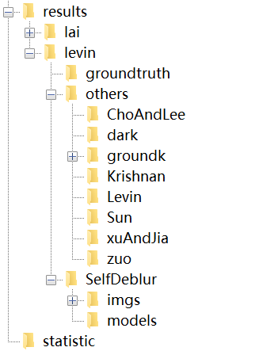

Then you can run ‘statistic/statistic_levin.m’ to compute the metrics reported in the paper.