《JAVA EE开发技术基础》上机实验报告
实验名称 | 实验七 Hibernate应用基础 |  |  | 实验时间 | 2022.5.20-26
学生姓名 | 胡恒宇 | 班级 | 计z1912 | 学号 | 19200135221
指导教师 | 陆悠 | 批阅教师 | 陆悠 | 成绩
一、实验目的
1、熟练掌握Hibernate或MyBatis配置、理解配置文件内容；
2、熟悉反向工程的概念，并能完成反向工程的相关ORMapping操作；
3、掌握Hibernate或MyBatis架构中实体操作与事务管理方法；
4、初步了解应用Hibernate或MyBatis架构技术完成数据库应用项目开发。
5、初步掌握Struts2或SpringMVC与Hibernate或MyBatis集成方法；
二、实验内容
1．根据实验指导书，练习MyEclipse开发环境下的MyBatis开发过程
2．根据实验指导书，完成扩展练习部分的用户信息增删查改的功能

三、实验步骤及实验结果记录
1、根据实验指导，各步骤及结果截图
mybatis依赖
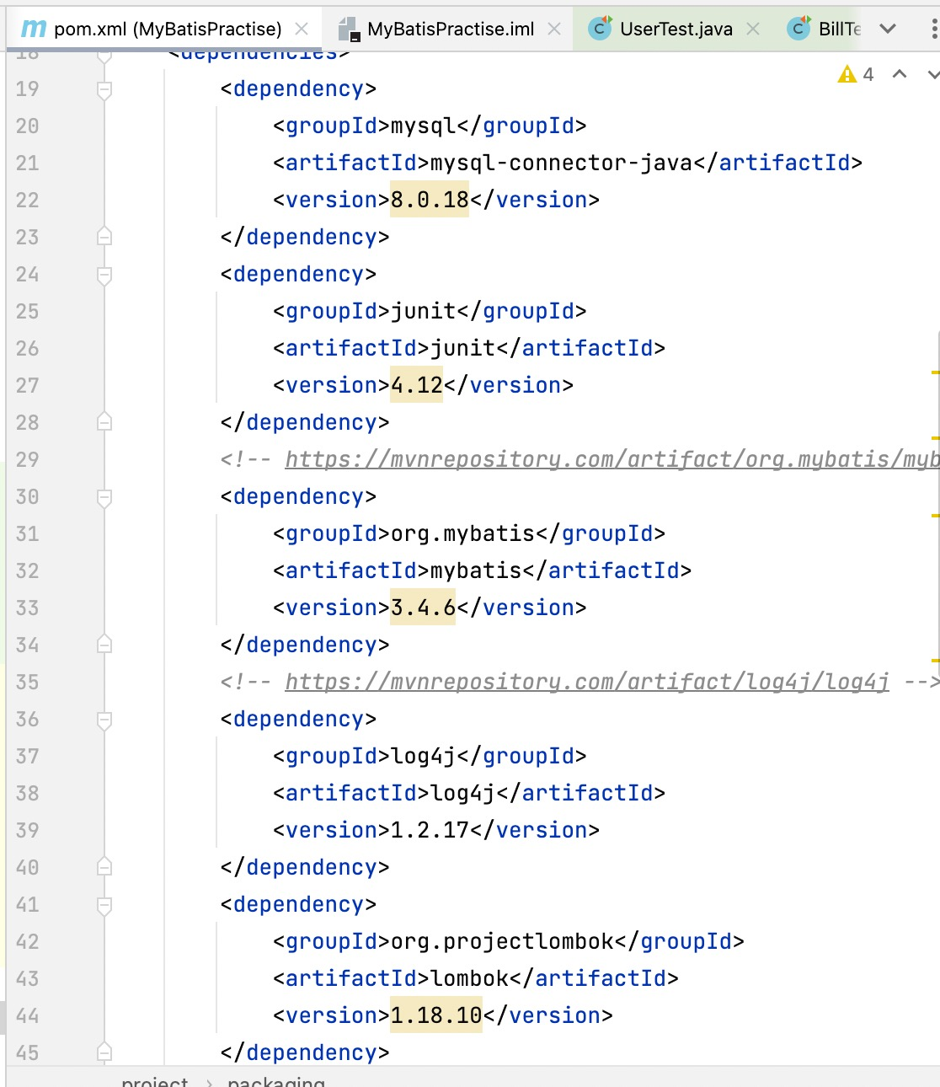
配置数据库文件：dp.properties
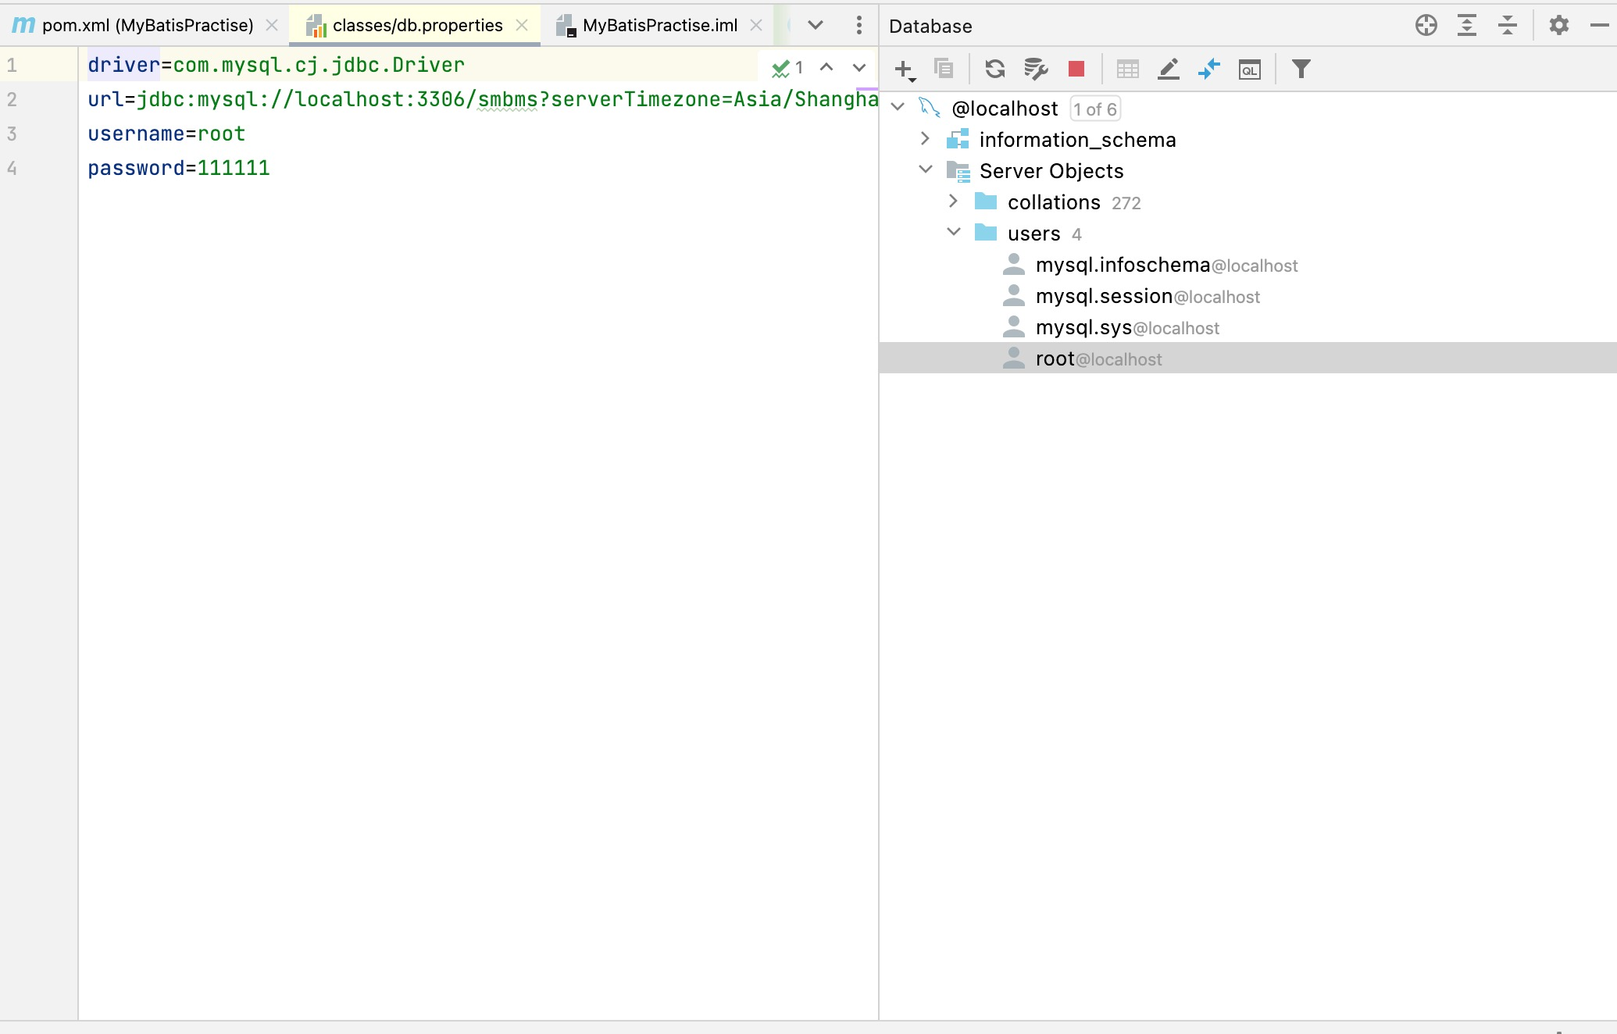
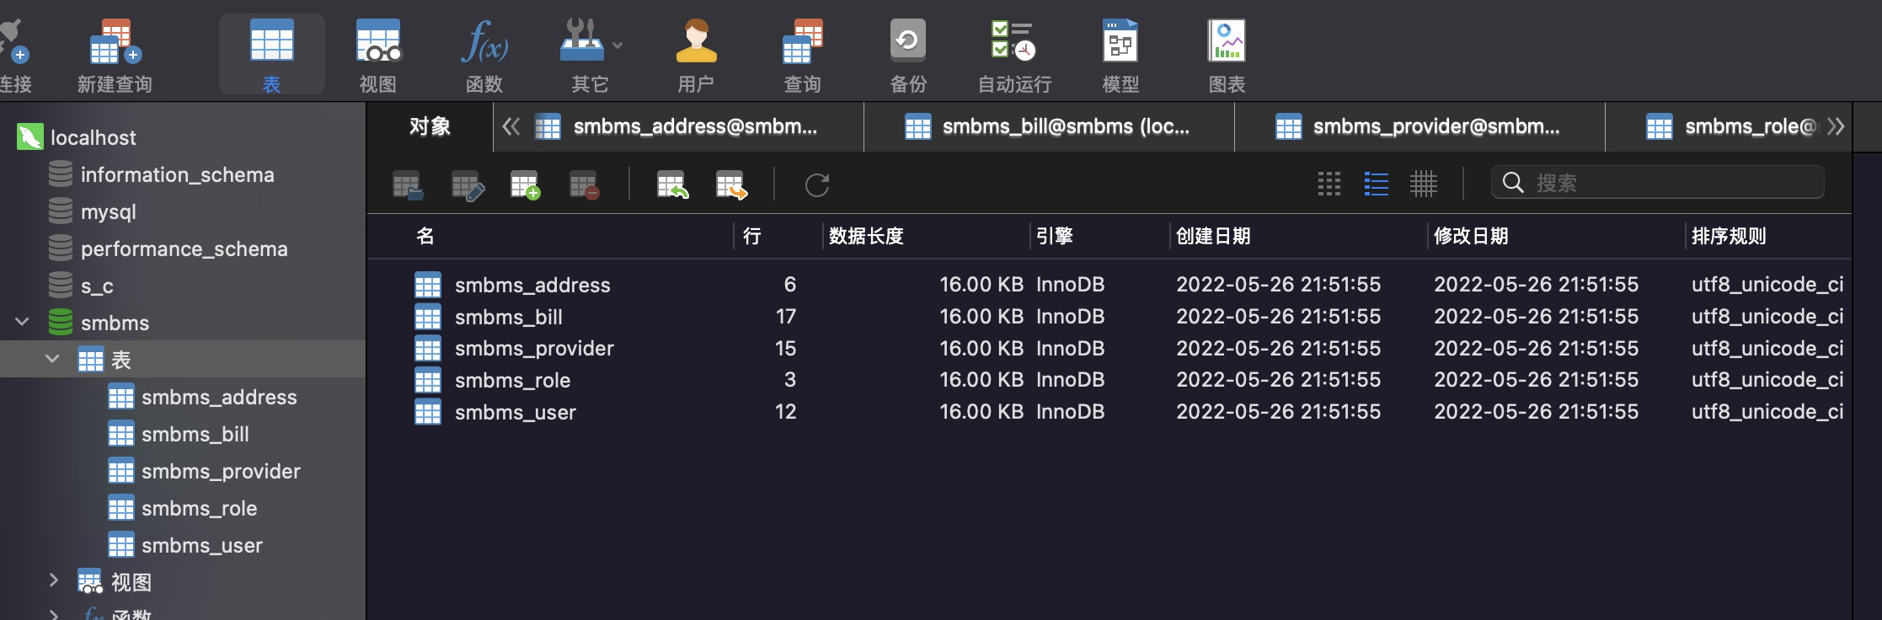
mybatis配置文件:mybatis-config.xml
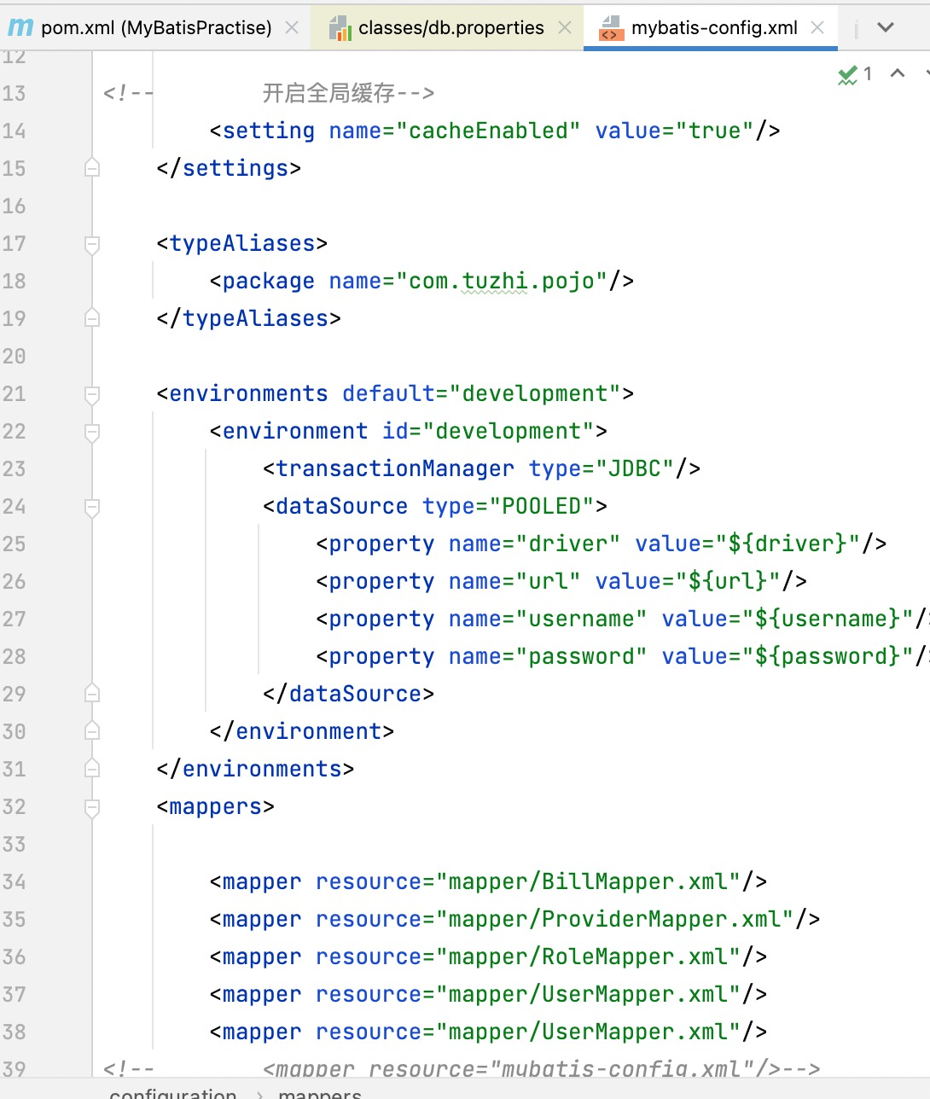
mybatis配置类
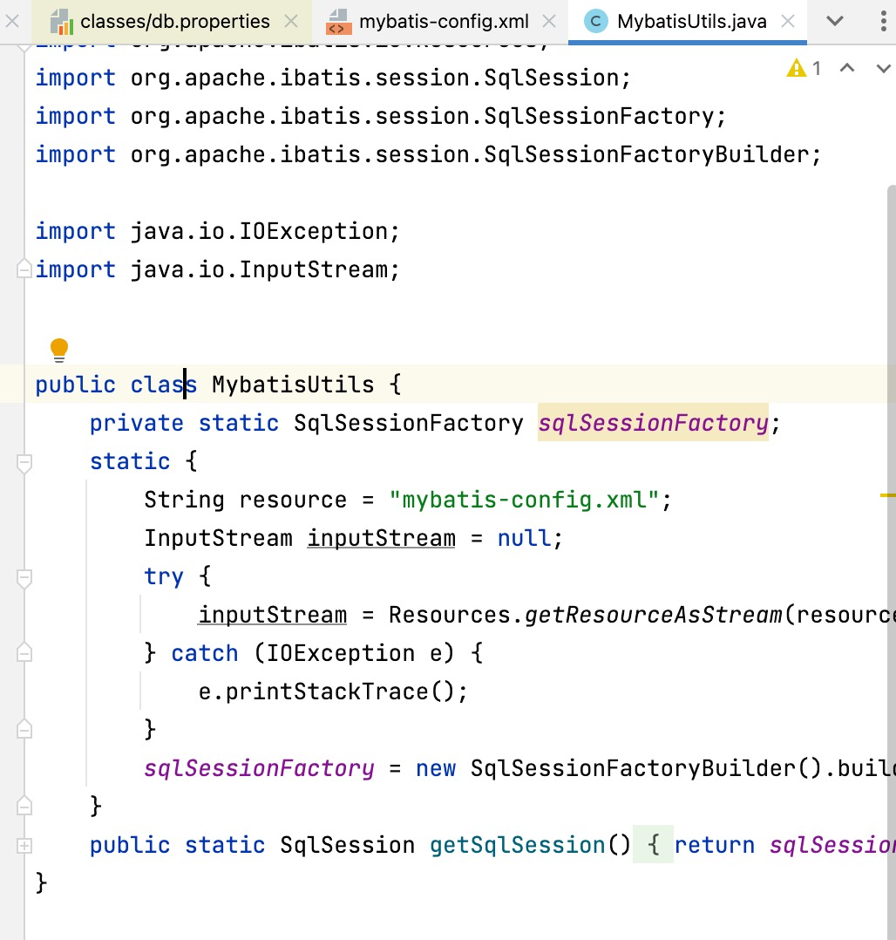
增删查改
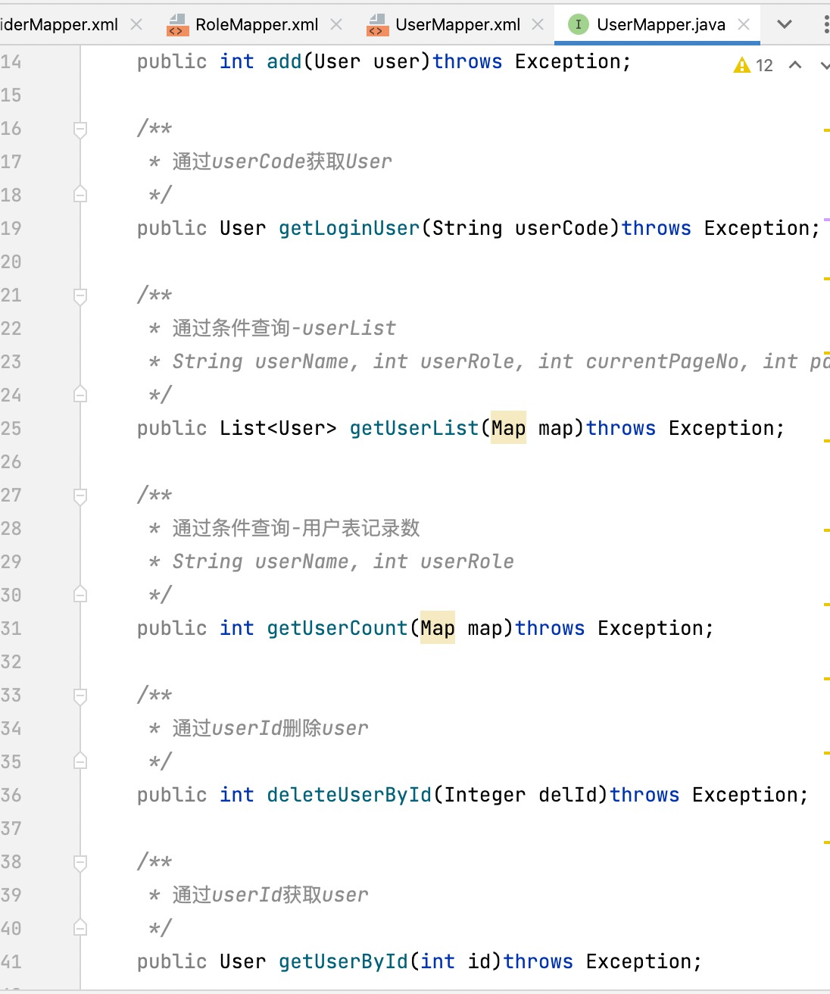
测试
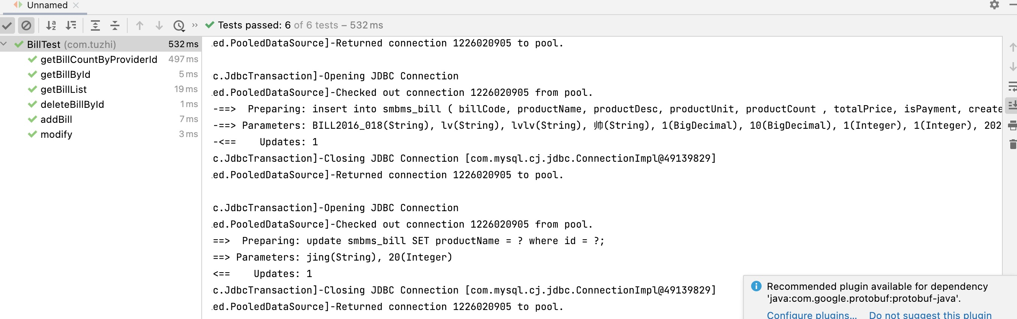
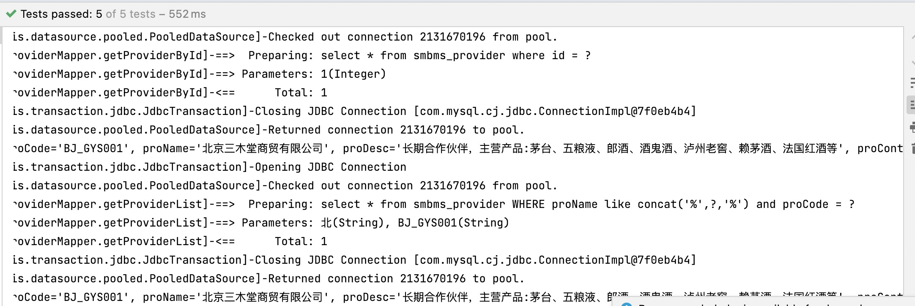
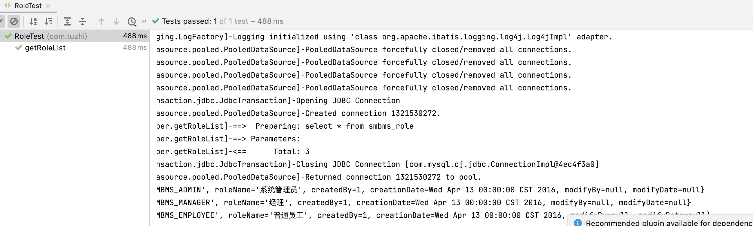
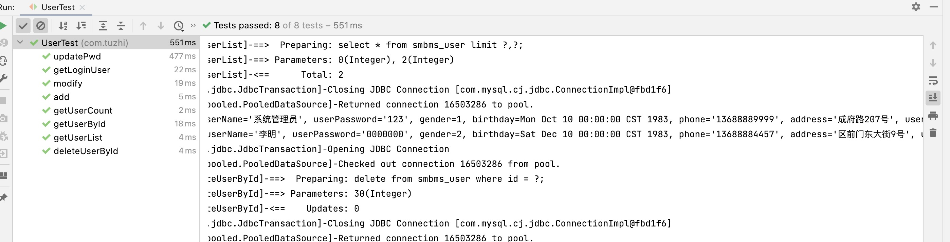

四、知识扩展
1、主码生成策略常见的有哪些？
答：AUTO：数据库ID自增。
NONE：无状态，该类型为未设置主键类型（注解里等于跟随全局，全局里约等于 INPUT)
INPUT: insert 前自行 set 主键值。
ASSIGN_ID: 分配 ID(主键类型为 Number(Long 和 Integer)或 String)(since 3.3.0),使用接口IdentifierGenerator的方法nextId(默认实现类为DefaultIdentifierGenerator雪花算法)
ASSIGN_UUID: 分配 UUID,主键类型为 String(since 3.3.0),使用接口IdentifierGenerator的方法nextUUID(默认 default 方法)。

五、实验总结：
通过本次实验，熟练掌握Hibernate或MyBatis配置、理解配置文件内容；熟悉反向工程的概念，并能完成反向工程的相关ORMapping操作；掌握Hibernate或MyBatis架构中实体操作与事务管理方法；初步了解应用Hibernate或MyBatis架构技术完成数据库应用项目开发。初步掌握Struts2或SpringMVC与Hibernate或MyBatis集成方法；为下步学习打下基础。

六、核心源代码（详细代码见电子文档）
BillTest
import com.tuzhi.pojo.Bill;
import com.tuzhi.service.bill.BillServiceImpl;
import org.junit.Test;
import java.math.BigDecimal;
import java.util.Date;
import java.util.List;
public class BillTest {
@Test
public void addBill() {
BillServiceImpl billService = new BillServiceImpl();
Bill bill = new Bill();
bill.setBillCode("BILL2016_018");
bill.setProductName("lv");
bill.setProductDesc("lvlv");
bill.setProductUnit("帅");
bill.setProductCount(new BigDecimal(1));
bill.setTotalPrice(new BigDecimal(10));
bill.setIsPayment(1);
bill.setCreatedBy(1);
bill.setCreationDate(new Date());
bill.setProviderId(1);
int i = billService.addBill(bill);
System.out.println(i);
}
@Test
public void getBillList() {
BillServiceImpl billService = new BillServiceImpl();
Bill bill = new Bill();
bill.setProductName("皂");
bill.setProviderId(1);
bill.setIsPayment(1);
List<Bill> billList = billService.getBillList(bill);
for (Bill bill1 : billList) {
System.out.println(bill1);
}
}
@Test
public void deleteBillById() {
BillServiceImpl billService = new BillServiceImpl();
int i = billService.deleteBillById(18);
System.out.println(i);
}
@Test
public void getBillById() {
BillServiceImpl billService = new BillServiceImpl();
Bill billById = billService.getBillById(20);
System.out.println(billById);
}
@Test
public void modify() {
BillServiceImpl billService = new BillServiceImpl();
Bill bill = new Bill();
bill.setId(20);
bill.setProductName("jing");
int modify = billService.modify(bill);
System.out.println(modify);
}
@Test
public void getBillCountByProviderId() {
BillServiceImpl billService = new BillServiceImpl();
int billCountByProviderId = billService.getBillCountByProviderId(1);
System.out.println(billCountByProviderId);
}
}

ProvviderTest
import com.tuzhi.pojo.Provider;
import com.tuzhi.service.provider.ProviderServiceImpl;
import org.junit.Test;
import java.util.Date;
import java.util.HashMap;
import java.util.List;
public class ProviderTest {
@Test
public void add() {
ProviderServiceImpl providerService = new ProviderServiceImpl();
Provider provider = new Provider();
provider.setProCode("BJ_GYS001");
provider.setProName("lv");
provider.setProDesc("lvlv");
provider.setProContact("llll");
provider.setProPhone("11111111111");
provider.setProAddress("lll");
provider.setProFax("010-58858787");
provider.setCreatedBy(1);
provider.setCreationDate(new Date());
int add = providerService.add(provider);
System.out.println(add);
}
@Test
public void getProviderList() {
ProviderServiceImpl providerService = new ProviderServiceImpl();
HashMap hashMap = new HashMap();
hashMap.put("proCode","BJ_GYS001");
hashMap.put("proName","北");
List<Provider> providerList = providerService.getProviderList(hashMap);
for (Provider provider : providerList) {
System.out.println(provider);
}
}
@Test
public void deleteProviderById() {
ProviderServiceImpl providerService = new ProviderServiceImpl();
int i = providerService.deleteProviderById(16);
System.out.println(i);
}
@Test
public void getProviderById() {
ProviderServiceImpl providerService = new ProviderServiceImpl();
Provider providerById = providerService.getProviderById(1);
System.out.println(providerById);
}
@Test
public void modifyBy() {
ProviderServiceImpl providerService = new ProviderServiceImpl();
Provider provider = new Provider();
provider.setId(1);
provider.setModifyDate(new Date());
int modify = providerService.modify(provider);
System.out.println(modify);
}
}

RoleTest
import com.tuzhi.pojo.Role;
import com.tuzhi.service.provider.ProviderServiceImpl;
import com.tuzhi.service.role.RoleServiceImpl;
import org.junit.Test;
import java.util.List;
public class RoleTest {
@Test
public void getRoleList() {
RoleServiceImpl roleService = new RoleServiceImpl();
List<Role> roleList = roleService.getRoleList();
for (Role role : roleList) {
System.out.println(role);
}
}
}

UserTest
import com.tuzhi.dao.UserMapper;
import com.tuzhi.pojo.User;
import com.tuzhi.service.user.UserServiceImpl;
import com.tuzhi.utils.MybatisUtils;
import org.apache.ibatis.session.SqlSession;
import org.junit.Test;
import java.util.Date;
import java.util.HashMap;
import java.util.List;
import java.util.Map;
public class UserTest{
@Test
public void getLoginUser() {
UserServiceImpl userService = new UserServiceImpl();
User admin = userService.getLoginUser("admin");
System.out.println(admin);
}
@Test
public void add() {
UserServiceImpl userService = new UserServiceImpl();
User user = new User();
user.setUserCode("lv");
user.setUserName("lv");
user.setUserPassword("123456789");
user.setGender(1);
user.setBirthday(new Date());
user.setPhone("11111111111");
user.setAddress("a");
user.setUserRole(2);
user.setCreatedBy(1);
user.setCreationDate(new Date());
int add = userService.add(user);
System.out.println(add);
}
@Test
public void getUserList() throws Exception{
UserServiceImpl userService = new UserServiceImpl();
HashMap hashMap = new HashMap();
// hashMap.put("userName","lv");
hashMap.put("currentPageNo",0);
hashMap.put("pageSize",2);
List<User> userList = userService.getUserList(hashMap);
for (User user : userList) {
System.out.println(user);
}
}
@Test
public void getUserCount() throws Exception {
UserServiceImpl userService = new UserServiceImpl();
HashMap hashMap = new HashMap();
hashMap.put("userName","admin");
hashMap.put("userRole",1);
int userCount = userService.getUserCount(hashMap);
System.out.println(userCount);
}
@Test
public void deleteUserById() throws Exception {
UserServiceImpl userService = new UserServiceImpl();
int i = userService.deleteUserById(30);
System.out.println(i);
}
@Test
public void getUserById() throws Exception {
UserServiceImpl userService = new UserServiceImpl();
User userById = userService.getUserById(1);
System.out.println(userById);
}
@Test
public void modify() throws Exception {
UserServiceImpl userService = new UserServiceImpl();
HashMap hashMap = new HashMap();
hashMap.put("id",1);
hashMap.put("userPassword",123);
int modify = userService.modify(hashMap);
System.out.println(modify);
}
@Test
public void updatePwd() throws Exception {
UserServiceImpl userService = new UserServiceImpl();
User user = new User();
user.setId(1);
user.setUserPassword("123456");
int i = userService.updatePwd(user);
System.out.println(i);
}
}

