苏州科技大学
电子信息与智能化实验中心

《移动互联网开发技术》

实 验 报 告

实验五：高级 UI

学 院： 电子与信息工程学院
专 业： 计算机科学与技术
班级学号：计算机1912班19200135221
学生姓名： 胡恒宇
指导老师： 张战成

实验日期： 2022.05.12 成绩评定：____________
实验名称： | 高级 UI
实验内容：
实现一个班级名单的列表视图
1. 每个列表项包含：个人照片，学号和姓名，电话；
2. 可以删除列表项，添加列表项；
3. 可以从列表项拨打对应的电话号码。
实验目的：
深入学习Fragment的用法，自定义列表视图的实现。
实验：

fragment_list.xml
<?xml version="1.0" encoding="utf-8"?>
<androidx.constraintlayout.widget.ConstraintLayout xmlns:android="http://schemas.android.com/apk/res/android"
xmlns:app="http://schemas.android.com/apk/res-auto"
xmlns:tools="http://schemas.android.com/tools"
android:layout_width="match_parent"
android:layout_height="match_parent"
android:orientation="vertical"
tools:context=".FragmentList">

<EditText
android:id="@+id/edit_id"
android:layout_width="wrap_content"
android:layout_height="35dp"
android:layout_marginStart="60dp"
android:layout_marginTop="16dp"
android:ems="10"
android:hint="请输入学号"
android:inputType="text"
android:textSize="13sp"
app:layout_constraintStart_toStartOf="parent"
app:layout_constraintTop_toTopOf="parent" />

<EditText
android:id="@+id/edit_name"
android:layout_width="wrap_content"
android:layout_height="35dp"
android:layout_marginTop="8dp"
android:ems="10"
android:hint="请输入姓名"
android:inputType="text"
android:textSize="13sp"
app:layout_constraintStart_toStartOf="@+id/edit_id"
app:layout_constraintTop_toBottomOf="@+id/edit_id" />

<EditText
android:id="@+id/edit_tel"
android:layout_width="wrap_content"
android:layout_height="35dp"
android:layout_marginTop="8dp"
android:ems="10"
android:hint="请输入手机号"
android:inputType="text"
android:textSize="13sp"
app:layout_constraintStart_toStartOf="@+id/edit_name"
app:layout_constraintTop_toBottomOf="@+id/edit_name" />

<ImageView
android:id="@+id/image_stu"
android:layout_width="84dp"
android:layout_height="65dp"
android:layout_marginTop="16dp"
android:layout_marginEnd="60dp"
android:src="@drawable/ls"
app:layout_constraintEnd_toEndOf="parent"
app:layout_constraintHorizontal_bias="1.0"
app:layout_constraintStart_toEndOf="@+id/edit_name"
app:layout_constraintTop_toTopOf="parent" />

<Button
android:id="@+id/btn_commit"
android:layout_width="wrap_content"
android:layout_height="wrap_content"
android:layout_marginTop="12dp"
android:text="添加"
app:layout_constraintStart_toStartOf="@+id/image_stu"
app:layout_constraintTop_toBottomOf="@+id/image_stu" />

<androidx.appcompat.widget.AppCompatImageButton
android:id="@+id/btn_id"
android:layout_width="35dp"
android:layout_height="35dp"
android:layout_marginStart="16dp"
android:layout_marginTop="16dp"
android:adjustViewBounds="true"
android:background="@android:drawable/btn_star_big_on"
android:scaleType="fitXY"
android:text="学号"
app:layout_constraintStart_toStartOf="parent"
app:layout_constraintTop_toTopOf="parent" />

<androidx.appcompat.widget.AppCompatImageButton
android:id="@+id/btn_name"
android:layout_width="35dp"
android:layout_height="35dp"
android:layout_marginTop="60dp"
android:adjustViewBounds="true"
android:background="@drawable/stu"
android:scaleType="fitXY"
android:text="姓名"
app:layout_constraintStart_toStartOf="@+id/btn_id"
app:layout_constraintTop_toTopOf="parent" />

<androidx.appcompat.widget.AppCompatImageButton
android:id="@+id/btn_phone"
android:layout_width="35dp"
android:layout_height="35dp"
android:layout_marginTop="100dp"
android:adjustViewBounds="true"
android:background="@android:drawable/sym_action_call"
android:scaleType="fitXY"
android:text="手机号"
app:layout_constraintStart_toStartOf="@+id/btn_name"
app:layout_constraintTop_toTopOf="parent" />

<androidx.recyclerview.widget.RecyclerView
android:id="@+id/rcv_stu"
android:layout_width="match_parent"
android:layout_height="592dp"
android:layout_marginTop="8dp"
app:layout_constraintTop_toBottomOf="@+id/btn_commit"
tools:layout_editor_absoluteX="0dp" />

</androidx.constraintlayout.widget.ConstraintLayout>

list_item_layout.xml
<?xml version="1.0" encoding="utf-8"?>
<androidx.constraintlayout.widget.ConstraintLayout xmlns:android="http://schemas.android.com/apk/res/android"
xmlns:app="http://schemas.android.com/apk/res-auto"
xmlns:tools="http://schemas.android.com/tools"
android:layout_width="match_parent"
android:layout_height="90dp">

<ImageView
android:id="@+id/imageView"
android:layout_width="86dp"
android:layout_height="66dp"
android:layout_marginStart="28dp"
android:layout_marginTop="12dp"
android:src="@drawable/ls"
app:layout_constraintStart_toStartOf="parent"
app:layout_constraintTop_toTopOf="parent" />

<TextView
android:id="@+id/tv_id"
android:layout_width="96dp"
android:layout_height="21dp"
android:layout_marginStart="40dp"
android:text="学号"
app:layout_constraintStart_toEndOf="@+id/imageView"
app:layout_constraintTop_toTopOf="@+id/imageView"
tools:ignore="MissingConstraints" />

<TextView
android:id="@+id/tv_name"
android:layout_width="96dp"
android:layout_height="20dp"
android:text="姓名"
app:layout_constraintBottom_toTopOf="@+id/tv_tel"
app:layout_constraintEnd_toEndOf="@+id/tv_id"
app:layout_constraintStart_toStartOf="@+id/tv_id"
app:layout_constraintTop_toBottomOf="@+id/tv_id"
tools:ignore="MissingConstraints" />

<TextView
android:id="@+id/tv_tel"
android:layout_width="96dp"
android:layout_height="20dp"
android:text="手机号"
app:layout_constraintBottom_toBottomOf="@+id/imageView"
app:layout_constraintEnd_toEndOf="@+id/tv_name"
app:layout_constraintStart_toStartOf="@+id/tv_name" />

<androidx.appcompat.widget.AppCompatImageButton
android:id="@+id/btn_delete"
android:layout_width="56dp"
android:layout_height="46dp"
android:layout_marginStart="176dp"
android:text="删除"
app:layout_constraintBottom_toBottomOf="@+id/tv_tel"
app:layout_constraintEnd_toEndOf="parent"
app:layout_constraintHorizontal_bias="0.184"
app:layout_constraintStart_toEndOf="@+id/imageView"
app:layout_constraintTop_toTopOf="@+id/tv_id"
app:srcCompat="@android:drawable/btn_dialog" />

</androidx.constraintlayout.widget.ConstraintLayout>
FragmentList
package com.suke.recyclerstudent;

import android.content.Intent;
import android.net.Uri;
import android.os.Bundle;
import android.util.Log;
import android.view.LayoutInflater;
import android.view.View;
import android.view.ViewGroup;
import android.widget.Button;
import android.widget.EditText;
import android.widget.ImageButton;
import android.widget.ImageView;
import android.widget.TextView;

import androidx.annotation.NonNull;
import androidx.annotation.Nullable;
import androidx.fragment.app.Fragment;
import androidx.recyclerview.widget.LinearLayoutManager;
import androidx.recyclerview.widget.RecyclerView;

import java.util.ArrayList;
import java.util.List;
import java.util.Random;

public class FragmentList extends Fragment {

//控制台打印提示
private final String TagCreate = "create";
private final String TagDelete = "delete";
//创建学生信息列表
private List<Student> list_stu = new ArrayList<>();
//学号、姓名、手机号
private EditText editId;
private EditText editName;
private EditText editTel;
private ImageView imageView;
//添加学生信息按钮
private Button btnCommit;

private StudentAdapter studentAdapter;
//学生信息视图列表
private RecyclerView rcvStu;

String[] ids = new String[]{"19200135221", "19200135222", "19200135223", "19200135224", "19200135225", "19200135226"};
String[] names = new String[]{"书启秋枫", "Gaze", "无羡", "阿斌", "家和万事兴", "石业大帝"};
String[] tels = new String[]{"15312133001", "153121330012", "153121330013", "153121330014", "153121330015", "153121330016"};
int[] images = new int[]{R.drawable.ls, R.drawable.cc, R.drawable.mr, R.drawable.zb, R.drawable.zjh, R.drawable.lishuo};

@Override
public void onCreate(Bundle savedInstanceState) {
super.onCreate(savedInstanceState);
setRetainInstance(true);
}

@Nullable
@Override
public View onCreateView(@NonNull LayoutInflater inflater, @Nullable ViewGroup container, @Nullable Bundle savedInstanceState) {
//1.获取fragment_list视图
View view = inflater.inflate(R.layout.fragment_list, container, false);
//2.初始化视图
initView(view);
//3.初始化数据
initData();
//4.返回视图
return view;
}

//2.初始化视图
private void initView(View view) {
editId = view.findViewById(R.id.edit_id);
editName = view.findViewById(R.id.edit_name);
editTel = view.findViewById(R.id.edit_tel);
btnCommit = view.findViewById(R.id.btn_commit);
rcvStu = view.findViewById(R.id.rcv_stu);
imageView = view.findViewById(R.id.image_stu);

//设置 recyclerview 显示布局
LinearLayoutManager linearLayoutManager = new LinearLayoutManager(getContext());
rcvStu.setLayoutManager(linearLayoutManager);

//选择随机头像
final int[] random = {0};
imageView.setOnClickListener(new View.OnClickListener() {
@Override
public void onClick(View view) {
random[0] = new Random().nextInt(6);
imageView.setImageResource(images[random[0]]);
}
});

//添加学生信息(lambda表达式)
btnCommit.setOnClickListener(v -> {
String id = editId.getText().toString();
String name = editName.getText().toString();
String tel = editTel.getText().toString();
editId.setText("");
editName.setText("");
editTel.setText("");
list_stu.add(new Student(id, name, tel, random[0]));
Log.e(TagCreate, "学生创建成功");
studentAdapter.notifyDataSetChanged();
});
}

//3.初始化数据
private void initData() {
for (int i = 0; i < 6; i++) {
Student student = new Student(ids[i], names[i], tels[i], i);
list_stu.add(student);
studentAdapter = new StudentAdapter();
rcvStu.setAdapter(studentAdapter);
}
}

private class StudentAdapter extends RecyclerView.Adapter<StudentAdapter.MyViewHolder> {

@NonNull
@Override
public MyViewHolder onCreateViewHolder(@NonNull ViewGroup parent, int viewType) {
View view = View.inflate(getContext(), R.layout.list_item_layout, null);
return new MyViewHolder(view);
}

@Override
public void onBindViewHolder(@NonNull MyViewHolder holder, int position) {
holder.tvId.setText(list_stu.get(position).getSno());
holder.tvName.setText(list_stu.get(position).getSname());
holder.tvTel.setText(list_stu.get(position).getStele());
holder.imageView.setImageResource(images[list_stu.get(position).getImageId()]);

//拨打电话(隐式调用)
holder.tvTel.setOnClickListener(v -> {
String tel = list_stu.get(position).getStele();
//传入两个参数(一个是拨号盘，一个是电话号)
Intent intent = new Intent(Intent.ACTION_DIAL, Uri.parse("tel:" + tel));
//实例化之后startActivity执行
startActivity(intent);
});

//切换随机头像
holder.imageView.setOnClickListener(v -> {
Random random = new Random();
holder.imageView.setImageResource(images[random.nextInt(6)]);
});

//删除学生信息
holder.btnDelete.setOnClickListener(v -> {
list_stu.remove(position);
studentAdapter.notifyDataSetChanged();
Log.e(TagDelete, "学生已删除");
});
}

//RecyclerView视图列表展示数量
@Override
public int getItemCount() {
//判断是否为空
return list_stu == null ? 0 : list_stu.size();
}

public class MyViewHolder extends RecyclerView.ViewHolder {
//学号、姓名、手机号
private TextView tvId;
private TextView tvName;
private TextView tvTel;
//学生头像
private ImageView imageView;
//删除学生
private ImageButton btnDelete;

public MyViewHolder(@NonNull View itemView) {
super(itemView);
tvId = itemView.findViewById(R.id.tv_id);
tvName = itemView.findViewById(R.id.tv_name);
tvTel = itemView.findViewById(R.id.tv_tel);
imageView = itemView.findViewById(R.id.imageView);
btnDelete = itemView.findViewById(R.id.btn_delete);
}
}
}
}
MainActivity
package com.suke.recyclerstudent;

import android.os.Bundle;

import androidx.appcompat.app.AppCompatActivity;
import androidx.fragment.app.Fragment;
import androidx.fragment.app.FragmentManager;

public class MainActivity extends AppCompatActivity {

@Override
protected void onCreate(Bundle savedInstanceState) {
super.onCreate(savedInstanceState);
setContentView(R.layout.activity_main);
FragmentManager fm = getSupportFragmentManager();
Fragment fragment = fm.findFragmentById(R.id.fragment_list);
if (fragment == null) {
fragment = new FragmentList();
fm.beginTransaction()
.add(R.id.fragment_list, fragment)
.commit();
}
}
}
Student
package com.suke.recyclerstudent;

public class Student {
private String Sno;
private String Sname;
private String Stele;
private int imageId;

public Student(String sno, String sname, String stele, int imageId) {
Sno = sno;
Sname = sname;
Stele = stele;
this.imageId = imageId;
}

public String getSno() {
return Sno;
}

public void setSno(String sno) {
Sno = sno;
}

public String getSname() {
return Sname;
}

public void setSname(String sname) {
Sname = sname;
}

public String getStele() {
return Stele;
}

public void setStele(String stele) {
Stele = stele;
}

public int getImageId() {
return imageId;
}

public void setImageId(int imageId) {
this.imageId = imageId;
}
}
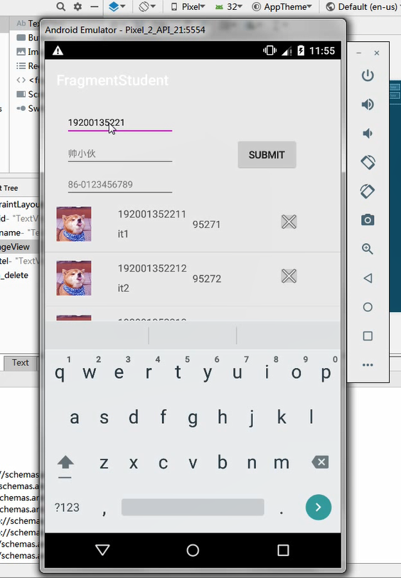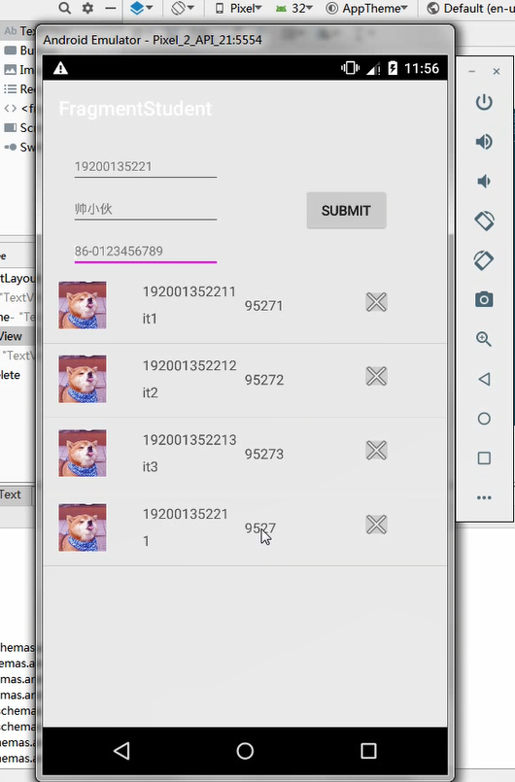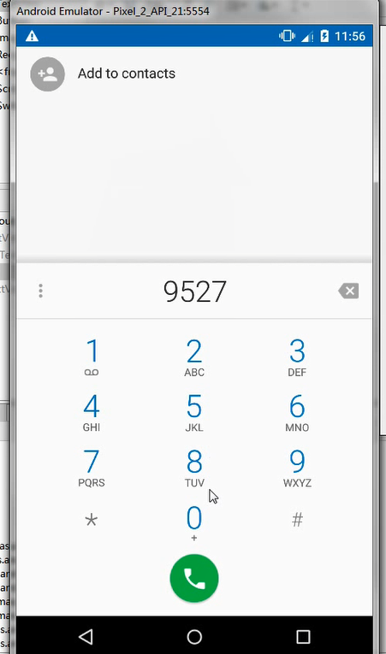

心得体会：
通过此次实验，深入学习了解Fragment的用法，自定义列表视图的实现。

