苏州科技大学
电子信息与智能化实验中心

《移动互联网开发技术》

实 验 报 告

实验六：SQLite

学 院： 电子与信息工程学院
专 业： 计算机科学与技术
班级学号：计算机1912班19200135221
学生姓名： 胡恒宇
指导老师： 张战成

实验日期： 2022.05.12 成绩评定：____________
实验名称： | SQLite
实验内容：
将班级名单以SQLite的方式保存在本地
1. 每个列表项包含：学号和姓名，电话；
2. 可以删除列表项，添加列表项（数据更新到SQLite数据库）；
3. 可以读取联系人(使用内容提供者)，将联系人的名字和电话号码读入到名单列表并插入数据库；
4. 支持在新的页面中学号和姓名，电话。
实验目的：
SQLite数据存储和访问。
实验：
UseDatabase
public class UseDatabase {
Context context;
DatabaseHelper dbhelper;
public SQLiteDatabase sqlitedatabase;

public UseDatabase(Context context) {
super();
this.context = context;
}

//打开数据库连接
public void opendb(Context context) {
dbhelper = new DatabaseHelper(context);
sqlitedatabase = dbhelper.getWritableDatabase();
}

//关闭数据库连接
public void closedb(Context context) {
if (sqlitedatabase.isOpen()) {
sqlitedatabase.close();
}
}
//查询数据库
@RequiresApi(api = Build.VERSION_CODES.N)
@SuppressLint("Range")
public List<User> select() {
ArrayList<User> users = new ArrayList<>();
try {
opendb(context);
String sql = "SELECT * FROM user";
Cursor c = sqlitedatabase.rawQuery(sql, null);
System.out.println("开始查询");
if(c!=null) {
while (c.moveToNext()) {
User user = new User();
user.setSno(c.getString(c.getColumnIndex("sno")));
user.setSname(c.getString(c.getColumnIndex("sname")));
user.setStele(c.getString(c.getColumnIndex("stele")));
users.add(user);
}
}
System.out.println("查询到的是=================");
users.forEach(System.out::println);
} catch (Exception e) {
e.printStackTrace();
}finally {
closedb(context);
}
return users;
}

//插入表数据
@RequiresApi(api = Build.VERSION_CODES.N)
public void insert(String table_name, ContentValues values) {
opendb(context);
sqlitedatabase.insert(table_name, null, values);
System.out.println("插入成功");
select();
closedb(context);
}

//更新数据
public int updatatable(String table_name, ContentValues values, int ID) {
opendb(context);
return sqlitedatabase.update(table_name, values, " Type_ID = ? ", new String[]{String.valueOf(ID)});
}

//删除表数据
@RequiresApi(api = Build.VERSION_CODES.N)
public void delete(String table_name, String sno) {
opendb(context);
try {
String[] snoArr = new String[1];
snoArr[0] = sno;
sqlitedatabase.delete(table_name, "sno", snoArr);
System.out.println("删除成功");
select();
} catch (Exception e) {
e.printStackTrace();
} finally {
closedb(context);
}
}
}
DatabaseHelper
public class DatabaseHelper extends SQLiteOpenHelper {

private static final int DATABASE_VERSION = 1; //数据库版本号

private static final String DATABASE_NAME = "Test"; //数据库名称

public DatabaseHelper(Context context) {
super(context, DATABASE_NAME, null, DATABASE_VERSION);
}

@Override
public void onCreate(SQLiteDatabase db) {
String sqldept = "create table user(sno String PRIMARY KEY, sname text, stele text)";
db.execSQL(sqldept);
System.out.println("数据库创建成功");
}

@Override
public void onUpgrade(SQLiteDatabase sqLiteDatabase, int i, int i1) {

}
}
ListFragment
public class ListFragment extends Fragment {
private List<User> list_stu = new ArrayList<>();
private StudentAdapter adapter;
private EditText editId;
private EditText editName;
private EditText editTel;
private Button btnCommit;
private ListView lvStu;
private Context context;

public ListFragment(MainActivity mainActivity) {
context = mainActivity;
}

@Override
public void onCreate(Bundle savedInstanceState) {
super.onCreate(savedInstanceState);
setRetainInstance(true);
}

@RequiresApi(api = Build.VERSION_CODES.N)
@Nullable
@Override
public View onCreateView(@NonNull LayoutInflater inflater, @Nullable ViewGroup container, @Nullable Bundle savedInstanceState) {
View view = inflater.inflate(R.layout.fragment_list, container, false);
initView(view);
initData();
return view;
}

//初始化数据
@RequiresApi(api = Build.VERSION_CODES.N)
private void initData() {
//查询数据库
UseDatabase dao = new UseDatabase(context);
List<User> selectis = dao.select();
for (User selecti : selectis) {
list_stu.add(selecti);
}
// for (int i = 1; i < 2; i++) {
// list_stu.add(new User("0" + i, "小" + i, "1530690372" + i));
// }
adapter = new StudentAdapter();
lvStu.setAdapter(adapter);

}

//增加操作
@RequiresApi(api = Build.VERSION_CODES.N)
private void initView(View view) {
editId = (EditText) view.findViewById(R.id.edit_id);
editName = (EditText) view.findViewById(R.id.edit_name);
editTel = (EditText) view.findViewById(R.id.edit_tel);
//增加组件
btnCommit = (Button) view.findViewById(R.id.btn_commit);
lvStu = (ListView) view.findViewById(R.id.lv_stu);

btnCommit.setOnClickListener(v -> {
String id = editId.getText().toString();
String name = editName.getText().toString();
String tel = editTel.getText().toString();
editId.setText("");
editName.setText("");
editTel.setText("");
// DBUtils.getInstance().insertData(id, name, tel);
UseDatabase user = new UseDatabase(context);

ContentValues values = new ContentValues();
values.put("sno", id);
values.put("sname", name);
values.put("stele", tel);

user.insert("user", values);

list_stu.add(new User(id, name, tel));
adapter.notifyDataSetChanged();
});

}

private class StudentAdapter extends BaseAdapter {
private TextView tvId;
private TextView tvName;
private ImageView imageView;
private TextView tvTel;
private ImageButton btnDelete;

@Override
public int getCount() {
return list_stu.size();
}

@Override
public Object getItem(int position) {
return list_stu.get(position);
}

@Override
public long getItemId(int position) {
return position;
}

@RequiresApi(api = Build.VERSION_CODES.N)
@Override
public View getView(int position, View convertView, ViewGroup parent) {
convertView = LayoutInflater.from(getContext()).inflate(R.layout.list_item_layout, parent, false);
tvId = (TextView) convertView.findViewById(R.id.tv_id);
tvName = (TextView) convertView.findViewById(R.id.tv_name);
imageView = (ImageView) convertView.findViewById(R.id.imageView);
tvTel = (TextView) convertView.findViewById(R.id.tv_tel);
btnDelete = (ImageButton) convertView.findViewById(R.id.btn_delete);

tvId.setText(list_stu.get(position).getSno());
tvName.setText(list_stu.get(position).getSname());
tvTel.setText(list_stu.get(position).getStele());

//打电话
tvTel.setOnClickListener(v -> {
String tel = list_stu.get(position).getStele();
Intent intent = new Intent(Intent.ACTION_DIAL, Uri.parse("tel:" + tel));
startActivity(intent);
});

//删除
btnDelete.setOnClickListener(v -> {
UseDatabase user = new UseDatabase(context);
user.delete("user", position+"");
list_stu.remove(position);
adapter.notifyDataSetChanged();
});

return convertView;
}
}
}
MainActivity
public class MainActivity extends AppCompatActivity {
//sd卡写入权限
public static final int EXTERNAL_STORAGE_REQ_CODE = 10 ;

@Override
protected void onCreate(Bundle savedInstanceState) {
super.onCreate(savedInstanceState);
setContentView(R.layout.activity_main);
FragmentManager fm = this.getSupportFragmentManager();
Fragment fragment = fm.findFragmentById(R.id.fragment_list);
if (fragment == null) {
fragment = new ListFragment(this);
fm.beginTransaction()
.add(R.id.fragment_list, fragment)
.commit();
}
int permission = ActivityCompat.checkSelfPermission(this,
Manifest.permission.WRITE_EXTERNAL_STORAGE);

if (permission != PackageManager.PERMISSION_GRANTED) {
// 请求权限
ActivityCompat.requestPermissions(this, new String[]{Manifest.permission.WRITE_EXTERNAL_STORAGE},
EXTERNAL_STORAGE_REQ_CODE);
}
}
}
User
package com.usts221.test6_s;

public class User {
private String Sno;
private String Sname;
private String Stele;

public User() {
}

public User(String sno, String sname, String stele) {
Sno = sno;
Sname = sname;
Stele = stele;
}

public String getSno() {
return Sno;
}

public void setSno(String sno) {
Sno = sno;
}

public String getSname() {
return Sname;
}

public void setSname(String sname) {
Sname = sname;
}

public String getStele() {
return Stele;
}

public void setStele(String stele) {
Stele = stele;
}
}
fragment_list
<?xml version="1.0" encoding="utf-8"?>
<androidx.constraintlayout.widget.ConstraintLayout xmlns:android="http://schemas.android.com/apk/res/android"
xmlns:app="http://schemas.android.com/apk/res-auto"
xmlns:tools="http://schemas.android.com/tools"
android:id="@+id/fragment_list"
android:layout_width="match_parent"
android:layout_height="match_parent"
android:orientation="vertical"
tools:context=".ListFragment">

<EditText
android:id="@+id/edit_id"
android:layout_width="wrap_content"
android:layout_height="35dp"
android:layout_marginStart="28dp"
android:layout_marginTop="16dp"
android:ems="10"
android:hint="@string/id"
android:inputType="text"
android:textSize="13sp"
app:layout_constraintStart_toStartOf="parent"
app:layout_constraintTop_toTopOf="parent"
android:layout_marginLeft="28dp"
android:autofillHints="" tools:targetApi="o"/>

<EditText
android:id="@+id/edit_name"
android:layout_width="wrap_content"
android:layout_height="35dp"
android:layout_marginTop="8dp"
android:ems="10"
android:hint="@string/edit_name"
android:inputType="text"
android:textSize="13sp"
app:layout_constraintStart_toStartOf="@+id/edit_id"
app:layout_constraintTop_toBottomOf="@+id/edit_id"
android:autofillHints="" tools:targetApi="o"/>

<EditText
android:id="@+id/edit_tel"
android:layout_width="wrap_content"
android:layout_height="35dp"
android:layout_marginTop="8dp"
android:ems="10"
android:hint="@string/edit_tel"
android:inputType="text"
android:textSize="13sp"
app:layout_constraintStart_toStartOf="@+id/edit_name"
app:layout_constraintTop_toBottomOf="@+id/edit_name"
android:autofillHints="" tools:targetApi="o"/>

<Button
android:id="@+id/btn_commit"
android:layout_width="wrap_content"
android:layout_height="wrap_content"
android:layout_marginStart="84dp"
android:layout_marginTop="52dp"
android:text="@string/btn_commit"
app:layout_constraintStart_toEndOf="@+id/edit_name"
app:layout_constraintTop_toTopOf="parent"
android:layout_marginLeft="84dp" />

<ListView
android:id="@+id/lv_stu"
android:layout_width="match_parent"
android:layout_height="592dp"
android:layout_marginTop="36dp"
app:layout_constraintTop_toBottomOf="@+id/btn_commit"
tools:layout_editor_absoluteX="0dp" />
</androidx.constraintlayout.widget.ConstraintLayout>
list_item_layout
<?xml version="1.0" encoding="utf-8"?>
<androidx.constraintlayout.widget.ConstraintLayout xmlns:android="http://schemas.android.com/apk/res/android"
xmlns:app="http://schemas.android.com/apk/res-auto"
xmlns:tools="http://schemas.android.com/tools"
android:id="@+id/list_item-layout"
android:layout_width="match_parent"
android:layout_height="75dp">

<TextView
android:id="@+id/tv_id"
android:layout_width="wrap_content"
android:layout_height="wrap_content"
android:layout_marginStart="36dp"
android:text="@string/textview"
app:layout_constraintStart_toEndOf="@+id/imageView"
app:layout_constraintTop_toTopOf="@+id/imageView"
android:layout_marginLeft="36dp" />

<TextView
android:id="@+id/tv_name"
android:layout_width="wrap_content"
android:layout_height="wrap_content"
android:layout_marginTop="8dp"
android:text="@string/textview"
app:layout_constraintStart_toStartOf="@+id/tv_id"
app:layout_constraintTop_toBottomOf="@+id/tv_id" />

<ImageView
android:id="@+id/imageView"
android:layout_width="49dp"
android:layout_height="48dp"
android:layout_marginStart="16dp"
android:layout_marginTop="12dp"
android:src="@drawable/wallhaven"
app:layout_constraintStart_toStartOf="parent"
app:layout_constraintTop_toTopOf="parent"
android:layout_marginLeft="16dp"
android:contentDescription="@string/todo" />

<TextView
android:id="@+id/tv_tel"
android:layout_width="wrap_content"
android:layout_height="wrap_content"
android:layout_marginStart="140dp"
android:text="@string/textview"
app:layout_constraintBottom_toBottomOf="@+id/imageView"
app:layout_constraintStart_toEndOf="@+id/imageView"
app:layout_constraintTop_toTopOf="@+id/imageView"
android:layout_marginLeft="140dp" />

<androidx.appcompat.widget.AppCompatImageButton
android:id="@+id/btn_delete"
android:layout_width="30dp"
android:layout_height="30dp"
android:layout_marginStart="324dp"
android:layout_marginTop="18dp"
android:text="@string/btn_delete"
app:layout_constraintStart_toStartOf="parent"
app:layout_constraintTop_toTopOf="parent"
app:srcCompat="@android:drawable/ic_menu_close_clear_cancel"
android:layout_marginLeft="324dp" />

</androidx.constraintlayout.widget.ConstraintLayout>
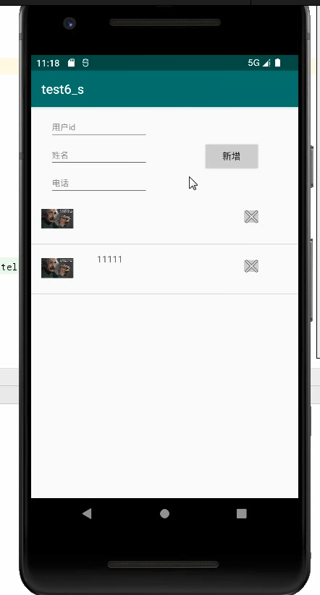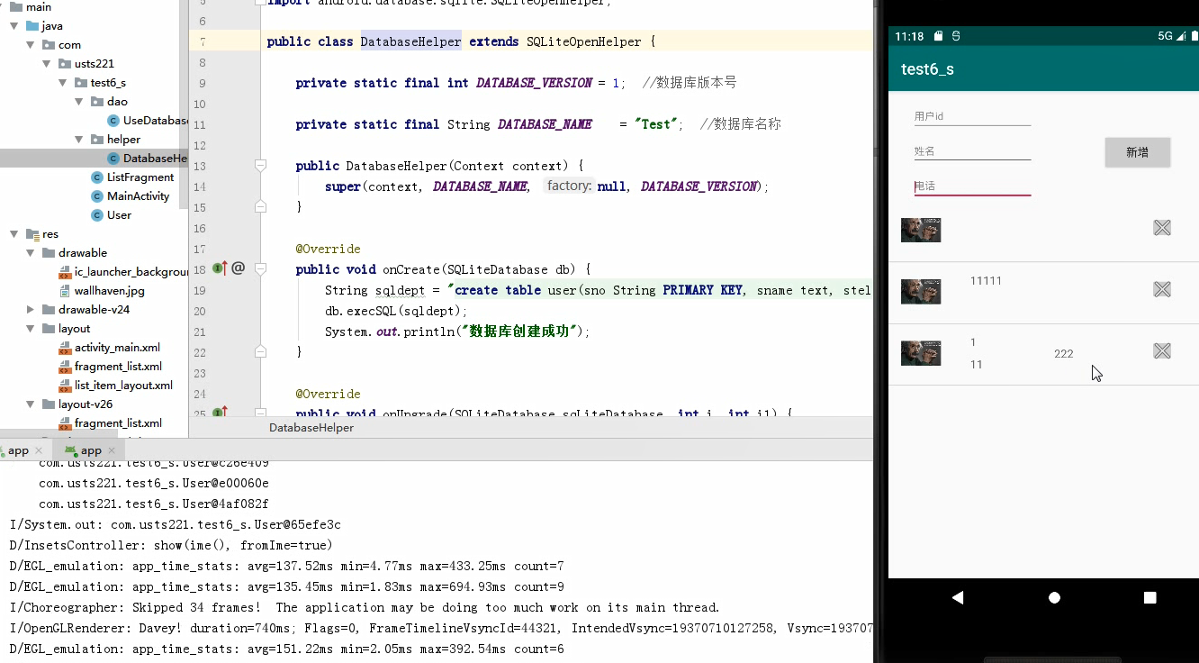

心得体会：
通过此次实验， 掌握SQLite数据存储和访问。

