苏州科技大学
电子信息与智能化实验中心

《移动互联网开发技术》

实 验 报 告

实验七：Intent

学 院： 电子与信息工程学院
专 业： 计算机科学与技术
班级学号：计算机1912班19200135221
学生姓名： 胡恒宇
指导老师： 张战成

实验日期： 2022.05.12 成绩评定：____________
实验名称： | Intent
实验内容：
在SQLite版本的班级名单基础上实现以下功能
1. 设计修改列表项的Fragment页面，支持调用相机和读取图库中照片；
2. 将拍摄的或选中的照片设置为该名单对应的头像，并在列表中更新显示；
3. 将名单和图片文件的对应关系保存在SQLite数据库中，下次重启应用的时候可以看到名单的头像；
4. 讲名单对应的头像照片保存在web服务器上，启动时批量下载头像（异步任务或独立工作线程）。
2,3是一组功能， 4 是一组功能，选做一组。
实验目的：
掌握Intent启动外部应用并交互数据的方法，了解Android权限和访问外部文件的方法。
实验：
UseDatabase
public class UseDatabase {
Context context;
DatabaseHelper dbhelper;
public SQLiteDatabase sqlitedatabase;

public UseDatabase(Context context) {
super();
this.context = context;
}

//打开数据库连接
public void opendb(Context context) {
dbhelper = new DatabaseHelper(context);
sqlitedatabase = dbhelper.getWritableDatabase();
}

//关闭数据库连接
public void closedb(Context context) {
if (sqlitedatabase.isOpen()) {
sqlitedatabase.close();
}
}
//查询数据库
@RequiresApi(api = Build.VERSION_CODES.N)
@SuppressLint("Range")
public List<User> select() {
ArrayList<User> users = new ArrayList<>();
try {
opendb(context);
String sql = "SELECT * FROM user";
Cursor c = sqlitedatabase.rawQuery(sql, null);
System.out.println("开始查询");
if(c!=null) {
while (c.moveToNext()) {
User user = new User();
user.setSno(c.getString(c.getColumnIndex("sno")));
user.setSname(c.getString(c.getColumnIndex("sname")));
user.setStele(c.getString(c.getColumnIndex("stele")));
user.setImguri(c.getString(c.getColumnIndex("imageUri")));
users.add(user);
}
}
System.out.println("查询到的是=================");
users.forEach(System.out::println);
} catch (Exception e) {
e.printStackTrace();
}finally {
closedb(context);
}
return users;
}

//插入表数据
@RequiresApi(api = Build.VERSION_CODES.N)
public void insert(String table_name, ContentValues values) {
opendb(context);
sqlitedatabase.insert(table_name, null, values);
System.out.println("插入成功");
select();
closedb(context);
}

//更新数据
public int updatatable(String table_name, ContentValues values, int ID) {
opendb(context);
return sqlitedatabase.update(table_name, values, " Type_ID = ? ", new String[]{String.valueOf(ID)});
}

//删除表数据
@RequiresApi(api = Build.VERSION_CODES.N)
public void delete(String table_name, String sno) {
opendb(context);
try {
String[] snoArr = new String[1];
snoArr[0] = sno;
sqlitedatabase.delete(table_name, "sno", snoArr);
System.out.println("删除成功");
select();
} catch (Exception e) {
e.printStackTrace();
} finally {
closedb(context);
}
}
}

DatabaseHelper
public class DatabaseHelper extends SQLiteOpenHelper {

private static final int DATABASE_VERSION = 1; //数据库版本号

private static final String DATABASE_NAME = "contact"; //数据库名称

public DatabaseHelper(Context context) {
super(context, DATABASE_NAME, null, DATABASE_VERSION);
}

@Override
public void onCreate(SQLiteDatabase db) {
String sqldept = "create table user(sno String PRIMARY KEY, sname text, stele text, imageUri text)";
db.execSQL(sqldept);
System.out.println("数据库创建成功");
}

@Override
public void onUpgrade(SQLiteDatabase sqLiteDatabase, int i, int i1) {

}
}

ListFragment
public class ListFragment extends Fragment {

private static final String TAG = "图片";

private static final int TAKE_PHOTO = 11;// 拍照
private static final int CROP_PHOTO_TAKE = 12;// 裁剪图片
private static final int CROP_PHOTO_LOCAL = 14;// 裁剪图片
private static final int LOCAL_CROP = 13;// 本地图库

private List<User> list_stu = new ArrayList<>();
private StudentAdapter adapter;
private EditText editId;
private EditText editName;
private EditText editTel;
private Button btnCommit;
private ListView lvStu;
private Context context;
private ImageView people_picture;

private Button btn_choose_picture;
private ImageView iv_show_picture;
private Uri imageUri;// 拍照时的图片uri

public ListFragment(MainActivity mainActivity) {
context = mainActivity;
}

@Override
public void onCreate(Bundle savedInstanceState) {
super.onCreate(savedInstanceState);

requestPermission(); //在其中若用户给予权限则请求相机拍照
setRetainInstance(true);
}

private void setListeners() {

// 展示图片按钮点击事件
btn_choose_picture.setOnClickListener(new View.OnClickListener() {
@Override
public void onClick(View v) {

takePhotoOrSelectPicture();// 拍照或者调用图库

}
});

}

/**
* 动态权限
*/
private void requestPermission() {
if (ContextCompat.checkSelfPermission(context, Manifest.permission.WRITE_EXTERNAL_STORAGE) != PackageManager.PERMISSION_GRANTED) {
//请求权限
ActivityCompat.requestPermissions((Activity) context, new String[]{Manifest.permission.WRITE_EXTERNAL_STORAGE, Manifest.permission.CAMERA}, 1);
}
}

@RequiresApi(api = Build.VERSION_CODES.N)
@Nullable
@Override
public View onCreateView(@NonNull LayoutInflater inflater, @Nullable ViewGroup container, @Nullable Bundle savedInstanceState) {
View view = inflater.inflate(R.layout.fragment_list, container, false);
initView(view);
initData();
return view;
}

//初始化数据
@RequiresApi(api = Build.VERSION_CODES.N)
private void initData() {
//查询数据库
UseDatabase dao = new UseDatabase(context);
List<User> selectis = dao.select();
for (User selecti : selectis) {
System.out.println("查询数据库====================");
System.out.println(selecti);
list_stu.add(selecti);
}
adapter = new StudentAdapter();
lvStu.setAdapter(adapter);
}

//增加操作
@RequiresApi(api = Build.VERSION_CODES.N)
private void initView(View view) {
editId = (EditText) view.findViewById(R.id.edit_id);
editName = (EditText) view.findViewById(R.id.edit_name);
editTel = (EditText) view.findViewById(R.id.edit_tel);
people_picture = view.findViewById(R.id.imageView);
//增加组件
btnCommit = (Button) view.findViewById(R.id.btn_commit);
lvStu = (ListView) view.findViewById(R.id.lv_stu);

//头像
btn_choose_picture = (Button) view.findViewById(R.id.btn_choose_picture);
iv_show_picture = (ImageView) view.findViewById(R.id.iv_show_picture);
setListeners();// 设置监听拍照和图库

btnCommit.setOnClickListener(v -> {
String id = editId.getText().toString();
String name = editName.getText().toString();
String tel = editTel.getText().toString();
editId.setText("");
editName.setText("");
editTel.setText("");
UseDatabase user = new UseDatabase(context);

ContentValues values = new ContentValues();
values.put("sno", id);
values.put("sname", name);
values.put("stele", tel);
values.put("imageUri", String.valueOf(imageUri));
System.out.println("=======================imageUri");
System.out.println(imageUri);

user.insert("user", values);

list_stu.add(new User(id, name, tel,String.valueOf(imageUri)));
adapter.notifyDataSetChanged();
});

}

/**
*拍照或图库
*/
private void takePhotoOrSelectPicture() {
CharSequence[] items = {"拍照", "图库"};// 裁剪items选项

// 弹出对话框提示用户拍照或者是通过本地图库选择图片
new AlertDialog.Builder(context)
.setItems(items, new DialogInterface.OnClickListener() {
@Override
public void onClick(DialogInterface dialog, int which) {

switch (which) {
// 选择了拍照
case 0:
System.out.println("================================");
System.out.println("选择了拍照");
//创建文件保存拍照的图片
File takePhotoImage = new File(Environment.getExternalStorageDirectory(), "take_photo_image.jpg");
try {
// 文件存在，删除文件
if (takePhotoImage.exists()) {
takePhotoImage.delete();
}
//动态的获取文件存取的权限
if (Build.VERSION.SDK_INT>=Build.VERSION_CODES.R) {
if (!Environment.isExternalStorageManager()) {
Intent intent = new Intent(Settings.ACTION_MANAGE_ALL_FILES_ACCESS_PERMISSION);
startActivity(intent);
return;
}
}

// 根据路径名自动的创建一个新的空文件
boolean newFile = takePhotoImage.createNewFile();
System.out.println("======================创建文件状态");
System.out.println(newFile);
} catch (Exception e) {
e.printStackTrace();
}
// 获取图片文件的uri对象
// imageUri = Uri.fromFile(takePhotoImage);
if (Build.VERSION.SDK_INT >= 24) {
imageUri = FileProvider.getUriForFile(context,
"com.tuzhi.contactbook.MainActivity", takePhotoImage);
} else {
imageUri = Uri.fromFile(takePhotoImage);
}
// // 创建Intent，用于启动手机的照相机拍照
Intent intent = new Intent(MediaStore.ACTION_IMAGE_CAPTURE);
// // 指定输出到文件uri中
intent.putExtra(MediaStore.EXTRA_OUTPUT, imageUri);
// 启动intent开始拍照
startActivityForResult(intent, TAKE_PHOTO);
break;
// 调用系统图库
case 1:

// 创建Intent，用于打开手机本地图库选择图片
Intent intent1 = new Intent(Intent.ACTION_PICK,
MediaStore.Images.Media.EXTERNAL_CONTENT_URI);
// 启动intent打开本地图库
startActivityForResult(intent1, LOCAL_CROP);
break;

}

}
}).show();

}
/**
* 调用startActivityForResult的回调
* 调用startActivityForResult方法启动一个intent后，
* 可以在该方法中拿到返回的数据
*/
@Override
public void onActivityResult(int requestCode, int resultCode, Intent data) {

super.onActivityResult(requestCode, resultCode, data);
System.out.println("======================回调=================");
switch (requestCode) {

case TAKE_PHOTO:// 拍照
if (resultCode == -1) {
File takePhotoImage = new File(Environment.getExternalStorageDirectory(), "take_photo_image.jpg");
// 创建intent用于裁剪图片
Intent intent = new Intent("com.android.camera.action.CROP");
// 设置数据为文件uri，类型为图片格式
intent.setDataAndType(imageUri, "image/*");
// 允许裁剪
intent.putExtra("scale", true);
// 指定输出到文件uri中
intent.putExtra(MediaStore.EXTRA_OUTPUT, imageUri);

intent.addFlags(Intent.FLAG_GRANT_READ_URI_PERMISSION);
intent.addFlags(Intent.FLAG_GRANT_WRITE_URI_PERMISSION);
imageUri = intent.getData();
iv_show_picture.setImageURI(intent.getData());
}
break;
case LOCAL_CROP:// 系统图库
System.out.println("图库结果码========================" + resultCode);
if (resultCode == -1) {
// 创建intent用于裁剪图片
Intent intent1 = new Intent("com.android.camera.action.CROP");
// 获取图库所选图片的uri
Uri uri = data.getData();
imageUri = uri;
System.out.println("==================图片选择成功");
iv_show_picture.setImageURI(uri);
}

break;

}

}

private class StudentAdapter extends BaseAdapter {
private TextView tvId;
private TextView tvName;
private ImageView imageView;
private TextView tvTel;
private ImageButton btnDelete;

@Override
public int getCount() {
return list_stu.size();
}

@Override
public Object getItem(int position) {
return list_stu.get(position);
}

@Override
public long getItemId(int position) {
return position;
}

@RequiresApi(api = Build.VERSION_CODES.N)
@Override
public View getView(int position, View convertView, ViewGroup parent) {
convertView = LayoutInflater.from(getContext()).inflate(R.layout.list_item_layout, parent, false);
tvId = (TextView) convertView.findViewById(R.id.tv_id);
tvName = (TextView) convertView.findViewById(R.id.tv_name);
imageView = (ImageView) convertView.findViewById(R.id.imageView);
tvTel = (TextView) convertView.findViewById(R.id.tv_tel);
btnDelete = (ImageButton) convertView.findViewById(R.id.btn_delete);

tvId.setText(list_stu.get(position).getSno());
tvName.setText(list_stu.get(position).getSname());
tvTel.setText(list_stu.get(position).getStele());
Uri uri = Uri.parse(list_stu.get(position).getImguri());
System.out.println("============设置url");
System.out.println(uri);
imageView.setImageURI(uri);

//打电话
tvTel.setOnClickListener(v -> {
String tel = list_stu.get(position).getStele();
Intent intent = new Intent(Intent.ACTION_DIAL, Uri.parse("tel:" + tel));
startActivity(intent);
});

//删除
btnDelete.setOnClickListener(v -> {
UseDatabase user = new UseDatabase(context);
user.delete("user", position+"");
list_stu.remove(position);
adapter.notifyDataSetChanged();
});

return convertView;
}
}
}

MainActivity
public class MainActivity extends AppCompatActivity {
//sd卡写入权限
public static final int EXTERNAL_STORAGE_REQ_CODE = 10 ;

@Override
protected void onCreate(Bundle savedInstanceState) {
super.onCreate(savedInstanceState);
setContentView(R.layout.activity_main);
FragmentManager fm = getSupportFragmentManager();
Fragment fragment = fm.findFragmentById(R.id.fragment_list);
if (fragment == null) {
fragment = new ListFragment(this);
fm.beginTransaction()
.add(R.id.fragment_list, fragment)
.commit();
}
int permission = ActivityCompat.checkSelfPermission(this,
Manifest.permission.WRITE_EXTERNAL_STORAGE);

if (permission != PackageManager.PERMISSION_GRANTED) {
// 请求权限
ActivityCompat.requestPermissions(this, new String[]{Manifest.permission.WRITE_EXTERNAL_STORAGE},
EXTERNAL_STORAGE_REQ_CODE);

}

}
}

User
public class User {
private String imguri;
private String Sno;
private String Sname;
private String Stele;

public User() {
}

public User(String sno, String sname, String stele, String uri) {
Sno = sno;
Sname = sname;
Stele = stele;
imguri = uri;
}

public String getImguri() {
return imguri;
}

public void setImguri(String imguri) {
this.imguri = imguri;
}

public String getSno() {
return Sno;
}

public void setSno(String sno) {
Sno = sno;
}

public String getSname() {
return Sname;
}

public void setSname(String sname) {
Sname = sname;
}

public String getStele() {
return Stele;
}

public void setStele(String stele) {
Stele = stele;
}

@Override
public String toString() {
return "User{" +
"imguri='" + imguri + '\'' +
", Sno='" + Sno + '\'' +
", Sname='" + Sname + '\'' +
", Stele='" + Stele + '\'' +
'}';
}
}

fragment_list
<?xml version="1.0" encoding="utf-8"?>
<androidx.constraintlayout.widget.ConstraintLayout xmlns:android="http://schemas.android.com/apk/res/android"
xmlns:app="http://schemas.android.com/apk/res-auto"
xmlns:tools="http://schemas.android.com/tools"
android:layout_width="match_parent"
android:layout_height="match_parent"
android:orientation="vertical"
tools:context=".ListFragment">

<EditText
android:id="@+id/edit_id"
android:layout_width="wrap_content"
android:layout_height="35dp"
android:layout_marginStart="28dp"
android:layout_marginTop="16dp"
android:ems="10"
android:hint="用户id"
android:inputType="text"
android:textSize="13sp"
app:layout_constraintStart_toStartOf="parent"
app:layout_constraintTop_toTopOf="parent" />

<EditText
android:id="@+id/edit_name"
android:layout_width="wrap_content"
android:layout_height="35dp"
android:layout_marginTop="8dp"
android:ems="10"
android:hint="姓名"
android:inputType="text"
android:textSize="13sp"
app:layout_constraintStart_toStartOf="@+id/edit_id"
app:layout_constraintTop_toBottomOf="@+id/edit_id" />

<EditText
android:id="@+id/edit_tel"
android:layout_width="wrap_content"
android:layout_height="35dp"
android:layout_marginTop="8dp"
android:ems="10"
android:hint="电话"
android:inputType="text"
android:textSize="13sp"
app:layout_constraintStart_toStartOf="@+id/edit_name"
app:layout_constraintTop_toBottomOf="@+id/edit_name" />

<Button
android:id="@+id/btn_commit"
android:layout_width="51dp"
android:layout_height="40dp"
android:layout_marginTop="52dp"
android:text="新增"
android:textSize="8sp"
app:layout_constraintTop_toTopOf="parent"
tools:layout_editor_absoluteX="220dp"
tools:ignore="MissingConstraints" />

<Button
android:id="@+id/btn_choose_picture"
android:layout_width="50dp"
android:layout_height="40dp"
android:text="添加头像"
android:textSize="8sp"
tools:layout_editor_absoluteX="221dp"
tools:layout_editor_absoluteY="11dp"
tools:ignore="MissingConstraints" />

<ListView
android:id="@+id/lv_stu"
android:layout_width="match_parent"
android:layout_height="592dp"
android:layout_marginTop="36dp"
app:layout_constraintTop_toBottomOf="@+id/btn_commit"
tools:layout_editor_absoluteX="0dp" />

<ImageView
android:id="@+id/iv_show_picture"
android:layout_width="97dp"
android:layout_height="85dp"
tools:layout_editor_absoluteX="282dp"
tools:layout_editor_absoluteY="11dp"
tools:src="@tools:sample/avatars"
tools:ignore="MissingConstraints" />
</androidx.constraintlayout.widget.ConstraintLayout>

list_item_layout
<?xml version="1.0" encoding="utf-8"?>
<androidx.constraintlayout.widget.ConstraintLayout xmlns:android="http://schemas.android.com/apk/res/android"
xmlns:app="http://schemas.android.com/apk/res-auto"
xmlns:tools="http://schemas.android.com/tools"
android:layout_width="match_parent"
android:layout_height="75dp">

<TextView
android:id="@+id/tv_id"
android:layout_width="wrap_content"
android:layout_height="wrap_content"
android:layout_marginStart="36dp"
android:text="TextView"
app:layout_constraintStart_toEndOf="@+id/imageView"
app:layout_constraintTop_toTopOf="@+id/imageView" />

<TextView
android:id="@+id/tv_name"
android:layout_width="wrap_content"
android:layout_height="wrap_content"
android:layout_marginTop="8dp"
android:text="TextView"
app:layout_constraintStart_toStartOf="@+id/tv_id"
app:layout_constraintTop_toBottomOf="@+id/tv_id" />

<ImageView
android:id="@+id/imageView"
android:layout_width="49dp"
android:layout_height="48dp"
android:layout_marginStart="16dp"
android:layout_marginTop="12dp"
app:layout_constraintStart_toStartOf="parent"
app:layout_constraintTop_toTopOf="parent"
android:src="@drawable/avatar" />

<TextView
android:id="@+id/tv_tel"
android:layout_width="wrap_content"
android:layout_height="wrap_content"
android:layout_marginStart="140dp"
android:text="TextView"
app:layout_constraintBottom_toBottomOf="@+id/imageView"
app:layout_constraintStart_toEndOf="@+id/imageView"
app:layout_constraintTop_toTopOf="@+id/imageView" />

<androidx.appcompat.widget.AppCompatImageButton
android:id="@+id/btn_delete"
android:layout_width="30dp"
android:layout_height="30dp"
android:layout_marginStart="324dp"
android:layout_marginTop="18dp"
android:text="删除"
app:layout_constraintStart_toStartOf="parent"
app:layout_constraintTop_toTopOf="parent"
app:srcCompat="@android:drawable/ic_menu_close_clear_cancel" />

</androidx.constraintlayout.widget.ConstraintLayout>
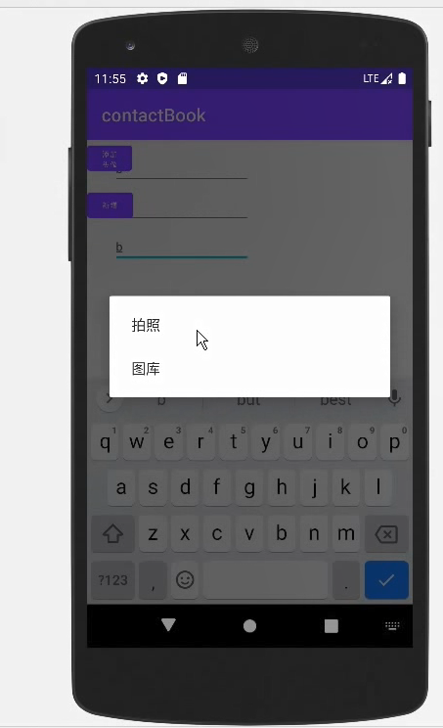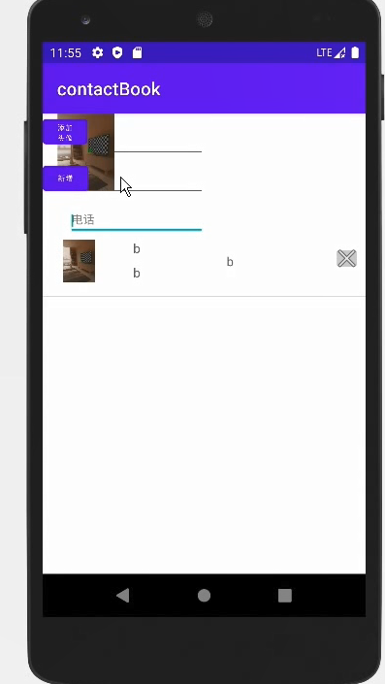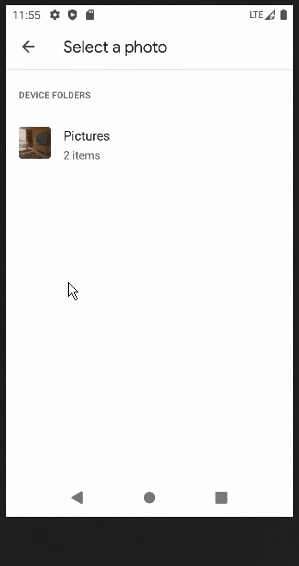

心得体会：
通过此次实验，掌握Intent启动外部应用并交互数据的方法，了解Android权限和访问外部文件的方法

