Table 1: Pharmacokinetic Parameters of Theophylline
{rpfy}:theoph-pk-parameters.csv
Subject | Cmax | Tmax | AUC | WTBL
1 | 6.44 | 1.15 | 71.69701 | 80.0
2 | 7.09 | 3.48 | 87.96923 | 64.6
3 | 7.56 | 2.02 | 86.80656 | 70.5
4 | 8.00 | 0.98 | 77.89347 | 65.0
5 | 8.20 | 1.02 | 95.87820 | 70.5
6 | 8.33 | 1.92 | 88.73128 | 72.4
7 | 8.60 | 1.07 | 102.63362 | 72.7
8 | 9.03 | 0.63 | 83.93743 | 86.4
9 | 9.75 | 3.52 | 115.22021 | 60.5
10 | 10.21 | 3.55 | 135.57607 | 58.2
11 | 10.50 | 1.12 | 147.23475 | 79.6
12 | 11.40 | 1.00 | 118.17935 | 54.6
[Source: scripts/01_analysis/analysis.R 2025-04-30 16:27:12]
Notes: The table presents the summary of a simple pharmacokinetic parameter calculation. AUC was calculated using linear trapezoidal integration for ascending and non-loggable segments and log-linear trapezoidal integration for descending segments.
Abbreviations: AUC: area under the curve. C_{max}: peak (maximum) concentration. T_{max}: time of maximum concentration. WTBL: baseline weight.

Figure 1: Linear Regression of AUC and Subject Weight
{rpfy}:theoph-pk-exposure.png<width: 6.0, height: 4.0>
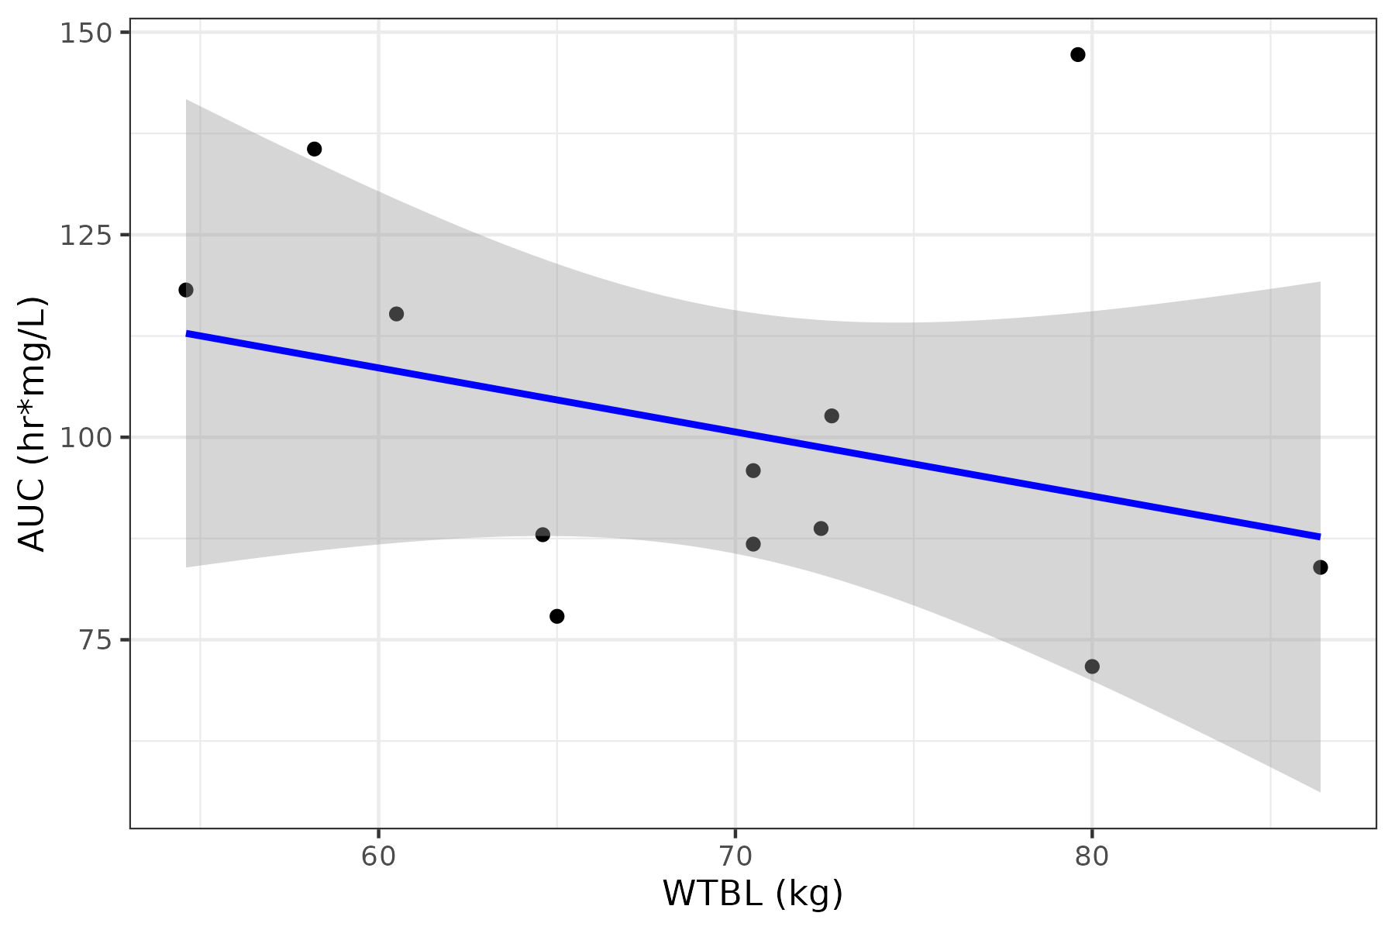
[Source: scripts/01_analysis/analysis.R 2025-04-30 16:27:12]
Notes: The plot shows a linear regression model, where the dots represent the observed data points and the line represents the fitted linear regression line. AUC was calculated using linear trapezoidal integration for ascending and non-loggable segments and log-linear trapezoidal integration for descending segments.
Abbreviations: AUC: area under the curve. WTBL: baseline weight.

Figure 2: Observed Theophylline Concentration–Time Profiles
{rpfy}:theoph-pk-conc.png<width: 6.0, height: 4.0>
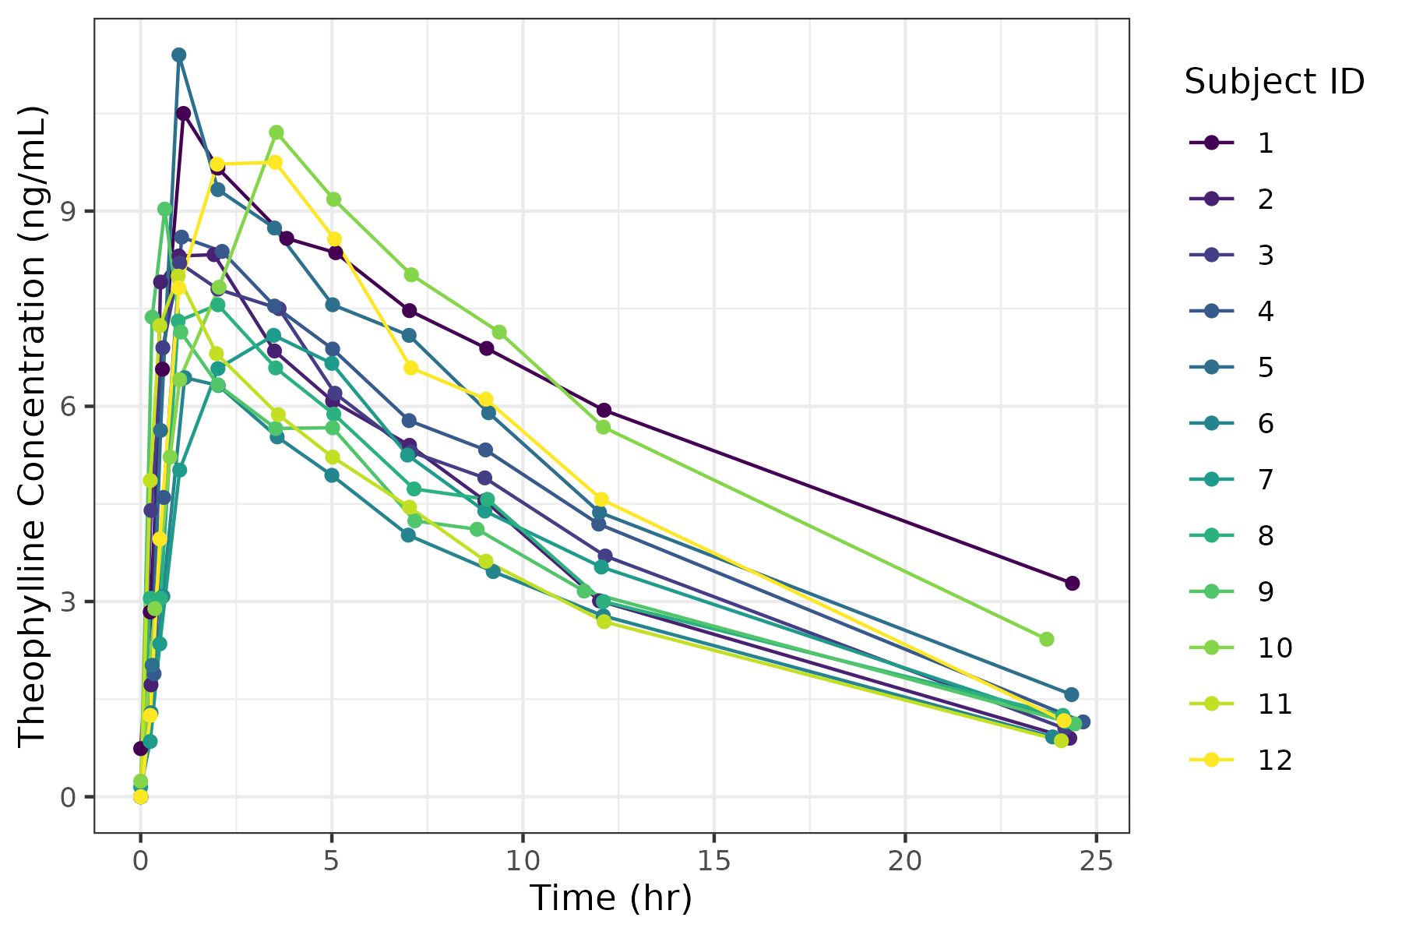
[Source: scripts/01_analysis/analysis.R 2025-04-30 16:27:12]
Notes: This plot shows individual concentration-time trajectories for subjects in the study. The x-axis represents time (hours) and the y-axis shows drug concentration (ng/mL). Each line corresponds to a subject's concentration profile, illustrating variability in pharmacokinetics across the population. Key points like peak concentration (Cmax) and time to peak (Tmax) can be identified visually. No aggregation or smoothing has been applied, preserving the raw individual data. Each colored line represents the observed concentration–time profile for a specific subject identifier.
Abbreviations: C_{max}: peak (maximum) concentration. T_{max}: time of maximum concentration.

