Figure 1: Theophylline Concentration Time Profiles & Effect of Weight on Exposure
{rpfy}:[theoph-pk-conc.png, theoph-pk-exposure.png]
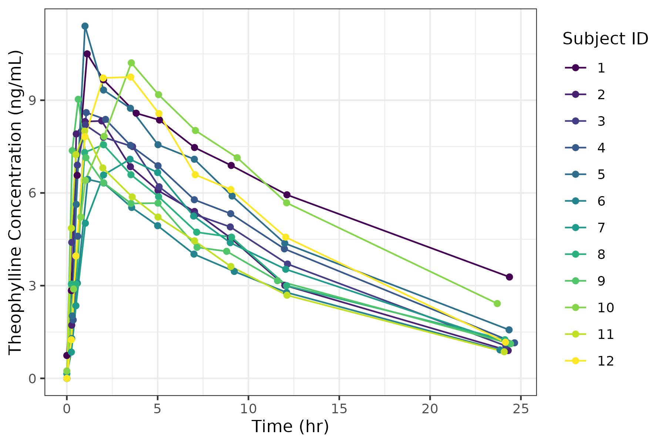
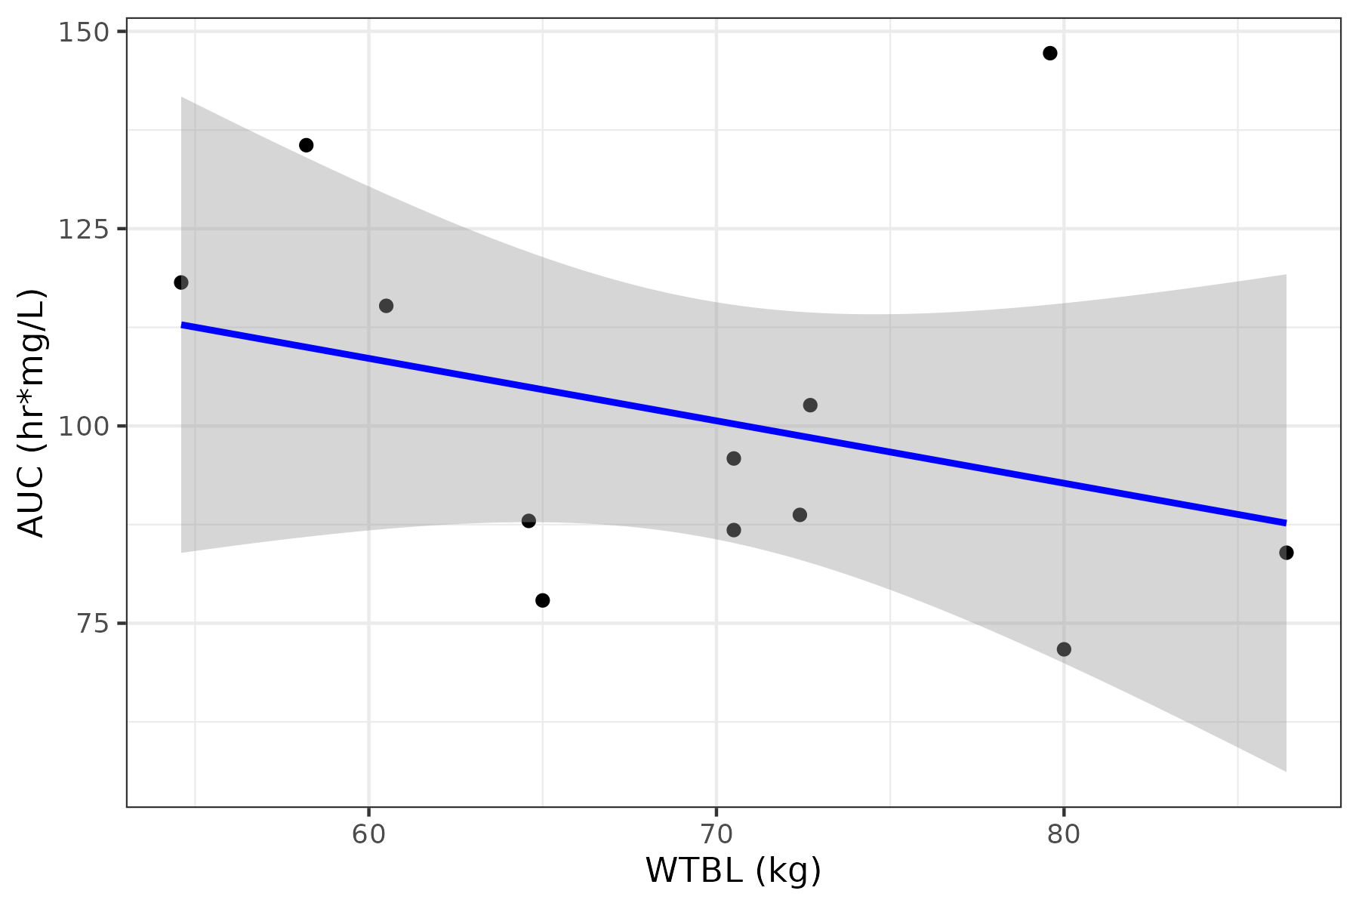

Figure 2: Effect of Weight on Exposure & Theophylline Concentration Time Profiles
{rpfy}:theoph-pk-conc.png

{rpfy}:theoph-pk-exposure.png


