Table 1: Pharmacokinetic Parameters of Theophylline
Subject | cmax | tmax | auc | wt
1 | 6.44 | 1.15 | 71.69701 | 80.0
2 | 7.09 | 3.48 | 87.96923 | 64.6
3 | 7.56 | 2.02 | 86.80656 | 70.5
4 | 8.00 | 0.98 | 77.89347 | 65.0
5 | 8.20 | 1.02 | 95.87820 | 70.5
6 | 8.33 | 1.92 | 88.73128 | 72.4
7 | 8.60 | 1.07 | 102.63362 | 72.7
8 | 9.03 | 0.63 | 83.93743 | 86.4
9 | 9.75 | 3.52 | 115.22021 | 60.5
10 | 10.21 | 3.55 | 135.57607 | 58.2
11 | 10.50 | 1.12 | 147.23475 | 79.6
12 | 11.40 | 1.00 | 118.17935 | 54.6
[Source: /cluster-data/user-homes/jacob/projects_internal/reportifyr_examples/scripts/01_analysis/analysis.R COULD NOT ACCESS GIT]
Notes: The table presents the summary of a simple pharmacokinetic parameter calculation. AUC was calculated using linear trapezoidal integration for ascending and non-loggable segments and log-linear trapezoidal integration for descending segments.
Abbreviations: AUC: Area under the curve. CMAX: maximum concentration. TMAX: time to maximum concentration. WT: weight.

Figure 1: Linear Regression of AUC and Subject Weight
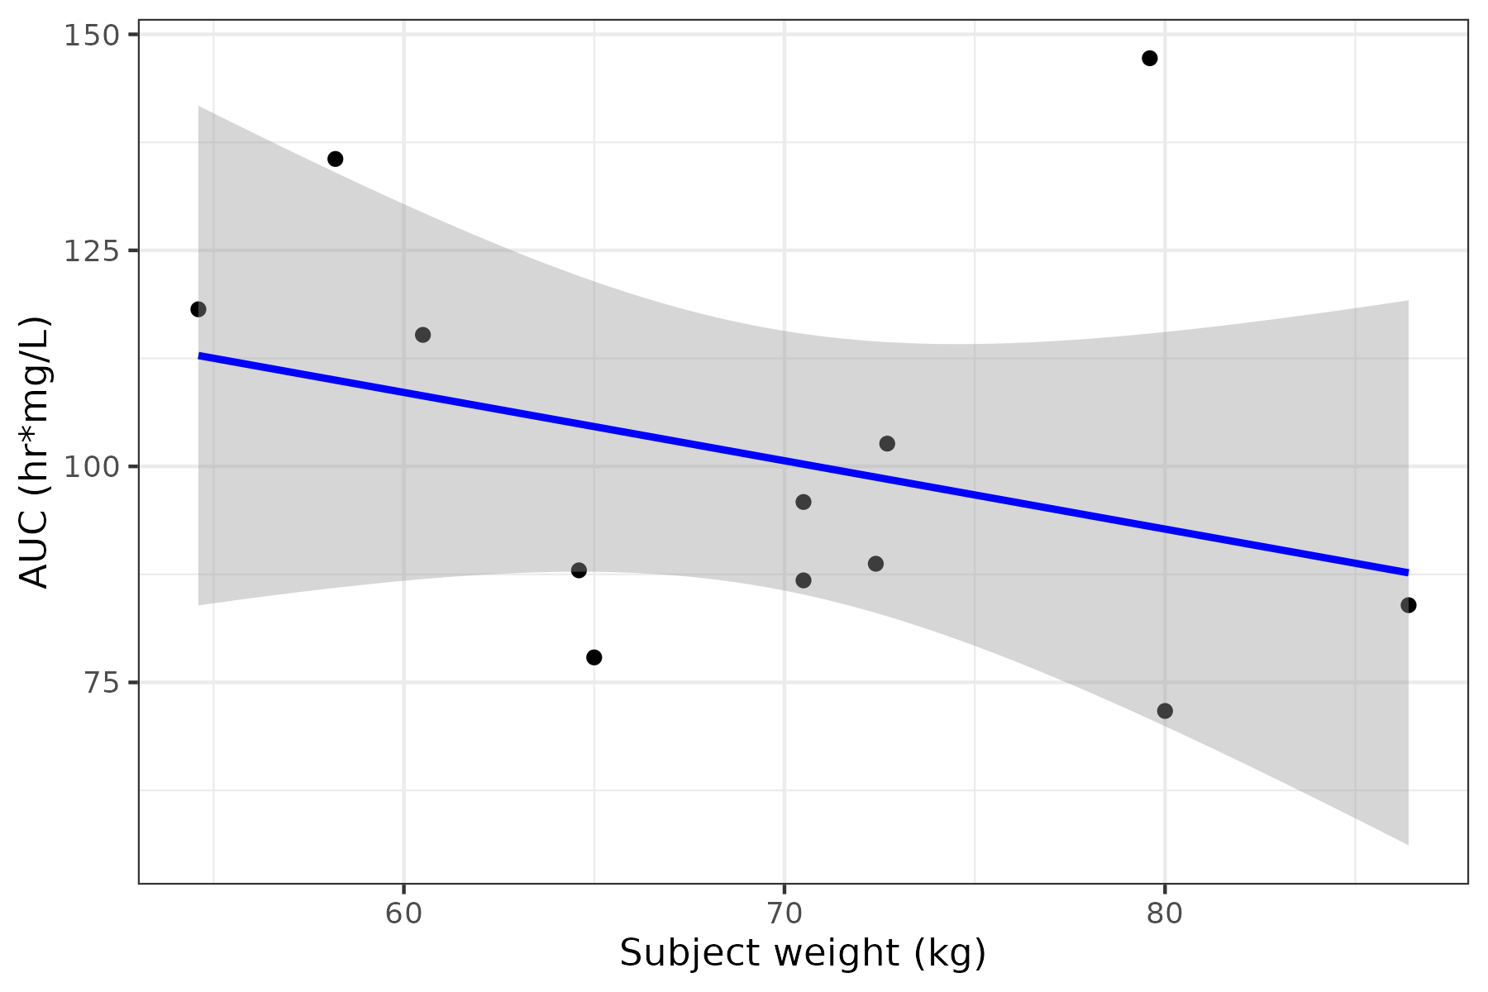
[Source: /cluster-data/user-homes/jacob/projects_internal/reportifyr_examples/scripts/01_analysis/analysis.R COULD NOT ACCESS GIT]
Notes: The plot shows a linear regression model, where the dots represent the observed data points and the line represents the fitted linear regression line. AUC was calculated using linear trapezoidal integration for ascending and non-loggable segments and log-linear trapezoidal integration for descending segments.
Abbreviations: AUC: Area under the curve.

