**AutoRun 操作手冊**

**CONTENTS**

USER MANUAL 5

I. BUILD AUTORUN/AGENTS SPEC 7

TRIGGER AGENTS 10

Active Check New 11

Bus Check New 12

Dropbox Watch 13

Evernote Watch Note 14

Evernote Watch Reminder 15

Exchange Calendar Check New 16

Exchange Calendar Watch 17

Exchange Mail Check New 18

Facebook Photo Tag 19

Facebook User 20

Facebook Watch Post 21

Gmail Check New 22

Gmail Check Starred 23

Google Calendar Check Current 24

Google Calendar Check New 25

Google Calendar Watch 26

Google Drive Watch 27

Imap Folder 28

Insnergy Check New 29

Instagram Check Liked 30

Instagram Check Location 31

Instagram Check New 32

Instagram Check Tag 33

Itri Exchange Calendar Check New 34

Itri Exchange Calendar Watch 35

Itri Exchange Mail Check New 36

Oil Check New 37

Open Weather Map 38

Open Weather Map Current 39

Pocket Retrieve 41

Rss 42

Scheduler 43

Trello Check Assigned 44

Trello Check New 45

Webhook 46

Youtube Check New 47

Youtube Watch Channel 48

SYSTEM AGENTS 49

Collect Event Count 50

Collect Event Simple 51

Dropbox File Url 52

Event Formatting 53

Google Drive File Url 54

Trigger 55

ACTION AGENTS 56

Dropbox File Upload 57

Email 58

Email Digest 59

Evernote Append Note 60

Evernote Create Note 61

Exchange Calendar Create Event 62

Exchange Mail Send Message 63

Facebook Publish 64

Gmail Send Message 65

Google Calendar Create Event 66

Google Drive Upload File 67

Google Spreadsheet Add Row 68

Itri Exchange Calendar Create Event 69

Itri Exchange Mail Send Message 70

Insnergy Controller 71

Lifx 72

Nexmo 73

Notification 74

Pocket Add 75

Trello Create Card 76

OTHER AGENTS 77

Fetch Weather Data 78

Manul event 79

Post 80

II. EDIT AUTORUN 81

III. COPY AUTORUN 87

IV. Appendix 89

# USER MANUAL

**AutoRun操作人員依照以下步驟可完成AutoRun建置**

1. 第一步 : 根據I. BUILD AUTORUN/AGENTS SPEC章節的資訊畫出`AutoRun Diagram`，並進入Huginn母片將`AutoRun Diagram`實際拉成`AutoRun`。
2. 第二步 : 根據II. EDIT AUTORUN章節的指示編輯資料庫欄位
3. 第三步 : 根據III. COPY AUTORUN章節的指示複製母片AutoRun到手機板Huginn資料庫

**按照以上步驟最後完成AutoRun建置**

# I. BUILD AUTORUN/AGENTS SPEC

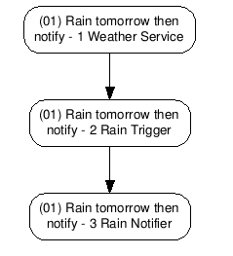

圖一、 首先藉由Agents Spec章節的資訊畫出`AutoRun Diagram`

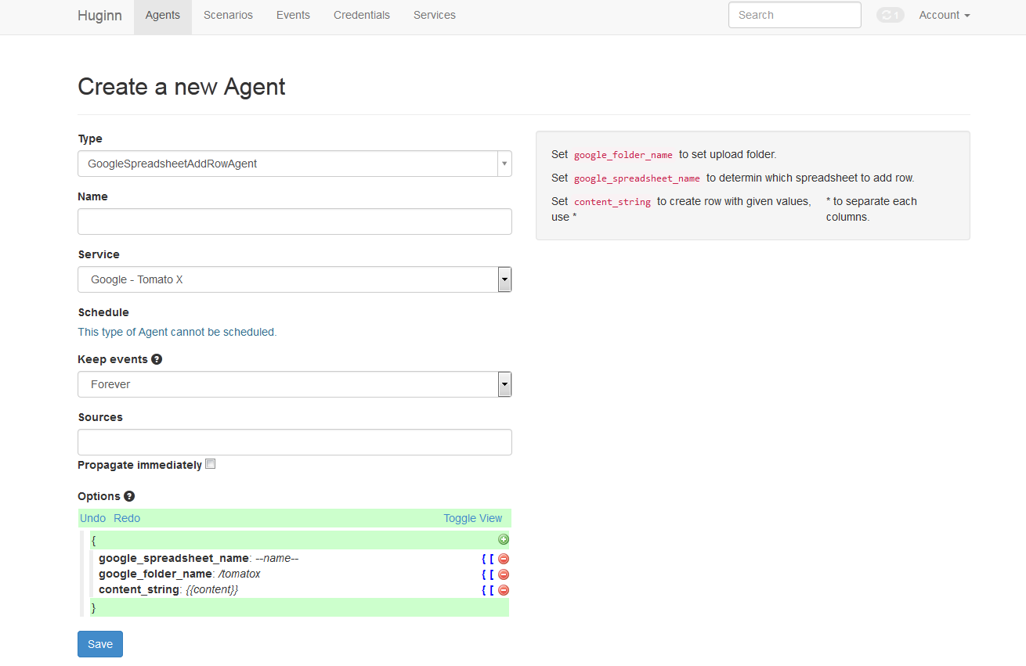

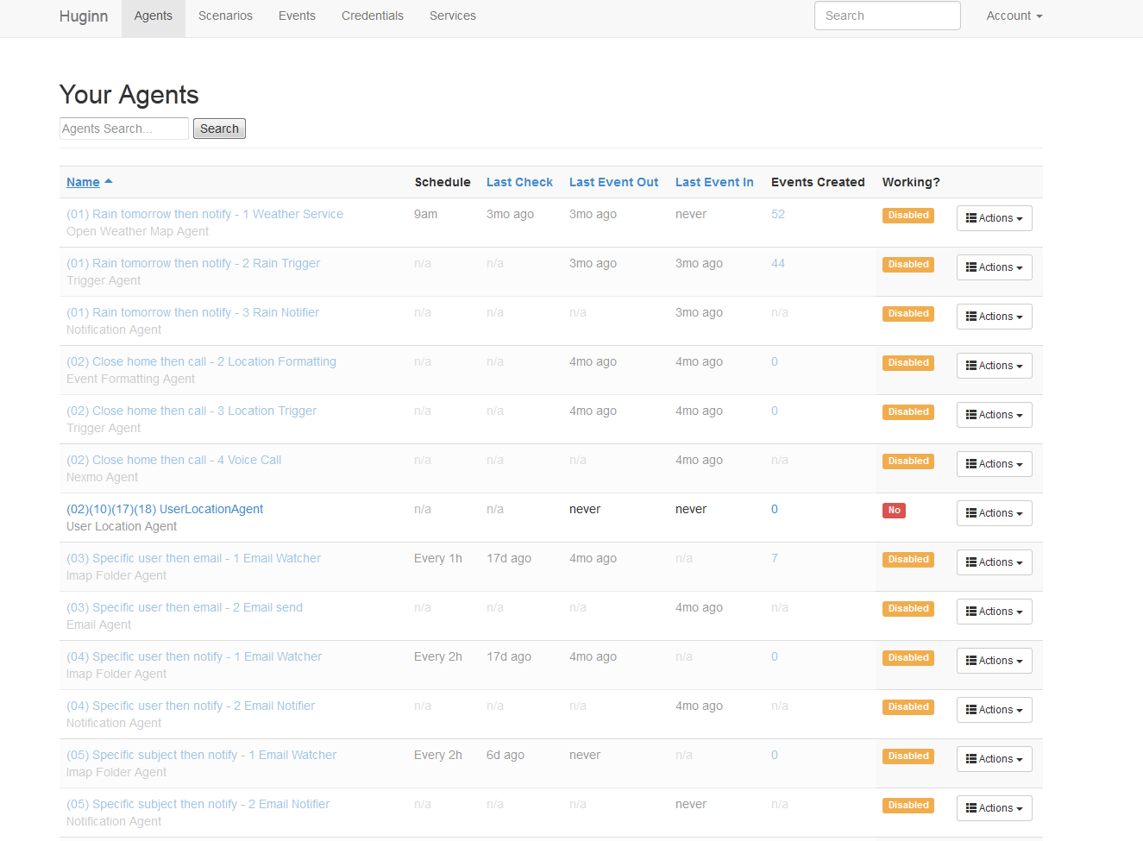

圖二、 再實際拉成`AutoRun`

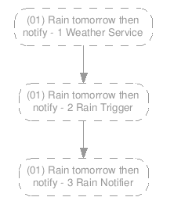

圖三、 最後比對`AutoRun Diagram`與之前規劃的是否一致

**完成第一步**

# TRIGGER AGENTS

Active Check New

|  |  |  |
| --- | --- | --- |
| **Agent Name** | **Agent Type** | **主要功能** |
| DropboxWatch | Trigger | 活動監控 |
| **本機測試** | 🗸 | |
| **雲端測試** | 🗸 | |

|  |  |
| --- | --- |
| * **Trigger Condition** | |
| 當有新活動新增時 | |
| * **Agents Option** | |
| category : 音樂 | 監控的活動類型 |
| expected_update_period_in_days : 1 | 填1 |
| * **Event Output** | |
|  | |

Bus Check New

|  |  |  |
| --- | --- | --- |
| **Agent Name** | **Agent Type** | **主要功能** |
| DropboxWatch | Trigger | 公車監控 |
| **本機測試** | 🗸 | |
| **雲端測試** | 🗸 | |

|  |  |
| --- | --- |
| * **Trigger Condition** | |
| 當有公車到站時間紀錄時 | |
| * **Agents Option** | |
| bus_number : 310 | 公車號碼 |
| stop_name : 貓纜指南宮站 | 站牌名稱 |
| expected_update_period_in_days : 1 | 填1 |
| * **Event Output** | |
|  | |

Dropbox Watch

|  |  |  |
| --- | --- | --- |
| **Agent Name** | **Agent Type** | **主要功能** |
| DropboxWatch | Trigger | Dropbox資料夾監控 |
| **本機測試** | 🗸 | |
| **雲端測試** | 🗸 | |

|  |  |
| --- | --- |
| * **Trigger Condition** | |
| 當監控的Dropbox資料夾有變動(新增、修改、移除)時 | |
| * **Agents Option** | |
| dir_to_watch : /photos | 監控的資料夾路徑 |
| expected_update_period_in_days : 1 | 填1 |
| * **Event Output** | |
|  | |

Evernote Watch Note

|  |  |  |
| --- | --- | --- |
| **Agent Name** | **Agent Type** | **主要功能** |
| EvernoteWatchNote | Trigger | 監控Evernote筆記狀況 |
| **本機測試** | 🗸 | |
| **雲端測試** | 🗸 | |

|  |  |
| --- | --- |
| * **Trigger Condition** | |
| Evernote有新筆記產生 | |
| * **Agents Option** | |
| expected_update_period_in_days : 1 | 填1 |
| watch_value : first notebook | 監控的筆記名稱或tag名稱 |
| watch_type : notebook或tag | 指定是監控筆記本或tag |
| * **Event Output** | |
|  | |

Evernote Watch Reminder

|  |  |  |
| --- | --- | --- |
| **Agent Name** | **Agent Type** | **主要功能** |
| EvernoteWatchReminder | Trigger | 監控Reminder狀況 |
| **本機測試** | 🗸 | |
| **雲端測試** | 🗸 | |

|  |  |
| --- | --- |
| * **Trigger Condition** | |
| Evernote新增Reminder | |
| * **Agents Option** | |
| expected_update_period_in_days : 1 | 填1 |
| * **Event Output** | |
|  | |

Exchange Calendar Check New

|  |  |  |
| --- | --- | --- |
| **Agent Name** | **Agent Type** | **主要功能** |
| ExchangeCalendarCheckNew | Trigger |  |
| **本機測試** | 🗸 | |
| **雲端測試** | 🗸 | |

|  |  |
| --- | --- |
| * **Trigger Condition** | |
|  | |
| * **Agents Option** | |
|  |  |
| * **Event Output** | |
|  | |

Exchange Calendar Watch

Exchange Mail Check New

Facebook Photo Tag

|  |  |  |
| --- | --- | --- |
| **Agent Name** | **Agent Type** | **主要功能** |
| FacebookPhotoTag | Trigger | 臉書Tag監控 |
| **本機測試** | 🗸 | |
| **雲端測試** | 🗸 | |

|  |  |
| --- | --- |
| * **Trigger Condition** | |
| 臉書有Tag自己的照片產生 | |
| * **Agents Option** | |
| expected_update_period_in_days : 1 | 填1 |
| * **Event Output** | |
|  | |

|  |
| --- |
| **備註** |
| 1. 定時偵測Facebook有沒有被tag的照片，當Facebook有被tag的照片時，將所有的照片url以array的形式送出Event |

Facebook User

|  |  |  |
| --- | --- | --- |
| **Agent Name** | **Agent Type** | **主要功能** |
| FacebookUser | Trigger | 臉書個人資料監控 |
| **本機測試** | 🗸 | |
| **雲端測試** | 🗸 | |

|  |  |
| --- | --- |
| * **Trigger Condition** | |
| 使用者大頭照改變 or 使用者居住地改變 or 使用者名稱改變 | |
| * **Agents Option** | |
| expected_update_period_in_days : 1 | 填1 |
| * **Event Output** | |
|  | |

|  |
| --- |
| **備註** |
| 1. 不同Trigger狀況會送出不同的Event |

Facebook Watch Post

|  |  |  |
| --- | --- | --- |
| **Agent Name** | **Agent Type** | **主要功能** |
| FacebookWatchPost | Trigger | 臉書動態貼文監控 |
| **本機測試** | 🗸 | |
| **雲端測試** | 🗸 | |

|  |  |
| --- | --- |
| * **Trigger Condition** | |
| 臉書有新動態貼文(當選項with_location : true時貼文必須標地點才會驅動) | |
| * **Agents Option** | |
| expected_update_period_in_days : 1 | 填1 |
| mode : one或all | one或all 決定產生最新的events或全部events |
| hash : tag | 追蹤文章的tag |
| with_location : true或false | 當設定為true時貼文必須標記地點才會驅動 |
| * **Event Output** | |
|  | |

Gmail Check New

|  |  |  |
| --- | --- | --- |
| **Agent Name** | **Agent Type** | **主要功能** |
| GmailCheckNew | Trigger | 監控Gmail狀況 |
| **本機測試** | 🗸 | |
| **雲端測試** | 🗸 | |

|  |  |
| --- | --- |
| * **Trigger Condition** | |
| Gmail有新信件 | |
| * **Agents Option** | |
| expected_update_period_in_days : 1 | 填1 |
| check_type : any或attachment或from或subject或label |  |
| check_value | 當check_type是from或subject或label時須設定 |
| query_string |  |
| * **Event Output** | |
|  | |

Gmail Check Starred

|  |  |  |
| --- | --- | --- |
| **Agent Name** | **Agent Type** | **主要功能** |
| GmailCheckStarred | Trigger | 標記星號的郵件監控 |
| **本機測試** | 🗸 | |
| **雲端測試** | 🗸 | |

|  |  |
| --- | --- |
| * **Trigger Condition** | |
| 一個月內新標記星號的郵件 | |
| * **Agents Option** | |
| expected_update_period_in_days : 1 | 填1 |
| * **Event Output** | |
|  | |

Google Calendar Check Current

|  |  |  |
| --- | --- | --- |
| **Agent Name** | **Agent Type** | **主要功能** |
| GoogleCalendarCheckCurrent | Trigger | 監控是否正在會議中 |
| **本機測試** | 🗸 | |
| **雲端測試** | 🗸 | |

|  |  |
| --- | --- |
| * **Trigger Condition** | |
| 正在google calendar會議中 | |
| * **Agents Option** | |
| expected_update_period_in_days : 1 | 填1 |
| * **Event Output** | |
|  | |

Google Calendar Check New

|  |  |  |
| --- | --- | --- |
| **Agent Name** | **Agent Type** | **主要功能** |
| GoogleCalendarCheckNew | Trigger | 監控是否有加新會議 |
| **本機測試** | 🗸 | |
| **雲端測試** | 🗸 | |

|  |  |
| --- | --- |
| * **Trigger Condition** | |
| 有加新會議 | |
| * **Agents Option** | |
| expected_update_period_in_days : 1 | 填1 |
| * **Event Output** | |
|  | |

|  |
| --- |
| **備註** |
| 1. 不能新增整天的會議來驅動，會出錯 |

Google Calendar Watch

|  |  |  |
| --- | --- | --- |
| **Agent Name** | **Agent Type** | **主要功能** |
| GoogleCalendarWatch | Trigger | 監控幾分鐘後是否有會議 |
| **本機測試** | 🗸 | |
| **雲端測試** | 🗸 | |

|  |  |
| --- | --- |
| * **Trigger Condition** | |
| 幾分鐘(依設定)後有會議進行 | |
| * **Agents Option** | |
| expected_update_period_in_days : 1 | 填1 |
| minutes : 15 | 監控幾分鐘後 |
| * **Event Output** | |
|  | |

Google Drive Watch

|  |  |  |
| --- | --- | --- |
| **Agent Name** | **Agent Type** | **主要功能** |
| GoogleDriveWatch | Trigger | GoogleDrive監控 |
| **本機測試** | 🗸 | |
| **雲端測試** | 🗸 | |

|  |  |
| --- | --- |
| * **Trigger Condition** | |
| GoogleDrive資料夾有變動時 | |
| * **Agents Option** | |
| watch_path : /test | 監控的資料夾路徑 |
| expected_update_period_in_days : 1 | 填1 |
| * **Event Output** | |
|  | |

Imap Folder

|  |  |  |
| --- | --- | --- |
| **Agent Name** | **Agent Type** | **主要功能** |
| ImapFolder | Trigger | 特定信箱的狀況 |
| **本機測試** | 🗸 | |
| **雲端測試** | 🗸 | |

|  |  |
| --- | --- |
| * **Trigger Condition** | |
| 監控的信箱更新 | |
| * **Agents Option** | |
| username：[tomatoxlink@gmail.com](mailto:tomatoxlink@gmail.com) | 要監控的信箱email 必須為xxx@gmail.com格式 |
| password：12345 | 要監控的信箱密碼 |
| folder：INBOX | 監控的信箱資料夾 (這個我沒有改過) |
| conditions | 可以在這裡寫監控的條件，詳情請閱Agent旁的description |
| * **Event Output** | |
|  | |

Insnergy Check New

|  |  |  |
| --- | --- | --- |
| **Agent Name** | **Agent Type** | **主要功能** |
| InsnergyCheckNew | Trigger | 監控Insnergy狀況 |
| **本機測試** | 🗸 | |
| **雲端測試** | 🗸 | |

|  |  |
| --- | --- |
| * **Trigger Condition** | |
| Insnergy API 回傳資料時 | |
| * **Agents Option** | |
| expected_update_period_in_days : 1 | 填1 |
| device_id : RS06000D6F0003BBA08C |  |
| * **Event Output** | |
|  | |

Instagram Check Liked

|  |  |  |
| --- | --- | --- |
| **Agent Name** | **Agent Type** | **主要功能** |
| InstagramCheckLiked | Trigger | 監控Instagram按讚狀況 |
| **本機測試** | 🗸 | |
| **雲端測試** | 🗸 | |

|  |  |
| --- | --- |
| * **Trigger Condition** | |
| Instagram照片或影片有被按讚 | |
| * **Agents Option** | |
| expected_update_period_in_days : 1 | 填1 |
| media_type : image/video |  |
| * **Event Output** | |
|  | |

Instagram Check Location

|  |  |  |
| --- | --- | --- |
| **Agent Name** | **Agent Type** | **主要功能** |
| InstagramCheckLocation | Trigger | 監控在標註地點附近的貼文 |
| **本機測試** | 🗸 | |
| **雲端測試** | 🗸 | |

|  |  |
| --- | --- |
| * **Trigger Condition** | |
| Instagram有在符合選項地點範圍標註的新貼文 | |
| * **Agents Option** | |
| expected_update_period_in_days : 1 | 填1 |
| lat : 35 | 經度 |
| lng : 135 | 緯度 |
| distance : 1000 | 距離多少範圍內，最大5000 |
| anyone : false | 填使用者id或是填false代表自己 |
| * **Event Output** | |
|  | |

Instagram Check New

|  |  |  |
| --- | --- | --- |
| **Agent Name** | **Agent Type** | **主要功能** |
| InstagramCheckNew | Trigger | 監控Instagram狀況 |
| **本機測試** | 🗸 | |
| **雲端測試** | 🗸 | |

|  |  |
| --- | --- |
| * **Trigger Condition** | |
| 當Instagram新增照片或影片 | |
| * **Agents Option** | |
| expected_update_period_in_days : 1 |  |
| media_type : image/video | 監控照片或影片 |
| username: self | 填id，當是自己帳號時填self |
| * **Event Output** | |
|  | |

Instagram Check Tag

|  |  |  |
| --- | --- | --- |
| **Agent Name** | **Agent Type** | **主要功能** |
| InstagramCheckTag | Trigger | 監控Instagram指定tag的照片 |
| **本機測試** |  | |
| **雲端測試** |  | |

|  |  |
| --- | --- |
| * **Trigger Condition** | |
| 有被tag的照片出現 | |
| * **Agents Option** | |
| expected_update_period_in_days: 1 |  |
| media_type: image |  |
| tag_name: xx |  |
| anyone: false |  |
| * **Event Output** | |
|  | |

Itri Exchange Calendar Check New

Itri Exchange Calendar Watch

Itri Exchange Mail Check New

Oil Check New

|  |  |  |
| --- | --- | --- |
| **Agent Name** | **Agent Type** | **主要功能** |
| OilCheckNew | Trigger | 今日的天氣狀態 |
| **本機測試** | 🗸 | |
| **雲端測試** | 🗸 | |

|  |  |
| --- | --- |
| * **Trigger Condition** | |
|  | |
| * **Agents Option** | |
| expected_update_period_in_days: 1 | 填1 |
| oil_type | 92無鉛汽油、98無鉛汽油、98無鉛汽油、超級柴油 |
| * **Event Output** | |
|  | |

Open Weather Map

|  |  |  |
| --- | --- | --- |
| **Agent Name** | **Agent Type** | **主要功能** |
| OpenWeatherMap | Trigger | 今日的天氣狀態 |
| **本機測試** | 🗸 | |
| **雲端測試** | 🗸 | |

|  |  |
| --- | --- |
| * **Trigger Condition** | |
| event trigger #當上個source送來的events裡有經緯度欄位資料時則驅動  schedule trigger #定時驅動 | |
| * **Agents Option** | |
| mode : schedule或event | 填schedule或event |
| latitude : 135 | 取得天氣的經度，當模式為schedule時須填 |
| longitude : 29 | 取得天氣的緯度，當模式為schedule時須填 |
| * **Event Output** | |
|  | |
| 00 | 明日00點的天氣狀況 |
| all | 本日所有時刻天氣串在一起的字串 |

|  |
| --- |
| **備註** |
| 1. 當 mode為event時上個source agent需送經緯度資料，模式為schedule時需填經緯度資料 |

Open Weather Map Current

|  |  |  |
| --- | --- | --- |
| **Agent Name** | **Agent Type** | **主要功能** |
| OpenWeatherMapCurrent | Trigger | 今日的天氣狀態 |
| **本機測試** | 🗸 | |
| **雲端測試** | 🗸 | |

|  |  |
| --- | --- |
| * **Trigger Condition** | |
| event trigger : 當events裡有經緯度欄位資料時  scheduling : 定時驅動 | |
| * **Agents Option** | |
| mode : schedule 或 event |  |
| latitude : 35 | 取得天氣的經度 |
| longitude : 139 | 取得天氣的緯度 |
| * **Event Output** | |
|  | |

|  |
| --- |
| 備註 |
| 1. event payload分三個group，分別為current, previous, difference。每一組裡有weather, temp, pm2_5, pm2_5_level, uvi, uvi_level。pm2_5及uvi為實際偵測數值，pm2_5_level及uvi_level為將偵測數值轉為分類等級0~3及0~4。 0:low, 1:medium, 2:high, 3:very high, 4:ganger 2. 當 mode為event時需送經緯度資料，模式為schedule時需填經緯度資料 |

Pocket Retrieve

|  |  |  |
| --- | --- | --- |
| **Agent Name** | **Agent Type** | **主要功能** |
| PocketRetrieve | Trigger | 監控Pocket狀況 |
| **本機測試** | 🗸 | |
| **雲端測試** | 🗸 | |

|  |  |
| --- | --- |
| * **Trigger Condition** | |
| Pocket在監控項目內有新增網頁 | |
| * **Agents Option** | |
| expected_update_period_in_days : 1 |  |
| retrieve_type : new或favorite或archive或tag |  |
| * **Event Output** | |
|  | |

Rss

|  |  |  |
| --- | --- | --- |
| **Agent Name** | **Agent Type** | **主要功能** |
| Rss | Trigger | 接收Rss |
| **本機測試** | 🗸 | |
| **雲端測試** | 🗸 | |

|  |  |
| --- | --- |
| * **Trigger Condition** | |
| Rss有新的訊息 | |
| * **Agents Option** | |
| expected_update_period_in_days : 1 |  |
| clean : false |  |
| url: <https://github.com/cantino/hug>... | 接收RSS的URL |
| headers : ?? |  |
| basic_auth : ?? |  |
| disable_ssl_verification : ?? |  |
| user_agent : ?? |  |
| max_events_per_run : ?? |  |
| * **Event Output** | |
|  | |

Scheduler

|  |  |  |
| --- | --- | --- |
| **Agent Name** | **Agent Type** | **主要功能** |
| Scheduler | Trigger | 定時驅動下個Agent |
| **本機測試** | 🗸 | |
| **雲端測試** | 🗸 | |

|  |  |
| --- | --- |
| * **Trigger Condition** | |
| 依據schedule定時trigger | |
| * **Agents Option** | |
| action: run或disable或enable | 定時驅動下個agent的行為 |
| schedule: 37-40 9 * * * | 37-40分 9點 每天 |
| * **Event Output** | |
| 驅動下個Agent | |

Trello Check Assigned

|  |  |  |
| --- | --- | --- |
| **Agent Name** | **Agent Type** | **主要功能** |
| TrelloCheckAssigned | Trigger | 監控Trello狀況 |
| **本機測試** | 🗸 | |
| **雲端測試** | 🗸 | |

|  |  |
| --- | --- |
| * **Trigger Condition** | |
| 有被指定給自己的新卡片時 | |
| * **Agents Option** | |
| expected_update_period_in_days : 1 |  |
| board_name : test... | 監控的board名稱 |
| * **Event Output** | |
|  | |

|  |
| --- |
| 備註 |
| 1. 自己指定給自己不行，要別人指定給自己 |

Trello Check New

|  |  |  |
| --- | --- | --- |
| **Agent Name** | **Agent Type** | **主要功能** |
| TrelloCheckNew | Trigger | 監控Trello狀況 |
| **本機測試** | 🗸 | |
| **雲端測試** | 🗸 | |

|  |  |
| --- | --- |
| * **Trigger Condition** | |
| 有新卡片時 | |
| * **Agents Option** | |
| expected_update_period_in_days: 1 |  |
| check_type : board/list | 選擇監控board或list |
| board_name : Test | 如果監控board則監控哪個board |
| list_name : Test | 如果監控list則監控哪個list |
| * **Event Output** | |
|  | |

|  |
| --- |
| 備註 |
| 1. 當check_type設為list時才須list_name欄位 2. 如果多個觸發則以多個events形式發出 |

Webhook

|  |  |  |
| --- | --- | --- |
| **Agent Name** | **Agent Type** | **主要功能** |
| Webhook | Trigger | 取得POST資訊 |
| **本機測試** | 🗸 | |
| **雲端測試** | 🗸 | |

|  |  |
| --- | --- |
| * **Trigger Condition** | |
| 發送POST | |
| * **Agents Option** | |
| secret : teco | 隨意填 |
| expected_receive_period_in_day : 1 |  |
| payload_path : $ | 可根據POST來的資料填寫key,$為全部接收的意思 |
| * **Event Output** | |
| 視接到的POST資料 | |

|  |
| --- |
| **備註** |
| 1. 設定好Webhook後會得到POST網址，當對此網址發送POST資料時，Webhook會產生event 2. 有Webhook的AutoRun一定要在 agent_editable_parameters 表格開放secret選填欄位 |

Youtube Check New

|  |  |  |
| --- | --- | --- |
| **Agent Name** | **Agent Type** | **主要功能** |
| YoutubeCheckNew | Trigger | 監控Youtube播放清單 |
| **本機測試** | 🗸 | |
| **雲端測試** | 🗸 | |

|  |  |
| --- | --- |
| * **Trigger Condition** | |
| 監控的播放清單有新影片 | |
| * **Agents Option** | |
| expected_update_period_in_days : 1 |  |
| type : uploads或likes或watch_later或uploads | 清單選項包括likes, watch_later, uploads |
| * **Event Output** | |
|  | |

Youtube Watch Channel

|  |  |  |
| --- | --- | --- |
| **Agent Name** | **Agent Type** | **主要功能** |
| YoutubeWatchChannel | Trigger | 取得Youtube頻道更新狀況 |
| **本機測試** | 🗸 | |
| **雲端測試** | 🗸 | |

|  |  |
| --- | --- |
| * **Trigger Condition** | |
| 當Youtube頻道有新影片時 | |
| * **Agents Option** | |
| expected_update_period_in_days : 1 |  |
| channel_id : UC6tFD4uxajqHoYkXLazB2Cw | 頻道ID |
| * **Event Output** | |
|  | |

# SYSTEM AGENTS

Collect Event Count

|  |  |  |
| --- | --- | --- |
| **Agent Name** | **Agent Type** | **主要功能** |
| CollectEventCount | System | 計算Events數量/累加由source來的特定變數 |
| **本機測試** | 🗸 | |
| **雲端測試** | 🗸 | |

|  |  |
| --- | --- |
| * **Event In** | |
| Events In可為任何形式來驅動 |  |
| * **Agents Option** | |
| path：累加source特定變數的名稱 increment：每收到一個event要累加的數字 |  |
| * **Event Output** | |
|  | |

|  |
| --- |
| **備註** |
| 1. 此Agent有兩種發出event的方式，一種是收到event後會立刻發出event，另一種是定時Schedule的時候會發出event。當options為空的時候，採用increment=1的方式累加，path和increment同時設定時，採用path。累加數字會在定時發出的時候清空 2. path與increment皆非必填 |

Collect Event Simple

|  |  |  |
| --- | --- | --- |
| **Agent Name** | **Agent Type** | **主要功能** |
| CollectEventSimple | System | 計算Events數量/累加由source來的特定變數 |
| **本機測試** | 🗸 | |
| **雲端測試** | 🗸 | |

|  |
| --- |
| * **Event In** |
| 任何events |
| * **Agents Option** |
| path：message #累加source特定變數的名稱 increment：5 #每收到一個event要累加的數字 |
| * **Event Output** |
|  |

|  |
| --- |
| **備註** |
| 1. 此Agent只會在定時Schedule的時間上發出event並清空累加數字 2. path與increment皆非必填 |

Dropbox File Url

|  |  |  |
| --- | --- | --- |
| **Agent Name** | **Agent Type** | **主要功能** |
| DropboxFileUrl | System | 將Dropbox的檔案路徑轉成url發送出去 |
| **本機測試** | 🗸 | |
| **雲端測試** | 🗸 | |

|  |
| --- |
| * **Event In** |
|  |
| * **Agents Option** |
| 無 |
| * **Event Output** |
|  |

|  |
| --- |
| **備註** |
| 1. 此Agent會將path中多筆的路徑，自動拆成多筆event發出去 2. Event In通常從DropboxWatchAgent來的 3. Event In 一定要真的Dropbox裡有此檔案路徑的，否則會報錯 |

Event Formatting

|  |  |  |
| --- | --- | --- |
| **Agent Name** | **Agent Type** | **主要功能** |
| EventFormatting | System | 轉換Event格式 |
| **本機測試** | 🗸 | |
| **雲端測試** | 🗸 | |

|  |
| --- |
| * **Event In** |
| 任何events |
| * **Agents Option** |
| Liquid語法(詢問小曹) |
| * **Event Output** |
| 任何events |

Google Drive File Url

|  |  |  |
| --- | --- | --- |
| **Agent Name** | **Agent Type** | **主要功能** |
| GoogleDriveFileUrl | System | 將GoogleDrive的檔案路徑轉成url發送出去 |
| **本機測試** | 🗸 | |
| **雲端測試** | 🗸 | |

|  |
| --- |
| * **Event In** |
|  |
| * **Agents Option** |
| 無 |
| * **Event Output** |
|  |

|  |
| --- |
| **備註** |
| 1. 此Agent與DropboxFileUrl類似 |

Trigger

|  |  |  |
| --- | --- | --- |
| **Agent Name** | **Agent Type** | **主要功能** |
| TriggerAgent | System | 進行邏輯判斷 |
| **本機測試** | 🗸 | |
| **雲端測試** | 🗸 | |

|  |
| --- |
| * **Event In** |
| 任何events |
| * **Agents Option** |
|  |
| * **Event Output** |
| 若邏輯判斷成立則輸出Message欄位 |

|  |
| --- |
| **備註** |
| 1. 邏輯判斷條件有AND與OR兩種模式(詳閱附件及詢問小曹) |

|  |  |
| --- | --- |
| "keep_event": "false" | 只傳參數Ｍessage |
| "keep_event": "Ｔrue” | 會傳整個 |

Value 要加{{}}

Path不能加{{}}

# ACTION AGENTS

Dropbox File Upload

|  |  |  |
| --- | --- | --- |
| **Agent Name** | **Agent Type** | **主要功能** |
| DropboxFileUpload | Action | 檔案上傳 |
| **本機測試** |  | |
| **雲端測試** |  | |

|  |  |
| --- | --- |
| * **Event In** | |
| "url": "some url" | |
| * **Agents Option** | |
| path : url |  |
| google_folder_name : /tomatox |  |
| * **Action** | |
| 檔案上傳 | |

|  |
| --- |
| **備註** |
| 1. 現在還不能真正上傳檔案 |

Email

|  |  |  |
| --- | --- | --- |
| **Agent Name** | **Agent Type** | **主要功能** |
| Email | Action | 發送Email通知 |
| **本機測試** | 🗸 | |
| **雲端測試** | 🗸 | |

|  |  |
| --- | --- |
| * **Event In** | |
| { "message": "Your message" } | |
| * **Agents Option** | |
| subject : You have a notification! |  |
| headline: Your notification |  |
| expected_receive_period_in_day... : 2 |  |
| body : 55555 |  |
| recipients : [  kaogaau@gmail.com  tomatoxlink@gmail.com] |  |
| * **Action** | |
| 發送Message欄位裡的訊息 | |

|  |
| --- |
| **備註** |
| 1. 將收到的event立刻以Email方式傳送出去 2. recipients：可多個收件者 (ex: recipients：[xxx@ooo.com, aaa.bbb.com] 3. 以上options都可以寫死或是用linquid語法動態產生，詳情可閱Agent旁的descriptions 4. 收到event馬上送 5. events模式 |

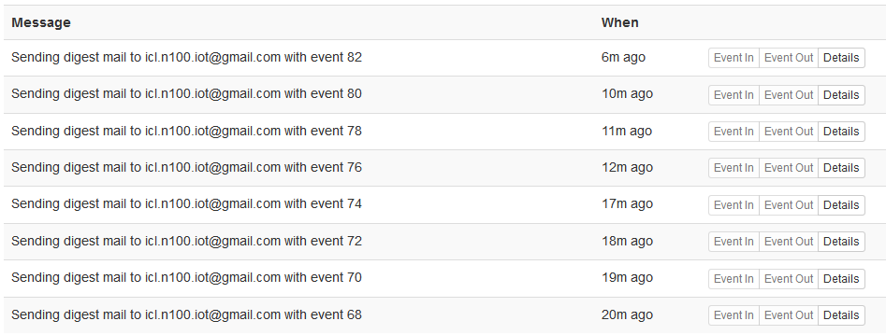

Email Digest

|  |  |  |
| --- | --- | --- |
| **Agent Name** | **Agent Type** | **主要功能** |
| EmailDigest | Action | 發送電子信件 |
| **本機測試** | 🗸 | |
| **雲端測試** | 🗸 | |

|  |
| --- |
| * **Event In** |
| { "message": "Your message" } |
| * **Agents Option** |
| subject: You have a notification!  headline: Your notification:  expected_receive_period_in_day...: 2  body: 55555  recipients:[  kaogaau@gmail.com  tomatoxlink@gmail.com] |
| * **Action** |
| 發送信件 |

|  |
| --- |
| **備註** |
| 1. 此Agent會將收到的event payload中，key為message的資料特別拿出來當作body內容寄出去。如果event payload中沒有key為message的資料，寄發的Email會將所有的資訊都寄發，包括寄件者收件者等等諸多資訊，通通塞在body中，看起來會很亂 2. 收到event先存在memory之後執行時送 3. Schedule模式 |

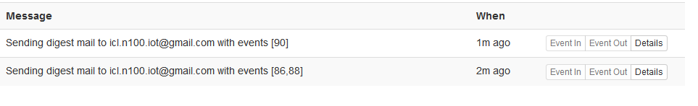

Evernote Append Note

|  |  |  |
| --- | --- | --- |
| **Agent Name** | **Agent Type** | **主要功能** |
| EvernoteAppendNote | Action | 附加內容 |
| **本機測試** |  | |
| **雲端測試** |  | |

|  |  |
| --- | --- |
| * **Event In** | |
| 任何 | |
| * **Agents Option** | |
| type : normal |  |
| note_title : test |  |
| note_body : test |  |
| notebook : first notebook |  |
| tags : [test,test1] |  |
| * **Action** | |
| 附加新內容 | |

Evernote Create Note

|  |  |  |
| --- | --- | --- |
| **Agent Name** | **Agent Type** | **主要功能** |
| EvernoteCreateNote | Action | 產生新筆記 |
| **本機測試** |  | |
| **雲端測試** |  | |

|  |  |
| --- | --- |
| * **Event In** | |
| 任何 | |
| * **Agents Option** | |
| type : normal |  |
| note_title : test |  |
| note_body : test |  |
| notebook : first notebook |  |
| tags : [test,test1] |  |
| * **Action** | |
| 增加新筆記 | |

Exchange Calendar Create Event

Exchange Mail Send Message

Facebook Publish

|  |  |  |
| --- | --- | --- |
| **Agent Name** | **Agent Type** | **主要功能** |
| FacebookPublish | Action | 臉書Po文 |
| **本機測試** | 測試通過 | |
| **雲端測試** | 測試通過 | |

|  |  |
| --- | --- |
| * **Event In** | |
| text:{777 } #Po文內容 | |
| * **Agents Option** | |
| expected_update_period_in_days : 1 |  |
| message_path : text |  |
| data_url : $ | 可不加 |
| * **Action** | |
| 上傳臉書文章 | |

|  |
| --- |
| **備註** |
| 1. 不支援Liquid語法( 不能加{{}} ) 2. 目前只能上傳到動態牆 不能放到相簿裡   三 一定要有message_path 欄位 |

Example

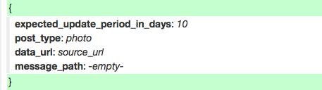

Gmail Send Message

|  |  |  |
| --- | --- | --- |
| **Agent Name** | **Agent Type** | **主要功能** |
| GmailSendMessage | Action | 送出信件 |
| **本機測試** | 測試通過 | |
| **雲端測試** | 測試通過 | |

|  |  |
| --- | --- |
| * **Event In** | |
| 任何 | |
| * **Agents Option** | |
| message_to_address : [kaogaau@gmail.com](mailto:kaogaau@gmail.com) |  |
| message_subject : Hi |  |
| message_body : play together |  |
| message_attachment_url : file url |  |
| * **Action** | |
| 送出Mail | |

Google Calendar Create Event

|  |  |  |
| --- | --- | --- |
| **Agent Name** | **Agent Type** | **主要功能** |
| GoogleCalendarCreateEvent | Action | 寫入會議 |
| **本機測試** | 🗸 | |
| **雲端測試** | 🗸 | |

|  |  |
| --- | --- |
| * **Event In** | |
|  | |
| * **Agents Option** | |
| expected_update_period_in_days : 1 | 填1 |
| Path : message | Event In的path |
| * **Action** | |
| 寫入會議 | |

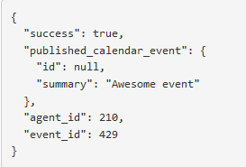

Google Drive Upload File

|  |  |  |
| --- | --- | --- |
| **Agent Name** | **Agent Type** | **主要功能** |
| GoogleDriveUploadFile | Action | 上傳檔案 |
| **本機測試** |  | |
| **雲端測試** |  | |

|  |
| --- |
| * **Event In** |
|  |
| * **Agents Option** |
|  |
| * **Action** |
|  |

|  |
| --- |
| **備註** |
| 1. 與DropboxFileUploadu一樣 |

Google Spreadsheet Add Row

|  |  |  |
| --- | --- | --- |
| **Agent Name** | **Agent Type** | **主要功能** |
| GoogleSpreadsheetAddRow | Action | Spreadsheet增加新的Row Data |
| **本機測試** |  | |
| **雲端測試** |  | |

|  |  |
| --- | --- |
| * **Event In** | |
| 任何 | |
| * **Agents Option** | |
| google_spreadsheet_name: --name-- |  |
| google_folder_name: /tomatox |  |
| content_string: {{content}} |  |
| * **Action** | |
| 增加新的Row Data | |

備註：google_spreadsheet_name 檔名一定要先建好，才能存資料進去

Itri Exchange Calendar Create Event

Itri Exchange Mail Send Message

Insnergy Controller

|  |  |  |
| --- | --- | --- |
| **Agent Name** | **Agent Type** | **主要功能** |
| InsnergyCheckNew | Action | 控制Insnergy開關 |
| **本機測試** | 🗸 | |
| **雲端測試** | 🗸 | |

|  |  |
| --- | --- |
| * **Trigger Condition** | |
| 上面有event送下來時 | |
| * **Agents Option** | |
| expected_update_period_in_days : 1 | 填1 |
| device_id : RS06000D6F0003BBA08C |  |
| Status : on | 填 on 或 off |
| * **Action** | |
| 把開插座或關閉插座 | |

Lifx

|  |  |  |
| --- | --- | --- |
| **Agent Name** | **Agent Type** | **主要功能** |
| Lifx | Action |  |
| 本機測試 |  | |
| 雲端測試 |  | |

|  |
| --- |
| * **Trigger Condition** |
|  |
| * **Agents Option** |
| Mode : breath  Color : kelvin:2500~9000 //顏色值 |
| * **Action** |
|  |

|  |
| --- |
| **備註** |
| **Token :** c00f627c52a90794c48ce4523a9b6bbf1e4a3f516c6ffe00e3631992f247eb28   1. label選項一定要有 label: XXX的格式 |

Nexmo

|  |  |  |
| --- | --- | --- |
| **Agent Name** | **Agent Type** | **主要功能** |
| Nexmo | Action | 透過Nexmo發送訊息或打電話 |
| **本機測試** | 🗸 | |
| **雲端測試** | 🗸 | |

|  |
| --- |
| * **Event In** |
| { "message": "Your message" } |
| * **Agents Option** |
| mode: SMS  message: Hi, I'm tomato.  voice: female  callNumber: 886987654321 |
| * **Action** |
| 根據mode模式發送訊息或打電話 |

|  |
| --- |
| **備註** |
| 1. message可中文，callNumber只能有一組號碼 2. 需由PHP API呼叫service，URL設定於.env中NOTIFICATION_SERVER |

Notification

|  |  |  |
| --- | --- | --- |
| **Agent Name** | **Agent Type** | **主要功能** |
| Notification | Action | 發送GCM通知 |
| **本機測試** | 🗸 | |
| **雲端測試** |  | |

|  |
| --- |
| * **Event In** |
| { "message": "Your message" } |
| * **Agents Option** |
| Message: {{message}} |
| * **Action** |
| 發送Message欄位裡的訊息 |

|  |
| --- |
| **備註** |
| 1. 跟User綁定的,User用哪支手機GCM就發到哪個手機 2. 要連上手機才能確定有無收到GCM huginn本身看不到(不會發event) |

CMD-NORMAL 鈴聲開啟

CMD-SILENT 鈴聲靜音

Pocket Add

|  |  |  |
| --- | --- | --- |
| **Agent Name** | **Agent Type** | **主要功能** |
| PocketAdd | Action | 將網頁加入Pocket裡 |
| **本機測試** | 🗸 | |
| **雲端測試** | 🗸 | |

|  |
| --- |
| * **Event In** |
| 任何 |
| * **Agents Option** |
| add_url: http://goessner.net/articles/J... #要加入的網頁  tags: [test1,test2] #網頁tag |
| * **Action** |
| 將網頁加入Pocket裡 |

Trello Create Card

|  |  |  |
| --- | --- | --- |
| **Agent Name** | **Agent Type** | **主要功能** |
| TrelloCreateCard | Action | 在Trello加入新東西 |
| **本機測試** | 🗸 | |
| **雲端測試** | 🗸 | |

|  |
| --- |
| * **Event In** |
| 任何 |
| * **Agents Option** |
| board_name: Test  list_name: bbb  position: top  card_title: play  card_description: play..  card_assigin_members: -empty-  card_apply_labels: ??  card_attachment_url: ?? |
| * **Action** |
| Trello加入新東西 |

# OTHER AGENTS

Fetch Weather Data

|  |  |  |
| --- | --- | --- |
| **Agent Name** | **Agent Type** | **主要功能** |
| FetchWeatherData | System | 定時抓紫外線與PM2.5資料 |
| **本機測試** | 🗸 | |
| **雲端測試** | 🗸 | |

|  |
| --- |
| * **Event In** |
| 定時驅動 |
| * **Agents Option** |
| 無 |
| * **Event Output** |
| 將紫外線與PM2.5資料寫進資料庫 |

|  |
| --- |
| **備註** |
| 1. 此Agent是由於天氣裡的紫外線與PM2.5不常更動於是固定改起一個此Agents每天某個時間抓取資料存進資料庫 2. 存入weather_observations資料表中 |

Manul event

|  |  |  |
| --- | --- | --- |
| **Agent Name** | **Agent Type** | **主要功能** |
| ManulEvent | System | 發測試event |
| **本機測試** | 🗸 | |
| **雲端測試** | 🗸 | |

|  |
| --- |
| * **Trigger Condition** |
| 用show來trigger |
| * **Agents Option** |
| 無 |
| * **Event Output** |
| 看show怎麼填 |

|  |
| --- |
| **備註** |
| 1. 此agent是用來發測試用的events用 |

Post

|  |  |  |
| --- | --- | --- |
| **Agent Name** | **Agent Type** | **主要功能** |
| Post | System | 發送Post |
| **本機測試** |  | |
| **雲端測試** |  | |

|  |
| --- |
| * **Trigger Condition** |
| 任何events |
| * **Agents Option** |
| post_url: http://www.example.com  expected_receive_period_in_day...: 1  content_type: form  method: post  payload:{  key: value  something: the event contained}  headers:{} |
| * **Event Output** |
| 發送POST |

|  |
| --- |
| **備註** |
| 1. 此Agents用來發送POST測試 |

# II. EDIT AUTORUN

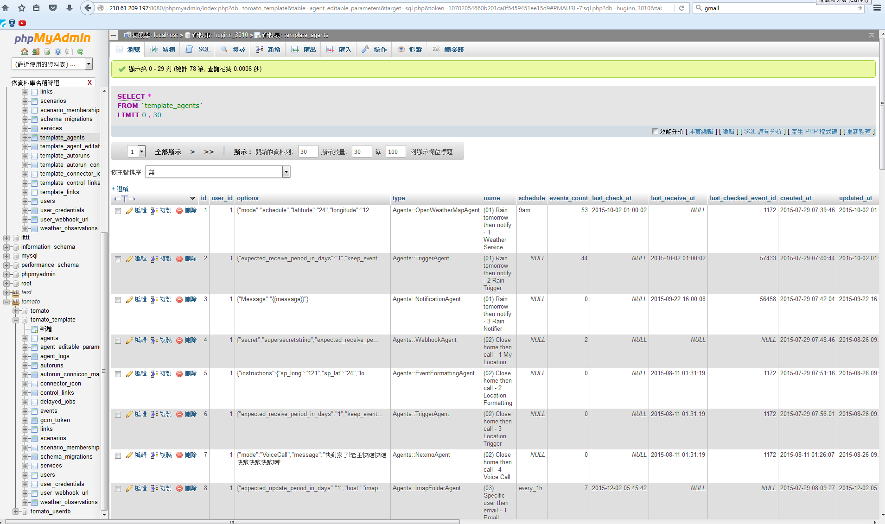

1. 進入<http://54.251.44.21/phpmyadmin> 裡
2. 找到huginn_3008資料庫
3. 進入agents表格找到前一章建置AutoRun所使用的agents id
4. 進入autoruns表格將autorun資料建置起來，填寫資料如下

|  |  |
| --- | --- |
| **欄位** | **填寫項目** |
| start_id | Autorun起始的第一個agent id |
| description | Autorun描述 |
| sequence | 去掉第一個agent，依序填入autorun的agent id ex: 47_48_49 |
| source_id | 與start_id一樣 |
| enable | 1 |

1. 找到agent_editable_parameters表格，對要開放給使用者的參數進行編輯
2. 進入autorun_connicon_map表格，進行APP圖案配置編輯，此部分要與APP負責人協調溝通

PS : 不能兩條AUTORUN尾巴接同一個AGENT

**手動更改資料庫以下三張表格**

1. 先更改autoruns

|  |  |
| --- | --- |
| 欄位 | 說明 |
| id | 依序填 |
| user_id | 都填1 |
| start_id | Autorun開始Agent的id |
| description | Autorun的描述 |
| sequence | Autorun從第二個Agent的id依序填到最後一個Agent的id |
| source_start | Autorun開始Agent的id |
| end_id | Autorun最後的Agent的id |
| enable | 填1（是否要在手機上顯示） |

1. 再更改agent_editable_parameters（想讓使用者設定的參數）

|  |  |
| --- | --- |
| 欄位 | 說明 |
| autoruns_id | autoruns表的id |
| agent_id | 要讓使用者自定選項Agent的id |
| display_order | 依據你想顯示的畫面做排序編號 |
| editable_column | 此欄位必須對應Agent的option key  ../../../../../../../Desktop/螢幕快照%202016-03-25%20 |
| display_name | 手機端顯示title名稱 |
| conditions_type | 選項形式 (參考備註) |
| conditions | 依據選項不同填入不同的參數(參考備註) |
| is_system | 是否屬於系統參數（手機需要知道的值，但不能給使用者修改！！如（webhookAgent）conditions_type ： key）  0:不是，使用者看得到1:是，使用者看不到 |
| connector_type | 屬於When參數還是Do的參數  0:When 1:Do |
| agent_parament | schedule:屬於時間頻率就填schedule  options:其他都是填options |
| default_value | 是否有預設值0:沒有1:有 |
| provider_id | 只要在conditions_type為querymappingtext填寫相對應的provider_id（看他是需要取的什麼哪個provider device list）備註3 |

備註1：

|  |  |
| --- | --- |
| conditions_type | conditions |
| key(目前專屬webhook使用) | 請填”key“（is_system必定唯”1“!!!） |
| map(地圖，給經緯度，但一次只能給一個數值，所以要一次要用兩個喲！！「一個經度，一個緯度」) | 121,24(填經緯度數值，請讓他們固定他們顯示的順序「display_order」1:經度 2:緯度 感恩！！) |
| radio單一選單 | 以”｜“為區隔  (Ex：Clear｜Clouds｜Drizzle｜Rain｜Thunderstorm｜Snow) 備註2 參數內容：必須符合agent可用參數！！ |
| richcheckbox 多選（目前for 天氣使用 有圖片＋文字） | 以”｜“為區隔  (Ex：Clear｜Clouds｜Drizzle｜Rain｜Thunderstorm｜Snow) 備註2 參數內容：必須符合agent可用參數！！ |
| checkbox多選（純文字顯示） | 以”｜“為區隔  (Ex：Clear｜Clouds｜Drizzle｜Rain｜Thunderstorm｜Snow) 備註2 參數內容：必須符合agent可用參數！！ |
| text 文字填寫 | 輸入要顯示文字內容即可！！！！  Note:  當default_value=0,所輸入文字會以hint方式顯示（灰色字體）  當default_value=1,所輸入文字會以一般方式顯示（黑色字體） |
| arraytext文字填寫（可輸入多筆資料） | 輸入樣式與規範與text相同  其中多了以”，“區格  (Ex：xxx@ooo.com,aaa@bbb.com) |
| richtext文字填寫 需要跟使用者另外說明或是提醒(為了美觀 考慮以html方式顯示) | 輸入的文字內容是為了提醒使用者此欄位應該輸入怎樣的形式資料  (Ex：1.完全符合標題 =>直接輸入Title 2.部分符合標題 =>(?i)Title (ex: (?i)test =>則test,Test,TEST...皆屬於符合)) |
| mappingtext單一選單 | 以”｜“為區隔 以”：“分別key value  (Ex：imap.gmail.com:gmail |  imap-mail.outlook.com:hotmail)  使用者只為看到value的值 ，但server只認得key 參數內容：必須符合agent可用參數！！ |
| email文字填寫 | 輸入樣式與規範與text相同  只輸入email格式 （手機端要檢驗格式） |
| password文字填寫 | 輸入樣式與規範與text相同  (手機端要以＊＊＊顯示) |
| phone文字填寫 | 輸入樣式與規範與text相同  （手機端要去檢查是否為國碼886） |
| querymappingtext單一選單 | 只要輸入”裝置列表“就好  （手機端遇到此類別 需要呼叫GetDeviceList API 是取得列表 以單選的方式顯示！！！！！！） |

備註2：

天氣(Clear｜Clouds｜Drizzle｜Rain｜Thunderstorm｜Snow)

時間頻率（every_1m｜every_2m｜every_5m｜every_10m｜every_30m｜every_1h｜every_2h｜every_5h｜every_12h｜every_1d｜every_2d｜every_7d｜midnight｜1am｜2am｜3am｜4am｜5am｜6am｜7am｜8am｜9am｜10am｜11am｜noon｜1pm｜2pm｜3pm｜4pm｜5pm｜6pm｜7pm｜8pm｜9pm｜10pm｜11pm｜never）

UVI指數（0:low|1:medium|2:high|3:very high|4:danger）

之後會有還有許多參數加入（依據agent的新增開發），所以有需要的話問agnet的開發者！！！

備註3:

proider_id請參考service_list的id(之後會一直持續更新這張table 所以近ＤＢ看吧！！)

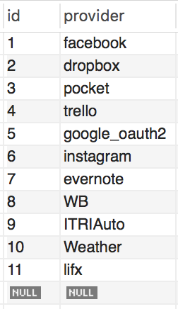

1. 再更改autorun_connicon_map

|  |  |
| --- | --- |
| 欄位 | 說明 |
| autoruns_id | autoruns表的id |
| connector_icon_id | 要顯示的圖示！！！！ |
| connector_type | 屬於When圖示還是Do的圖示  0:When圖示 1:Do圖示 |

# III. COPY AUTORUN

找小曹拿script

# IV. Appendix

PostMan使用:



輸入webhook的網址



選擇“Body” 在選 “raw” 格式要改成“JSON(application/json)”

填寫傳輸內容“{"location":{"longitude":121.0437915,"latitude":24.7773078}}“

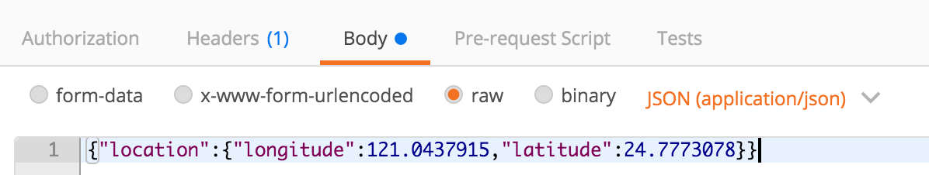

{

"location":

{

"longitude": "121",

"latitude": "24"

}

}

{

"trigger_device": "79-69-69-2D-30-31-0",

"trigger_type": "1",

"trigger_status": "1"

}