CHAPTER 7 DATA VISUALIZATION

***Listing 7-16.*** Matplotlib Line Plotting

*In [2]: import matplotlib.pyplot as plt*

*x =[3,6,8,11,13,14,17,19,21,24,33,37]*

*y = [7.5,12,13.2,15,17,22,24,37,34,38.5,42,47]*

*x2 =[3,6,8,11,13,14,17,19,21,24,33]*

*y2 = [50,45,33,24,21.5,19,14,13,10,6,3]*

*plt.plot(x,y, label='First Line')*

*plt.plot(x2, y2, label='Second Line')*

*plt.xlabel('Plot Number')*

*plt.ylabel('Important var')*

*plt.title('Interesting Graph\n2018 ')*

*plt.yticks([0,5,10,15,20,25,30,35,40,45,50], ['0B','5B','10B','15B','20B','25B','30B','35B', '40B','45B','50*

*B'])*

*plt.legend()*

*plt.show()*

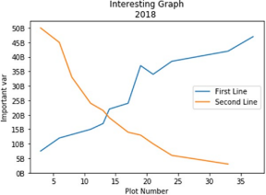322

*In [13]: plt.plot(phd, label='Ph.D.')*

CHAPTER 7 DATA VISUALIZATION

*plt.plot(service, label='service')*

*plt.xlabel('Ph.D./service')*

*plt.ylabel('Frequency')*

*plt.title('Ph.D./service\nDistribution') plt.legend()*

*plt.show()*

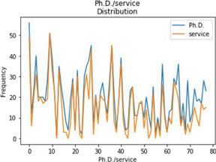

*In [15]: plt.plot(phd, service, 'bo', label="Ph.D. Vs services", lw=10)*

*plt.grid()*

*plt.legend()*

*plt.xlabel('Ph.D')*

*plt.ylabel('service')*

*plt.title('Ph.D./salary\nDistribution') plt.yscale('log')*

323

CHAPTER 7 DATA VISUALIZATION

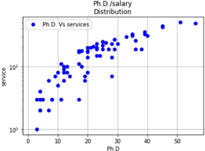

Bar Chart

Listing 7-17 shows how to create a bar chart to present students registered for courses; there are two students who are registered for four courses.

***Listing 7-17.*** Matplotlib Bar Chart Plotting

*In [3]: Students = [2,4,6,8,10]*

*Courses = [4,5,3,2,1]*

*plt.bar(Students,Courses, label="Students/Courses") plt.xlabel('Students ')*

*plt.ylabel('Courses')*

*plt.title('Students Courses Data\n 2018') plt.legend()*

*plt.show()*

324

CHAPTER 7 DATA VISUALIZATION

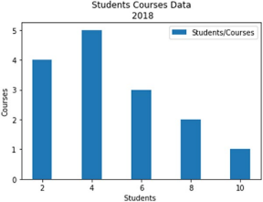

*In [4]: Students = [2,4,6,8,10]*

*Courses = [4,5,3,2,3]*

*stds = [3,5,7,9,11]*

*Projects = [1,2,4,3,2]*

*plt.bar(Students, Courses, label="Courses", color='r') plt.bar(stds, Projects, label="Projects", color='c') plt.xlabel('Students')*

*plt.ylabel('Courses/Projects')*

*plt.title('Students Courses and Projects Data\n 2018') plt.legend()*

*plt.show()*

325

CHAPTER 7 DATA VISUALIZATION

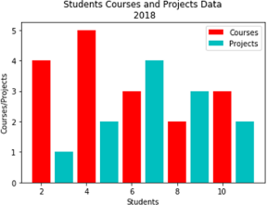

Histogram Plot

Listing 7-18 shows how to create a histogram showing age frequencies; most people in the data set are between 30 and 40. In addition, you can create a histogram of the years of service and the number of PhDs.

***Listing 7-18.*** Matplotlib Histogram Plotting

*In [5]: Ages = [22.5, 10, 55, 8, 62, 45, 21, 34, 42, 45, 99, 75, 82,*

*77, 55, 43, 66, 66, 78, 89, 101, 34, 65, 56, 25, 34,*

*52, 25, 63, 37, 32]*

*binsx = [0, 10, 20, 30, 40, 50, 60, 70, 80, 90, 100, 110] plt.hist(Ages, bins=binsx, histtype='bar', rwidth=0.7)*

326

*plt.xlabel('Ages') plt.ylabel('Frequency')*

CHAPTER 7 DATA VISUALIZATION

*plt.title('Ages frequency for sample pouplation\n 2018') plt.show()*

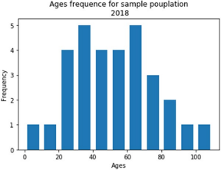

*In [18]: plt.hist(service, bins=30, alpha=0.4, rwidth=0.8, color='green', label='service')*

*plt.hist(phd, bins=30, alpha=0.4, rwidth=0.8, color='red', label='phd')*

*plt.xlabel('Services/phd')*

*plt.ylabel('Distribution')*

*plt.title('Services/phd\n 2018')*

*plt.legend(loc='upper right')*

*plt.show()*

327

CHAPTER 7 DATA VISUALIZATION

Visualize service years since Ph.D. had attained.

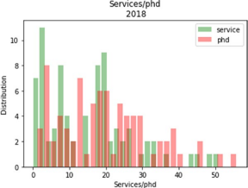

*In [19]: plt.hist(service, bins=10, alpha=0.4, rwidth=0.8, color='green', label='service')*

*plt.hist(phd, bins=10, alpha=0.4, rwidth=0.8, color='red', label='phd')*

*plt.xlabel('Services/phd')*

*plt.ylabel('Distribution')*

*plt.title('Services/phd\n 2018')*

*plt.legend(loc='upper right')*

*plt.show()*

328

CHAPTER 7 DATA VISUALIZATION

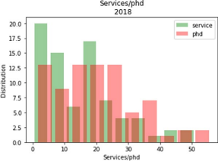

*In [21]: plt.hist(salary, bins=100)*

*plt.show()*

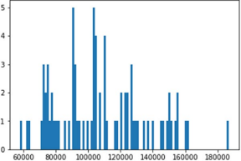329

CHAPTER 7 DATA VISUALIZATION

Scatter Plot

Listing 7-19 shows how to create a scatter plot to present students registered for courses, where four students are registered for five courses.

***Listing 7-19.*** Matplotlib Scatter Plot

*In [7]: Students = [2,4,6,8,6,10, 6] Courses = [4,5,3,2,4, 3, 4] plt.scatter(Students,Courses, label='Students/Courses', color='green', marker='*', s=75 )*

*plt.xlabel('Students')*

*plt.ylabel('Courses')*

*plt.title('Students courses\n Spring 2018') plt.legend()*

*plt.show()*

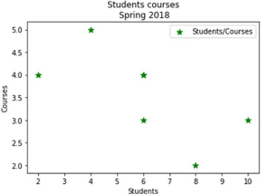330

CHAPTER 7 DATA VISUALIZATION

*In [16]: plt.scatter(rank,salary, label='salary/rank', color='g', marker='+', s=50 )*

*plt.xlabel('rank') plt.ylabel('salary') plt.title('salary/rank\n Spring 2018')*

*plt.legend() plt.show()*

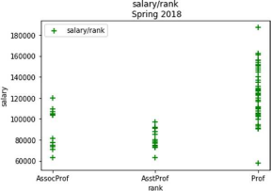

*In [20]: plt.scatter(phd,salary, label='Salary/phd', color='g', marker='+', s=80 )*

*plt.xlabel('phd') plt.ylabel('salary')*

*plt.title('phd/ salary\n Spring 2018')*

*plt.legend() plt.show()*

331

CHAPTER 7 DATA VISUALIZATION

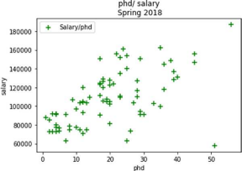

Stack Plot

Stack plots present the frequency of every activity, such as the frequency of sleeping, eating, working, and playing per day (see Listing 7-20). In this data set, on day 2, a person spent eight hours sleeping, three hours in eating, eight hours working, and five hours playing.

***Listing 7-20.*** Persons Weekly Spent Time per activities using Matplotlib Stack Plot

*In [9]: days = [1,2,3,4,5]*

*sleeping = [7,8,6,11,7]*

*eating = [2,3,4,3,2]*

*working = [7,8,7,2,2]*

*playing = [8,5,7,8,13]*

*plt.plot([],[], color='m', label='Sleeping') plt.plot([],[], color='c', label='Eating') plt.plot([],[], color='r', label='Working')*

332

CHAPTER 7 DATA VISUALIZATION

*plt.plot([],[], color='k', label='Playing') plt.stackplot(days, sleeping, eating, working , playing, colors=['m','c', 'r', 'k'])*

*plt.xlabel('days')*

*plt.ylabel('Activities')*

*plt.title('Persons Weekly Spent Time per activities\n Spring 2018')*

*plt.legend()*

*plt.show()*

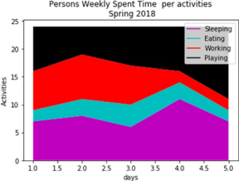333

CHAPTER 7 DATA VISUALIZATION

Pie Chart

In Listing 7-21, you are using the *explode* attribute to slice out a specific activity. After that, you can add the gender and title to the pie chart.

***Listing 7-21.*** Persons Weekly Spent Time per activities using Matplotlib Pie Chart

*In [10]: days = [1,2,3,4,5]*

*sleeping = [7,8,6,11,7]*

*eating = [2,3,4,3,2]*

*working = [7,8,7,2,2]*

*playing = [8,5,7,8,13]*

*slices = [39,14,26,41]*

*activities = ['sleeping', 'eating', 'working', 'playing']*

*cols = ['c','m','r', 'b','g']*

*plt.pie(slices,*

*labels= activities,*

*colors= cols,*

*startangle=100,*

*shadow=True,*

*explode = (0.0,0.0,0.09,0),*

*autopct = '%1.1f%%')*

*plt.title('Persons Weekly Spent Time per activities\n Spring 2018')*

*plt.legend()*

*plt.show()*

334

CHAPTER 7 DATA VISUALIZATION

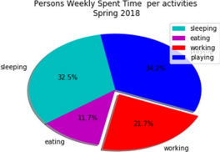

Summary

This chapter covered how to plot data from different collection structures. You learned the following:

– How to directly plot data from a series, data frame, or panel using Python plotting tools such as line plots, bar plots, pie charts, box plots, histogram plots, and scatter plots

– How to implement the Seaborn plotting system using strip plotting, box plotting, swarm plotting, and joint

plotting

– How to implement Matplotlib plotting using line plots, bar charts, histogram plots, scatter plots, stack plots, and pie charts

The next chapter will cover the techniques you’ve studied in this book via two different case studies; it will make recommendations, and much more.

335

CHAPTER 7 DATA VISUALIZATION

Exercises and Answers

1. Create 500 random temperature readings for six cities over a season and then plot the generated data using Matplotlib.

***Answer****:*

See Listing 7-22.

***Listing 7-22.*** Plotting the Temperature Data of Six Cities

*In [4]: import matplotlib.pyplot as plt*

*plt.style.use('classic')*

*%matplotlib inline*

*import numpy as np*

*import pandas as pd*

*In [30]: # Create temperature data*

*rng = np.random.RandomState(0)*

*season1 = np.cumsum(rng.randn(500, 6), 0)*

*In [32]: # Plot the data with Matplotlib defaults plt.plot(season1)*

*plt.legend('ABCDEF', ncol=2, loc='upper left');*

336

CHAPTER 7 DATA VISUALIZATION

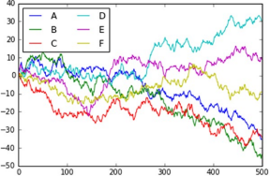

2. Load the well-known Iris data set, which lists

measurements of petals and sepals of three iris

species. Then plot the correlations between each

pair using the *.pairplot()* method.

***Answer:***

See Listing 7-23.

***Listing 7-23.*** Pair Correlations

*In [33]: import seaborn as sns*

*iris = sns.load_dataset("iris")*

*iris.head()*

*sns.pairplot(iris, hue='species', size=2.5);*

337

CHAPTER 7 DATA VISUALIZATION



3. Load the well-known Tips data set, which shows the number of tips received by restaurant staff based on

various indicator data; then plot the percentage of

tips per bill according to staff gender.

338

***Answer:***

See Listing 7-24.

CHAPTER 7 DATA VISUALIZATION

***Listing 7-24.*** First five records in the Tips dataset

*In [36]: import seaborn as sns*

*tips = sns.load_dataset('tips')*

*tips.head()*

**

*In [37]: tips['Tips Percentage'] = 100 * tips['tip'] / tips['total_bill']*

*grid = sns.FacetGrid(tips, row="sex", col="time", margin_titles=True)*

*grid.map(plt.hist, "Tips Percentage", bins=np. linspace(0, 40, 15));*

339

CHAPTER 7 DATA VISUALIZATION



4. Load the well-known Tips data set, which shows the number of tips received by restaurant staff based on

various indicator data; then implement the factor

plots to visualize the total bill per day according to

staff gender.

340

***Answer:***

See Listing 7-25.

CHAPTER 7 DATA VISUALIZATION

***Listing 7-25.*** Implementing Factor Plotting

*In [39]: import seaborn as sns*

*tips = sns.load_dataset('tips')*

*with sns.axes_style(style='ticks'):*

*g = sns.factorplot("day", "total_bill", "sex", data=tips, kind="box")*

*g.set_axis_labels("Bill Day", "Total Bill Amount") *341

CHAPTER 7 DATA VISUALIZATION

5. Reimplement the previous exercise using the Seaborn joint plot distributions.

***Answer:***

See Listing 7-26.

***Listing 7-26.*** Implementing Joint Plot Distributions

*In [43]: import seaborn as sns*

*tips = sns.load_dataset('tips')*

*with sns.axes_style('white'):*

*sns.jointplot( "total_bill", "tip", data=tips, kind='hex')*

**342