Database desing
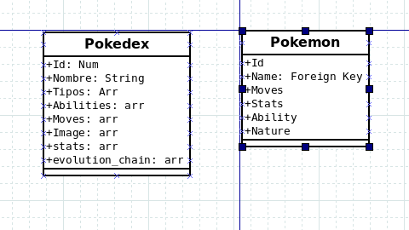

Screen Designs:

HomePage:

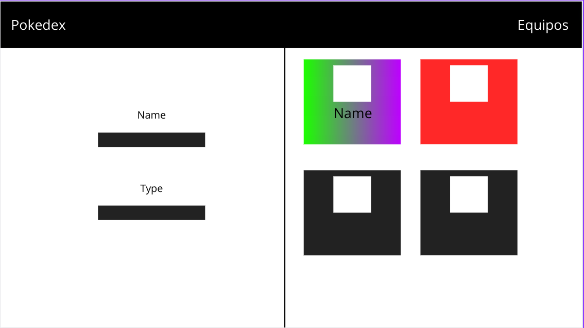

Get Info
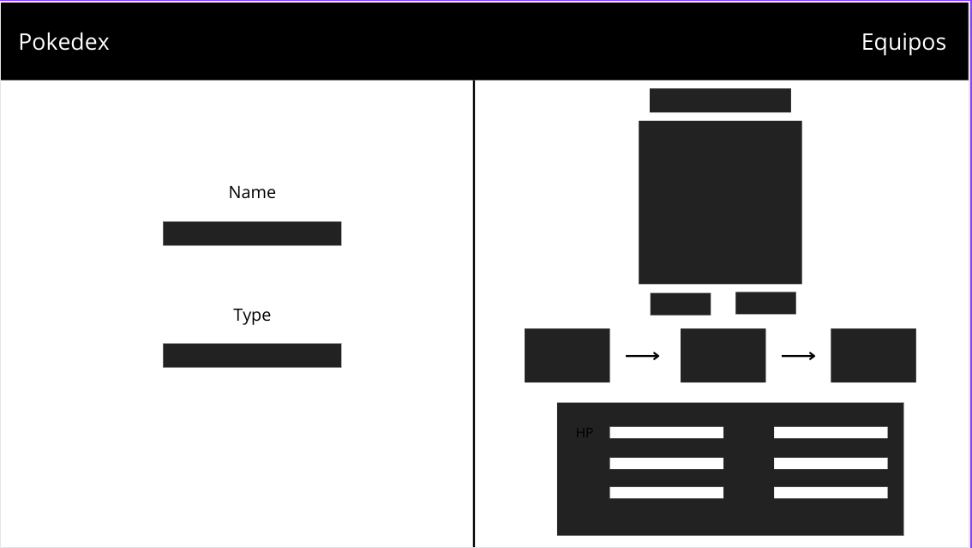

Teams:

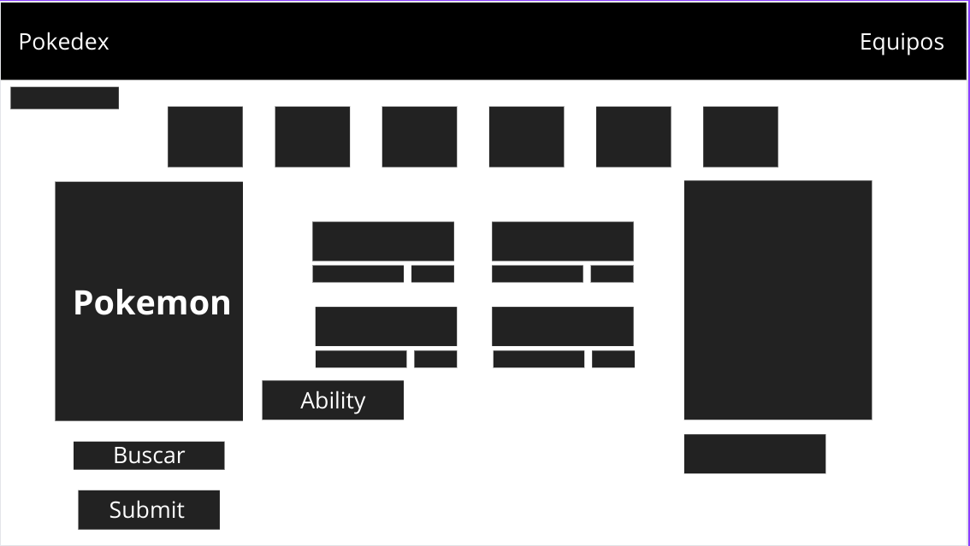

The App uses the following Bundles:

Twig : used for the desing of the webpage.

Doctrine: for database manipulation:

SassBundle: to allow the use of sass on the page.

WebpackEncore: To handle Css and JavaScript

Symfony Form: to render Forms

The project is split in four pages, all handled by the same controller.

The controller is PokedexController and the pages are:

- pokemon/add used to insert data into the database, it queries the pokeapi.co public api and constructs the objects to insert into the database

- app_pokedex , url ‘/’ : It’s the main page of the project, on load it shows 20 diferent pokemons selected at random from the database. It also has a form that allows queries based on name and typing.

- app_getInfo , url ‘/{slug}’ : Where slug is the id of a pokemon in the database , It shows that pokemons stats, it also has the same form from the previous controller which redirects to it.

- app_teams , url ‘/pokemon/teams/{slug}’ : This page has two forms, one of them selects a pokemon from the database and the other one

