
PHP Final Project – Mini D&D simulator – Brais García Pol – 2ºDAW DWCS

Screens and how to navigate between them:

1- First screen is a menu with different options :
- Login
- Character Creation
- Dice rolling
- Logout

Additionally, in every screen there are included a header a footer for easier navigation inbetween the screens and additional information about the web application.

When clicking on each option (a button made with the tag <a> and padding) the user would be redirected to the following screens.

The main objective of the application is to provide a TTRPG (tabletop role playing game) combat simulator in order to make it easier to keep track of interactions during sessions of play and to ease the calculation for people how might have a difficult time with math or understanding the rules of combat. I believe this could be expanded to adopt different systems of play but the current iteration is based on the most popular ttrpg, Dungeons and Dragons.

Colors:
I chose the following colors because I think they communicate the calmness and familiar setting that TTRPG tend to share as they are played mostly among friends:

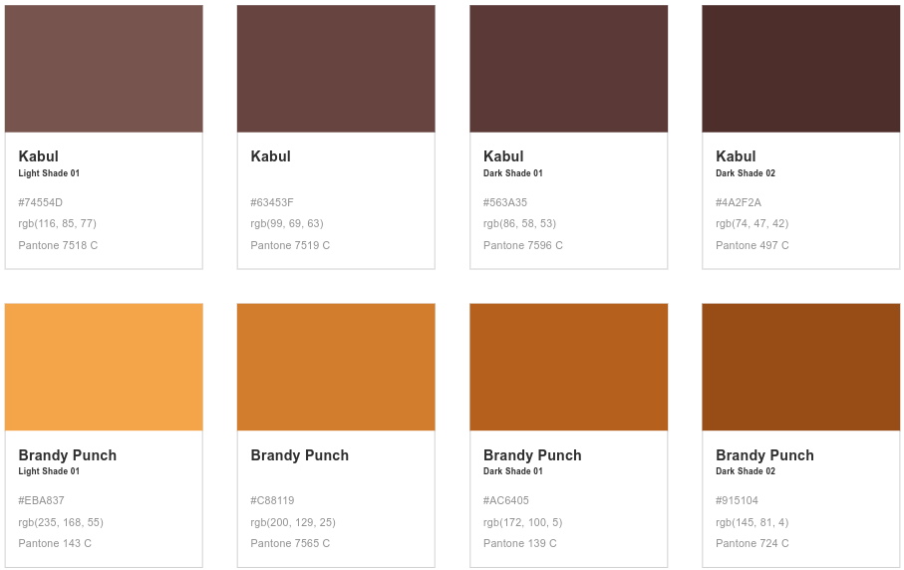
Login:

In this screen the user would be able to access a session in which their data would be kept inbetween pages (form with start_session()). They’ll be able to log out as well (session_unset() and session_destroy()).
At this time, the only possible access is with user: Brais password: 123, but we can arrange a key=>value array in which we record

Form:

In this screen the user would be able to create a character via a form in which they introduce different data, all preserved in their session, taking security and data persistance in mind.

Character creation:

In this screen the user is able to create a character that shares their username as alias. They can manipulate the stats of the chosen weapon along a determined range. In a next update of the application, said weapons would bear an advantage against each other as a form of rock, paper, scissors, hence the choice.

Dice Rolling:

In this screen the user is able to input some modifications to the roll and then proceed to simulate combat until their’s or the enemy’s hp reaches 0. This is made possible by the implementation of classes which, in this case, make up for the structure of the enemy stats allowing each implementation of them to have their separate stats and weapon, as well as adaptability to the app as it can be updated easily with more enemies.

Log out:

A simple logout screen in which the user is informed that they have been logged out of the app. Consecuentially, if they try to access any other screen without being logged in first they will be redirected to the log in screen with the according message.

Common:

Every page contains a header and a footer in order to ease navigation and provide additional information about the app (currently empty). Every link does a background color change on hover to indicate that it`s so.

The extra value considered in the application is that this one takes into consideration statistics and other modifications in order to provide a better simulation of TTRPG combat. It is also possible to update it to take advantage of different persistance systems, such as databases, and keep log of the stats and information of the users throught days, as well as update the number of enemies and variables that might appear on combat.

Directory:
The only directory used was /img, which contains both photos of die represented in the header. Each php file shares the name of its functionality, in order to update the application and make it easier to read in next iterations I would separate some of the functions in other files, but I failed to see that option at the time of writing the original code, I learned to keep everything better organized through the creation of this project

Screen captures:

- Index:
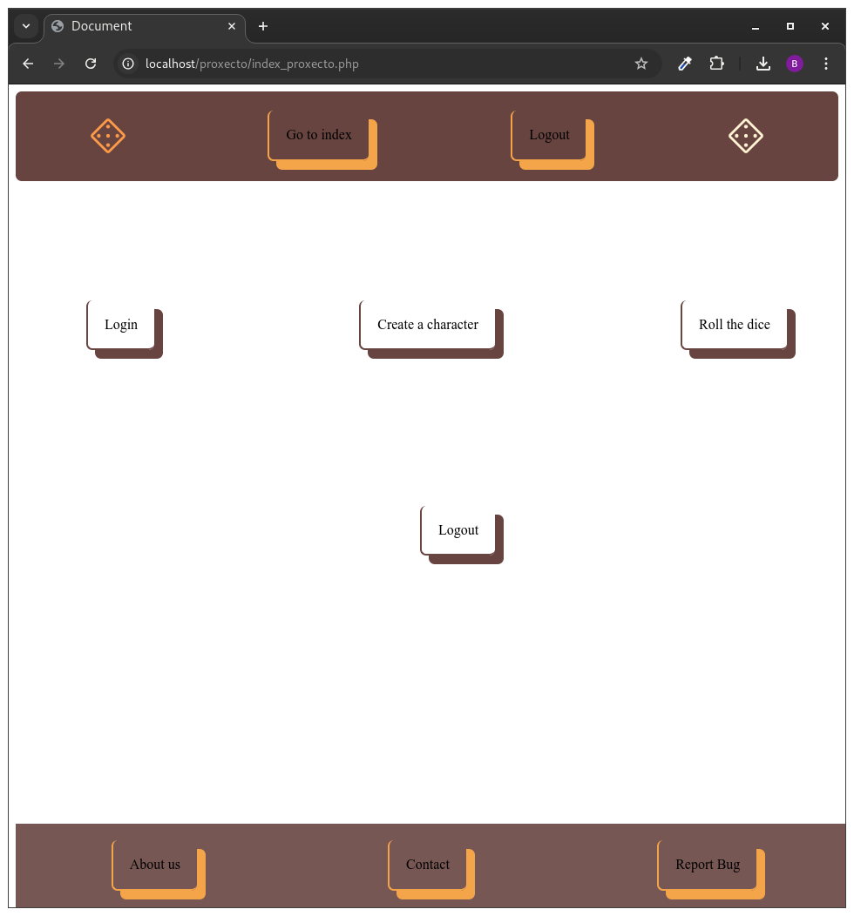

- Login:

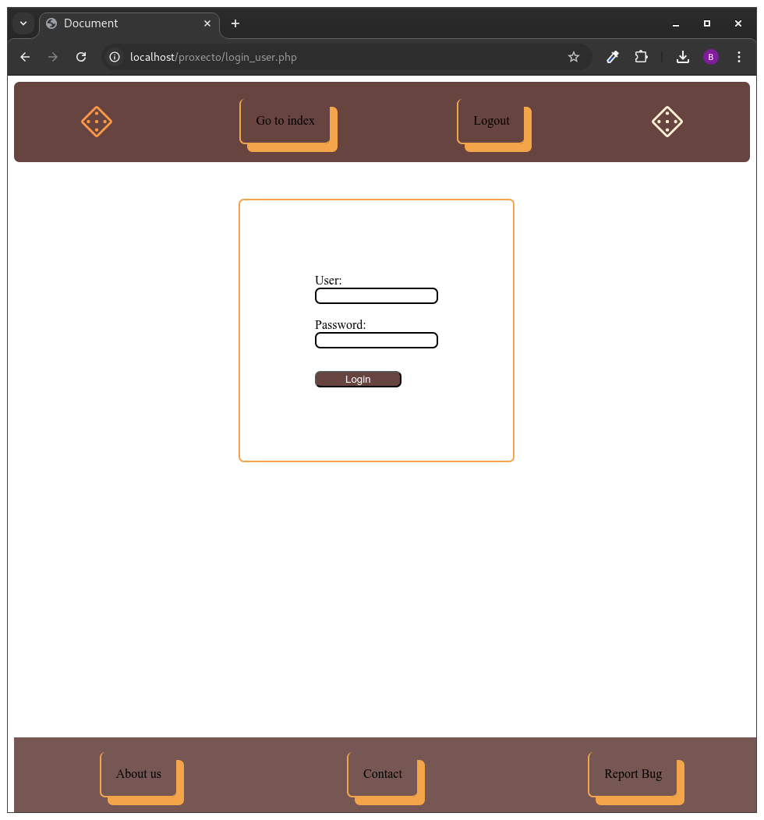

- Login (if the user gets redirected):

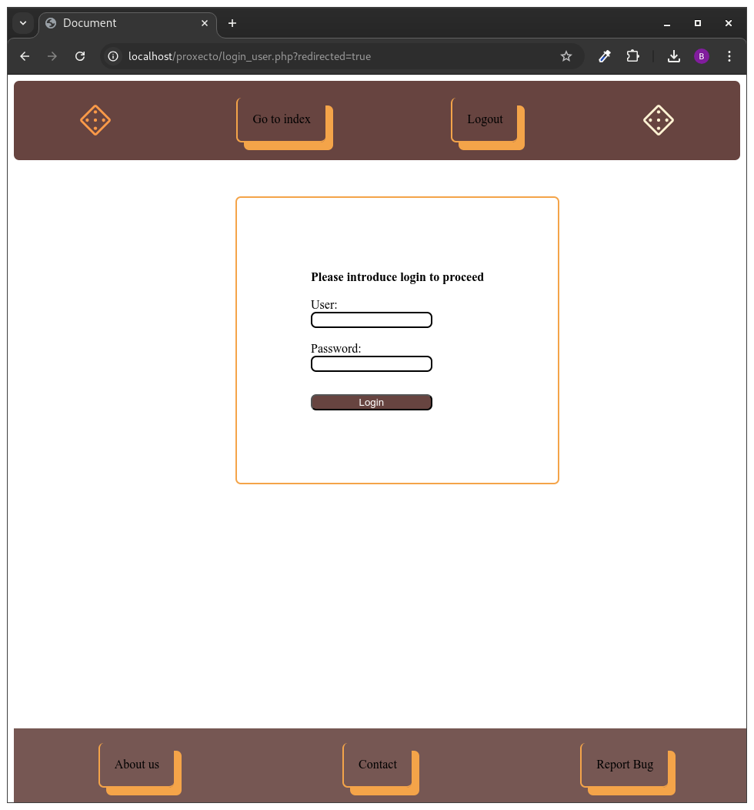

- Character Creation (first Form) :

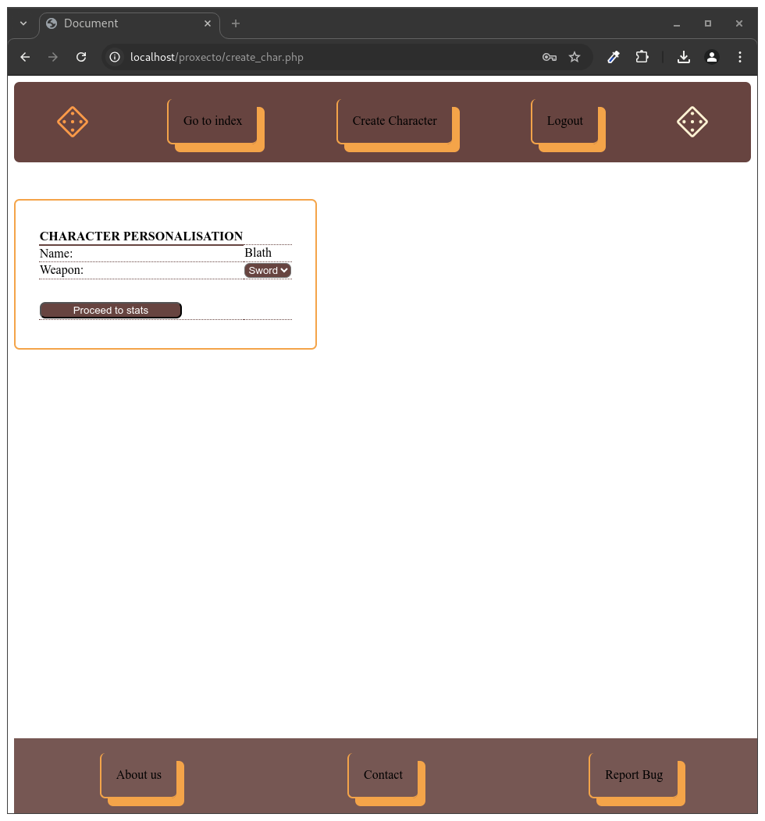

- Character Creation (Second Form):

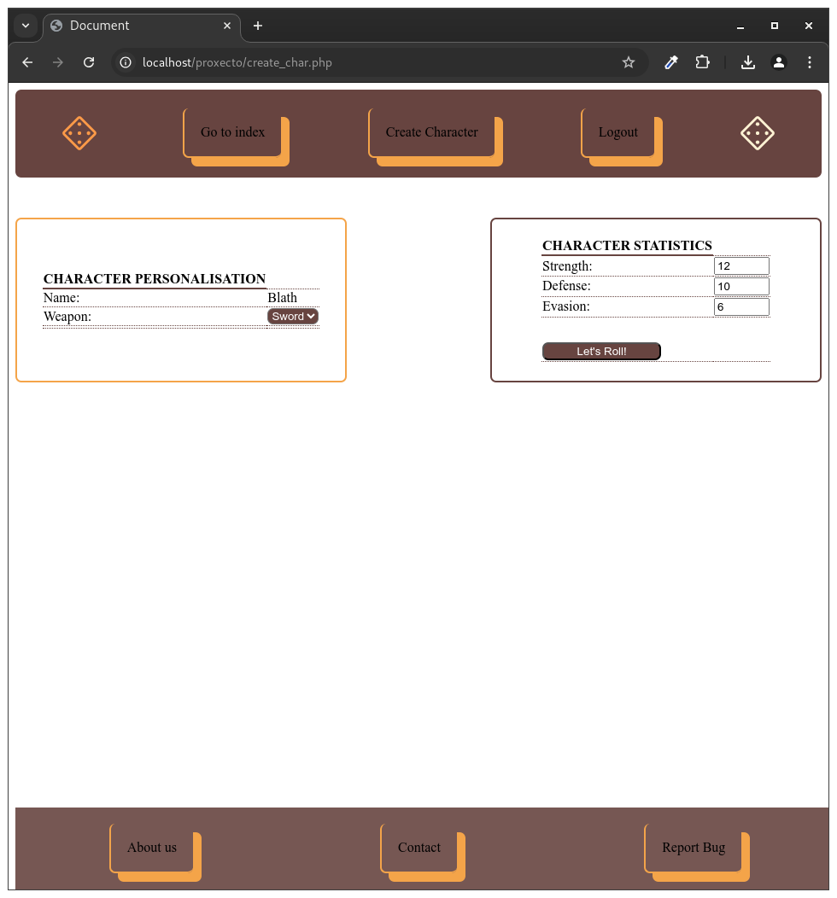

- Character Creation (Final check and proceed to roll_dice.php):

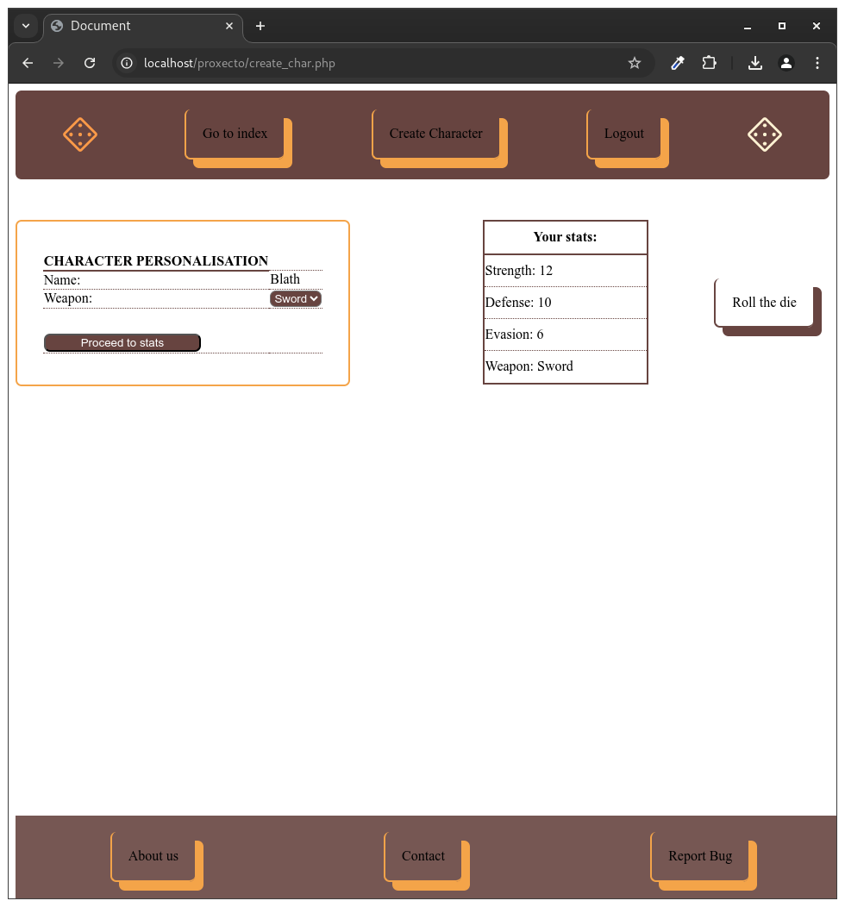

- Roll the dice:

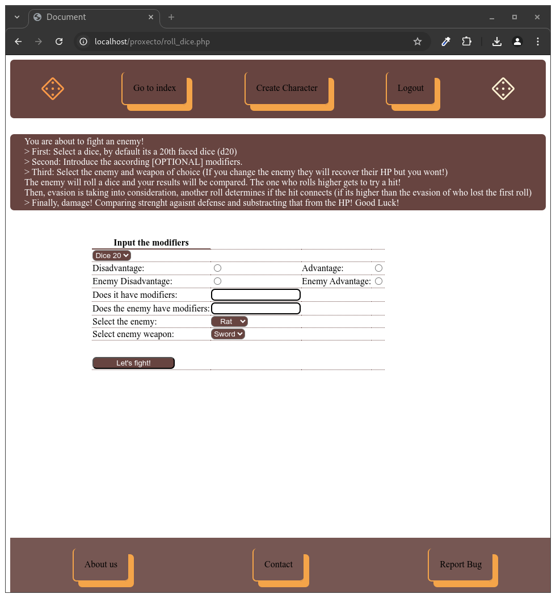

- Roll the dice (With results):

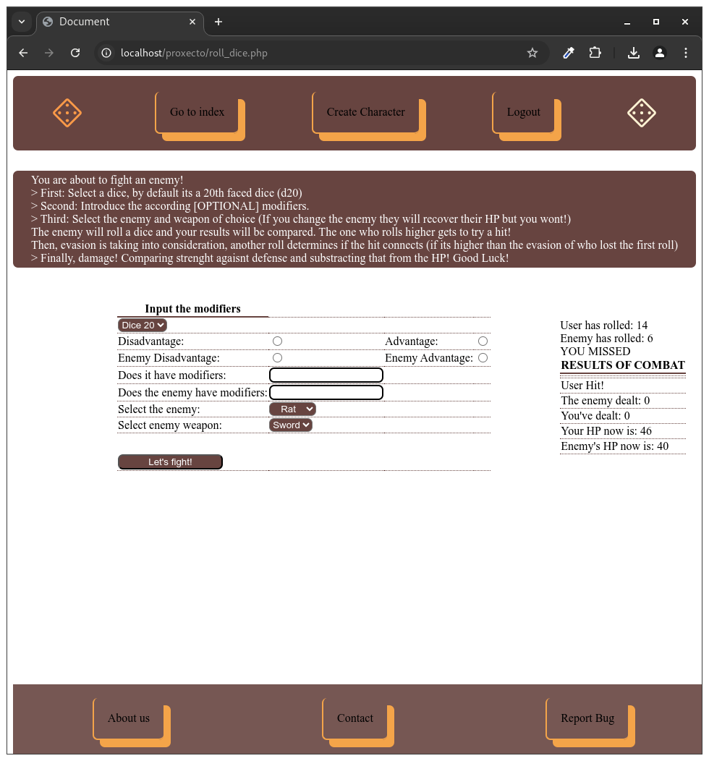

- Roll the dice (If the user falls $_SESSION[“hpUser”] <= 0):

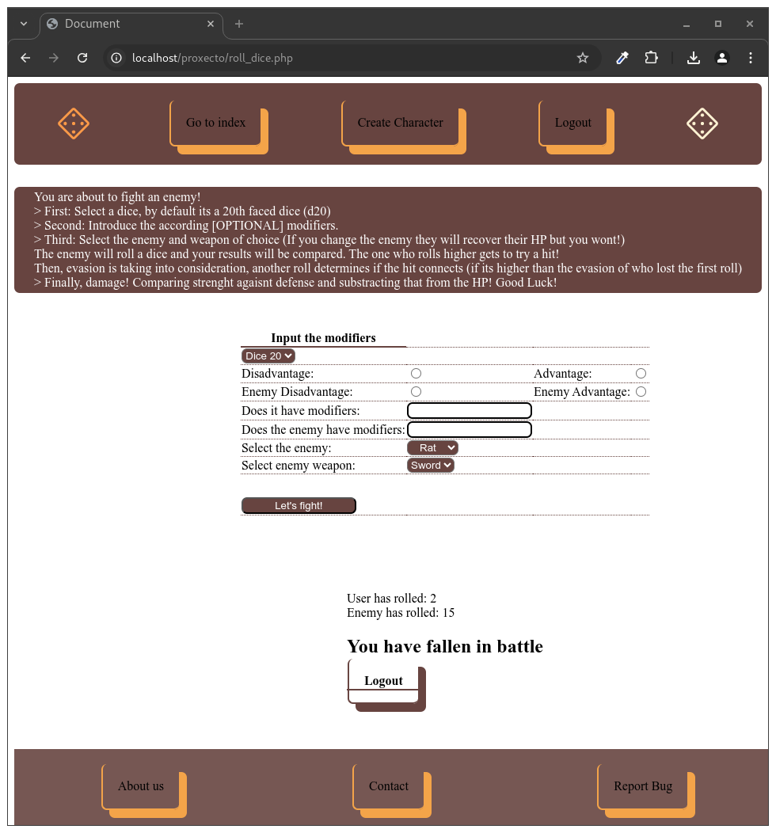

- Roll the dice (If the enemy falls):

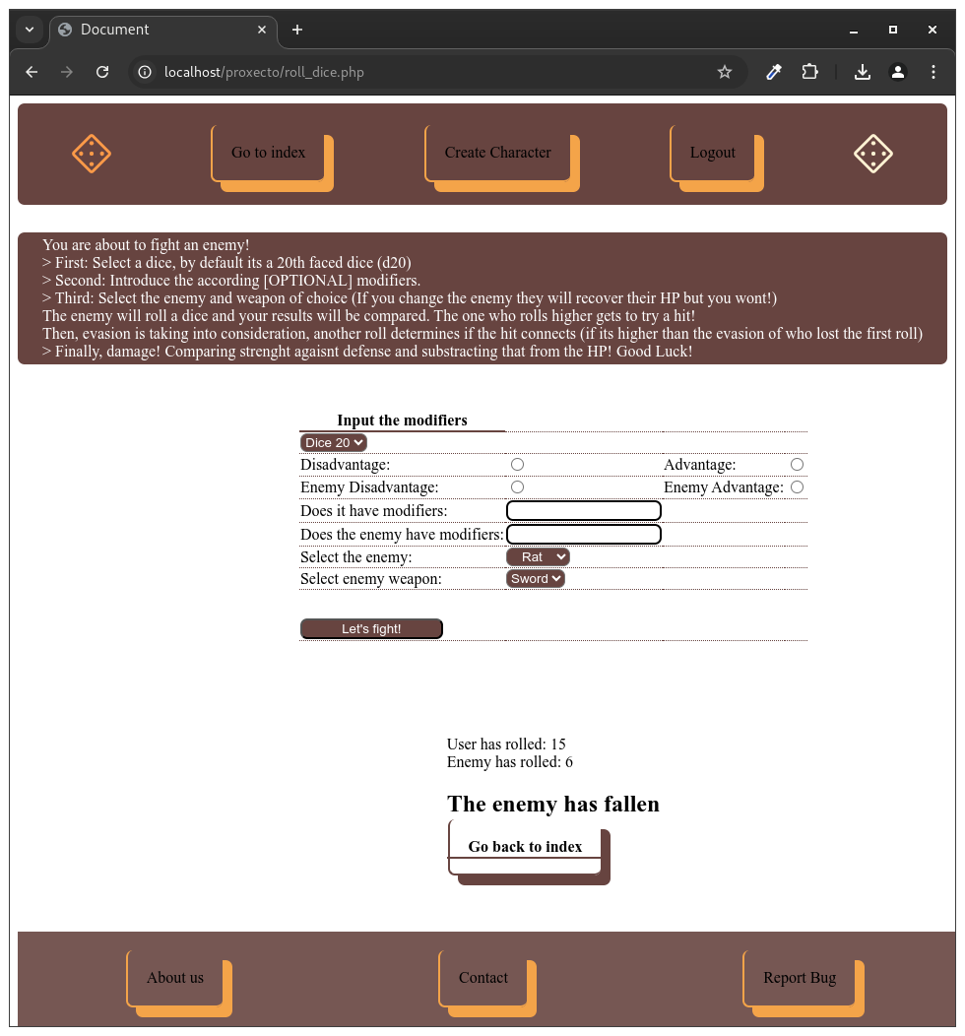

- Logout:
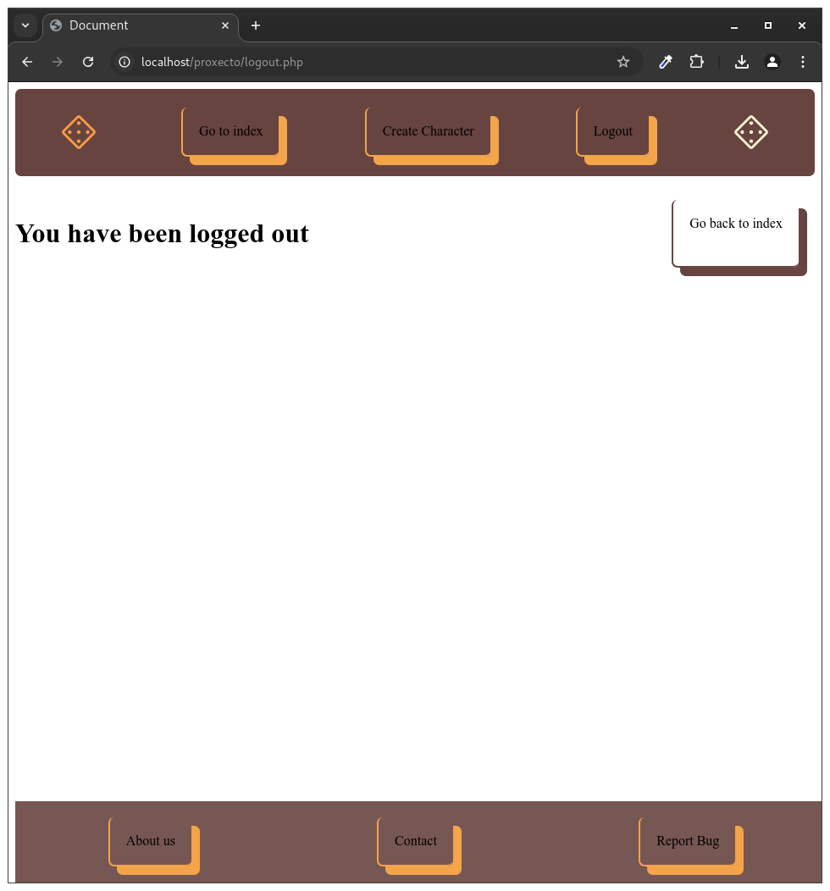

- Directory schema -

