**Running a jar file and database on EC2.**

Step 1: Create an EC2 instance or use the one from the previous lab.

Step 2: Install a database on the EC2 instance. Login using SSH. Set the root password for mariadb.

**sudo su –**

**yum install –y mariadb-server**

**systemctl enable mariadb**

**systemctl start mariadb**

**mysql_secure_installation**

**mysql –uroot –p**

**create database servicedb**

**use servicedb**

<Copy in sql to create tables>

CTRL+C

**yum list java**\*

**yum install java-17-amazon-corretto.x86_64**

**java –version**

Step 3: Upload couponservice jar file to the S3 bucket.

Perform a wget on the url of the jar file to fetch it from the bucket.

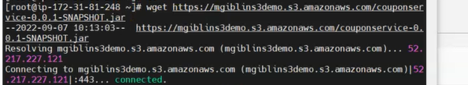

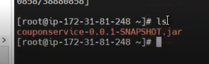

Step 4: Execute the jar file and test the coupon service.

**java –jar couponservice-0.0.1-SNAPSHOT.jar**

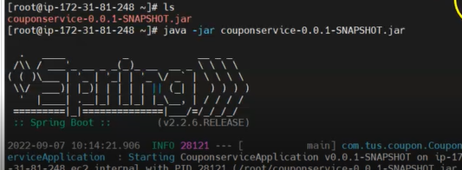

.

Step 5: Edit the security group of your EC2 instance to expose port 9091.

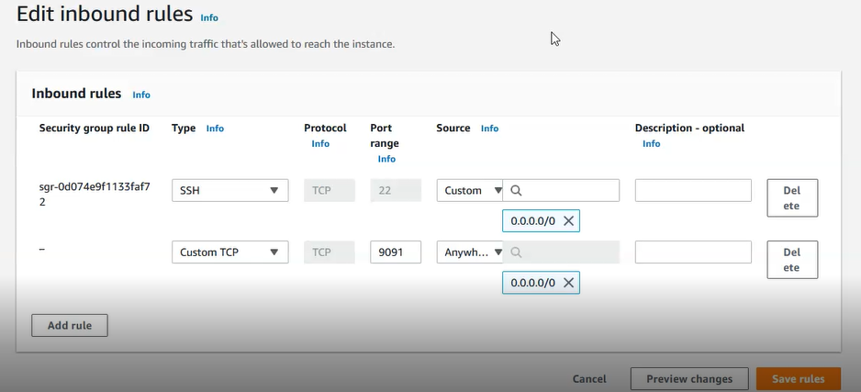

Step 6: Test using Postman

