**Running a basic Microservice.**

Step 1: For this lab you will need the following software

* Java 8 or later
* Spring Tool Suite (if you want to browse code)
* Postman
* MySQL and MySQL Workbench (or alternative)

Step 2: Import the couponservice and the productservice projects (provided) into your IDE. No need to change any code. Database url and password is set in the application.properties file. You may need to change these.

.

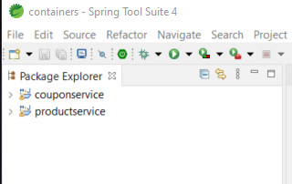

Step 3: Configure the database using the tables.sql file.

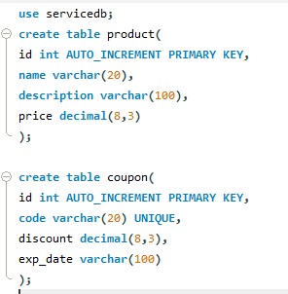

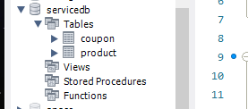

Run the Springboot Applications

Use Postman to create (POST) coupons and products and to fetch (GET) coupons and products.