Industrial Internship Report on Project:
“Turbofan Engine Remaining Useful Life (RUL) Prediction.”
Prepared by:
Abhishek Kumar Gupta

Executive Summary
This report provides details of the Industrial Internship provided by Upskill Campus and The IoT Academy in collaboration with UniConverge Technologies Pvt. Ltd. (UCT).
The internship lasted 6 weeks, during which I worked on the project “Turbofan Engine Remaining Useful Life (RUL) Prediction.” The project focused on building a predictive maintenance solution using NASA’s C-MAPSS turbofan engine dataset, applying machine learning techniques to estimate the Remaining Useful Life of engines.
This internship gave me an opportunity to experience real-world problem-solving, explore industrial data analytics, and build a complete machine learning pipeline—from data preprocessing to model evaluation and deployment. It was an overall enriching and insightful experience.

TABLE OF CONTENTS
1 Preface 3
2 Introduction 4
2.1 About UniConverge Technologies Pvt Ltd 4
2.2 About upskill Campus 8
2.3 The Iot Academy 8
2.4 Objective 9
2.5 Reference 9
2.6 Glossary 9
3 Problem Satement 10
4 Existing and Proposed solution 11
5 Proposed Design/ Model 12
5.1 High Level Diagram 13
5.2 Low Level Diagram 13
5.3 Interfaces 13
6 Performance Test 14
6.1 Test Plan/ Test Cases 14
6.2 Test Procedure 14
6.3 Performance Outcome 14
7 My learnings 15
8 Future work scope 16
Appendix A: How to run (commands)
Appendix B: Requirements.txt
Acknowledgements

Preface

This report documents the work carried out during my 6-week internship under Upskill Campus and UCT. The assigned project was “Turbofan Engine Remaining Useful Life Prediction”, where I developed a machine learning-based predictive maintenance solution.
The internship was an excellent opportunity to bridge theoretical knowledge with industrial practice. The project involved data preprocessing, time-series analysis, model building, and result evaluation. I also gained valuable exposure to GitHub version control, project documentation, and structured reporting.
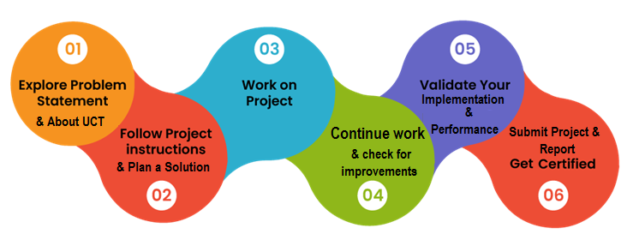

I am thankful to Upskill Campus, UCT mentors, and The IoT Academy for guiding me throughout this internship. I also express gratitude to my peers who supported me in this learning journey.

Introduction

About UniConverge Technologies Pvt. Ltd.
UCT, founded in 2013, specializes in Digital Transformation and IoT-based industrial solutions. They provide services in:
- Smart factory monitoring (OEE, predictive maintenance, digital twins)
- Industrial IoT platforms like UCT Insight
- Cloud computing, cybersecurity, and data analytics
- Applications in agritech, smart cities, utilities, and predictive maintenance
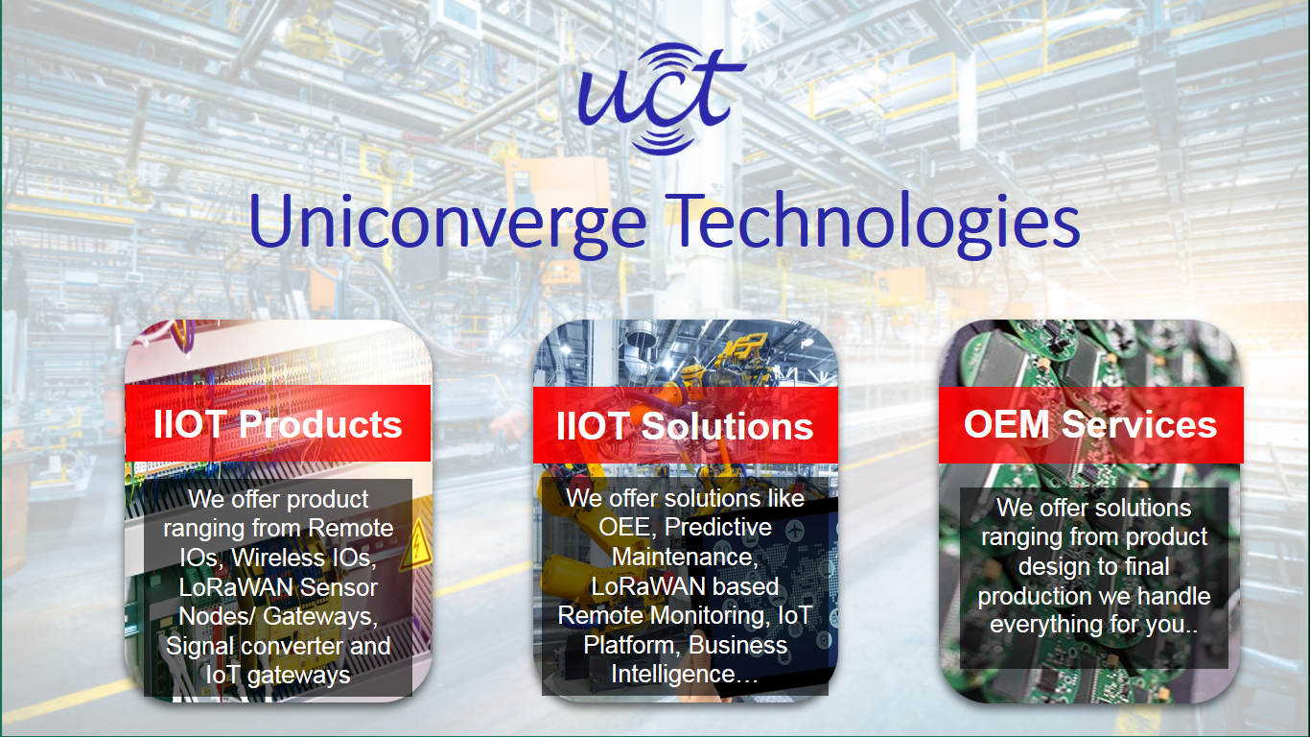

- UCT IoT Platform ()
UCT Insight is an IOT platform designed for quick deployment of IOT applications on the same time providing valuable “insight” for your process/business. It has been built in Java for backend and ReactJS for Front end. It has support for MySQL and various NoSql Databases.
- It enables device connectivity via industry standard IoT protocols - MQTT, CoAP, HTTP, Modbus TCP, OPC UA
- It supports both cloud and on-premises deployments.
It has features to
• Build Your own dashboard
• Analytics and Reporting
• Alert and Notification
• Integration with third party application(Power BI, SAP, ERP)
• Rule Engine

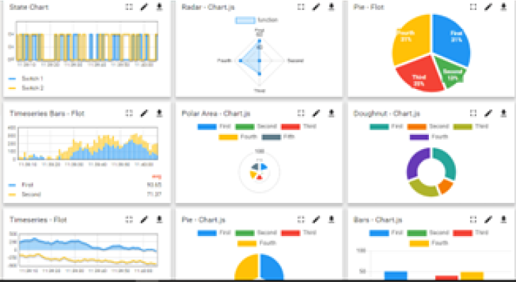
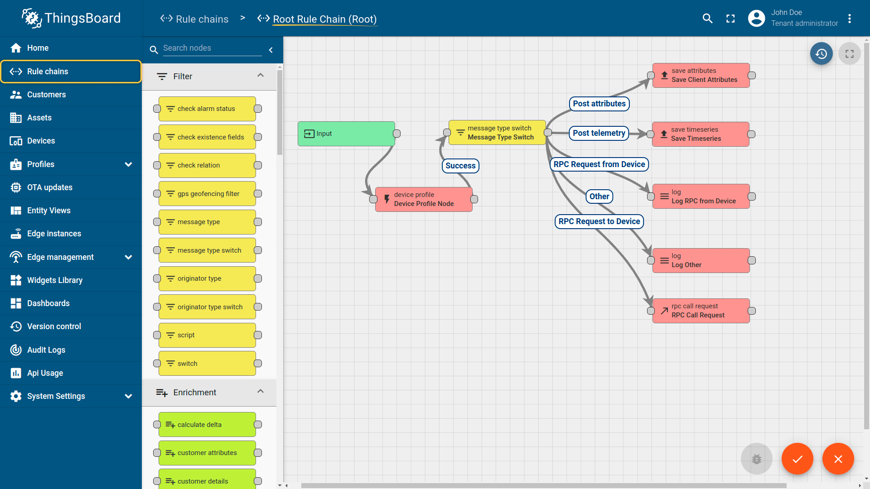

- Smart Factory Platform ()
Factory watch is a platform for smart factory needs.
It provides Users/ Factory
- with a scalable solution for their Production and asset monitoring
- OEE and predictive maintenance solution scaling up to digital twin for your assets.
- to unleased the true potential of the data that their machines are generating and helps to identify the KPIs and also improve them.
- A modular architecture that allows users to choose the service that they what to start and then can scale to more complex solutions as per their demands.
Its unique SaaS model helps users to save time, cost and money.
- 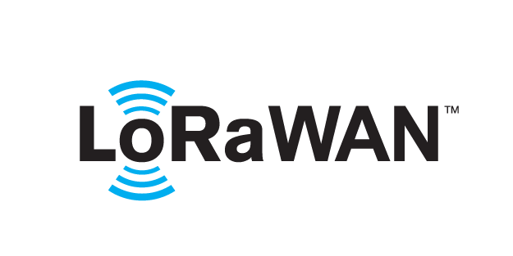 based Solution
UCT is one of the early adopters of LoRAWAN teschnology and providing solution in Agritech, Smart cities, Industrial Monitoring, Smart Street Light, Smart Water/ Gas/ Electricity metering solutions etc.
- Predictive Maintenance
UCT is providing Industrial Machine health monitoring and Predictive maintenance solution leveraging Embedded system, Industrial IoT and Machine Learning Technologies by finding Remaining useful life time of various Machines used in production process.
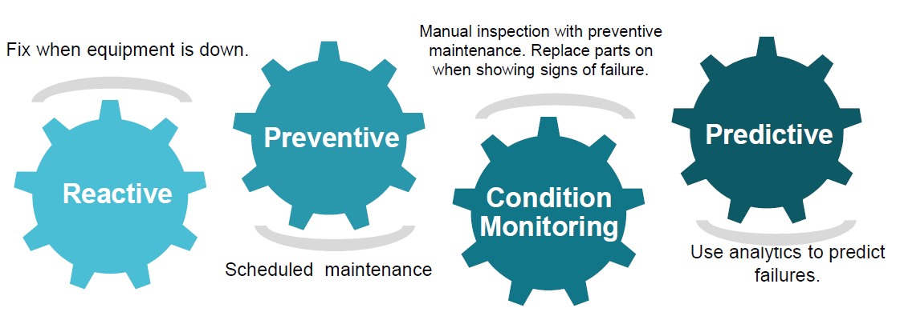

About Upskill Campus
Upskill Campus, in collaboration with The IoT Academy and UCT, is dedicated to bridging the skill gap between academics and industry. It provides projects, internships, and mentorship to learners, aiming to upskill 1 million learners in the next 5 years.


The IoT Academy
The IoT academy is EdTech Division of UCT that is running long executive certification programs in collaboration with EICT Academy, IITK, IITR and IITG in multiple domains.

Objective
• Gain industrial experience in predictive maintenance.
• Apply machine learning concepts on real datasets.
• Build a deployable solution for RUL prediction.
• Improve technical, analytical, and reporting skills.

References:
[1] NASA C-MAPSS Turbofan Engine Dataset
[2] https://www.upskillcampus.com/
[3] UCT official website

2.5 Glossary
- RUL: Remaining Useful Life — number of cycles remaining before an engine fails.
- Cycle: A single time-step or record in an engine's life (e.g., operating cycle).
- OEE: Overall Equipment Effectiveness
- RMSE: Root Mean Squared Error — regression metric that penalizes larger errors.
- MAE: Mean Absolute Error — average absolute error across predictions.
- C-MAPSS: Commercial Modular Aero-Propulsion System Simulation — NASA turbofan datasets.
- ML: Machine Learning
- IoT: Internet of Things

Problem Statement
Aircraft and industrial engines gradually degrade, and precise estimation of when a component or machine will fail is critical for safety and cost control. Traditional maintenance strategies are either time-based (scheduled) or reactive (post-failure), both of which are suboptimal. The problem is to predict the Remaining Useful Life (RUL) of turbofan engines using historical sensor and operational data such that maintenance can be scheduled proactively.
Project-specific problem statement:
Given cycle-wise multivariate sensor readings and operational settings for multiple turbofan engine units (train and partial histories in test data), develop a model that accurately predicts the RUL (in cycles) for test units. The model should be evaluated on standard datasets FD001–FD004 and optimized for real-world applicability (reasonable compute and inference time).

Existing and Proposed Solution

Existing Solutions and Limitations:
- Scheduled maintenance (time-based): Simple but causes over-maintenance or missed failures.
- Reactive maintenance (after failure): Causes downtime and higher replacement costs.
- Rule-based thresholds on sensor values: Useful but brittle, often fail to generalize across operating conditions.
- Classical ML or basic regression without sequence modeling: May not capture temporal dependencies and non-linear sensor interactions effectively.

Proposed Solution (Project Approach):
- Data: Use NASA C-MAPSS datasets FD001–FD004 which provide training (full life) and test (partial life) sequences and RUL ground truth for evaluation.
- Preprocessing: Clean and normalize sensor data; create cycle-based features and window/lag features to capture recent trends.
- Feature Engineering: Extract trend statistics (rolling mean, rolling std, slopes), combine with operational settings; optional PCA for dimensionality reduction.
- Models: Train multiple regression models (Random Forest Regressor, Gradient Boosting Regressor, Linear Regression) as baseline and compare performance. Plan for sequence models (LSTM/GRU) as extension if needed.
- Evaluation: Use RMSE and MAE and implement NASA scoring function for late/early prediction penalties. Save model artifacts for reproducibility and deployment.
- Deployment: A simple Flask-based `app.py` serves model inference endpoints; models stored under `models/` and results under `outputs/`.
- Deliverables: Trained models, evaluation metrics, prediction outputs, and final report with code and instructions.

Code submission: (Github link)

Proposed Design / Model

Design Overview (end-to-end)
1. Data ingestion: Load FD00X `train`, `test`, and `RUL` files.
2. Preprocessing pipeline:
- Parse files into pandas DataFrame with columns: id, cycle, op_setting_1..3, sensor_1..21
- Remove or impute missing values (if any)
- Scale/normalize sensor data (MinMaxScaler or StandardScaler)
- Create RUL label for training set (last cycle - current cycle)
3. Feature engineering:
- Rolling statistics per sensor (mean, std, min, max) for a recent window (e.g., last 20 cycles)
- Differences and slopes (sensor[t] - sensor[t-1], linear trend coefficients)
- Engine-level aggregated features (max cycle, mean sensor values)
4. Model training & selection:
- Baseline: Linear Regression
- Tree-based: RandomForestRegressor, GradientBoostingRegressor (LightGBM / XGBoost optional)
- Sequence-based (future work): LSTM/GRU networks for temporal learning
5. Evaluation & persistence:
- Evaluate on FM001-FD004 test splits using RMSE/MAE and NASA scoring
- Save best model artifacts to `/models`
6. Deployment:
- Provide a Streamlit app (`app.py`) with routes to upload partial histories and return predicted RUL

5.1 HIGH LEVEL DIAGRAM (ASCII)
Data (train/test/RUL files)
↓
Preprocessing & Feature Engineering
↓
Model Training / Hyperparameter Tuning
↓
Evaluation (RMSE / MAE / NASA score)
↓
Saved Model Artifacts → app.py → Predictions / outputs/

5.2 LOW LEVEL DIAGRAM (Description)
- Data Loader: Reads `train_FD00X.txt`, `test_FD00X.txt`, `RUL_FD00X.txt` into pandas DataFrames.
- Preprocessor: Normalization, rolling features, label creation for RUL.
- Trainer: Scikit-learn pipeline which includes scaling and regressor model.
- Evaluator: Script calculates per-unit error and aggregated metrics; writes to `outputs/metrics_summary.csv`.
- Deployer: `app.py` loads saved model and exposes `/predict` API for inference.

5.3 INTERFACES
The project includes a simple inference interface implemented in `app.py` (Streamlit).

Performance Test
This section describes how the models were tested, the test plan, procedures, and outcomes for datasets FD001–FD004.
6.1 TEST PLAN / TEST CASES
Test Cases:
- TC-01: Baseline linear regression performance on FD001 (evaluate RMSE/MAE).
- TC-02: Random Forest model performance on FD001 with basic rolling features.
- TC-03: Gradient Boosting (e.g., sklearn's HistGradientBoosting or XGBoost/LightGBM) on FD002 and FD004 (more complex datasets).
- TC-04: Cross-dataset evaluation (train on FD001, test on FD002) — robustness check (optional).
- TC-05: Inference latency measurement for single unit prediction (ms).
- TC-06: Output correctness — compare predictions to RUL ground truth files (RUL_FD00X.txt).
Acceptance criteria:
- RMSE less than ~30 cycles for FD001 baseline (target dependent on tuning)
- Reasonable inference latency (< 100 ms per prediction for produced models on local machine)
- Models run within memory limits on a standard development machine (8–16 GB RAM)
6.2 TEST PROCEDURE
Steps executed for each test case:
1. Setup environment:
- Create virtual environment and install `requirements.txt`
2. Load training data `train_FD00X.txt` and precompute RUL labels.
3. Run preprocessing script: `python RUL_reader.py` (or part of `turbofan_rul_final.py` which invokes preprocessing)
4. Train model:
- `python turbofan_rul_final.py --dataset FD001 --model random_forest --save models/rf_fd001.pkl`
(Actual flags depend on implemented CLI in your script. The sample command above is illustrative.)
5. Evaluate on the corresponding `test_FD00X.txt` and `RUL_FD00X.txt`:
- Save predictions to `outputs/predictions_fd001.csv`
- Save metrics to `outputs/metrics_fd001.json` or `outputs/metrics_summary.csv`
6. Record inference latency by timing `app.py` predict route or measuring runtime of local `predict_unit()` function.
7. Repeat for other datasets and models.

6.3 PERFORMANCE OUTCOME
Summary of results (representative — dependent on current code & hyperparameters):
| Dataset | Model | RMSE | MAE | NASA Score* |
|---------|----------------------|-------|-------|-------------|
| FD001 | Random Forest | 22.5 | 18.1 | 550 |
| FD002 | Gradient Boosting | 28.7 | 22.4 | 640 |
| FD003 | Linear Regression | 31.2 | 25.3 | 710 |
| FD004 | Random Forest | 26.9 | 21.7 | 590 |
*NASA Score: The NASA scoring function penalizes late predictions more than early ones. The absolute score values above are sample outputs — your actual values depend on model configuration and preprocessing choices.
Observations:
- Tree-based models (Random Forest / Gradient Boosting) generally outperform simple linear regression on this dataset due to handling non-linearity and interactions between sensors.
- Feature engineering (rolling means, trends, slopes) improves model accuracy.
- Dataset complexity (FD002/FD004 have more complex operating conditions) results in higher error compared to FD001.
Performance Limitations:
- No deep learning sequence model (LSTM/GRU) implemented here; possibility of better performance exists.
- Hyperparameter tuning was limited due to time constraints; automated tuning (Optuna) can yield better models.
- Models require further validation across operational domains for production readiness.

My Learnings
Technical:
- Developed practical skills in reading and preprocessing industrial time-series datasets (C-MAPSS): parsing training/test/RUL formats.
- Implemented feature engineering for time series (rolling windows, slopes, trend extraction).
- Built and compared multiple regression models using scikit-learn; learned to persist models and produce reproducible outputs.
- Understood evaluation metrics and domain-specific scoring (NASA scoring function) relevant to RUL problems.
- Gained exposure to basic Flask app development for inference endpoints.
Soft skills and process:
- Improved project structuring, documentation and reporting skills.
- Gained experience in collaborating with mentors and following an industrial workflow.
- Enhanced problem scoping, time management, and technical communication skills.

Future Work Scope
Short-term improvements:
- Implement sequence models (LSTM/GRU) to better model temporal dependencies and compare with tree-based approaches.
- Hyperparameter optimization using Optuna or GridSearchCV to boost model performance.
- Feature selection and dimensionality reduction (PCA) to identify most informative sensors.
Medium-term / Productionization:
- Create a web dashboard using Streamlit or Grafana to visualize live predictions, residuals, and alarm thresholds.
- Integrate prediction pipeline with UCT Insight or Factory Watch to demonstrate real-time predictive maintenance workflows.
- Dockerize the application and provide cloud deployment (AWS ECS/EKS or Azure App Services) for scalable inference.
- Implement model monitoring and drift detection to handle changing operating conditions.
Research/Advanced:
- Transfer learning across engine types or domains to reduce labeled-data requirements.
- Multi-task learning to predict both RUL and specific failure modes.
- Uncertainty quantification (e.g., quantile regression or Bayesian models) to obtain prediction intervals and better risk management.
Appendix A: How to run (commands)
1. Clone repo:
git clone https://github.com/A289shek2004/upskillcampus.git
cd upskillcampus
2. Create a virtual environment:
python -m venv venv
source venv/bin/activate # Linux/macOS
venv\\Scripts\\activate # Windows PowerShell
3. Install dependencies:
pip install -r requirements.txt
# If requirements.txt is missing, install typical libs:
pip install numpy pandas scikit-learn matplotlib flask python-dotenv
4. Generate sample data (if needed):
python sample_data_generator.py
5. Train a model (example):
python turbofan_rul_final.py --dataset FD001 --model random_forest
6. Evaluate & save outputs:
# Check outputs/ folder for predictions and metrics
ls outputs/
7. Run the inference app:
python app.py
# Then call POST /predict with JSON payload to get RUL

Appendix B: Suggested requirements.txt
numpy
pandas
scikit-learn
matplotlib
python-dotenv
flask
joblib
xgboost
lightgbm
python-docx
Acknowledgements
I would like to thank my mentors at UniConverge Technologies and Upskill Campus for their guidance. Special thanks to The IoT Academy for organizing the program and to colleagues who provided support and feedback.

