World Bank-Light Every Night

-----Open Nighttime lights

Wenjie Tong

1332679

Contents:

Overview

World Bank Light Every Night is a comprehensive data repository of light satellite images collected at night by two sensors in the past 30 years:

* The Defense Meteorological Satellite Program (DMSP) Operational Line Scanning System (OLS), with data from 1992 to 2017.
* The data of the Visible Infrared Imaging Radiometer Suite (VIIRS) Day and Night Band (DNB) is in 2012-2020.

Both DMSP-OLS and VIIRS-DNB sensors capture various low-light emission sources from the earth as light data. The light source includes brightness data generated by various human activities, such as city lights, gas flares, fishing boats and agricultural fires, and also captures other natural lighting phenomena at night, such as aurora.

The World Bank, in collaboration with the National Oceanic and Atmospheric Administration (NOAA) and the University of Michigan, released this repository for analysis. The basic data comes from NOAA National Center for Environmental Information (NCEI) archives.

Additional processing from the University of Michigan supports access in cloud-optimized GeoTIFF format (COG) and searches using the Spatio-temporal Asset Catalog (STAC) standard. And these standards are part of a growing ecosystem of analytics-ready data that is improving access to geospatial data sets, enabling a wider audience to easily discover, process, and analyze geospatial data. Our project data will also use cloud-optimized GeoTIFF format (COG) and STAC standards to implement network-level applications.

In this web-based application will include *** parts, for instance: the remote sensing, nighttime light data, and data overview. The remote sensing demonstrate the different sensors,like passive and active sensors and this introduction is giving a general concept to people to understand how remote sensors work and how the data be transmited during the long period. Moreover, the spatial, spectral and temporal resolutions are the vital elements for data collections and using. Next, the nighttime light data have some sub-points, the remotely sensed data of nighttime lights,DMSP-OLS and VIIRS-DNB (the follow-on sensor for DMSP-OLS).

Remote sensing

1. Remote sensing

Research by NASA shows that modern remote sensing technology began with the invention of the camera more than 150 years ago. The first original photo appeared as a "still image", but it inspired people's ideas and practices for shooting and looking down on the surface of the earth. This idea appeared in the 1840s. The first photos were used for topographic mapping. Later in the First World War, the cameras mounted on the aircraft provided a bird's-eye view of a considerable surface area and provided a large amount of terrain data for military activities. After continuous research and development, the current remote sensing technology has reached a qualitative leap. It is now commonly used to describe the science and art of identifying, observing, and measuring objects without directly touching it. The process involves detecting and measuring radiation of different wavelengths reflected or emitted from distant objects or materials, through which they can be identified and classified by category/type, substance, and spatial distribution (NASA,2021, August 28).

* 1. Orbits
     1. Polar and non-polar

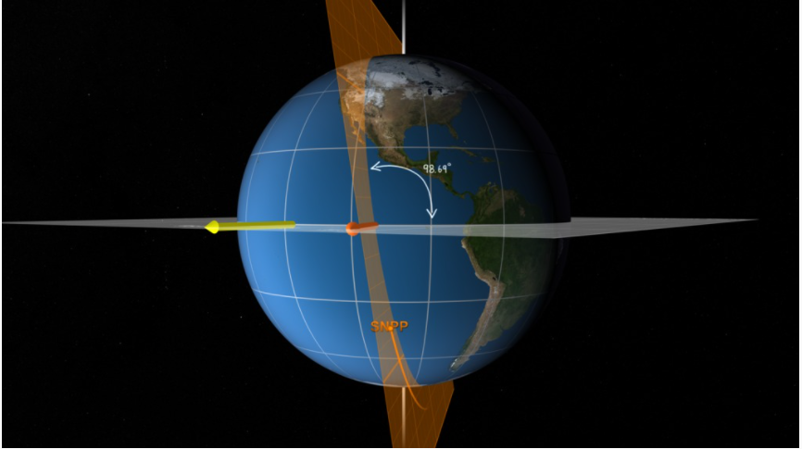

Retrieved from: <https://earthdata.nasa.gov/learn/backgrounders/remote-sensing>

* + 1. Low-Earth orbit

Low Earth Orbit (LEO) is an orbit relatively close to the surface of the earth. It is usually located at an altitude of less than 2000 kilometers, but it may be as low as 400 kilometers above the earth. Compared to other orbits, it is low, but still far from the surface of the earth(NASA,2021, August 28).

It is the most commonly used orbit for satellite imaging because it is possible to take higher resolution images close to the surface. It is also the orbit used by the International Space Station (ISS) because it is easier for astronauts to travel to and from it at shorter distances. The satellite in this orbit travels at a speed of about 7.8 kilometers per second; at this speed, it takes about 90 minutes for the satellite to orbit the earth, which means that the International Space Station orbits the earth about 16 times a day (ESA, n.d.).

* + 1. Geostationary
  1. passive and active sensors
  2. passive remote sensing
  3. active remote sensing

1. Spatial, spectral and temporal resolutions in remote sensing
   1. Spatial resolution
   2. Spectral resolution
   3. Temporal resolution

Nighttime light data

1. Remotely sensed data of nighttime lights
2. DMSP-OLS
3. VIIRS-DNB: the follow-on sensor for the DMSP-OLS

Data Overview

1. Data structure
2. The world Bank’s “Light Every Night” dataset
3. GeoTIFFs
4. Cloud-optimized geoTIFFs (COGs)
5. Spatial Temporal Asset Catalog (STAC) standard

Refereces:

*Low earth orbit*. ESA. (n.d.). https://www.esa.int/ESA_Multimedia/Images/2020/03/Low_Earth_orbit.

NASA. (2021, August 28). *What is Remote Sensing?* NASA. https://earthdata.nasa.gov/learn/backgrounders/remote-sensing.