## Logical Scheme

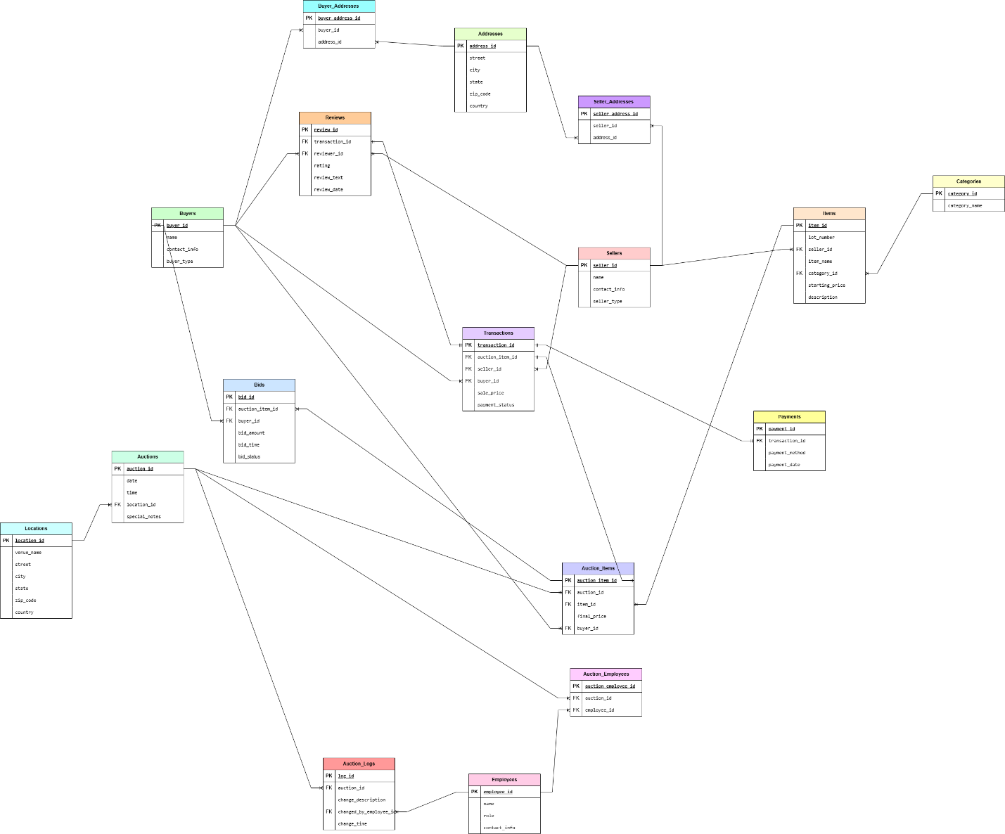

## Objects

**1. Table Description**

Stores information about sellers who list items for auction.

|  |  |  |  |
| --- | --- | --- | --- |
| Table Name | Field name | Field Description | Data Type |
| **Sellers** | seller_id | Unique ID for the seller, PK | INT (AUTO_INCREMENT) |
| name | Seller's name | VARCHAR(255), NOT NULL |
| contact_info | Seller's contact details | VARCHAR(255), NOT NULL |
| seller_address_id | References Seller_Addresses table, FK | INT |
| seller_type | Indicates if seller is Individual/Company | ENUM('Individual', 'Company'), NOT NULL |

Sellers to Seller_Addresses, One-to-Many Relationship

Example with data

|  |  |  |  |  |
| --- | --- | --- | --- | --- |
| seller_id | name | contact_info | seller_address_id | seller_type |
| 1 | Charles Johnson | +7(701)-123-4567 | 5 | Individual |
| 2 | American Antiques | +7(771)-765-4321 | 8 | Company |

**2. Table Description**

Stores information about buyers who purchase auctioned items.

|  |  |  |  |
| --- | --- | --- | --- |
| Table Name | Field name | Field Description | Data Type |
| **Buyers** | buyer_id | Unique ID for the buyer, PK | INT (AUTO_INCREMENT) |
| name | Buyer's name | VARCHAR(255), NOT NULL |
| contact_info | Buyer's contact details | VARCHAR(255), NOT NULL |
| buyer_address_id | References Buyer_Addresses table, FK | INT |
| buyer_type | Indicates if buyer is Individual/Company | ENUM('Individual', 'Company'), NOT NULL |

Buyers to Buyer_Addresses, One-to-Many Relationship

Example with data

|  |  |  |  |  |
| --- | --- | --- | --- | --- |
| buyer_id | name | contact_info | buyer_address_id | buyer_type |
| 1 | Chloe Black | +7(701)-567-8910 | 3 | Individual |
| 2 | The History Savers | +7(771)-897-1065 | 11 | Company |

**3. Table Description**

Stores the addresses of sellers to avoid redundancy.

|  |  |  |  |
| --- | --- | --- | --- |
| Table Name | Field name | Field Description | Data Type |
| **Seller_Addresses** | seller_address_id | Unique ID for the address, PK | INT (AUTO_INCREMENT) |
| seller_id | References Sellers table, FK | INT |
| address_id | References Addresses table, FK | INT |

Links Sellers and Addresses, representing a Many-to-Many relationship.

Example with data

|  |  |  |
| --- | --- | --- |
| seller_address_id | seller_id | address_id |
| 1 | 789 | 321 |
| 2 | 456 | 951 |

**4. Table Description**

Stores the addresses of buyers to avoid redundancy.

|  |  |  |  |
| --- | --- | --- | --- |
| Table Name | Field name | Field Description | Data Type |
| **Buyer_Addresses** | buyer_address_id | Unique ID for the address, PK | INT (AUTO_INCREMENT) |
| buyer_id | References Buyers table, FK | INT |
| address_id | References Addresses table, FK | INT |

Links Buyers and Addresses, representing a Many-to-Many relationship.

Example with data

|  |  |  |
| --- | --- | --- |
| buyer_address_id | buyer_id | address_id |
| 1 | 542 | 471 |
| 2 | 1001 | 59 |

**5. Table Description**

Stores the addresses of buyers and sellers to avoid redundancy.

|  |  |  |  |
| --- | --- | --- | --- |
| Table Name | Field name | Field Description | Data Type |
| **Addresses** | address_id | Unique ID for the address, PK | INT (AUTO_INCREMENT) |
| street | Street name and number | VARCHAR(255), NOT NULL |
| city | City name | VARCHAR(100), NOT NULL |
| state | State or region | VARCHAR(100), NOT NULL |
| zip_code | ZIP or postal code | VARCHAR(20), NOT NULL |
| country | Country | VARCHAR(100), NOT NULL |

Addresses to Seller_Addresses & Buyer_Addresses, One-to-Many relationship

Example with data

|  |  |  |  |  |  |
| --- | --- | --- | --- | --- | --- |
| address_id | street | city | state | zip_code | country |
| 1 | 383 Kennedy | Springfield | Illinois | 62701 | USA |
| 2 | 543 Winter | Salt Lake City | Utah | 84101 | USA |

**6. Table Description**

Stores details of items that are auctioned.

|  |  |  |  |
| --- | --- | --- | --- |
| Table Name | Field name | Field Description | Data Type |
| **Items** | item_id | Unique ID for each item, PK | INT (AUTO_INCREMENT) |
| lot_number | Unique identifier for an item | VARCHAR(50), UNIQUE, NOT NULL |
| seller_id | References Sellers table, FK | INT |
| item_name | Name of the item | VARCHAR(255), NOT NULL |
| category_id | References Categories table, FK | INT |
| starting_price | Initial auction price | DECIMAL(10,2) CHECK(starting_price > 0), NOT NULL |
| description | Description of the item | TEXT |

Sellers to Items, one seller can have multiple items, but each item belongs to one seller

Example with data

|  |  |  |  |  |  |  |
| --- | --- | --- | --- | --- | --- | --- |
| item_id | lot_number | seller_id | item_name | category_id | starting_price | description |
| 1 | AJ200870 | 6 | Chanel Sac a Rabat Flap Bag | 5 | 1500.00 | Chanel 'Sac a Rabat' flap bag in marine fonce satin with canted squares of dark blue sequin quilted pattern. |
| 2 | LR489034 | 10 | US Coin Assortment | 3 | 1200.00 | NULL |

**7. Table Description**

Stores different item categories to prevent data duplication.

|  |  |  |  |
| --- | --- | --- | --- |
| Table Name | Field name | Field Description | Data Type |
| **Categories** | category_id | Unique ID for each category, PK | INT (AUTO_INCREMENT) |
| category_name | Name of the category | VARCHAR(255), UNIQUE |

Categories to Itmes, a category can have many items, an item belongs to one category

Example with data

|  |  |
| --- | --- |
| category_id | category_name |
| 3 | Jewelry |
| 5 | Coins |

**8. Table Description**

Stores details of auctions where items are sold.

|  |  |  |  |
| --- | --- | --- | --- |
| Table Name | Field name | Field Description | Data Type |
| **Auctions** | auction_id | Unique ID for each auction, PK | INT (AUTO_INCREMENT) |
| date | Date of the auction | DATE, NOT NULL |
| time | Time of the auction | TIME, NOT NULL |
| location_id | References Locations table, FK | INT |
| special_notes | Additional auction details | TEXT |

Auctions to Locations, each auction takes place at one location, but a location can host multiple auctions

Example with data

|  |  |  |  |  |
| --- | --- | --- | --- | --- |
| auction_id | date | time | location_id | special_notes |
| 1 | 2025-03-14 | 09:00:00 | 3 | Charity Auction |
| 2 | 2019-10-09 | 12:00:00 | 11 | NULL |

**9. Table Description**

Stores the locations where auctions take place.

|  |  |  |  |
| --- | --- | --- | --- |
| Table Name | Field name | Field Description | Data Type |
| **Locations** | location_id | Unique ID for each location, PK | INT (AUTO_INCREMENT) |
| street | Street address | VARCHAR(255), NOT NULL |
| city | City name | VARCHAR(100), NOT NULL |
| state | State or region | VARCHAR(100), NOT NULL |
| zip_code | Postal code | VARCHAR(20), NOT NULL |
| country | Country | VARCHAR(100), NOT NULL |

Auctions to Locations, each auction takes place at one location, but a location can host multiple auctions

Example with data

|  |  |  |  |  |  |
| --- | --- | --- | --- | --- | --- |
| location_id | street | city | state | zip_code | country |
| 3 | 780 Greg | Carson City | Nevada | 89701 | USA |
| 11 | 8827 152b | Edmonton | Alberta | T5A 0A1 | Canada |

**10. Table Description**

Links auctions and items, representing a Many-to-Many relationship.

|  |  |  |  |
| --- | --- | --- | --- |
| Table Name | Field name | Field Description | Data Type |
| **Auction_Items** | auction_item_id | Unique ID for the buyer, PK | INT (AUTO_INCREMENT) |
| auction_id | Buyer's name | INT |
| item_id | Buyer's contact details | INT |
| final_price | References Addresses table, FK | DECIMAL(10,2) CHECK(final_price > 0), NOT NULL |
| buyer_id | Indicates if buyer is Individual/Company | INT |

Buyers to Auction_Items, a buyer can purchase multiple auctioned items, and an item can be purchased by one buyer

Auction_Items to Auctions & Items, Many-to-Many relationship between auctions and items is handled via the Auction_Items table

Example with data

|  |  |  |  |  |
| --- | --- | --- | --- | --- |
| auction_item_id | auction_id | item_id | final_price | buyer_id |
| 1 | 5 | 51 | 3000.00 | 871 |
| 2 | 9 | 13 | 1500.00 | 47 |

**11. Table Description**

Stores financial records of completed sales for auctioned items.

|  |  |  |  |
| --- | --- | --- | --- |
| Table Name | Field name | Field Description | Data Type |
| **Transactions** | transaction_id | Unique ID for each transaction, PK | INT (AUTO_INCREMENT) |
| auction_item_id | References Auction_Items table, FK | INT |
| seller_id | References Sellers table, FK | INT |
| buyer_id | References Buyers table, FK | INT |
| sale_price | Final sale price of the item | DECIMAL(10,2) CHECK(sale_price > 0), NOT NULL |
| payment_status | Status of payment | ENUM ('Pending', 'Completed', 'Cancelled'), NOT NULL |

Transactions to Auction_Items, Sellers, Buyers, each transaction is linked to an auctioned item, a seller, and a buyer

Transactions to Payments, One-to-One Relationship, transaction_id is a FK in the Payments table

Example with data

|  |  |  |  |  |  |
| --- | --- | --- | --- | --- | --- |
| transaction_id | auction_item_id | seller_id | buyer_id | sale_price | payment_status |
| 36 | 57 | 38 | 3 | 8999 | Completed |
| 95 | 360 | 78 | 11 | 1785 | Pending |

**12. Table Description**

Stores information about buyers who purchase auctioned items.

|  |  |  |  |
| --- | --- | --- | --- |
| Table Name | Field name | Field Description | Data Type |
| **Bids** | bid_id | Unique ID for each bid, PK | INT (AUTO_INCREMENT) |
| auction_item_id | References Auction_Items table, FK | INT |
| buyer_id | References Buyers table, FK | INT |
| bid_amount | Amount offered for the item | DECIMAL(10,2) CHECK(bid_amount > 0), NOT NULL |
| bid_time | Timestamp of the bid | TIMESTAMP DEFAULT CURRENT_TIMESTAMP |
| bid_status | Current status of the bid | ENUM ('Active', 'Winning', 'Rejected') DEFAULT 'Active' |

Bids to Auction_Items & Buyers, Many-to-Many relationship between buyers and auction items is handled via the Bids table

Example with data

|  |  |  |  |  |  |
| --- | --- | --- | --- | --- | --- |
| bid_id | auction_item_id | buyer_id | bid_amount | bid_time | bid_status |
| 55 | 89 | 101 | 6500.00 | 2010-05-12 15:24:45 | Active |
| 312 | 127 | 97 | 2200.00 | 2025-03-12 09:30:01 | Winning |

**13. Table Description**

Stores details of auction house employees.

|  |  |  |  |
| --- | --- | --- | --- |
| Table Name | Field name | Field Description | Data Type |
| **Employees** | employee_id | Unique ID for each employee, PK | INT (AUTO_INCREMENT) |
| name | Employee's name | VARCHAR(255), NOT NULL |
| role | Role in the auction house | VARCHAR(100), NOT NULL |
| contact_info | Employee's contact details | VARCHAR(255), NOT NULL |

Employees to Auction_Employees, Many-to-Many relationship between auctions and employees is handled via the Auction_Employees table

Example with data

|  |  |  |  |
| --- | --- | --- | --- |
| employee_id | name | role | contact_info |
| 3 | Daniel Smith | Manager | +7701-564-4578 |
| 7 | Noah Jackson | Manager | +771-951-7535 |

**14. Table Description**

Links employees to auctions they manage, representing a Many-to-Many relationship.

|  |  |  |  |
| --- | --- | --- | --- |
| Table Name | Field name | Field Description | Data Type |
| **Auction_Employees** | auction_employee_id | Unique ID, PK | INT (AUTO_INCREMENT) |
| auction_id | References Auctions table, FK | INT |
| employee_id | References Employees table, FK | INT |

Auction_Employees to Auctions & Employees, Many-to-Many relationship between auctions and employees is handled via the Auction_Employees table

Example with data

|  |  |  |
| --- | --- | --- |
| auction_employee_id | auction_id | employee_id |
| 1 | 2 | 5 |
| 2 | 4 | 6 |

**15. Description**

Stores details of payments for auction transactions.

|  |  |  |  |
| --- | --- | --- | --- |
| Table Name | Field name | Field Description | Data Type |
| **Payments** | payment_id | Unique ID for each payment, PK | INT (AUTO_INCREMENT) |
| transaction_id | References Transactions table, FK | INT, UNIQUE |
| payment_method | Mode of payment | ENUM ('Credit Card', 'Bank Transfer', 'PayPal', 'Cash'), NOT NULL |
| payment_date | Date of payment | DATE, NOT NULL |

Payments to Transactions, each transaction has a corresponding payment (One-to-One relationship)

Example with data

|  |  |  |  |
| --- | --- | --- | --- |
| payment_id | transaction_id | payment_method | payment_date |
| 1 | 56 | Credit Card | 2024-08-07 |
| 2 | 15 | Cash | 2024-09-25 |

**16. Table Description**

Stores logs of changes made to auction records for tracking and security.

|  |  |  |  |
| --- | --- | --- | --- |
| Table Name | Field name | Field Description | Data Type |
| **Auction_Logs** | log_id | Unique ID for each log, PK | INT (AUTO_INCREMENT) |
| auction_id | References Auctions table, FK | INT |
| change_description | Description of changes made | TEXT, NOT NULL |
| changed_by_employee_id | References Employees table, FK | INT |
| change_time | Timestamp of change | TIMESTAMP DEFAULT CURRENT_TIMESTAMP |

Auction_Logs to Auctions & Employees, employees log changes made to auctions for tracking purposes.

Example with data

|  |  |  |  |  |
| --- | --- | --- | --- | --- |
| log_id | auction_id | change_description | changed_by_employee_id | change_time |
| 71 | 17 | Cancelled the Transaction | 3 | 2025-01-02 15:56:47 |
| 95 | 23 | 4th bid:4500 | 11 | 2025-02-05 17:45:36 |

**17. Table Description**

Stores buyer and seller reviews on transactions.

|  |  |  |  |
| --- | --- | --- | --- |
| Table Name | Field name | Field Description | Data Type |
| **Reviews** | review_id | Unique ID for each review, PK | INT (AUTO_INCREMENT) |
| transaction_id | References Transactions table, FK | VARCHAR(255), NOT NULL |
| reviewer_id | ID of the buyer or seller who submitted the review | VARCHAR(255), NOT NULL |
| reviewer_type | Specifies if reviewer is Buyer or Seller | ENUM ('Buyer', 'Seller') |
| rating | Rating given (1-5) | INT CHECK(rating BETWEEN 1 AND 5) |
| review_text | Text review content | TEXT |
| review_date | Date of review submission | DATE DEFAULT CURRENT_DATE |

Reviews to Transactions, each transaction can have one review from either a buyer or a seller.

Example with data

|  |  |  |  |  |  |  |
| --- | --- | --- | --- | --- | --- | --- |
| review_id | transaction_id | reviewer_id | reviewer_type | rating | review_text | review_date |
| 36 | 85 | 56 | Buyer | 5 | I’m glad that I’ve purchased that | 2017-07-30 |
| 52 | 75 | 85 | Seller | 3 | NULL | 2019-02-07 |