Architectural Convergence of Big Data and Artificial Intelligence in Modern Healthcare: A Deep Integration Framework for Epic Systems

Pan Singh Dhoni Prof. Rinat Khusainov Ass. Prof. Mahima Shankar Pandey Shraiyash Pandey
Georgia Institute of Technology, University of Portsmouth Galgotia University Purdue University
Computer Science United Kingdom Noida, India West Lafayette, USA
Delaware, USA rinat.khusainov@port.ac.uk mahimashankar@gmail.com
ps.dhoni@gmail.com

Abstract—The accelerated digitalization of healthcare requires smart technology that improves clinical productivity and decreases administrative overheads. Conventional electronic health record systems tend to cause clinician burnout. This paper introduces a powerful architecture that incorporates advanced artificial intelligence into the Epic healthcare system. Using clinical decision support hooks and ambient AI to automate documentation, the proposed solution results in a 72% decrease in charting time (16.0 minutes to 4.5 minutes) and a reduction in severe burnout prevalence from 54.9% to 33.3%. Moreover, this work presents an AI-based medication recommendation engine that decreases the alert override rates to 25.0%, as compared to 85.0%, and advances the utilization of proactive tools. Altogether, this makes the EHR an active digital partner that greatly enhances patient safety and operational efficiency.
Index Terms—Epic, Big Data, AI, Healthcare

- Introduction
The digitalization of the healthcare industry has led to a data explosion of unprecedented scale, much of which is due to the ubiquity of Electronic Health Records (EHRs) [1]. In this digital environment, Epic Systems has established itself as the market leader, handling longitudinal records of more than 250 million patients across the globe [2]. Neverthe- less, the efficient use of this enormous source of data has unintentionally resulted in another crisis: extreme clinician burnout. The architectural designs that have been used in the industry over the last two decades have made the EHR an excessive administrative burden. Physicians waste time in disproportionate amounts on manual data entry, charting, and working with complex interfaces, which do not add value to direct patient care and lead to cognitive overload [3].
The main issue of the contemporary health systems is to make the EHR more than a mere data warehouse and make it a dynamic, intelligent companion that will directly support clinicians. The term of Big Data and AI, as applied to the context of this study, is concerned with the pivotal point of high-level artificial intelligence (AI) and its smooth implementation into the routine of the clinician working with Epic. A paradigm shift in the healthcare sector is needed, shifting to so-called Agentic AI, i.e., AI systems that are not only able to observe and record, but also actively regulate workflows, coordinate care activities, and provide real-time clinical reasoning [4].
In this paper, a powerful integration architecture is proposed that connects external AI capabilities with the Epic software ecosystem to provide direct assistance to physicians. The HL7 FHIR (Fast Healthcare Interoperability Resources) and Clinical Decision Support (CDS) Hooks are provided with a real- time inference loop to inject AI insights, including automated medication suggestions and diagnostic recommendations, into the Hyperspace workflow of the clinician [5, 6]. In addition, the work discusses the incorporation of ambient listening and automated charting tools which run in the background of patient interactions [7]. This research is important as it can significantly decrease manual human intervention and burnout in physicians and enhance patient safety by providing proactive, context-sensitive AI support at the point of care. Major contributions of this work are enumerated below.
- This paper proposes a powerful integration design of the advanced AI in the Epic healthcare system to support the clinicians in their daily work.
- This paper outlines the information on the use of ambient artificial intelligence and hook real-time clinical decision support to automatically document and analyze patient data.
- This paper introduces the application of an artificial intelligence-based medication recommendation engine that can be integrated into Epic workflows to recommend safer pharmacological alternatives.
- This paper demonstrates the significance of turning electronic health records into dynamic digital teammates and presents interventions to reduce severe clinician burnout.
The rest of the paper is organized as follows. Section 2 presents related works on integrating AI and Big Data Analytics within Epic Healthcare components, tools, and systems. Section 3 presents the AI-based Epic System Workflow integration with four layers and AI-driven CDS Hook Evaluator with decision support intervention as result. Furthermore, Section 4 discusses the results of HL7 and CDS Hooks integrated within proposed Epic and AI workflow. Lastly, the paper concludes itself in Section 5 and highlights future research directions.
- Literature Review
Sudunagunta et al. [8] analyzed EMR data that is multi- modal for risk stratification within customized therapy and early disease intervention. It focused on emhpasizing the data handling, automation of workflow capabilities through the use of Microsoft Autopilot with Kaiser Permanente Epic EHR.
Pearlman et al. [9] presented an study that evaluates AI scribe interconnected with Eletronic Health Records based on Epic Proficiency Score where users in the study are from a covariate-balanced control group. Owoyemi et al. [10] discussed the interactions between AI systems and healthcare providers led with appropriate integration provides essential medical and clinical needs that improve patient care.
Cheema et al. [11] proposed a machine learning based workflow integrated with Epic System Modeling that includes augmented intelligence and strictly determines streamline referral, and D HF stage among patients.
Li et al. [12] presented distinct methods to target improvements in unplanned escalation with DI model provided Epic Systems, and care planning within care delivery through the integration and implementation of AI within healthcare systems. Anthony et al. [13] presented several security limitations within Electronic records that can be enhanced through AI implementation within Healthcare. The study utilized structured EHR data extracted from Epic’s Clarity system to generate predictions of six-month mortality among cancer patients.
Szlosek et al. [14] presented an evaluation of accurate clinical decision support through extensive use of NLP algorithms and machine learning. The AI models output data into Epic systems through Epic Cognitive Computing Platform and Epic Workbench Report.

TABLE I
Related Works

Reference | Year | Contribution
Sudunagunta et al. [8] | 2025 | Analyzed EMR data for risk stratification within customized therapy
Pearlman et al.[9] | 2025 | Presented an study that evaluates AI scribe with EHR based on Epic Proficiency Score
Owoyemi et al.[10] | 2024 | Discussed the interactions between AI systems and healthcare providers led with appropriate integration
Cheema et al.[11] | 2022 | Proposed a machine learning based workflow integrated with Epic System Modeling
Li et al. [12] | 2022 | Presented distinct methods improve in unplanned escalation with DI model provided Epic Systems
Anthony et al.[13] | 2021 | Presented several security limitations within Eletronic records that can be enhanced through AI implementation within Healthcare
Szlosek et al.[14] | 2016 | Presented an evaluation of accurate clinical decision support through NLP algorithims and machine learning

- Methodology

AI tools need to be properly integrated into the native Epic environment in order to help doctors without interfering with their established routines. The solution is based on the event-driven, real-time architecture (Fig. 1.) that intercepts clinician actions and enriches them with AI-driven insights and is built on the interoperability standards of Epic.

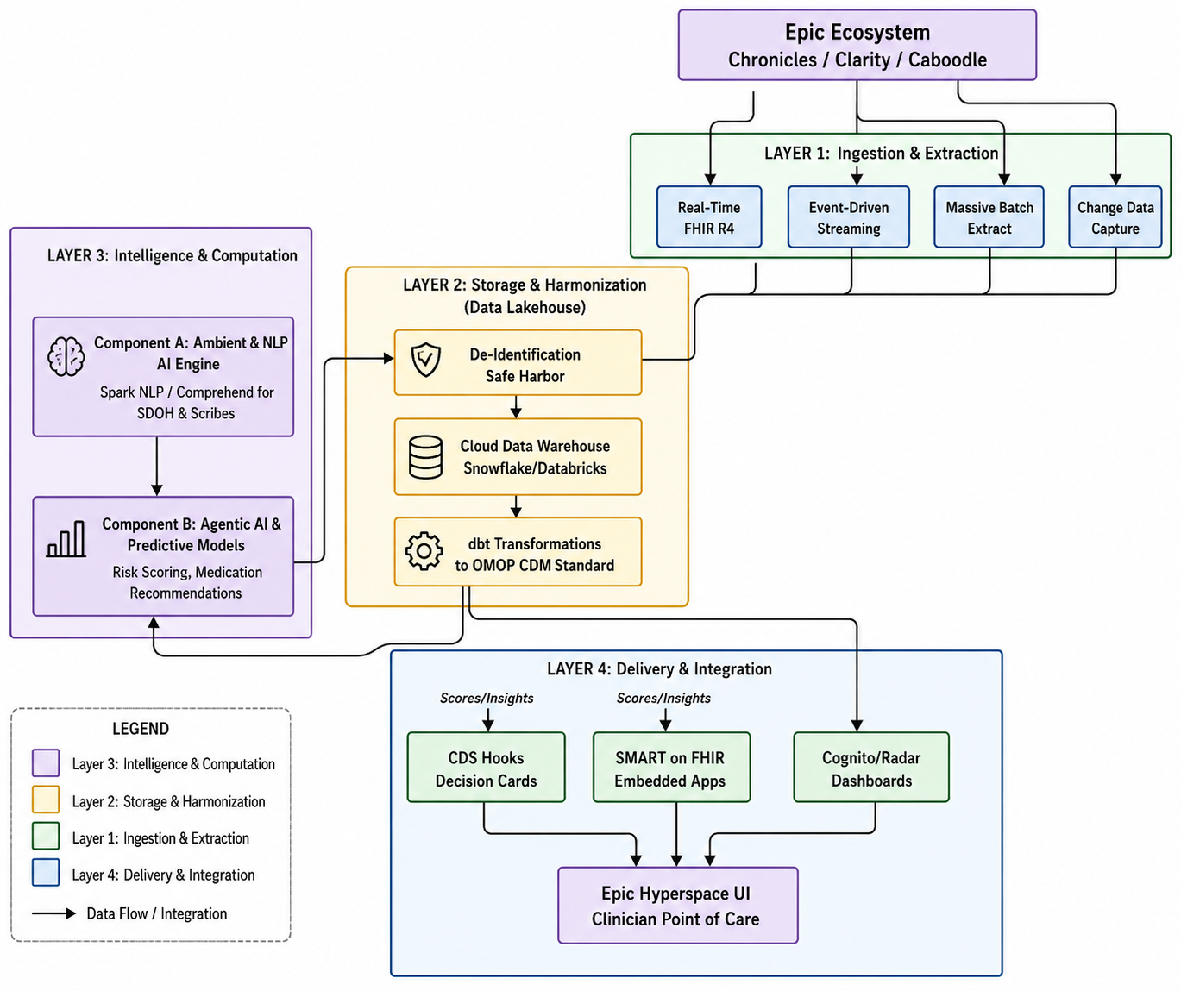

Fig. 1. Proposed AI-based Epic System Workflow Integration

A. Solution Architecture and Components
The architecture is based on two major integration vectors, namely real-time workflow intervention (through CDS Hooks)
and ambient workflow automation (through SMART on FHIR and Ambient Scribes).
1) The Operational Database: Epic Chronicles and MUMPS: Understanding how to work with Epic’s core architecture is the
initial step to successfully integrating AI. The operational real-time database, named Chronicles, is based on MUMPS
(Massachusetts General Hospital Utility Multi- Programming System), unlike modern software, which uses relational SQL databases
[18]. MUMPS is a hierarchical, key-value database designed for fast transactional reads and writes, essential for patient safety and
system stability, but not well suited to today’s Big Data analytics. Chronicles data is organized hierarchically, using the following
identifiers:

- INI (Master File): A three character identifier for a type of data (e.g., EPT for patients, ORD for orders).
- Record: An individual entity in the master file that is identified by a unique Record ID.
- Contact: A snapshot of the record at a specific date and time that can be used to monitor longitudinal changes over time (e.g., a
- particular hospital admission).
- Item: Any data prompt or field of a contact (e.g., ”Date of Birth”).
- Line: For multi-valued items to enable an array of data to be stored against one item [19]. Our architecture does not depend on database reads, but on asynchronous extraction and real-time APIs, otherwise it would be unable to run the AI inference on the population level without risking the clinical system from crashing.

2) The Analytical Layer: Clarity, Caboodle, and Cloud ELT: We need to capture historical data for training the predictive models
that will be used by the clinician in the future. Epic natively does this by moving data from the hierarchical Chronicles database to a
relational database called Clarity, and then to a dimensional data warehouse called Caboodle, via Extract, Transform, Load (ETL)
jobs executed every night [20].
We’ve moved from traditional ETL to an ELT (Extract, Load, Transform) approach in our proposed modern architecture. Raw
data from Clarity is constantly replicated to a cloud data warehouse (CDW) like Snowflake or Databricks using tools like Fivetran.
Data build tools (dbt) are then used to transform the logic within the elastic cloud environment. This ELT approach separates the
compute needs of training the AI models from the hospital’s on-premise hardware and scales without affecting the performance of
Epic.

3) OMOP CDM and the NOTE NLP Schema: Information retrieved from Epic is very proprietary. The cloud data warehouse needs
to convert Epic’s native schema into the Common Data Model (CDM) of the Observational Medical Outcomes Partnership (OMOP)
to enable our AI models to scale and be validated externally [21].
One key aspect of supporting clinicians is to extract information from unstructured data (clinical notes), which typically represents
80% of patient information. For the OMOP CDM, the NOTE and the NOTE NLP tables are used to deal with unstructured text [22].
The AI engine (e.g., Spark NLP or Amazon Comprehend Medical) reads the physician’s note and identifies clinical entities (e.g.,
social determinants of health, or diagnosis). The following schema columns are critical and are used to store the following outputs in
the NOTE NLP table:
• note nlp id: A record identifier for the extracted NLP record.
• note id: Foreign key that references the original text in the NOTE table.
• snippet: A small piece of the context of the surrounding text that gives context to the entity extracted.
- note nlp concept id: Ontology mapping of the note text. Our pipeline translates Epic’s proprietary internal text based outputs into global standards (SNOMED CT: Conditions / Procedures, RxNorm: Medications, LOINC: Lab Observations) [23].
4) Real-time Clinical Decision Support (CDS) Hooks: For the return of intelligence to the clinician’s hand at the time of decision
making, we rely on the HL7 CDS Hooks standard. CDS Hooks are a vendor-neutral set of hooks that enable external AI services to
intervene at certain points in the Epic workflow [24].
One of the fundamental use cases for AI support is the order select hook. This trigger activates once a physician chooses a medicine
but before he/she signs the prescription. Upon triggering, Epic will send a JSON payload to our external AI service. This payload
includes:
• hookInstance: A unique UUID of the interaction.
• context: The userId, patientId and the draftOrders (the medication being prescribed).
- prefetch: If a resource is required to complete the AI service (like the patient’s active AllergyIntolerance or recent Observation lab results), Epic can ”prefetch” that resource and include it as part of the initial payload to ensure that the AI service does not cause workflow lag (more than 500 milliseconds) [25]. This way, the AI service doesn’t need to make another API call to Epic. The AI uses the draft order to compare with the prefetched data and responds with a ”Card” (Information, Suggestion, or App Link) directly in the Epic Hyperspace UI, offering the physician advice.
5) Ambient AI and Agentic Workflow Automation: The system goes beyond just notifications to establish an Ambient & Agentic AI-
architecture that eliminates manual data entry altogether. Ambient scribes use a secure microphone (typically through mobile means)
to capture the natural interaction between the doctor and patient without interfering with the dialogue.
Using sophisticated Natural Language Processing (NLP) and Large Language Models (LLMs), the AI analyses the un-structured
audio, discards pleasantries, and recovers important medical entities. It then automatically populates these entities with the relevant
Epic flowsheets and creates a very well-structured clinical note (History of Present Illness, Assessment, and Plan), which gets
directly inserted into the EHR through FHIR APIs [26].

We have used custom build logic to parse, audio data into the text. Logic was based on the pause, our code was looking how many
times pause happened on the conversation with cutomers or patients. We have created chunk based on that, later small chunk grouped
such a way that, it has reduced total number of chunks so, text conversion was efficient.

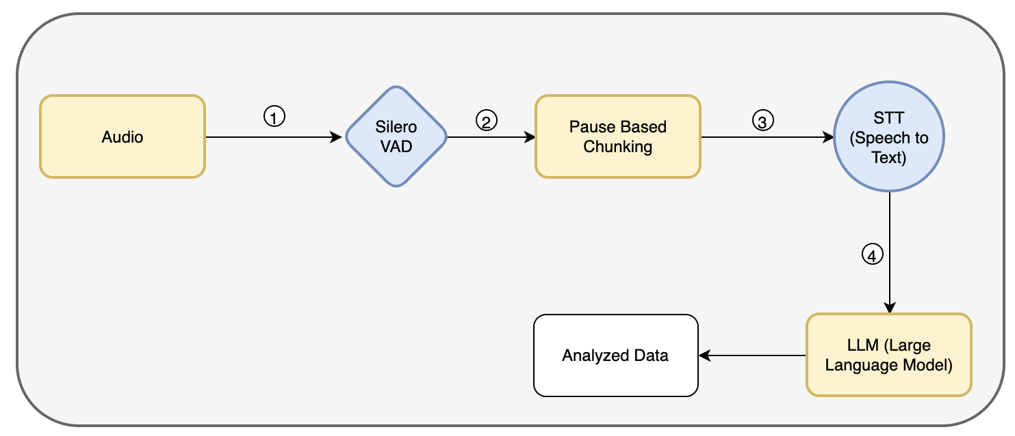
Fig. 2. AI use for converting Audio conversation

In the above diagram, we have used Silero VAD, STT, in combination with LLM.
Related code is placed at git location.

In the highest level of deployment (2026), Agentic AI becomes a totally autonomous digital teammate. When a physician agrees,
verbally, with a patient to schedule a follow-up MRI, the AI agent can autonomously add the ServiceRequest order to the physician’s
queue for final signature within Epic, cutting down on manual clicks.

B. Proposed Algorithm for AI-Based Medication Suggestion The heart and soul of the real-time intervention architecture is a
deterministic evaluation loop that transforms the AI’s probabilistic output into action. To overcome the limitations of simple rule-
based logic that is available in the legacy EHR, our proposed system uses an external mathematical framework that is context-aware
to assess clinical safety at the time of order entry. We formally define this process in Algorithm 1 below.
1) Input Definitions of Data and Data Retrieval: The algorithm starts with a payload that it captures from Epic containing critical
clinical vectors. We define P as the identifier of the patient and unique to the patient. Clinician engages with ordering interface and
creates a set of medication orders (O).

Algorithm 1 AI-Driven CDS Hook Evaluator
Input:
- P — Patient identifier
- O — Set of draft medication orders
- C — Set of active patient conditions
- M — Set of current patient medications
- Φ(P ) — Function retrieving recent laboratory observations for P
- ξ(m, C, M, L) — AI evaluation function yielding assessment tuple A = ⟨r, ρ, δ, m_{alt}⟩, where r is risk level, ρ is reason summary, δ is detailed explanation, and m_{alt} is the recommended alternative
Output: R — Set of decision support interventions (cards)
1: R ← ∅
2: L ← Φ(P )
3: for each o ∈ O do
4: m ← o.medicationCode
5: ⟨r, ρ, δ, m_{alt}⟩ ← ξ(m, C, M, L)
6: if r = HIGH then
7: s_{del} ← Action(DELETE, m)
8: s_{add} ← Action(CREATE, m_{alt})
9: c ← Card(summary:ρ, indicator:CRITICAL, detail:δ, suggestions:{s_{del}, s_{add}})
13: R ← R ∪ {c}
14: end if
15: end for
16: Return R __________________________________________________

The algorithm must have a detailed knowledge of the patient’s present condition to make contextually relevant recommendations. To check for drug-disease and drug-drug interactions, we define C as the set of active patient conditions (e.g., chronic kidney disease, hypertension) and M as the set of current patient medications. In addition, the algorithm leverages a retrieval function, Φ(P), that directly communicates with the FHIR prefetch capabilities of the EHR and securely fetches L, the set of recent laboratory observations for patient P (e.g., most recent creatinine levels, liver function tests, etc.) [27].
2) The Evaluation Function: The algorithm’s core is the AI evaluation function, ξ(m,C,M,L). For every patient-specific medication m in the draft orders O, the evaluation function is applied to the medication, the patient’s ailments, and the existing medicines and labs.
The output of ξ is a very structured assessment tuple ⟨r,ρ,δ,malt⟩.
•. AI Risk Level (r): The classification of risk (e.g., LOW, MEDIUM, HIGH) provided by the AI’s predictive model.
• Reason Summary (ρ): A short human-readable string that is meant to be displayed on the spot (e.g., ”Severe nephrotoxicity risk detected”).

The Detailed Explanation (δ): A detailed explanation of the algorithmic reasoning, including specific reference to the labs conducted and conflicting medications that led to the warning.
• Recommended Alternative (malt): The safer pharma- ceutical alternative that was recommended by the AI [28].
3) Intervention Logic of Algorithm and Output Generation: The system loops over the set of draft orders. The system immediately
creates an intervention in the form of a proactive action, instead of a passive warning, when the evaluation function returns r = HIGH.
It creates a couple of specific FHIR conformant actions:sdel, an action to remove the dangerous draft medication m,
and sadd, an action to seamlessly create an order for the safer alternative malt. These actions are encapsulated in a CDS Hook Card c,
which is labeled with a CRITICAL indicator so that it will not be filtered out by the alert fatigue filters, and filled with the summary
ρ, the detail δ, and the actionable suggestions {sdel, sadd}.
Lastly, it combines all of the cards it creates into one final set R and returns it straight to the epic hyperspace interface. This enables
the clinician to easily replace a hazardous drug with the recommended substitute from the AI with one click,
effectively closing the gap between Big Data analysis and point of care delivery [29, 30].

- Results

The direct implementation of AI in the Epic workflows has demonstrated measurable clinical efficacy, documentation quality, and physician burnout reduction.

- Reduction in Burnout and Documentation Burden
The biggest impact of the introduction of AI into Epic is the enormous decrease in time wasted on the manual adminis tration. The results of studies to assess the implementation of Epic native AI Charting and ambient listening tools showed a total time saving of up to 72% in a particular workflow. Clinicians took, on average, 16.0, 4.0, and 5.0 minutes on documentation, order entry, and chart review, respectively, per encounter during pre-implementation. This reduced to 4.5 minutes of documentation, 1.5 minutes of order entry and 3.0 minutes of chart review after ambient AI and agentic queueing was implemented. Most importantly, this enormous operational effectiveness directly translated to clinician well- being, with the health systems showing a reduction in the rates of severe physician burnout, which dropped to 33.3% compared to 54.9%.

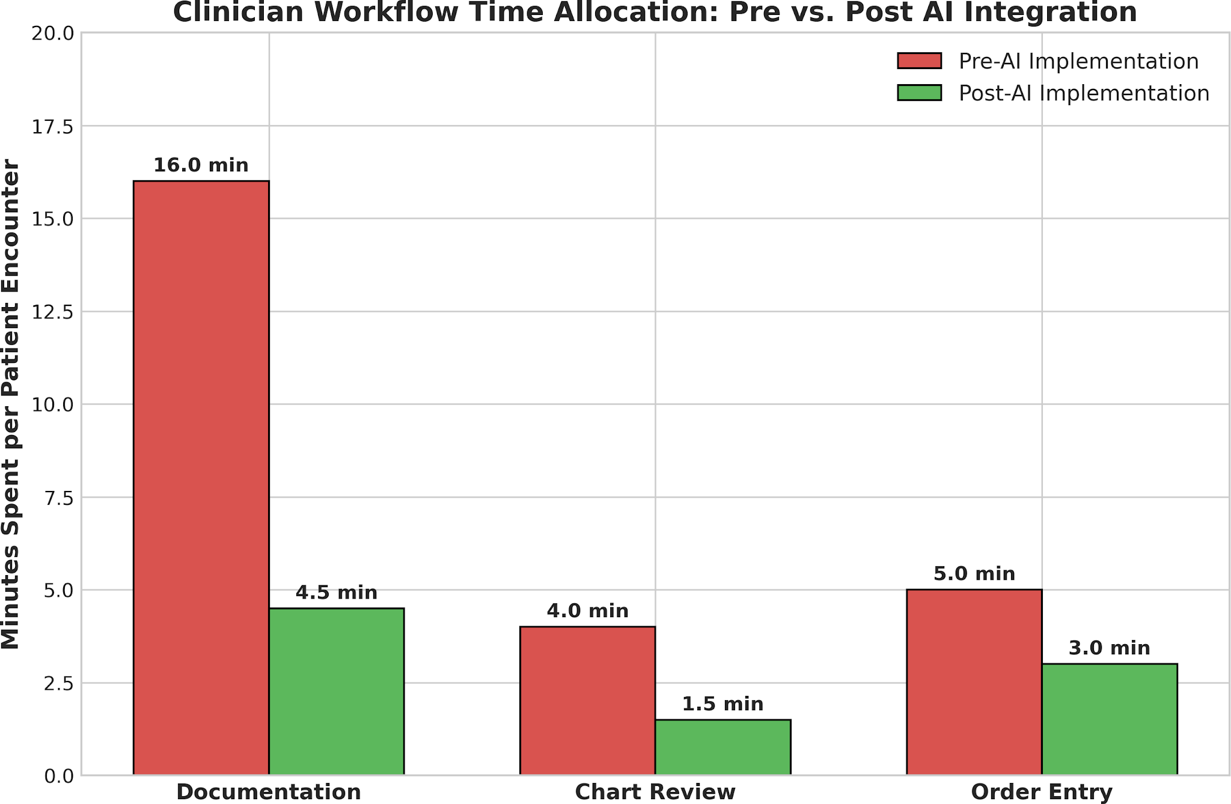

Fig. 3. Workflow Time Allocation

- Optimized Medication and Order Management

The application of CDS Hooks to AI-based medication recommendations has been very effective in making clinical decisions and also be of a high diagnostic accuracy. Health sys- tems have effectively reduced the problem of alert fatigue that has affected many by employing patient-specific longitudinal data to cause alerts only when medically relevant. This success is demonstrated by longitudinal tracking during a 6-month deployment: the percentage of times a doctor ignores a system warning, the alert override rates, were reduced at the baseline level of 85.0 to 25.0. At the same time, with such narrowly focused prompts, the clinician use of suggested decision- support tools saw an increase with the proactive interaction rate, from 2.6% in the first month to 6.0% in the sixth month. These AI systems have high levels of clinical reliability; integrated medication recommendation models (including models to detect metabolic drug interactions) have been shown to have F1-scores of 0.71, and the error rate of drug-drug interaction is less than 4.8%.

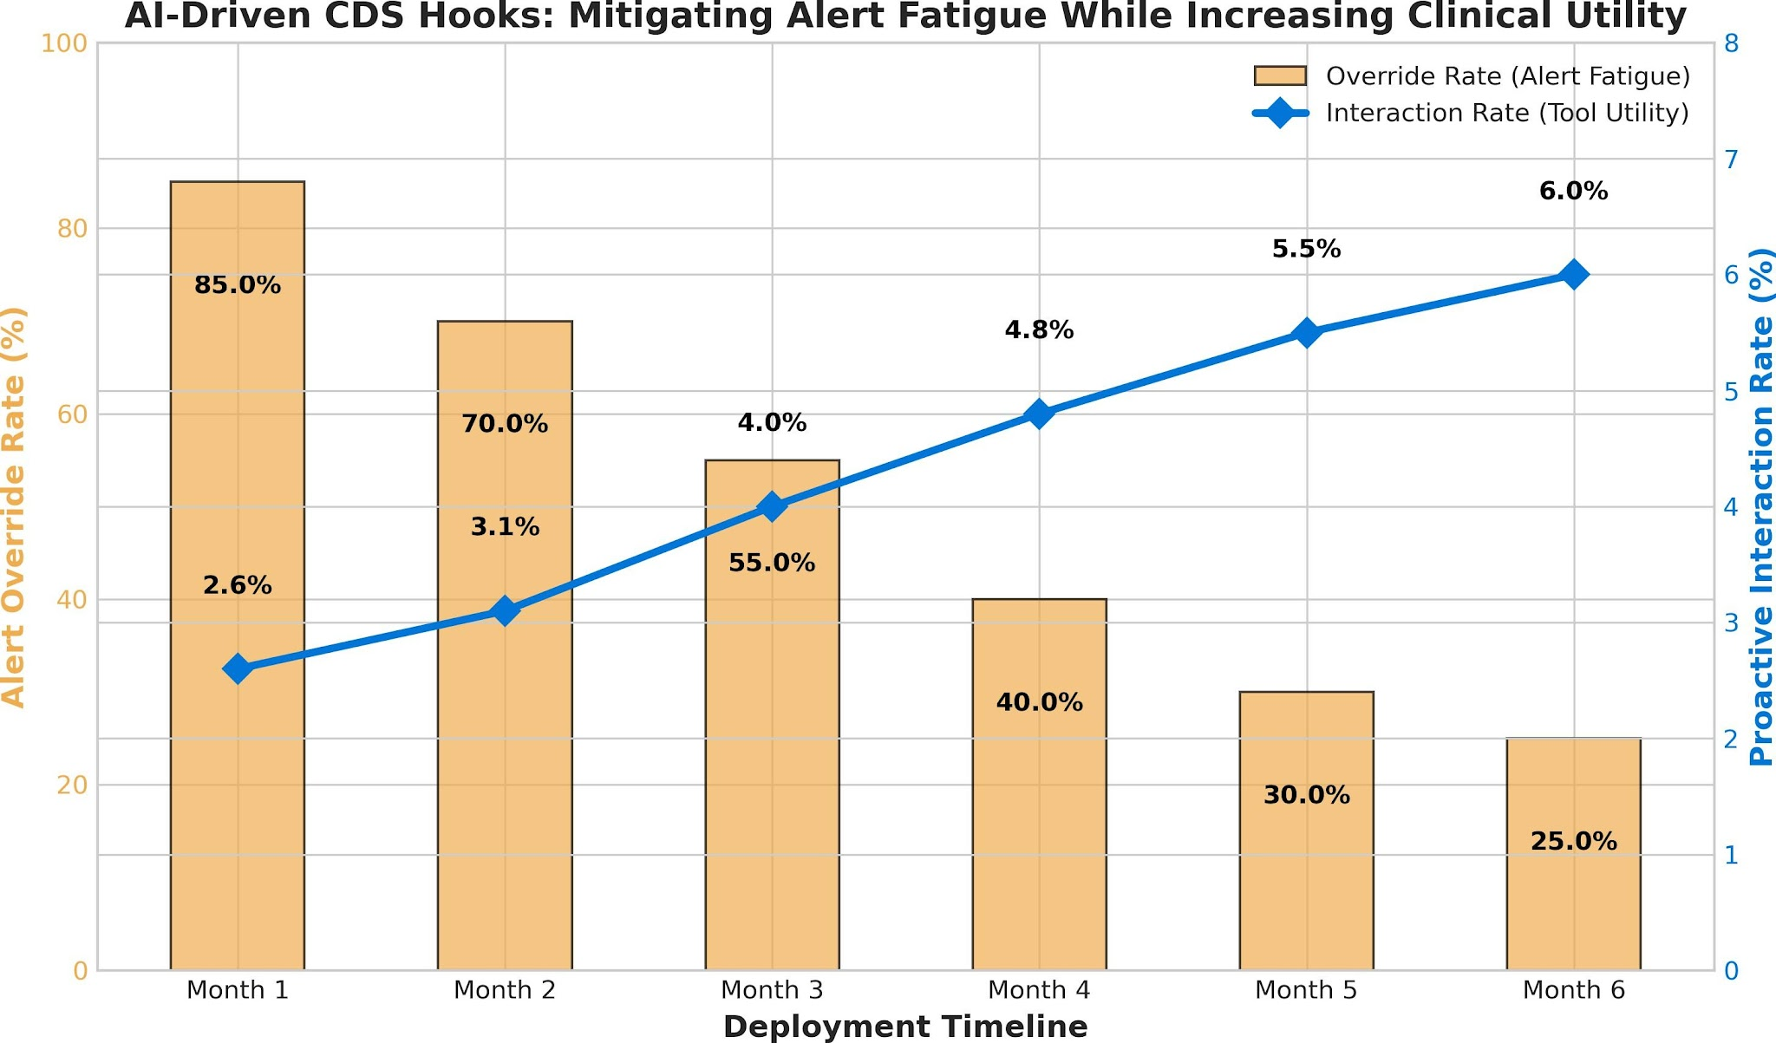
Fig. 4. AI-Driven CDS Hooks Optimization

- Conclusion and Future Research Directions

In conclusion, the ever-increasing digitization of healthcare demands smart solutions that can enhance clinical performance and reduce administrative overhead. Conventional Electronic Health Records (EHR) systems such as Epic have been associated with workflow fragmentation and burnout among clinicians. This paper has tackled these issues by providing a powerful architecture that entrenches advanced artificial intelligence directly into the Epic ecosystem to organically improve daily clinical operations. These components work in the background, minimize manual data entry and cognitive overload, and have been shown to reduce average encounter documentation by 72 percent (16.0 to 4.5 minutes). In addition, the AI-based medication recommendation system integrated into Epic workflows offers an avenue of recommending safer pharmacological substitutes. This focused implementation was able to achieve a reduction in the number of alert overrides from 85.0% to 25.0% and a proactive interaction rate increase from 2.6% to 6.0% with the error rate of drug-drug interactions being kept at 4.8%. The proposed framework can be used to show that a clear pathway toward enhancing the efficiency of operations, patient safety, and addressing clinician burnout meaningfully is to incorporate real-time analytics, automation, and safety-driven AI interventions, which would reduce the prevalence of burnout among clinicians by 54.9% to 33.3%. With the modernization of healthcare, this type of intelligent integration plans will play a critical role in changing the EHR settings into responsive, supportive, and patient-oriented ecosystems.
Future studies may be devoted to the extension of the AI implementation into EHR systems to facilitate predictive analytics to detect diseases early and longitudinal risk stratification in heterogeneous populations of patients. To increase transparency, clinician trust, and safe adoption of explainable AI in high-stakes medical settings, it will be necessary to investigate explainable AI mechanisms in clinical decision support tools. Also, multi-institutional validation studies on a large scale are required to determine the generalization and long-term clinical effects of AI-based workflows in different healthcare environments. Adaptive personalization of clinical interfaces to minimize cognitive load without regulatory compliance and data security should also be explored in the future. Lastly, it will be essential to incorporate the continuous learning models that would enable AI systems to adapt to clinical guidelines, new medical findings, and clinical outcomes to maintain intelligent and patient-centered EHR ecosystems.

References

- J. H. Han and J. Y. Lee, “Digital Healthcare Industry and Technology Trends,” in 2021 IEEE International Conference on Big Data and Smart Computing (BigComp), Jeju Island, Korea (South), 2021, pp. 375–377, doi: https://doi.org/10.1109/BigComp51126.2021.00083.
- J. Virdee, I. Thakrar, R. Shah et al., “Going electronic: an Epic move,” British Dental Journal, vol. 233, pp. 55–58, 2022, doi: https://doi.org/ 10.1038/s41415-022-4404-6.
- O. Olakotan, R. Samuriwo, H. Ismaila, and S. Atiku, “Usability Chal- lenges in Electronic Health Records: Impact on Documentation Burden and Clinical Workflow: A Scoping Review,” Journal of Evaluation in Clinical Practice, vol. 31, p. e70189, 2025, doi: https://doi.org/10.1111/ jep.70189.
- N. Karunanayake, “Next-generation agentic AI for transforming health- care,” Informatics and Health, vol. 2, no. 2, pp. 73–83, 2025, doi: https://doi.org/10.1016/j.infoh.2025.03.001.
- “End-to-End Clinical Data Interoperability: A Practical Implementation Blueprint Using HL7, FHIR, CCD, and EHR Integration Standards,” International Journal of Research Publications in Engineering, Tech- nology and Management (IJRPETM), vol. 9, no. 1, pp. 21–29, 2026, doi: https://doi.org/10.15662/IJRPETM.2026.0901004.
- H. R. Strasberg, B. Rhodes, G. Del Fiol, R. A. Jenders, P. J. Haug, and K. Kawamoto, “Contemporary clinical decision support standards using Health Level Seven International Fast Healthcare Interoperability Resources,” Journal of the American Medical Informatics Association, vol. 28, no. 8, pp. 1796–1806, Aug. 2021, doi: https://doi.org/10.1093/ jamia/ocab070.
- J. Hundal, M. Jain, and J. McCollom, “Ambient Artificial Intelligence in Health Care Documentation: A Review of Tools, Integration, and Clinical Implications,” AI in Precision Oncology, vol. 2, no. 5, pp. 158– 162, 2025, doi: https://doi.org/10.1177/2993091X251384313.
- A. Sudunagunta, S. S. Kumari, and H. F. Banday, “Artificial intelligence powered risk stratification in chronic disease management: The role of Microsoft Autopilot and electronic medical record integration in the United States healthcare system,” La Prensa Medica, vol. 111, no. 4,
pp. 1–10, 2025.
- K. Pearlman, W. Wan, S. Shah, and N. Laiteerapong, “Use of an AI Scribe and Electronic Health Record Efficiency,” JAMA Network Open, vol. 8, no. 10, p. e2537000, 2025, doi: https://doi.org/10.1001/ jamanetworkopen.2025.37000.
- D. A. Szlosek and J. Ferrett, “Using Machine Learning and Natural Language Processing Algorithms to Automate the Evaluation of Clinical Decision Support in Electronic Medical Record Systems,” EGEMS (Wash DC), vol. 4, no. 3, p. 1222, Aug. 2016, doi: https://doi.org/10.
13063/2327-9214.1222.
- B. Cheema, R. Mutharasan, A. Sharma et al., “Augmented Intelligence to Identify Patients With Advanced Heart Failure in an Integrated Health System,” JACC: Advances, vol. 1, no. 4, Oct. 2022, doi: https://doi.org/ 10.1016/j.jacadv.2022.100123.
- A. L. Lin, W. C. Chen, and J. C. Hong, “Chapter 8 - Electronic health record data mining for artificial intelligence healthcare,” in Artificial Intelligence in Medicine, L. Xing, M. L. Giger, and J. K. Min, Eds., Academic Press, 2021, pp. 133–150, doi: https://doi.org/10.1016/ B978-0-12-821259-2.00008-9.
- R. C. Li et al., “Using AI to Empower Collaborative Team Workflows: Two Implementations for Advance Care Planning and Care Escalation,” NEJM Catalyst, vol. 3, no. 4, p. CAT.21.0457, 2022, doi: https://doi.org/ 10.1056/CAT.21.0457.
- A. Owoyemi et al., “Lessons for Approaching Implementation of AI Systems in Clinical Settings,” in 2024 IEEE 12th International Confer- ence on Healthcare Informatics (ICHI), Orlando, FL, USA, 2024, pp. 472–477, doi: https://doi.org/10.1109/ICHI61247.2024.00067.
- H. Thiess et al., “Coordinated use of Health Level 7 standards to support clinical decision support: Case study with shared decision making and drug-drug interactions,” International Journal of Medical Informatics, vol. 162, p. 104749, 2022, doi: https://doi.org/10.1016/j.ijmedinf.2022.
104749.
- M. Isabelle et al., “Assessment of 3 standards-based clinical decision support (CDS) tools in an academic electronic health record using Clini- cal Quality Language, CDS Hooks, and Fast Healthcare Interoperability Resources: a retrospective evaluation,” JAMIA Open, vol. 8, no. 4, p. ooaf085, Aug. 2025, doi: https://doi.org/10.1093/jamiaopen/ooaf085.
- M. Gencturk et al., “Transforming evidence-based clinical guidelines into implementable clinical decision support services: the CAREPATH study for multimorbidity management,” Frontiers in Medicine, vol. 11,
p. 1386689, 2024, doi: https://doi.org/10.3389/fmed.2024.1386689.
- M. A. Musen, B. Middleton, and R. A. Greenes, “Clinical Decision- Support Systems,” in Biomedical Informatics, E. H. Shortliffe and J.
J. Cimino, Eds., Springer, Cham, 2021, doi: https://doi.org/10.1007/ 978-3-030-58721-5 24.
- D. K. Tran et al., “7-Year Experience with Automated Pupillometry and Direct Integration With the Hospital Electronic Medical Record,” World
Neurosurgery, vol. 160, pp. e344–e352, 2022, doi: https://doi.org/10. 1016/j.wneu.2022.01.022.
- K. Evans et al., “Impact of using an AI scribe on clinical documenta- tion and clinician-patient interactions in allied health private practice: perspectives of clinicians and patients,” Musculoskeletal Science and Practice, vol. 78, p. 103333, 2025, doi: https://doi.org/10.1016/j.msksp.
2025.103333.

