VidoraAI Research Paper
Architecture-freeze draft v0.1
Prepared 12 October 2026 from the code on branch main at commit 7a1693a. Sections I–III are drafted in paper form. Sections IV–V are an evaluation plan only.
How to read this draft. Every parameter in Section III was read from the code (functions/app/pipeline/, app/core/vad_config.py, app/repository/transcript_chunk_repository.py, app/services/qa_log_service.py, .env.example). Yellow highlights are placeholders. They must be replaced with measured values before anything is submitted. No number in this draft is a result yet.

0.1 Decisions to finalise before writing results
# | Decision | Recommendation | Status
1 | Paper title | Option A below. It names the two technical ideas and the task without over-claiming. | Open
2 | Is the Shorts feature (clip suggestion/rendering) in scope? | Mention only in Future Work. It has no evaluation yet and would dilute the core contribution. | Open
3 | Authors, affiliation, corresponding author | Use the A2R affiliation. Get written permission from A2R to publish the system design and production statistics. | Open
4 | Overlap with the Epic healthcare manuscript | Its Fig. 2 already describes Silero VAD, pause-based chunking and STT. If it shares authors or is under review, cite it. Present this paper's segmentation contribution as the two-stage packing, timestamp remap and seam rule, which that paper does not describe. Do not reuse its text or figure. | Open
5 | Target venue and format | Choose before writing Section IV, because it sets the page budget. This draft follows the single-column style of the reference paper. | Open
6 | Language claims | Lexical search uses the PostgreSQL 'english' configuration. If live traffic includes Hindi or Hinglish videos, measure and report that as a finding. Otherwise restrict the claims to English. | Open
7 | Use of live-user data | Report only aggregate operational metrics. Do not publish user transcripts, questions, titles or video IDs. Confirm that the privacy policy allows research use of aggregate logs. | Open

0.2 Candidate titles
- (A, recommended) Pause-Aware Segmentation and Silence-Compressed Transcription for Cost-Efficient, Timestamp-Grounded Question Answering over Long YouTube Videos
- VidoraAI: A Speech-First Retrieval-Augmented Generation Pipeline with Hybrid Retrieval and Temporal Query Routing for Long-Form Video
- From Speech to Seconds: Timestamp-Preserving Audio Packing and Hybrid Retrieval for Video Question Answering

0.3 Instrumentation gaps (must be fixed before mining GCP logs)
Logs that already exist and can be mined now: analysis_stage (per-stage elapsed seconds per video), audio_chunks_ready (VAD chunk count), stt_request_completed, analysis_failed (stage, error type), analysis_deferred (quota wait), analysis_reused (cache hit), groq_chunk_transcription_retryable. The videos table also stores duration, number of STT requests, status and created_at.
Missing, and needed for the paper's claims:
- Per-video audio accounting (needed for contribution C2): duration_s, speech_s, packed_audio_s (seconds actually sent to STT), n_speech_regions, n_vad_chunks, n_stt_requests, n_forced_splits and n_words_dropped_at_seams. At present the saving from silence compression cannot be computed from production.
- Per-question retrieval record: route (temporal or hybrid), k, number of chunks returned, whether the no-context answer was given, and retrieval and LLM latency.
- LLM token usage per answer and per summary, for the cost table.
Retention risk. Transcript rows are deleted after about 24 hours, and Cloud Logging's _Default bucket keeps logs for 30 days by default. Data from earlier live traffic may already be gone. Export the relevant log entries to a BigQuery or Cloud Storage sink now, before adding the new log lines.

Pause-Aware Segmentation and Silence-Compressed Transcription for Cost-Efficient, Timestamp-Grounded Question Answering over Long YouTube Videos
Author 1, Author 2, … · A2R, City, Country · email
__Abstract__—Long-form online video is mostly speech, yet most video question-answering systems either sample visual frames at high cost or transcribe fixed-length windows that split words and bill silence. This paper presents VidoraAI, a production speech-first retrieval-augmented generation (RAG) system that answers natural-language questions about a YouTube video with answers grounded in, and cited to, timestamps on the original video clock. The ingestion pipeline uses Silero voice-activity detection with hysteresis and a pause-merge planner to form chunks of at most 30 s without cutting through a pause. A second packing stage joins these chunks into transcription requests of up to 240 s and caps each silence at 1 s. Word timestamps are then remapped exactly to the original timeline, and audio already covered is trimmed so that no speech is transcribed twice. At query time, questions that contain a time range are routed to an interval lookup. All other questions use in-video hybrid retrieval that fuses pgvector cosine ranking with PostgreSQL full-text ranking by reciprocal rank fusion, with a retrieval depth that grows with video length. On N videos processed in production, silence compression reduced transcribed audio by X% and transcription requests by Y%. On a benchmark of M annotated questions, hybrid retrieval reached Recall@5 of R, compared with R_dense for dense-only retrieval. The whole pipeline runs on CPU-only serverless functions.
__Index Terms__—retrieval-augmented generation, video question answering, voice activity detection, speech recognition, hybrid retrieval, reciprocal rank fusion, temporal grounding.

I. Introduction
Video is now a primary medium for lectures, podcasts, tutorials and talks, and many of these videos run from tens of minutes to several hours. A viewer who wants one fact from such a video must scrub through it by hand. Large multimodal models can answer questions about short clips, but processing every frame of a long video is expensive, and for speech-dominated content most of the answer-bearing information is in the audio track ref.
A natural alternative is to transcribe the audio and apply retrieval-augmented generation (RAG) to the transcript [5]. Building such a system for real users raises engineering problems that are rarely evaluated together. First, how the audio is segmented before automatic speech recognition (ASR) affects both accuracy and cost. Fixed windows cut words in half, and hosted ASR bills every second sent, including silence. Second, answers are useful only if they point the user to the right moment, so timestamps must survive segmentation, batching and retrieval exactly. Third, user questions are of two kinds: semantic questions ("what does the speaker say about X?") and time-anchored questions ("what happens between 12:30 and 14:00?"). No single retriever serves both well. Fourth, a public service must operate within provider rate limits and fail safely.
This paper describes VidoraAI, a speech-first video RAG system that addresses these problems and is deployed in production at A2R. Its main contributions are:
- C1 – Pause-aware segmentation. Silero VAD with hysteresis and a pause-merge planner produce ASR chunks of at most 30 s that preserve the original timeline. A mid-speech cut, with overlap, is made only when uninterrupted speech exceeds the cap (Section III-C).
- C2 – Silence-compressed transcription with exact timestamp remapping. VAD chunks are packed into requests of up to 240 s with every silence capped at 1 s. A span table maps each word back to the original video clock. Audio already covered by an earlier chunk is trimmed, so no speech is billed twice, and a forced split inside one request is re-joined into continuous audio (Section III-D).
- C3 – Query-aware in-video retrieval. A temporal router sends time-anchored questions to an interval lookup. Other questions use a single-query hybrid retriever that fuses dense and lexical rankings by reciprocal rank fusion, with retrieval depth adapted to video duration (Section III-G).
- C4 – Production evaluation. The paper reports operational measurements from N live videos and an offline benchmark with ablations of C1–C3 (Section IV). Write this bullet only after the numbers exist.
The rest of the paper is organised as follows. Section II reviews related work. Section III presents the architecture and algorithms. Section IV describes the evaluation design and results. Section V concludes and outlines future work.

II. Related Work
Video RAG. Video-RAG [1] augments large video-language models with auxiliary texts, including ASR transcripts produced with Whisper, that are retrieved per query. VideoRAG [2] targets extremely long videos by combining ASR, visual captions and graph-based indexing. SceneRAG [3] segments long videos into scenes and uses silent intervals in ASR output to refine scene boundaries, starting from fixed 5-minute windows with 10 s overlap. These systems are mainly visual or multimodal. None studies how ASR segmentation affects cost and timestamp fidelity.
Temporal grounding in RAG. The intra-video temporal-aware RAG framework of Shafiq et al. [4] is the closest to this work. It builds timestamped chunks from Whisper large-v3 output and visual captions, retrieves with dense embeddings and a cross-encoder, and filters by time. It is evaluated on 2–5 minute lecture videos, and its temporal window comes from gold annotations rather than from the question. TV-RAG [6] re-ranks ASR and OCR text with a time-decay term. TG-RAG [7] extracts temporal expressions from questions over a knowledge graph.
VAD and segmentation for ASR. WhisperX [8] uses VAD to cut and merge long audio into Whisper-sized segments. Recent ASR reports use Silero VAD clips of up to 30 s as a baseline [9]. These works target transcription accuracy and do not consider downstream retrieval or per-second ASR billing.
Hybrid retrieval. Reciprocal rank fusion (RRF) [10] combines rankings without score calibration and is widely used to fuse BM25-style lexical retrieval with dense retrieval [11]. This work applies RRF inside a single video's transcript, inside one SQL statement.
TABLE I
Related Works (preliminary – to be verified against full texts)
Work | Year | Segmentation of speech | Retrieval | Gap addressed here
Video-RAG [1] | 2024 | Whisper ASR as auxiliary text | Per-query auxiliary-text retrieval | No cost-aware ASR; no word-level remap
VideoRAG [2] | 2025 | ASR per clip + captions | Graph + multimodal | Visual-heavy; not timestamp-cited QA
SceneRAG [3] | 2025 | Fixed 5 min windows, 10 s overlap | Scene-level | Fixed windows; silence still transcribed
Shafiq et al. [4] | 2026 | Whisper segments, semantic chunks | Dense + cross-encoder; gold time filter | 2–5 min videos only; no lexical signal; time window not from question
TV-RAG [6] | 2025 | ASR/OCR snippets | Lexical + time-decay re-rank | No segmentation or cost study
WhisperX [8] | 2023 | VAD cut & merge | — | ASR only; no retrieval
This work | 2026 | VAD pause-merge + silence-compressed packing + exact remap | Temporal routing + hybrid RRF, adaptive k | —

III. Methodology

A. System Overview
VidoraAI is organised in four layers (Fig. 1). Layer 1 downloads and normalises the audio. Layer 2 converts speech into word-level timestamps on the original video clock. Layer 3 builds and stores retrieval units. Layer 4 routes each question, retrieves evidence from a single video and generates a grounded, timestamp-cited answer. Ingestion runs asynchronously. The API stores the job, enqueues it with Cloud Tasks and immediately returns a PROCESSING record, which the client polls for stage-level progress.
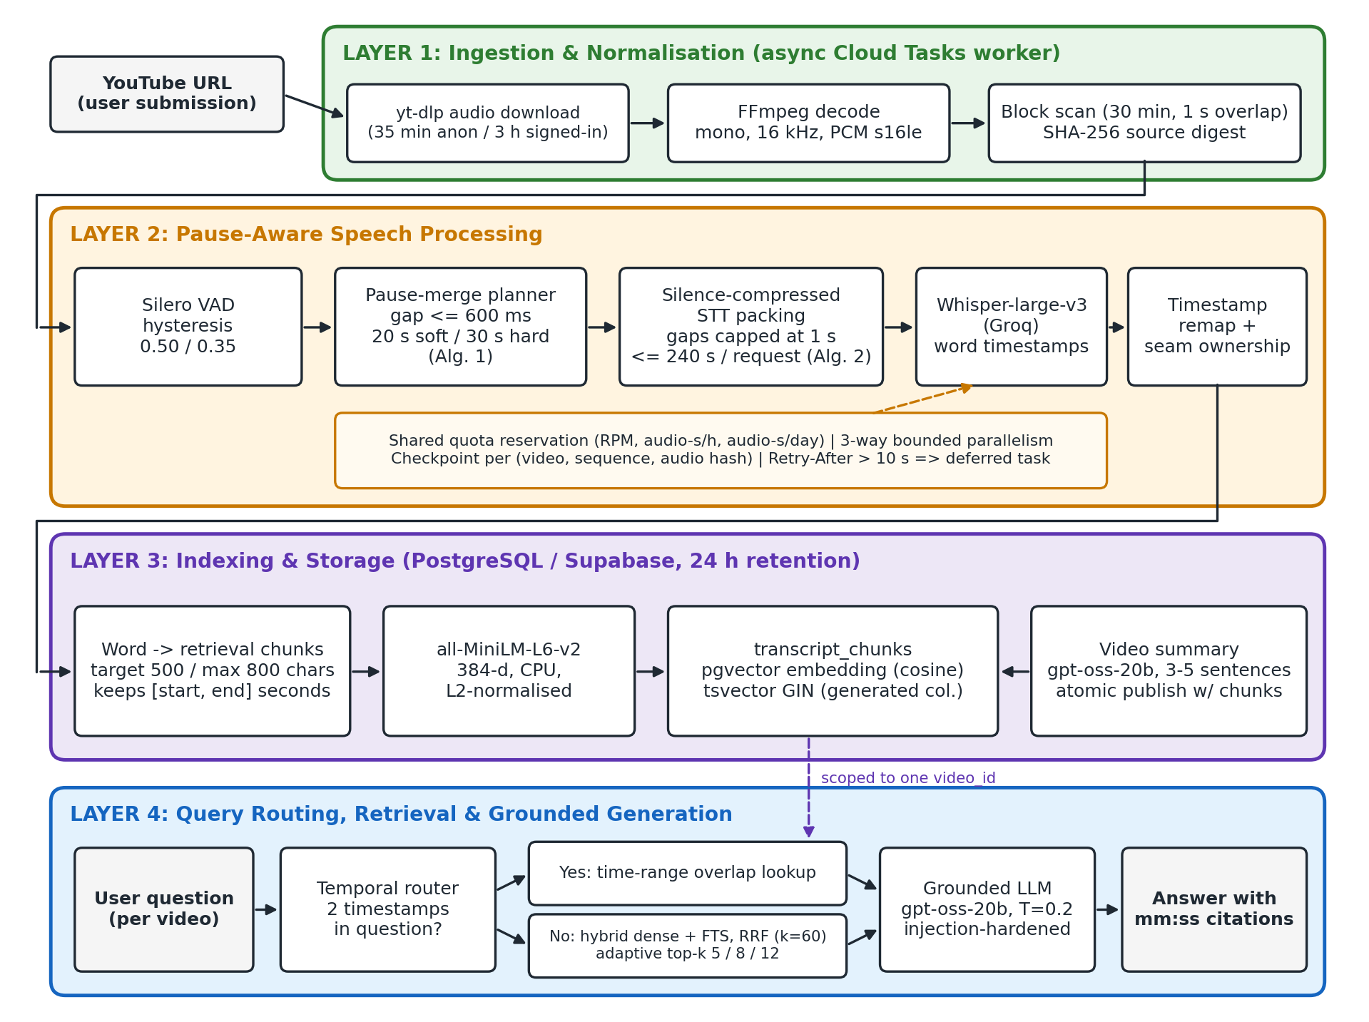
Fig. 1. Proposed VidoraAI architecture: four layers from YouTube URL to a timestamp-cited answer.

B. Ingestion and Normalisation (Layer 1)
The worker downloads only the audio stream with yt-dlp. The original video is never stored. Duration limits are 35 min for anonymous users and 3 h for signed-in users. FFmpeg decodes the audio to mono, 16 kHz, 16-bit PCM. Longer inputs are rejected rather than silently truncated. To bound memory on CPU-only functions, the normalised audio is scanned in 30-minute blocks with 1 s overlap. A SHA-256 digest of the PCM stream identifies the source, and chunk identifiers are deterministic UUIDv5 values derived from the video ID and sample bounds.

C. Pause-Aware Segmentation (Contribution C1)
Silero VAD [12] produces speech regions with hysteresis: a region opens when speech probability exceeds θ = 0.50 and closes only when it falls below θ⁻ = 0.35. This prevents rapid toggling on noisy audio. Regions shorter than 250 ms are ignored, silences shorter than 100 ms do not split a region, and detection uses no padding, so that merge decisions see the true gaps. The detector is also told to close an over-long region at its best internal silence before the hard cap (max_speech_duration = 30 s − 2·pad).
Algorithm 1 merges neighbouring regions into chunks. A region joins the current group only if (i) the group is still below the soft target T = 20 s, (ii) the pause before it is at most g = 600 ms, and (iii) the merged span fits the hard budget B = 30 s − 2p, where p = 150 ms is the export padding. Pauses inside a chunk are kept as real audio. Nothing is concatenated or time-compressed at this stage, so chunk times equal video times. Only a single uninterrupted region longer than B is force-split, with o = 250 ms of speech overlap between parts. The packer of Section III-D later trims this overlap.
Algorithm 1 Pause-Aware VAD Chunk Planning
Input:
• R = ⟨(s₁,e₁), …, (sₙ,eₙ)⟩ — ordered speech regions from Silero VAD (samples)
• g = 600 ms (merge pause), p = 150 ms (padding), o = 250 ms (forced-split overlap)
• B = 30 s − 2p (hard budget), T = min(B, 20 s) (soft target), N = total samples
Output: K — ordered chunks [aₖ, bₖ] on the original timeline
1: G ← ∅
2: for each (sᵢ, eᵢ) ∈ R do
3: if G ≠ ∅ and len(G_last) < T and sᵢ − end(G_last) ≤ g and eᵢ − start(G_last) ≤ B then
4: end(G_last) ← eᵢ ▷ keep the pause as real audio
5: else G ← G ∪ {[sᵢ, eᵢ]}
6: K ← ∅
7: for each [a, b] ∈ G do
8: c ← a
9: repeat
10: z ← min(c + B, b)
11: K ← K ∪ {[max(0, c − p), min(N, z + p)]} ▷ id = UUIDv5(video, index, bounds)
12: c ← z − o ▷ overlap only when one region exceeds B
13: until z = b
14: return K

D. Silence-Compressed Transcription and Timestamp Remapping (Contribution C2)
Sending each ≤30 s chunk as its own ASR request would multiply request counts and run into provider per-minute limits. Sending the whole file would bill every second of silence. Algorithm 2 packs consecutive chunks into one request of at most Q = min(240 s, (20 MB − 44 B)/2 samples). Between two chunks it inserts min(gap, Γ) of digital silence, with Γ = 1 s, so long pauses are shortened but the speech is not. Audio already covered by a previous chunk's overlap is trimmed so that it is never transcribed twice in the same request. For every packed clip the packer records a span σ = (π_start, π_end, src_start, src_end) linking the packed position to the source position (Fig. 2).
Algorithm 2 Silence-Compressed STT Request Packing
Input:
• K — ordered chunks with WAV clips; Q — request cap (samples); Γ = 1 s — maximum retained gap
Output: Requests ⟨r₁, …, r_m⟩, each with a span table Σⱼ
1: M ← ∅; L ← 0; E ← 0 ▷ members, packed length, covered source end
2: for each chunk k = [aₖ, bₖ] ∈ K do
3: c ← (k is the first chunk) ? aₖ : max(aₖ, E) ▷ drop audio already covered; E is never reset
4: if c ≥ bₖ then continue
5: γ ← (M ≠ ∅) ? min(max(0, c − E), Γ) : 0 ▷ compress the silence
6: if L + (bₖ − c) + γ > Q and M ≠ ∅ then EMIT(M); M ← ∅; L ← 0; γ ← 0
7: M ← M ∪ {(k, c, γ)}; L ← L + (bₖ − c) + γ; E ← max(E, bₖ)
8: EMIT(M) ▷ writes γ zero-samples then clip [c, bₖ), appending σ to Σ

The ASR model (Whisper-large-v3 [13] served by Groq) returns word timestamps local to the request. A word w with local interval [τₛ, τₑ] is assigned to the span σ that contains its midpoint, and its video-clock interval is given by Eq. (1)–(2), where f = 16 kHz:
σ(w) = the σ ∈ Σ with π_start(σ) ≤ f·(τₛ + τₑ)/2 < π_end(σ) (1)
tₛ = src_start(σ) + max(f·τₛ − π_start(σ), 0)/f, tₑ = src_start(σ) + min(f·τₑ − π_start(σ), |σ|)/f (2)
Words whose midpoint falls inside a synthetic gap, words with non-finite or out-of-range times, and empty tokens are discarded. Because the covered-source pointer E is never reset between requests, the source intervals of all requests are disjoint. A forced split (Algorithm 1) that falls inside one request is therefore re-joined into continuous audio, and the 250 ms split overlap is never transcribed twice. As a guard against provider timestamps that drift past a request boundary, a word from request rⱼ is kept only if its midpoint lies in the seam-bounded interval [ℓⱼ, uⱼ) of Eq. (3). Global de-duplication is deliberately avoided because speakers legitimately repeat phrases.
ℓⱼ = (end(rⱼ₋₁) + start(rⱼ))/2, uⱼ = (end(rⱼ) + start(rⱼ₊₁))/2 (3)
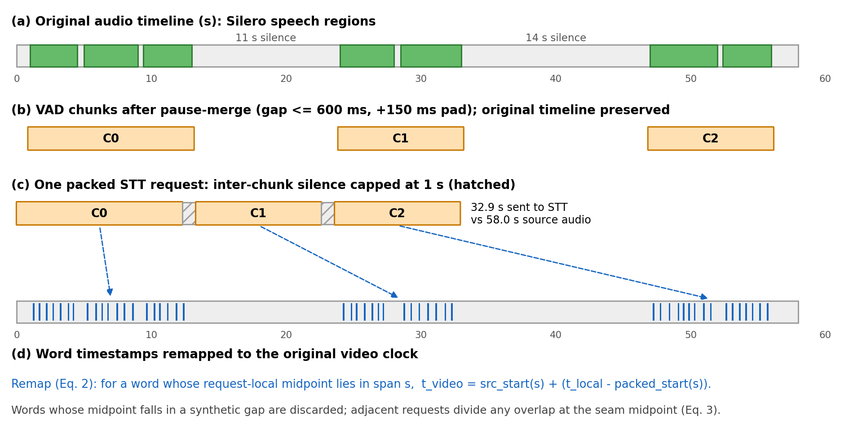
Fig. 2. Silence-compressed packing: (a) speech regions, (b) pause-merged VAD chunks on the original timeline, (c) one packed request with silences capped at 1 s, (d) words remapped to video time. Illustrative example, not measured data.

E. Quota-Aware, Resumable Transcription
Requests are transcribed with bounded parallelism (3 per video). Before each call, the worker reserves capacity in shared PostgreSQL counters for requests per minute, audio-seconds per hour and audio-seconds per day, so that all concurrent workers respect provider limits. Transient failures are retried up to four times with jittered exponential back-off. If the provider asks for a wait longer than 10 s, the job is re-enqueued with that delay instead of holding a function instance. Each completed request is checkpointed under the key (video, first sequence, SHA-256 of the request audio). A resumed job re-derives identical requests and pays only for those not yet transcribed. If any request fails after retries, publication is blocked. An empty VAD result or an all-empty transcript fails the video rather than inventing text.

F. Retrieval Units and Indexing (Layer 3)
Words on the video clock are merged in order into retrieval chunks. A chunk is closed once it reaches 500 characters and never exceeds 800 characters. Each chunk keeps the start time of its first word and the end time of its last word, so retrieval units have word-accurate boundaries rather than fixed 30 s windows. Each chunk is embedded with all-MiniLM-L6-v2 [14] (384-d, L2-normalised, CPU, model bundled with the function). It is stored in PostgreSQL with a pgvector column for cosine search and a generated tsvector column (to_tsvector('english', text)) with a GIN index for lexical search. A 3–5 sentence summary is generated from the first 20,000 characters of the transcript. The chunks and the COMPLETED status are written in one transaction, so a video is never visible half-indexed. All transcript data expires after about 24 hours.

G. Query Routing and Hybrid Retrieval (Contribution C3)
Temporal routing. A question that contains exactly two timestamps of the form m:ss or h:mm:ss is treated as time-anchored. The two times are sorted into [t₁, t₂], and every chunk whose interval overlaps that range (start ≤ t₂ and end ≥ t₁) is returned in chronological order, bypassing semantic search. Questions with zero, one or more than two timestamps fall through to hybrid retrieval rather than guessing.
Hybrid retrieval. Within one video, a semantic list ranks chunks by pgvector cosine distance and a lexical list ranks chunks matching plainto_tsquery by ts_rank. Each list is truncated to a candidate pool P = max(4k, 20). The two lists are fused by reciprocal rank fusion [10] with constant κ = 60. A chunk missing from a list receives the penalty rank P + 1, so lexical-only and semantic-only hits are both kept:
score(d) = 1/(κ + r_sem(d)) + 1/(κ + r_lex(d)), r(d) = P + 1 if d ∉ list (4)
The top k chunks are returned, where k depends on video duration D: k = 5 for D ≤ 10 min, 8 for D ≤ 30 min and 12 otherwise. Both lists and the fusion run as one SQL statement with common table expressions, scoped by video_id, so no question can retrieve another video's content.
Algorithm 3 Query Routing and Retrieval
Input:
• q — question; v — video with duration D; E(·) — MiniLM encoder
Output: C — ordered evidence chunks with [start, end] times
1: τ ← all timestamps matching \d{1,2}(:\d{2}){1,2} in q
2: if |τ| = 2 then
3: [t₁, t₂] ← sort(τ); return chunks of v with start ≤ t₂ ∧ end ≥ t₁, by start
4: k ← 5 if D ≤ 600 s; 8 if D ≤ 1800 s; else 12; P ← max(4k, 20)
5: S ← top-P chunks of v by cosine(E(q), e_d)
6: L ← top-P chunks of v with tsv_d @@ plainto_tsquery(q), by ts_rank
7: return top-k of S ∪ L by Eq. (4)

H. Grounded Answer Generation
Each retrieved chunk is prefixed with its interval in [mm:ss–mm:ss] form, HTML-escaped and placed inside <transcript_context> tags. The question goes inside <user_question>. The answer model (gpt-oss-20b served by Groq, temperature 0.2, at most 1024 output tokens) is instructed to use only the excerpts, to cite timestamps when they help, to say plainly when the excerpts are insufficient, and to treat both the transcript and the question as untrusted data rather than instructions. If retrieval returns nothing, a fixed "not found in this video" answer is given without calling the model.

I. Deployment, Privacy and Retention
The backend is FastAPI on Firebase (Google Cloud) Python functions with 2 GB of memory and 1 vCPU, with no GPU. The API has a 300 s timeout and the worker 900 s. Cloud Tasks retries a failed worker up to 3 times, and a completed video is never reprocessed on redelivery. Submissions and questions are rate-limited and protected by reCAPTCHA. Only audio is downloaded. Transcripts, embeddings and question logs expire after about 24 hours, and the original video is never stored.
TABLE II
Production Configuration
Parameter | Value | Role
VAD threshold θ / θ⁻ | 0.50 / 0.35 | Hysteresis open/close
Min speech / min silence | 250 ms / 100 ms | Region filtering
Merge pause g | 600 ms | Max pause bridged inside a chunk
Soft target T / hard cap | 20 s / 30 s (incl. 2×150 ms pad) | Chunk size
Forced-split overlap o | 250 ms | Only for speech longer than the cap
Request cap Q | 240 s and ≤ 20 MB | STT request size
Max retained gap Γ | 1 s | Silence compression
STT model / concurrency | whisper-large-v3 (Groq) / 3 | Word timestamps
Retrieval chunk | target 500, max 800 chars | Retrieval unit
Embedding | all-MiniLM-L6-v2, 384-d | Dense signal
RRF κ / pool P | 60 / max(4k, 20) | Fusion
k by duration | 5 (≤10 min), 8 (≤30 min), 12 | Retrieval depth
Answer LLM | gpt-oss-20b, T = 0.2, 1024 tokens | Generation

IV. Evaluation Design and Results
Planning section. It will be rewritten as Results once the measurements exist. Tables III–V define what will be measured, from which source, and the baselines each claim needs.
TABLE III
Research Questions and Measurements
RQ | Question | Metrics | Data source
RQ1 | Does pause-aware chunking (C1) transcribe better than fixed windows? | WER, word omissions/duplications at boundaries, % words cut by a boundary | Offline: benchmark videos with reference transcripts; baselines fixed 30 s, fixed 240 s, whole-file
RQ2 | How much audio and how many requests does silence compression (C2) save? | packed_audio_s / duration_s, speech ratio, requests per hour of video, STT cost per hour | Production logs (after adding the audio-accounting log) + offline replay
RQ3 | Are remapped timestamps exact? | Mean/95th-pct |t_remap − t_ref| per word; % words dropped at seams | Offline: compare packed vs unpacked transcription of the same audio
RQ4 | Does hybrid RRF (C3) retrieve better than dense or lexical alone? | Recall@k, MRR, nDCG@k, timestamp hit within ±10 s | Offline QA benchmark; ablate dense / lexical / hybrid and fixed vs adaptive k
RQ5 | Does temporal routing answer time-anchored questions correctly? | Interval coverage, answer accuracy on time-range questions | Offline: templated time-range questions
RQ6 | Are end-to-end answers correct and grounded? | Answer correctness, groundedness/faithfulness, correct refusal rate, citation accuracy | Offline: human labels + LLM-judge with agreement check
RQ7 | How does the system perform in production? | Per-stage latency, processing time ÷ video duration, success rate, failure causes, quota deferrals, cache reuse | GCP logs: analysis_stage, analysis_failed, analysis_deferred, analysis_reused

A. Datasets (proposed)
- Long-video benchmark (new). 30–50 public, Creative-Commons or permission-cleared YouTube videos of 10–120 min across lectures, podcasts, tutorials and talks, with ~20 annotated questions each (answer text and gold time span). Include time-anchored and unanswerable questions.
- LectQA-Vid [4] (public, 2–5 min lectures) for a direct comparison with the closest prior work.
- Production telemetry from date range covering N videos (aggregates only).

B. Results tables (to be filled)
TABLE IV
Segmentation Ablation (RQ1–RQ2)
Segmentation | WER ↓ | Audio sent (s/h) ↓ | Requests/h ↓ | Boundary errors ↓
Whole file |  | 3600
Fixed 30 s windows |  | 3600 | 120
VAD chunks, one request each
VAD + silence-compressed packing (ours)

TABLE V
Retrieval Ablation (RQ4)
Retriever | Recall@5 ↑ | MRR ↑ | nDCG@10 ↑ | Hit@±10 s ↑
Lexical only (ts_rank)
Dense only (MiniLM)
Hybrid RRF, fixed k
Hybrid RRF, adaptive k (ours)

V. Conclusion and Future Research Directions
Final wording after results. This paper presented VidoraAI, a speech-first RAG system for timestamp-grounded question answering over long YouTube videos. Its pause-aware segmentation and silence-compressed transcription reduce transcription cost while keeping word timestamps exact on the video clock. Its query-aware hybrid retrieval serves both semantic and time-anchored questions within a single video. Future work includes multilingual and code-mixed (Hindi-English) lexical search, cross-encoder re-ranking, adding visual signals for non-speech content, cross-video retrieval, and using the same timestamped index to recommend short-form clips.

References
Preliminary list. Entries marked [verify] were identified by title or arXiv ID during the literature search. Confirm authors, venue and year against the full text before submission. Add a proper systematic search (Google Scholar, Semantic Scholar, ACL Anthology) before finalising Section II.
[1] Y. Luo et al. [verify], "Video-RAG: Visually-aligned retrieval-augmented long video comprehension," arXiv:2411.13093, 2024.
[2] X. Ren et al. [verify], "VideoRAG: Retrieval-augmented generation with extreme long-context videos," arXiv:2502.01549, 2025.
[3] [verify authors], "SceneRAG: Scene-level retrieval-augmented generation for video understanding," arXiv:2506.07600, 2025.
[4] S. Shafiq, N. Ejaz, M. A. Shah, R. Kamal, A. Sohail and S. Aslam, "Intra-video temporal-aware RAG: A self-contained framework for video-based question answering," Computers, Materials & Continua, vol. 88, no. 2, 2026.
[5] P. Lewis et al., "Retrieval-augmented generation for knowledge-intensive NLP tasks," in Proc. NeurIPS, 2020.
[6] [verify authors], "TV-RAG: A temporal-aware and semantic entropy-weighted framework for long video retrieval and understanding," arXiv:2512.23483, 2025.
[7] [verify authors], "RAG meets temporal graphs: Time-sensitive modeling and retrieval for evolving knowledge," arXiv:2510.13590, 2025.
[8] M. Bain, J. Huh, T. Han and A. Zisserman, "WhisperX: Time-accurate speech transcription of long-form audio," in Proc. Interspeech, 2023.
[9] [verify authors], "VibeVoice-ASR technical report," arXiv:2601.18184, 2026.
[10] G. V. Cormack, C. L. A. Clarke and S. Büttcher, "Reciprocal rank fusion outperforms Condorcet and individual rank learning methods," in Proc. ACM SIGIR, 2009.
[11] [verify authors], "From BM25 to corrective RAG: Benchmarking retrieval strategies for text-and-table documents," arXiv:2604.01733, 2026.
[12] Silero Team, "Silero VAD: pre-trained enterprise-grade voice activity detector," GitHub repository, v6.2.2.
[13] A. Radford, J. W. Kim, T. Xu, G. Brockman, C. McLeavey and I. Sutskever, "Robust speech recognition via large-scale weak supervision," in Proc. ICML, 2023.
[14] N. Reimers and I. Gurevych, "Sentence-BERT: Sentence embeddings using Siamese BERT-networks," in Proc. EMNLP-IJCNLP, 2019.

