Pause-Aligned Segmentation and Request Packing for Timestamp-Grounded Question Answering over Long YouTube Videos
Author 1, Author 2, … · A2R, City, Country · email
Abstract—Long-form online video is mostly speech, yet most video question-answering systems either sample visual frames at high cost or transcribe fixed-length windows that cut words in half. This paper presents VidoraAI, a production speech-first retrieval-augmented generation (RAG) system that answers natural-language questions about a YouTube video with answers grounded in, and cited to, timestamps on the original video clock. Silero voice-activity detection with hysteresis and a pause-merge planner form chunks of at most 30 s that never cut through a pause. A packing stage joins these chunks into transcription requests of up to 240 s, capping each silence at 1 s and remapping every word timestamp exactly to the original timeline. At query time, questions that contain a time range are routed to an interval lookup, and all other questions use in-video hybrid retrieval that fuses dense and full-text rankings by reciprocal rank fusion. In four weeks of live operation (79 ingestion jobs), packing cut transcription requests by 95.1%, and after the pipeline stabilised no job failed once its audio had been obtained. On a 71-recording, 57.9-hour long-form benchmark, packing needed about as many requests as fixed 240 s windows (15.7 vs 15.6 per hour) while placing 2.4% of request boundaries inside speech, against 84% for fixed windows. On 10 TED talks transcribed with Whisper-large-v3, packed requests reached 3.36% WER, on par with fixed 240 s windows (3.34%) and lower than fixed 30 s windows (3.98%), which needed seven times as many requests. The evaluation also exposed a timestamp-assembly defect in the deployed system that had raised WER to 7.63%. It was fixed and redeployed. In a 138-question retrieval study we find that the production lexical branch matches no passage for 97% of natural-language questions, so hybrid retrieval degenerates to dense retrieval. An OR-semantics lexical query restores the signal and raises Hit@1 from 0.587 to 0.638, although not significantly at this sample size. End to end, 89.9% of answerable questions were answered correctly and 0% contained invented facts. The whole system runs on CPU-only serverless functions.
Index Terms—retrieval-augmented generation, video question answering, voice activity detection, speech recognition, hybrid retrieval, reciprocal rank fusion, temporal grounding.

I. Introduction
Video is now a primary medium for lectures, podcasts, tutorials and talks, and many of these videos run from tens of minutes to several hours. A viewer who wants one fact from such a video must scrub through it by hand. Large multimodal models can answer questions about short clips, but processing every frame of a long video is expensive, and for speech-dominated content most of the answer-bearing information is in the audio track, which is why recent video RAG systems add ASR transcripts to visual features [1], [2].
A natural alternative is to transcribe the audio and apply retrieval-augmented generation (RAG) to the transcript [5]. Building such a system for real users raises engineering problems that are rarely evaluated together. First, how the audio is segmented before automatic speech recognition (ASR) affects both accuracy and cost. Fixed windows cut words in half, and hosted ASR bills every second sent, including silence. Second, answers are useful only if they point the user to the right moment, so timestamps must survive segmentation, batching and retrieval exactly. Third, user questions are of two kinds: semantic questions ("what does the speaker say about X?") and time-anchored questions ("what happens between 12:30 and 14:00?"). No single retriever serves both well. Fourth, a public service must operate within provider rate limits and fail safely.
This paper describes VidoraAI, a speech-first video RAG system that addresses these problems and is deployed in production at A2R. Its main contributions are:
- C1 – Pause-aware segmentation. Silero VAD with hysteresis and a pause-merge planner produce ASR chunks of at most 30 s that preserve the original timeline. A mid-speech cut, with overlap, is made only when uninterrupted speech exceeds the cap (Section III-C).
- C2 – Pause-aligned request packing with exact timestamp remapping. VAD chunks are packed into requests of up to 240 s, with every silence capped at 1 s. A span table maps each word back to the original video clock. The result needs about as many requests as large fixed windows while almost never cutting inside detected speech (Section III-D).
- C3 – Query-aware in-video retrieval and its analysis. A temporal router sends time-anchored questions to an interval lookup. Other questions use a single-query hybrid retriever that fuses dense and lexical rankings by reciprocal rank fusion, with retrieval depth adapted to video duration. We show that AND-semantics full-text queries silently disable the lexical branch for natural questions, and we evaluate a one-line fix (Sections III-G, IV-E).
- C4 – Production and offline evidence. Four weeks of live telemetry, an offline replay of the production code on 71 long-form recordings, a paired WER study of three segmentation strategies, a 143-question retrieval study and an end-to-end answer study (Section IV). The evaluation found and quantified a word-ordering defect in the deployed assembly step (Section IV-E3).
The rest of the paper is organised as follows. Section II reviews related work. Section III presents the architecture and algorithms. Section IV describes the evaluation design and results. Section V concludes and outlines future work.

II. Related Work
Video RAG. Video-RAG [1] augments large video-language models with auxiliary texts, including ASR transcripts produced with Whisper, that are retrieved per query. VideoRAG [2] targets extremely long videos by combining ASR, visual captions and graph-based indexing. SceneRAG [3] segments long videos into scenes and uses silent intervals in ASR output to refine scene boundaries, starting from fixed 5-minute windows with 10 s overlap. These systems are mainly visual or multimodal. None studies how ASR segmentation affects cost and timestamp fidelity.
Temporal grounding in RAG. The intra-video temporal-aware RAG framework of Shafiq et al. [4] is the closest to this work. It builds timestamped chunks from Whisper large-v3 output and visual captions, retrieves with dense embeddings and a cross-encoder, and filters by time. It is evaluated on 2–5 minute lecture videos, and its temporal window comes from gold annotations rather than from the question. TV-RAG [6] re-ranks ASR and OCR text with a time-decay term. TG-RAG [7] extracts temporal expressions from questions over a knowledge graph.
VAD and segmentation for ASR. WhisperX [8] uses VAD to cut and merge long audio into Whisper-sized segments. Recent ASR reports use Silero VAD clips of up to 30 s as a baseline [9]. These works target transcription accuracy and do not consider downstream retrieval or per-second ASR billing.
Hybrid retrieval. Reciprocal rank fusion (RRF) [10] combines rankings without score calibration and is widely used to fuse BM25-style lexical retrieval with dense retrieval [11]. This work applies RRF inside a single video's transcript, inside one SQL statement.
TABLE I
Related Works (preliminary – to be verified against full texts)
Work | Year | Segmentation of speech | Retrieval | Gap addressed here
Video-RAG [1] | 2024 | Whisper ASR as auxiliary text | Per-query auxiliary-text retrieval | No cost-aware ASR; no word-level remap
VideoRAG [2] | 2025 | ASR per clip + captions | Graph + multimodal | Visual-heavy; not timestamp-cited QA
SceneRAG [3] | 2025 | Fixed 5 min windows, 10 s overlap | Scene-level | Fixed windows; silence still transcribed
Shafiq et al. [4] | 2026 | Whisper segments, semantic chunks | Dense + cross-encoder; gold time filter | 2–5 min videos only; no lexical signal; time window not from question
TV-RAG [6] | 2025 | ASR/OCR snippets | Lexical + time-decay re-rank | No segmentation or cost study
WhisperX [8] | 2023 | VAD cut & merge | — | ASR only; no retrieval
This work | 2026 | VAD pause-merge + silence-compressed packing + exact remap | Temporal routing + hybrid RRF, adaptive k | —

III. Methodology

A. System Overview
VidoraAI is organised in four layers (Fig. 1). Layer 1 downloads and normalises the audio. Layer 2 converts speech into word-level timestamps on the original video clock. Layer 3 builds and stores retrieval units. Layer 4 routes each question, retrieves evidence from a single video and generates a grounded, timestamp-cited answer. Ingestion runs asynchronously. The API stores the job, enqueues it with Cloud Tasks and immediately returns a PROCESSING record, which the client polls for stage-level progress.
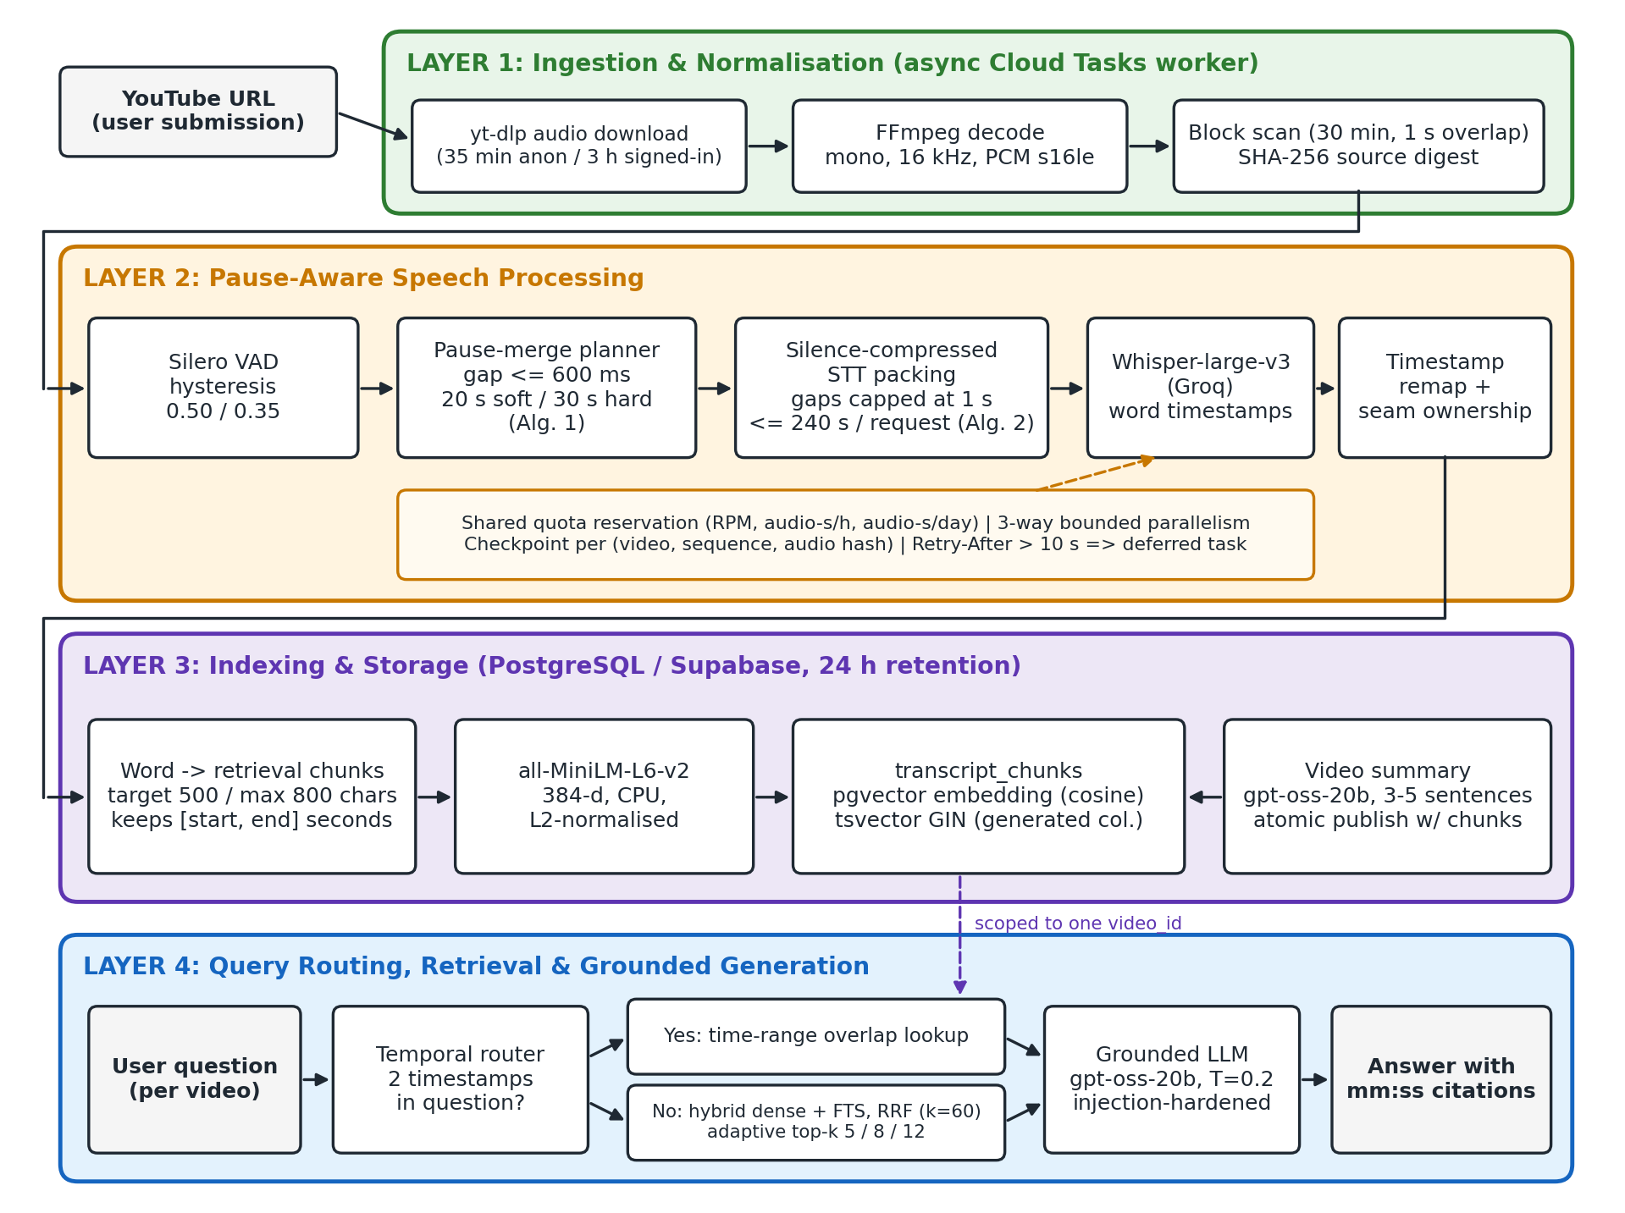
Fig. 1. Proposed VidoraAI architecture: four layers from YouTube URL to a timestamp-cited answer.

B. Ingestion and Normalisation (Layer 1)
The worker downloads only the audio stream with yt-dlp. The original video is never stored. Duration limits are 35 min for anonymous users and 3 h for signed-in users. FFmpeg decodes the audio to mono, 16 kHz, 16-bit PCM. Longer inputs are rejected rather than silently truncated. To bound memory on CPU-only functions, the normalised audio is scanned in 30-minute blocks with 1 s overlap. A SHA-256 digest of the PCM stream identifies the source, and chunk identifiers are deterministic UUIDv5 values derived from the video ID and sample bounds.

C. Pause-Aware Segmentation (Contribution C1)
Silero VAD [12] produces speech regions with hysteresis: a region opens when speech probability exceeds θ = 0.50 and closes only when it falls below θ⁻ = 0.35. This prevents rapid toggling on noisy audio. Regions shorter than 250 ms are ignored, silences shorter than 100 ms do not split a region, and detection uses no padding, so that merge decisions see the true gaps. The detector is also told to close an over-long region at its best internal silence before the hard cap (max_speech_duration = 30 s − 2·pad).
Algorithm 1 merges neighbouring regions into chunks. A region joins the current group only if (i) the group is still below the soft target T = 20 s, (ii) the pause before it is at most g = 600 ms, and (iii) the merged span fits the hard budget B = 30 s − 2p, where p = 150 ms is the export padding. Pauses inside a chunk are kept as real audio. Nothing is concatenated or time-compressed at this stage, so chunk times equal video times. Only a single uninterrupted region longer than B is force-split, with o = 250 ms of speech overlap between parts. The packer of Section III-D later trims this overlap.
Algorithm 1 Pause-Aware VAD Chunk Planning
Input:
• R = ⟨(s₁,e₁), …, (sₙ,eₙ)⟩ — ordered speech regions from Silero VAD (samples)
• g = 600 ms (merge pause), p = 150 ms (padding), o = 250 ms (forced-split overlap)
• B = 30 s − 2p (hard budget), T = min(B, 20 s) (soft target), N = total samples
Output: K — ordered chunks [aₖ, bₖ] on the original timeline
1: G ← ∅
2: for each (sᵢ, eᵢ) ∈ R do
3: if G ≠ ∅ and len(G_last) < T and sᵢ − end(G_last) ≤ g and eᵢ − start(G_last) ≤ B then
4: end(G_last) ← eᵢ ▷ keep the pause as real audio
5: else G ← G ∪ {[sᵢ, eᵢ]}
6: K ← ∅
7: for each [a, b] ∈ G do
8: c ← a
9: repeat
10: z ← min(c + B, b)
11: K ← K ∪ {[max(0, c − p), min(N, z + p)]} ▷ id = UUIDv5(video, index, bounds)
12: c ← z − o ▷ overlap only when one region exceeds B
13: until z = b
14: return K

D. Silence-Compressed Transcription and Timestamp Remapping (Contribution C2)
Sending each ≤30 s chunk as its own ASR request would multiply request counts and run into provider per-minute limits. Sending the whole file would bill every second of silence. Algorithm 2 packs consecutive chunks into one request of at most Q = min(240 s, (20 MB − 44 B)/2 samples). Between two chunks it inserts min(gap, Γ) of digital silence, with Γ = 1 s, so long pauses are shortened but the speech is not. Audio already covered by a previous chunk's overlap is trimmed so that it is never transcribed twice in the same request. For every packed clip the packer records a span σ = (π_start, π_end, src_start, src_end) linking the packed position to the source position (Fig. 2).
Algorithm 2 Silence-Compressed STT Request Packing
Input:
• K — ordered chunks with WAV clips; Q — request cap (samples); Γ = 1 s — maximum retained gap
Output: Requests ⟨r₁, …, r_m⟩, each with a span table Σⱼ
1: M ← ∅; L ← 0; E ← 0 ▷ members, packed length, covered source end
2: for each chunk k = [aₖ, bₖ] ∈ K do
3: c ← (k is the first chunk) ? aₖ : max(aₖ, E) ▷ drop audio already covered; E is never reset
4: if c ≥ bₖ then continue
5: γ ← (M ≠ ∅) ? min(max(0, c − E), Γ) : 0 ▷ compress the silence
6: if L + (bₖ − c) + γ > Q and M ≠ ∅ then EMIT(M); M ← ∅; L ← 0; γ ← 0
7: M ← M ∪ {(k, c, γ)}; L ← L + (bₖ − c) + γ; E ← max(E, bₖ)
8: EMIT(M) ▷ writes γ zero-samples then clip [c, bₖ), appending σ to Σ

The ASR model (Whisper-large-v3 [13] served by Groq) returns word timestamps local to the request. A word w with local interval [τₛ, τₑ] is assigned to the span σ nearest to its midpoint (the containing span when there is one), and its video-clock interval is given by Eq. (1)–(2), where f = 16 kHz:
σ(w) = argmin over σ ∈ Σ of dist(f·(τₛ + τₑ)/2, [π_start(σ), π_end(σ))) (1)
tₛ = max(src_start(σ) + clip(f·τₛ − π_start(σ), 0, |σ|)/f, tₛ of the previous word), tₑ = max(src_start(σ) + clip(f·τₑ − π_start(σ), 0, |σ|)/f, tₛ + 10 ms) (2)
Words with non-finite or out-of-range times and empty tokens are discarded. Words whose midpoint falls inside a synthetic gap are kept and attached to the nearest span, because ASR word timings around pauses are imprecise. Start times are made non-decreasing within a request, so the provider's word order survives the final stable sort by start time. An earlier version dropped gap words and sorted by (start, end). Section IV-E3 shows that this cost 4.3 WER points. Because the covered-source pointer E is never reset between requests, the source intervals of all requests are disjoint. A forced split (Algorithm 1) that falls inside one request is therefore re-joined into continuous audio, and the 250 ms split overlap is never transcribed twice. As a guard against provider timestamps that drift past a request boundary, a word from request rⱼ is kept only if its midpoint lies in the seam-bounded interval [ℓⱼ, uⱼ) of Eq. (3). Global de-duplication is deliberately avoided because speakers legitimately repeat phrases.
ℓⱼ = (end(rⱼ₋₁) + start(rⱼ))/2, uⱼ = (end(rⱼ) + start(rⱼ₊₁))/2 (3)
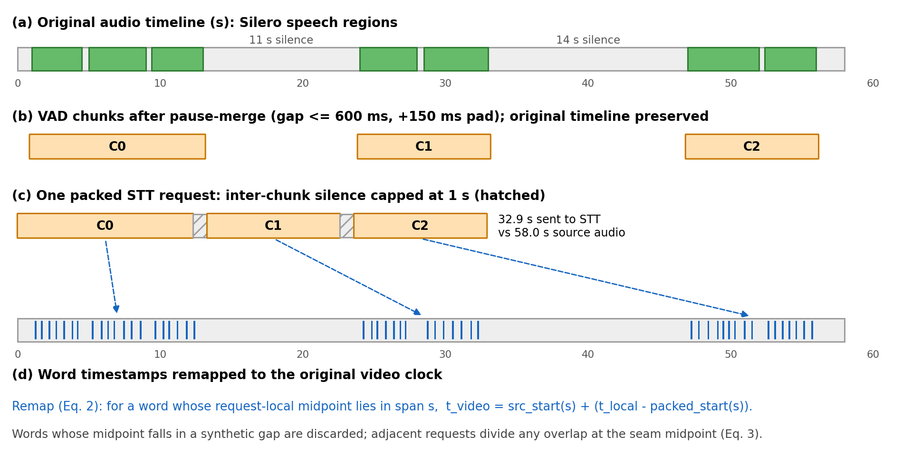
Fig. 2. Silence-compressed packing: (a) speech regions, (b) pause-merged VAD chunks on the original timeline, (c) one packed request with silences capped at 1 s, (d) words remapped to video time. Illustrative example, not measured data.

E. Quota-Aware, Resumable Transcription
Requests are transcribed with bounded parallelism (3 per video). Before each call, the worker reserves capacity in shared PostgreSQL counters for requests per minute, audio-seconds per hour and audio-seconds per day, so that all concurrent workers respect provider limits. Transient failures are retried up to four times with jittered exponential back-off. If the provider asks for a wait longer than 10 s, the job is re-enqueued with that delay instead of holding a function instance. Each completed request is checkpointed under the key (video, first sequence, SHA-256 of the request audio). A resumed job re-derives identical requests and pays only for those not yet transcribed. If any request fails after retries, publication is blocked. An empty VAD result or an all-empty transcript fails the video rather than inventing text.

F. Retrieval Units and Indexing (Layer 3)
Words on the video clock are merged in order into retrieval chunks. A chunk is closed once it reaches 500 characters and never exceeds 800 characters. Each chunk keeps the start time of its first word and the end time of its last word, so retrieval units have word-accurate boundaries rather than fixed 30 s windows. Each chunk is embedded with all-MiniLM-L6-v2 [14] (384-d, L2-normalised, CPU, model bundled with the function). It is stored in PostgreSQL with a pgvector column for cosine search and a generated tsvector column (to_tsvector('english', text)) with a GIN index for lexical search. A 3–5 sentence summary is generated from the first 20,000 characters of the transcript. The chunks and the COMPLETED status are written in one transaction, so a video is never visible half-indexed. All transcript data expires after about 24 hours.

G. Query Routing and Hybrid Retrieval (Contribution C3)
Temporal routing. A question that contains exactly two timestamps of the form m:ss or h:mm:ss is treated as time-anchored. The two times are sorted into [t₁, t₂], and every chunk whose interval overlaps that range (start ≤ t₂ and end ≥ t₁) is returned in chronological order, bypassing semantic search. Questions with zero, one or more than two timestamps fall through to hybrid retrieval rather than guessing.
Hybrid retrieval. Within one video, a semantic list ranks chunks by pgvector cosine distance and a lexical list ranks chunks matching plainto_tsquery by ts_rank. Each list is truncated to a candidate pool P = max(4k, 20). The two lists are fused by reciprocal rank fusion [10] with constant κ = 60. A chunk missing from a list receives the penalty rank P + 1, so lexical-only and semantic-only hits are both kept:
The lexical query is built with plainto_tsquery, which joins every stemmed, non-stop-word term of the question with AND. A chunk is a lexical candidate only if it contains all of them. Section IV-E2 shows the consequence for natural-language questions.
score(d) = 1/(κ + r_sem(d)) + 1/(κ + r_lex(d)), r(d) = P + 1 if d ∉ list (4)
The top k chunks are returned, where k depends on video duration D: k = 5 for D ≤ 10 min, 8 for D ≤ 30 min and 12 otherwise. Both lists and the fusion run as one SQL statement with common table expressions, scoped by video_id, so no question can retrieve another video's content.
Algorithm 3 Query Routing and Retrieval
Input:
• q — question; v — video with duration D; E(·) — MiniLM encoder
Output: C — ordered evidence chunks with [start, end] times
1: τ ← all timestamps matching \d{1,2}(:\d{2}){1,2} in q
2: if |τ| = 2 then
3: [t₁, t₂] ← sort(τ); return chunks of v with start ≤ t₂ ∧ end ≥ t₁, by start
4: k ← 5 if D ≤ 600 s; 8 if D ≤ 1800 s; else 12; P ← max(4k, 20)
5: S ← top-P chunks of v by cosine(E(q), e_d)
6: L ← top-P chunks of v with tsv_d @@ plainto_tsquery(q), by ts_rank
7: return top-k of S ∪ L by Eq. (4)

H. Grounded Answer Generation
Each retrieved chunk is prefixed with its interval in [mm:ss–mm:ss] form, HTML-escaped and placed inside <transcript_context> tags. The question goes inside <user_question>. The answer model (gpt-oss-20b served by Groq, temperature 0.2, at most 1024 output tokens) is instructed to use only the excerpts, to cite timestamps when they help, to say plainly when the excerpts are insufficient, and to treat both the transcript and the question as untrusted data rather than instructions. If retrieval returns nothing, a fixed "not found in this video" answer is given without calling the model.

I. Deployment, Privacy and Retention
The backend is FastAPI on Firebase (Google Cloud) Python functions with 2 GB of memory and 1 vCPU, with no GPU. The API has a 300 s timeout and the worker 900 s. Cloud Tasks retries a failed worker up to 3 times, and a completed video is never reprocessed on redelivery. Submissions and questions are rate-limited and protected by reCAPTCHA. Only audio is downloaded. Transcripts, embeddings and question logs expire after about 24 hours, and the original video is never stored.
TABLE II
Production Configuration
Parameter | Value | Role
VAD threshold θ / θ⁻ | 0.50 / 0.35 | Hysteresis open/close
Min speech / min silence | 250 ms / 100 ms | Region filtering
Merge pause g | 600 ms | Max pause bridged inside a chunk
Soft target T / hard cap | 20 s / 30 s (incl. 2×150 ms pad) | Chunk size
Forced-split overlap o | 250 ms | Only for speech longer than the cap
Request cap Q | 240 s and ≤ 20 MB | STT request size
Max retained gap Γ | 1 s | Silence compression
STT model / concurrency | whisper-large-v3 (Groq) / 3 | Word timestamps
Retrieval chunk | target 500, max 800 chars | Retrieval unit
Embedding | all-MiniLM-L6-v2, 384-d | Dense signal
RRF κ / pool P | 60 / max(4k, 20) | Fusion
k by duration | 5 (≤10 min), 8 (≤30 min), 12 | Retrieval depth
Answer LLM | gpt-oss-20b, T = 0.2, 1024 tokens | Generation

IV. Results

A. Experimental Setup
Production telemetry. VidoraAI is publicly deployed and receives YouTube links from real users. We analysed the structured events emitted by the API and worker services between 12 September and 10 October 2026 in Google Cloud Logging: per-stage elapsed time, VAD chunk counts, per-request STT completions, failures with stage and error type, and cache reuse. Jobs are identified only by random UUIDs. No transcript, question, title or video identity was used. The pipeline was revised during this window. The VAD pipeline was rolled out on 22 September, per-request STT logging was in place from 23 September, and we call 24 September – 10 October the stable period. Transcript rows and video metadata are purged after about 24 hours, so video durations are not available retrospectively. Measurements that need duration or reference transcripts are taken from the offline benchmark (Section IV-E).
Offline benchmark. To measure what production logs cannot, we replay the production code on 71 public long-form recordings with human transcripts and run a 143-question retrieval study (Section IV-E).

B. Operational Reliability
TABLE III
Ingestion Outcomes in Production
Outcome | Whole window  (79 jobs) | Stable period  (24 jobs)
Completed (fresh ingestion) | 31 | 12
Served by reusing an earlier completed analysis | 3 | 3
Rejected: video longer than the duration limit | 9 | 2
Failed: YouTube download error | 11 | 2
Failed: YouTube bot challenge | 8 | 5
Failed in transcription stage | 16 | 0
Failed in summary (LLM provider error) | 1 | 0

All 16 transcription-stage failures happened on 22–23 September, on the first three worker revisions of the VAD rollout (11 aggregated errors from concurrent STT tasks, 3 validation errors and 2 empty transcripts). No transcription failure has occurred since. In the stable period, every job whose audio was obtained completed (12 of 12), and 3 further requests were served instantly from an earlier analysis of the same video. All 9 failures in the stable period happened before the AI pipeline started: 7 were YouTube access errors and 2 were duration-policy rejections. Upstream media access, not the speech or retrieval pipeline, is therefore the dominant operational risk.

C. Ingestion Latency
Fig. 3 and Table IV give per-stage latency for the 21 completed jobs that ran the VAD pipeline. Each stage is measured from its start to the start of the next stage. End-to-end ingestion took a median of 115.3 s (90th percentile 183.4 s, maximum 297.9 s). In the stable period the median was 144.0 s (90th percentile 169.2 s, n = 12). That sample contains longer videos: a median of 42 VAD chunks per video, against 24 for jobs completed before 23 September.
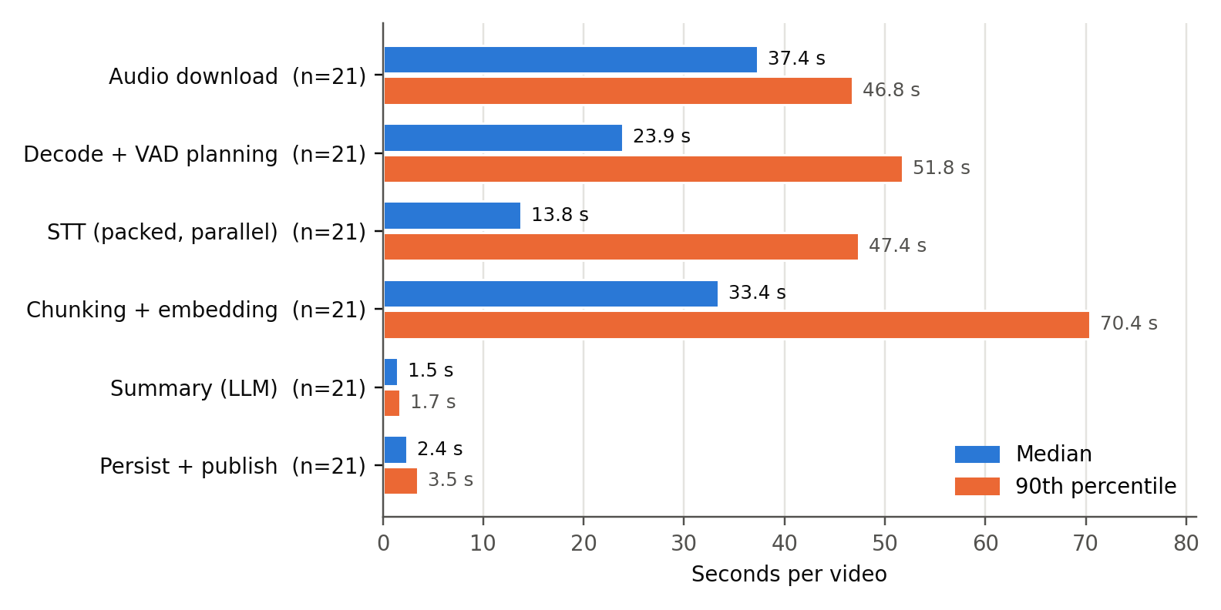
Fig. 3. Per-stage ingestion latency in production (median and 90th percentile, n = 21 completed VAD-pipeline jobs).
TABLE IV
Ingestion Latency by Stage
Stage | Median (s) | P90 (s) | n
Audio download (yt-dlp) | 37.4 | 46.8 | 21
Decode + VAD planning (CPU) | 23.9 | 51.8 | 21
STT, packed and parallel | 13.8 | 47.4 | 21
Retrieval chunking + embedding (CPU) | 33.4 | 70.4 | 21
Summary (LLM) | 1.5 | 1.7 | 21
Persist + atomic publish | 2.4 | 3.5 | 21
End-to-end | 115.3 | 183.4 | 21

Transcription is not the bottleneck. Packed requests run three at a time, so the median STT stage takes 13.8 s. The longest video in the sample (191 VAD chunks, 11 requests) finished all of its requests within 23 s of its chunks being ready. Download and the two CPU-bound stages, VAD and embedding, together take most of the time on a single vCPU. These are the targets for future optimisation, for example ONNX-based VAD inference and larger embedding batches. Real-time factor (processing time ÷ video duration) to be added from the new duration telemetry; see Appendix A, item 2.

D. Effect of Silence-Compressed Packing on Requests
Thirteen completed jobs have per-request STT logs. Without packing, each VAD chunk would be one transcription request. With packing, these jobs produced 940 VAD chunks but sent only 46 requests, 95.1% fewer (20.4× fewer) (Fig. 4). The median job sent 3 requests. Each request carried a median of 17 VAD chunks (mean 20.4, maximum 60, n = 46). The 46 logged request completions match the computed request total exactly, which cross-checks the measurement.
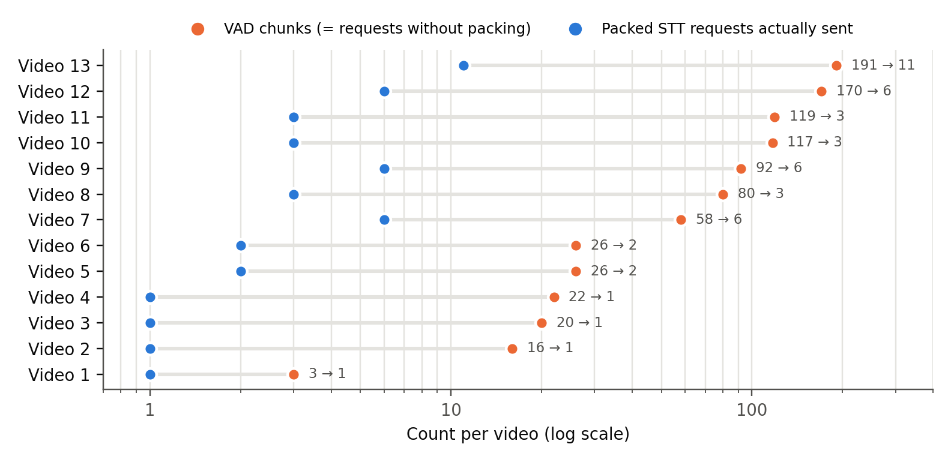
Fig. 4. VAD chunks (orange; one request each without packing) versus packed STT requests actually sent (blue), per production job (n = 13, log scale).
The reduction matters because hosted ASR is rate-limited per request. Under the configured limit of 19 requests per minute, the 940 unpacked requests would need at least 49.5 minutes of request budget, against 2.4 minutes for 46. The largest job alone would need at least 10 minutes instead of one. This analysis is derived from the measured counts and the configured limit, not measured directly. Packing also caps billed silence at Γ = 1 s per gap. The resulting audio-seconds saving cannot be computed from production logs. The offline replay (Table VI) shows that it is small.

E. Offline Benchmark
Data. We assembled a long-form English benchmark from three public corpora with human reference transcripts: the TED-LIUM 3 long-form test set [15] (talks), the Rev16 podcast subset used for long-form evaluation of Whisper [13], and Earnings-21 [16] (earnings calls). In total it has 71 recordings and 57.9 hours of audio. The corpora stand in for the three most common kinds of speech-heavy YouTube content (talks, podcasts, panel-style calls), and their audio is publicly redistributable for research, unlike YouTube media. Questions in the retrieval study (Section IV-E2) were written over a 14-recording subset.

1) Segmentation and packing (RQ1–RQ2)
Every recording was passed through the unmodified production functions (prepare_audio and pack_stt_requests) with the production defaults of Table II. No ASR call was made, so this replay measures segmentation and packing only. As baselines we compute fixed 30 s and fixed 240 s windows over the same audio. We also measure how often a request boundary falls strictly inside a VAD speech region, which is where a word can be cut in half.
TABLE VI
Offline Replay of Segmentation and Packing
Corpus | Hours | Speech ratio | Requests / h  fixed 30 s · fixed 240 s · ours | Audio sent  (ours ÷ duration) | Boundaries inside speech  fixed 30 s · fixed 240 s · ours
TED-LIUM 3 long-form | 2.47 | 85.7% | 122.1 · 17.4 · 17.8 | 99.5% | 81.8% (238/291) · 90.6% (29/32) · 0.0% (0/33)
Rev16 podcasts | 16.16 | 90.5% | 120.5 · 15.5 · 16 | 98.4% | 90.4% (1747/1932) · 88.5% (207/234) · 8.3% (20/242)
Earnings-21 calls | 39.26 | 82.4% | 120.5 · 15.5 · 15.4 | 96.5% | 82.9% (3885/4687) · 81.9% (463/565) · 0.0% (0/561)
All | 57.9 | 84.8% | 120.6 · 15.6 · 15.7 | 97.2% | 84.9% (5870/6910) · 84.1% (699/831) · 2.4% (20/836)

Packing sends about as many requests as fixed 240 s windows (15.7 versus 15.6 per hour) and 7.7× fewer than fixed 30 s windows. The difference is where the cuts fall. 84% of fixed 240 s boundaries and 85% of fixed 30 s boundaries land inside speech, against 2.4% (20 of 836) for packed requests. All of those occurred in Rev16 podcasts, where Silero had split an utterance of about 30 s at a very short internal pause. In 19 of the 20 cases the boundary lies only 22–118 ms after the next speech onset, inside the 150 ms export padding, and in one case 0.51 s after it. TED-LIUM and Earnings-21 had no packed boundary inside speech. Silence compression saves less audio than one might expect: the audio sent is 97.2% of the source duration, because these recordings are 85% speech and most inter-chunk pauses are already shorter than the 1 s cap. The best single recording reached 61.2%. The VAD stage itself is cheap: its real-time factor was 0.0332 on a desktop CPU with two threads per process, and 0 of 18210 chunks needed a forced mid-speech split. The main benefit of C1–C2 is therefore boundary quality at a low request count, not audio reduction. Transcription accuracy is reported in Section IV-E3.

2) Retrieval (RQ4)
Questions. For 14 recordings (10 TED talks with usable references, plus 2 earnings calls and 2 podcasts of 34–58 min each), 143 natural-language questions were written with a short answer that occurs verbatim in the human reference transcript. Questions were paraphrased rather than copied from the transcript. They were authored with the help of an LLM (Claude) and are released for inspection. Human spot-check pending. Retrieval is run over the reference transcripts chunked by the production chunker (500/800 characters), which isolates retrieval from ASR errors. A question counts as answered at rank r if the r-th retrieved chunk contains the normalised answer string. 5 questions whose answer spans a chunk boundary were excluded, leaving 138 (86 TED, 52 long-form).
Systems. All systems use the production components. Dense is MiniLM with exact cosine ranking. The lexical branch is the production SQL, run unchanged on PostgreSQL 18. Fusion is RRF with κ = 60 and the production candidate pool. We also test one variant that changes only the lexical query from AND semantics (plainto_tsquery, as in production) to OR semantics over the same stemmed terms.
TABLE VII
Retrieval Accuracy over Reference Transcripts
Retriever (n = 138) | Hit@1 [95% CI] | Hit@5 | Hit@k (production k) | MRR
Lexical only, production AND query | 0.029 [0.007, 0.058] | 0.029 | 0.029 | 0.029
Lexical only, OR query | 0.616 [0.529, 0.696] | 0.855 | 0.906 | 0.725
Dense only (MiniLM) | 0.587 [0.507, 0.667] | 0.870 | 0.928 | 0.708
Hybrid RRF, production (AND) | 0.601 [0.522, 0.681] | 0.870 | 0.928 | 0.715
Hybrid RRF, OR query | 0.638 [0.558, 0.717] | 0.870 | 0.913 | 0.740

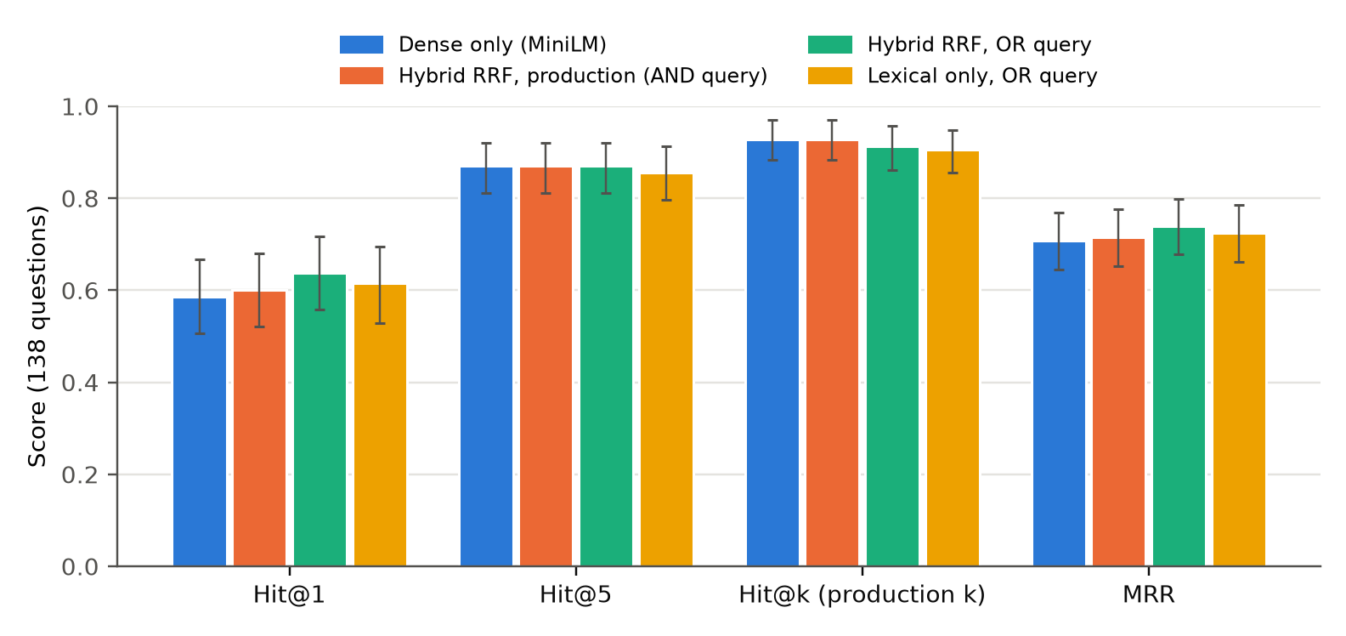
Fig. 5. Retrieval accuracy by system (n = 138 questions, 95% bootstrap confidence intervals).
The most important finding is about the production lexical branch. plainto_tsquery joins every content word of the question with AND, so it matched no chunk for 134 of 138 questions (97%). For natural questions, production hybrid retrieval therefore behaves as dense retrieval with an occasional lexical tie-break: Hit@1 is 0.601 against 0.587 for dense alone. Changing the lexical query to OR semantics gives the lexical signal back. RRF-OR has the best Hit@1 (0.638) and MRR (0.740), with the gain concentrated on long-form recordings (Hit@1 0.577 vs 0.538 dense), where names and figures are frequent. On this sample size the differences are not statistically significant (exact McNemar on Hit@1, dense vs RRF-OR: 18 vs 11 discordant, p = 0.26). With the production duration-based k, the answer-bearing chunk reaches the LLM context for 92.8% of questions.

3) Transcription accuracy (RQ1, RQ3)
Setup. The 10 TED-LIUM 3 talks with full references (26,558 reference words, 2.4 h) were transcribed three ways with the production model (Whisper-large-v3 on Groq) and the production request code: fixed 30 s windows, fixed 240 s windows, and the production pipeline (VAD, packing and assembly). Fixed-window words are concatenated in order. Hypotheses and references are normalised with Whisper's English text normaliser [13] before scoring. Every API response was cached, so the packed transcripts could be re-assembled with different assembly code without new ASR calls.
TABLE VIII
Word Error Rate by Segmentation Strategy (10 TED talks, pooled)
Segmentation | Requests | WER ↓ | Sub. | Del. | Ins. | Better than packed (files)
Fixed 30 s windows | 301 | 3.98% | 1.03% | 2.16% | 0.79% | 1 / 10
Fixed 240 s windows | 42 | 3.34% | 0.85% | 2.02% | 0.47% | 2 / 10
Packed, original assembly (deployed until Oct 2026) | 43 | 7.63% | 1.05% | 4.57% | 2.01% | –
Packed, fixed assembly (ours, deployed) | 43 | 3.36% | 0.84% | 2.00% | 0.52% | –

With the fixed assembly, packed requests reach 3.36% WER. This is on par with fixed 240 s windows (3.34%). The paired bootstrap 95% CI of the difference over recordings is [-0.22, 0.44] points, and packed is better on 8 of 10 talks. Packed is significantly better than fixed 30 s windows (3.98%; CI [-1.00, -0.12] points; better on 9 of 10 talks), while sending 43 instead of 301 requests. Together with Table VI, packing therefore gives the request count and accuracy of long windows while almost never placing a boundary inside speech.
An assembly defect found by this evaluation. The deployed assembly reached 7.63% WER on the same ASR output, worse than both baselines. Two steps caused the gap. First, words whose midpoint fell inside an inserted silence were dropped, which removed short function words next to pauses. Second, the final sort by (start, end) reordered words, because the provider occasionally returns word start times that are not monotonic (17–36 per talk on four talks). One out-of-order word costs one deletion and one insertion. Concatenating the raw request text without remapping gave 1.1–5.4% WER on those four talks, which shows that the loss came from assembly and not from ASR on packed audio. The fix (Section III-D) keeps gap words and enforces non-decreasing start times. It lowered WER on all 10 talks and more than halved it overall, without changing any request, and it is now deployed. The defect also shows a general risk of timestamp-sorted assembly: word timings from hosted ASR are not reliable enough to define word order.

4) End-to-end answers (RQ6)
Setup. For the 138 answerable retrieval questions and 20 added questions whose answer is not in the recording, the production retriever (hybrid RRF with the production k) selected chunks of the reference transcript. The production answer function then generated an answer with the production model (gpt-oss-20b on Groq), system prompt, temperature and context format. Reference transcripts carry no word times, so the chunk timestamps in the context were interpolated from word position. Citation accuracy is therefore not measured. Answers were graded by an LLM judge (Claude) against the gold answer and the retrieved context. Human check of the grades pending.
TABLE IX
End-to-End Answer Outcomes (Production Retriever and Prompt)
Outcome | Answerable (n = 138) | Gold chunk in context | Gold chunk not in context
Correct | 124 (89.9%) | 122 | 2
Partially correct | 2 | 1 | 1
Declined ("not in the excerpts") | 11 | 5 | 6
Wrong but grounded in context | 1 | 0 | 1
Invented facts | 0 | – | –

89.9% of answerable questions were answered fully correctly, and no answer to an answerable question contained invented facts. Most failures were retrieval failures. When the gold chunk was outside the top k, the model usually declined, which is the intended behaviour, and it answered correctly anyway in 2 cases from other chunks. The model also declined 5 times although the gold chunk was in context, so the prompt is slightly conservative. On the 20 unanswerable questions it declined 19 times (95%) and gave an unsupported answer once. That answer attached a fact from the context to the wrong person, naming the speaker's orchestra as the subject's. Median generation latency was 0.95 s.

F. Discussion and Limitations
- Retrieval finding. The production hybrid retriever is, in practice, a dense retriever. Its lexical branch matched no passage for 97% of questions. An OR-semantics query is a one-line change that restores the lexical signal. We report it as a recommendation, not a proven improvement, because the gain is not significant at n = 138.
- Assembly defect. Production ran the original assembly until 13 Oct 2026, so on our benchmark its transcripts would have had about twice the WER of the fixed system. The production telemetry in Sections IV-B to IV-D is not affected, because it measures requests, latency and failures, not text.
- Question set. The 143 questions were written by the authors with LLM assistance from reference transcripts. Answers are verbatim spans, which makes scoring objective but may favour lexical matching. Retrieval and answers were evaluated on reference transcripts, so ASR errors are not included, and grading used an LLM judge.
- Benchmark domain. The offline benchmark uses talks, podcasts and earnings calls as stand-ins for YouTube content, because redistributable YouTube audio with human transcripts is not available. Production telemetry covers real YouTube videos.
- Sample size. The production sample is small: 31 completed jobs, 21 on the VAD pipeline and 13 with per-request logs. It comes from uncontrolled live traffic, so it shows feasibility and operating behaviour, not a controlled comparison. The offline benchmark provides the controlled comparison.
- Missing duration data. Because of the 24-hour retention policy, durations and answer logs are not available retrospectively. Real-time factor and live answer quality therefore cannot be reported from production.
- WER sample. WER was measured on 10 TED talks (2.4 h) only, because the ASR budget was limited. Conversational audio (podcasts, calls) may behave differently.
- Language. Lexical search uses the English text-search configuration, and the embedding model is English-centric. Behaviour on Hindi and code-mixed speech is untested.
- VAD. VAD is probabilistic. Music, laughter and very quiet speech can be missed or included. Speech-free videos fail explicitly rather than producing invented text.
- Dependencies. The system depends on a hosted ASR/LLM provider and on YouTube access, and YouTube access caused every stable-period failure.

V. Conclusion and Future Research Directions
This paper presented VidoraAI, a speech-first retrieval-augmented generation system for timestamp-grounded question answering over long YouTube videos. Pause-aware VAD segmentation keeps chunk boundaries on natural pauses. Packing then sends those chunks to ASR as a few large requests while every word keeps its exact original-video timestamp. In production this cut transcription requests by 95.1%. On a 57.9-hour offline benchmark it matched the request count of fixed 240 s windows while placing 2.4% of boundaries inside speech, against 84% for fixed windows. The audio saved by silence compression, however, was small (2.8%) on speech-dense content. Our retrieval study found that AND-semantics full-text search silently turns hybrid retrieval into dense retrieval for natural questions, and that a simple OR query restores the lexical signal. With a corrected assembly step, packed transcription matched the WER of fixed 240 s windows and beat fixed 30 s windows while sending seven times fewer requests than the latter. The same evaluation exposed and fixed a word-ordering defect that had doubled production WER. End to end, 90% of answerable questions were answered correctly without invented facts.
Future work includes multilingual and code-mixed (Hindi-English) lexical search and embeddings, cross-encoder re-ranking, visual signals for non-speech content, retrieval across a user's videos, faster CPU inference for VAD and embedding, and reuse of the same timestamped index to recommend short-form clips.

References
Preliminary list. Entries marked [verify] were identified by title or arXiv ID during the literature search. Confirm authors, venue and year against the full text before submission. Add a proper systematic search (Google Scholar, Semantic Scholar, ACL Anthology) before finalising Section II.
[1] Y. Luo et al. [verify], "Video-RAG: Visually-aligned retrieval-augmented long video comprehension," arXiv:2411.13093, 2024.
[2] X. Ren et al. [verify], "VideoRAG: Retrieval-augmented generation with extreme long-context videos," arXiv:2502.01549, 2025.
[3] [verify authors], "SceneRAG: Scene-level retrieval-augmented generation for video understanding," arXiv:2506.07600, 2025.
[4] S. Shafiq, N. Ejaz, M. A. Shah, R. Kamal, A. Sohail and S. Aslam, "Intra-video temporal-aware RAG: A self-contained framework for video-based question answering," Computers, Materials & Continua, vol. 88, no. 2, 2026.
[5] P. Lewis et al., "Retrieval-augmented generation for knowledge-intensive NLP tasks," in Proc. NeurIPS, 2020.
[6] [verify authors], "TV-RAG: A temporal-aware and semantic entropy-weighted framework for long video retrieval and understanding," arXiv:2512.23483, 2025.
[7] [verify authors], "RAG meets temporal graphs: Time-sensitive modeling and retrieval for evolving knowledge," arXiv:2510.13590, 2025.
[8] M. Bain, J. Huh, T. Han and A. Zisserman, "WhisperX: Time-accurate speech transcription of long-form audio," in Proc. Interspeech, 2023.
[9] [verify authors], "VibeVoice-ASR technical report," arXiv:2601.18184, 2026.
[10] G. V. Cormack, C. L. A. Clarke and S. Büttcher, "Reciprocal rank fusion outperforms Condorcet and individual rank learning methods," in Proc. ACM SIGIR, 2009.
[11] [verify authors], "From BM25 to corrective RAG: Benchmarking retrieval strategies for text-and-table documents," arXiv:2604.01733, 2026.
[12] Silero Team, "Silero VAD: pre-trained enterprise-grade voice activity detector," GitHub repository, v6.2.2.
[13] A. Radford, J. W. Kim, T. Xu, G. Brockman, C. McLeavey and I. Sutskever, "Robust speech recognition via large-scale weak supervision," in Proc. ICML, 2023.
[14] N. Reimers and I. Gurevych, "Sentence-BERT: Sentence embeddings using Siamese BERT-networks," in Proc. EMNLP-IJCNLP, 2019.
[15] F. Hernandez, V. Nguyen, S. Ghannay, N. Tomashenko and Y. Estève, "TED-LIUM 3: Twice as much data and corpus repartition for experiments on speaker adaptation," in Proc. SPECOM, 2018.
[16] M. Del Rio, N. Delworth, R. Westerman, M. Huang, N. Bhandari, J. Palakapilly, Q. McNamara, J. Dong, P. Żelasko and M. Jetté, "Earnings-21: A practical benchmark for ASR in the wild," in Proc. Interspeech, 2021.

Appendix A. Author Notes (Remove Before Submission)
Status of draft v0.4. All result tables are filled from measured data. Remaining yellow items are authorship details and the human checks listed below. Production figures come from Cloud Logging for project vidoraai-2bbce (services api and processvideo, 12 Sep – 10 Oct 2026) and were computed by scripts kept outside the repository.

A.1 What is not ready yet
# | Item | What it blocks | Needed from
1 | Human spot-check of the 163 questions and of the answer grades | Credibility of Sections IV-E2 and IV-E4 | You or a colleague (~45 min; files in vidoraai-research-data/bench)
2 | Re-mine production logs after 1–2 weeks of traffic (new telemetry is live) | Real-time factor, live audio-seconds, route mix, token cost | Me, once traffic exists
3 | Decision on the lexical OR-query fix in production | Whether the paper reports it as deployed | You (I can implement it)
4 | Authors, affiliations, emails, corresponding author | Title block | You
5 | Written permission from A2R to publish | Submission | You
6 | Target venue | Page limit, format, reference style | You (or ask me to shortlist)
7 | Relationship to the Epic healthcare paper | Related Work wording, self-plagiarism check | You
8 | Final title; Shorts out of scope? | Title, Future Work | You
9 | Reference verification ([verify] entries) and systematic search | Section II, References | Me
10 | Export logs to a BigQuery/GCS sink | Logs older than 30 days are deleted | You approve; I set it up
11 | Revoke the benchmark Groq key | Security hygiene | You

A.2 Alternative titles
- (Used above) Pause-Aligned Segmentation and Request Packing for Timestamp-Grounded Question Answering over Long YouTube Videos
- VidoraAI: A Speech-First Retrieval-Augmented Generation Pipeline with Hybrid Retrieval and Temporal Query Routing for Long-Form Video
- From Speech to Seconds: Timestamp-Preserving Audio Packing and Hybrid Retrieval for Video Question Answering

