Pause-Aligned Segmentation and Request Packing for Timestamp-Grounded Question Answering over Long YouTube Videos
Nitin Singh Mahar  Affiliation / organisation  City, Country  email | Pan Singh Dhoni  Affiliation / organisation  City, Country  email

Abstract—Long-form online video is mostly speech, yet most video question-answering systems either sample visual frames at high cost or transcribe fixed windows that cut words in half. This paper presents VidoraAI, a production speech-first retrieval-augmented generation (RAG) system that answers questions about a YouTube video with answers cited to timestamps on the original video clock. Voice-activity detection and a pause-merge planner form chunks that never cut through a pause. A packing stage joins them into transcription requests of up to 240 s, caps each silence at 1 s and remaps every word to the original timeline. Time-anchored questions go to an interval lookup and all others to in-video hybrid retrieval that fuses dense and full-text rankings. In four weeks of live operation, packing cut transcription requests by 95.1%. On 71 recordings (57.9 h), packing needed as many requests as fixed 240 s windows (15.7 vs 15.6 per hour) while placing 2.4% of request boundaries inside speech, against 84%. On 10 talks it reached 3.36% WER, equal to fixed 240 s windows (3.34%) and better than fixed 30 s windows (3.98%), after we fixed a timestamp-assembly defect that had raised the deployed system to 7.63%. The production lexical search matched no passage for 97% of natural questions, which an OR query corrects. 124 of 138 answerable questions were answered correctly, with no invented facts. The same index drives captioned short-clip generation.
__Index Terms—__retrieval-augmented generation, video question answering, voice activity detection, speech recognition, hybrid retrieval, temporal grounding

1 Introduction
Video is now a primary medium for lectures, podcasts and talks, and many videos run from tens of minutes to several hours. A viewer who wants one fact must scrub through it by hand. Processing every frame of a long video with a multimodal model is expensive, and for speech-dominated content most of the answer-bearing information is in the audio, which is why recent video RAG systems add ASR transcripts to visual features [1], [2]. A natural alternative is to transcribe the audio and apply retrieval-augmented generation (RAG) to the transcript [5].
Building this for real users raises four problems that are rarely evaluated together. First, how audio is segmented before ASR affects accuracy and cost: fixed windows cut words in half, and hosted ASR bills every second sent, including silence. Second, answers are useful only if they point to the right moment, so timestamps must survive segmentation, batching and retrieval. Third, questions are semantic ("what does the speaker say about X?") or time-anchored ("what happens between 12:30 and 14:00?"), and no single retriever serves both. Fourth, a public service must respect provider rate limits and fail safely. This paper describes VidoraAI, a speech-first video RAG system deployed in production at A2R. Its contributions are:
- Pause-aware segmentation and packing. VAD chunks that follow the pause structure are packed into requests of up to 240 s with every silence capped at 1 s, and an exact span table maps each word back to the video clock (Sections 3.3–3.4).
- Query-aware in-video retrieval. A temporal router sends time-anchored questions to an interval lookup, and other questions to a hybrid retriever with duration-adaptive depth. We show that AND-semantics full-text queries disable the lexical branch for natural questions (Section 3.7).
- Transcript-grounded short clips. The same index drives validated clip suggestions and bounded, idempotent rendering jobs (Section 3.9).
- Production and offline evidence. Four weeks of live telemetry, a replay of the production code on 71 recordings, a paired WER study, a 143-question retrieval study and an end-to-end answer study (Section 4). The evaluation exposed a word-ordering defect in the deployed assembly step that doubled WER (Section 4.5).
The rest of the paper is organised as follows. Section 2 reviews related work, Section 3 presents the architecture, Section 4 reports results, and Section 5 concludes.

2 Literature Review
Video RAG. Video-RAG [1] augments video-language models with auxiliary texts, including Whisper transcripts, retrieved per query. VideoRAG [2] targets extremely long videos with ASR, visual captions and graph indexing. SceneRAG [3] segments videos into scenes, starting from fixed 5-minute windows. These systems are mainly multimodal, and none studies how ASR segmentation affects cost and timestamp fidelity.
Temporal grounding. The intra-video temporal-aware RAG of Shafiq et al. [4] is closest to this work. It builds timestamped chunks from Whisper output and captions and filters by time, but is evaluated on 2–5 minute videos with a gold temporal window. TV-RAG [6] re-ranks ASR text with a time-decay term, and Han et al. [7] extract temporal expressions over a temporal knowledge graph. WhisperX [8] uses VAD to cut and merge long audio for Whisper, and RRF [10] is widely used to fuse lexical and dense rankings [11]. None of these considers per-second ASR billing together with retrieval.
TABLE I
Related Works
Reference | Year | Contribution and gap addressed here
Luo et al. [1] | 2024 | Whisper transcripts as auxiliary text for video-language models; no cost-aware ASR or word-level remapping
Ren et al. [2] | 2025 | ASR with visual captions and graph indexing; visual-heavy, not timestamp-cited QA
SceneRAG [3] | 2025 | Scene segmentation starting from fixed 5 min windows; silence is still transcribed
Shafiq et al. [4] | 2026 | Timestamped chunks, dense and cross-encoder retrieval, gold time filter; 2–5 min videos only, no lexical signal
Bain et al. [8] | 2023 | VAD cut and merge for long-form ASR; transcription only, no retrieval
This work | 2026 | Pause-aligned packing with exact remap, temporal routing and hybrid RRF with adaptive k, in production

3 Methodology

3.1 System Overview
VidoraAI has four layers plus a clip service (Fig. 1). Layer 1 downloads and normalises audio, Layer 2 turns speech into word timestamps on the original clock, Layer 3 builds retrieval units, and Layer 4 routes each question and generates a cited answer. Ingestion is asynchronous: the API stores the job, enqueues it with Cloud Tasks and returns a PROCESSING record that the client polls for stage progress.
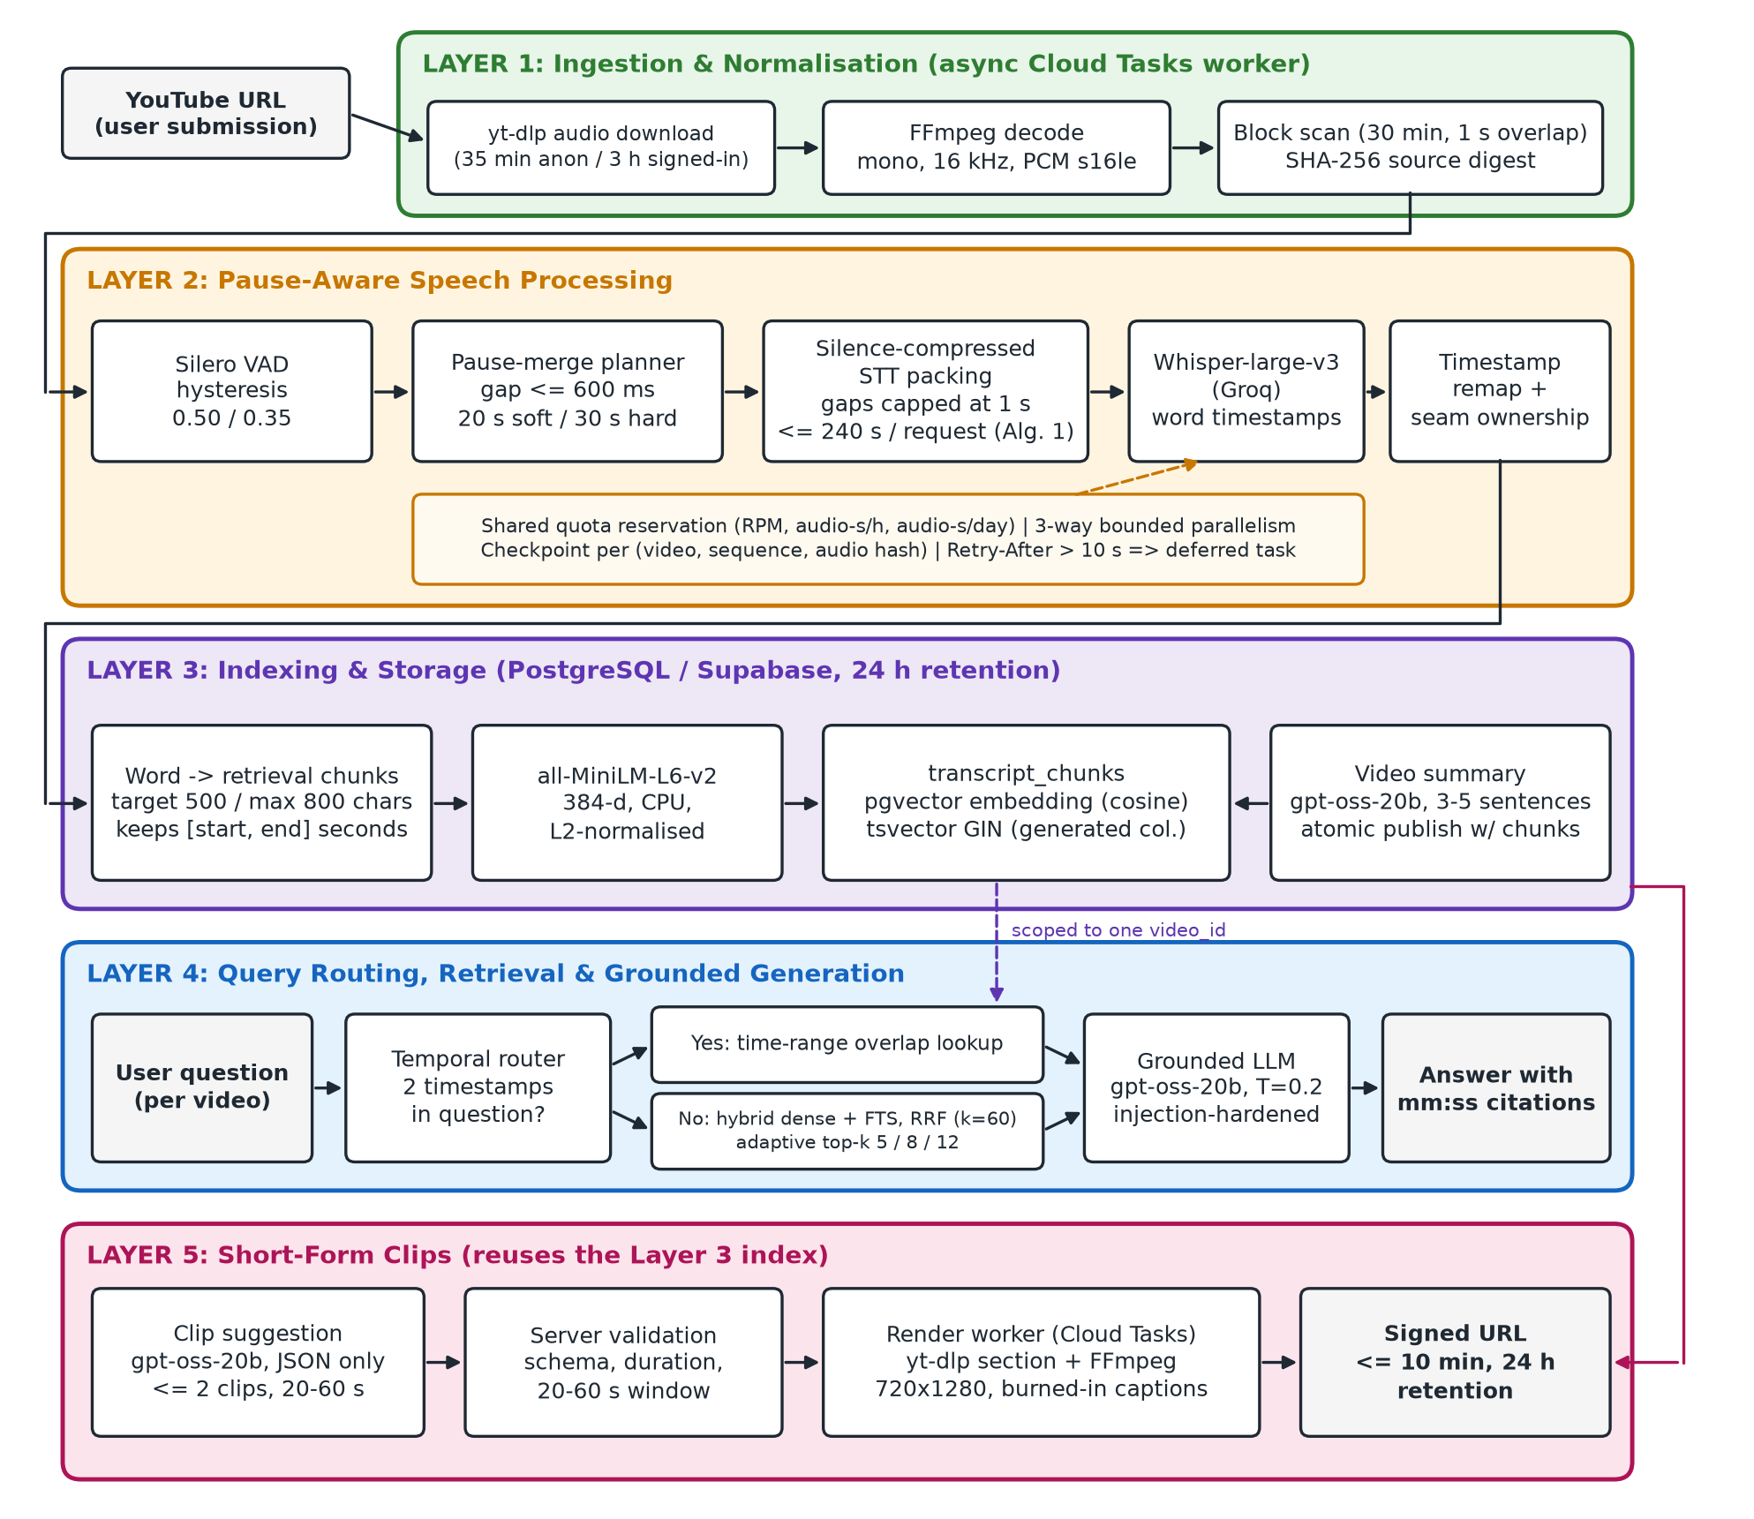
Fig. 1. Proposed VidoraAI architecture: from a YouTube URL to a timestamp-cited answer and to short-form clips.

3.2 Ingestion and Normalisation
The worker downloads only the audio stream with yt-dlp, and the video is never stored. Duration limits are 35 min for anonymous and 3 h for signed-in users, and longer inputs are rejected rather than truncated. FFmpeg decodes to mono 16 kHz PCM, which is scanned in 30-minute blocks with 1 s overlap to bound memory. A SHA-256 digest identifies the source, and chunk identifiers are deterministic UUIDv5 values.

3.3 Pause-Aware Segmentation
Silero VAD [12] produces speech regions with hysteresis: a region opens above probability θ = 0.50 and closes below θ⁻ = 0.35. Regions shorter than 250 ms are ignored and silences shorter than 100 ms do not split a region. Neighbouring regions are merged into one chunk only if the group is below a soft target of 20 s, the pause before the region is at most 600 ms, and the merged span fits a hard budget of 30 s minus twice the 150 ms export padding. Pauses inside a chunk stay as real audio, so nothing is concatenated at this stage and chunk times equal video times. Only a single uninterrupted region longer than the budget is force-split, with 250 ms of speech overlap.

3.4 Silence-Compressed Transcription and Timestamp Remapping
Sending each chunk as its own request multiplies request counts and hits per-minute limits, while sending the whole file bills every second of silence. Algorithm 1 packs consecutive chunks into one request of at most 240 s (20 MB). Between two chunks it inserts min(gap, Γ) of digital silence with Γ = 1 s, and audio already covered by a previous chunk's overlap is trimmed so that it is never transcribed twice. Each packed clip records a span σ = (π_start, π_end, src_start, src_end) that links packed and source positions (Fig. 2).
Algorithm 1 Silence-Compressed STT Request Packing
Input: K — ordered chunks with WAV clips; Q — request cap (samples); Γ = 1 s
Output: requests, each with a span table Σ
1: M ← ∅; L ← 0; E ← 0 ▷ members, packed length, covered source end
2: for each chunk k = [aₖ, bₖ] ∈ K do
3: c ← (k is first) ? aₖ : max(aₖ, E); if c ≥ bₖ then continue ▷ drop audio already covered
4: γ ← (M ≠ ∅) ? min(max(0, c − E), Γ) : 0 ▷ compress the silence
5: if L + (bₖ − c) + γ > Q and M ≠ ∅ then EMIT(M); M ← ∅; L ← 0; γ ← 0
6: M ← M ∪ {(k, c, γ)}; L ← L + (bₖ − c) + γ; E ← max(E, bₖ)
7: EMIT(M) ▷ writes γ zero-samples then clip [c, bₖ), appending σ to Σ

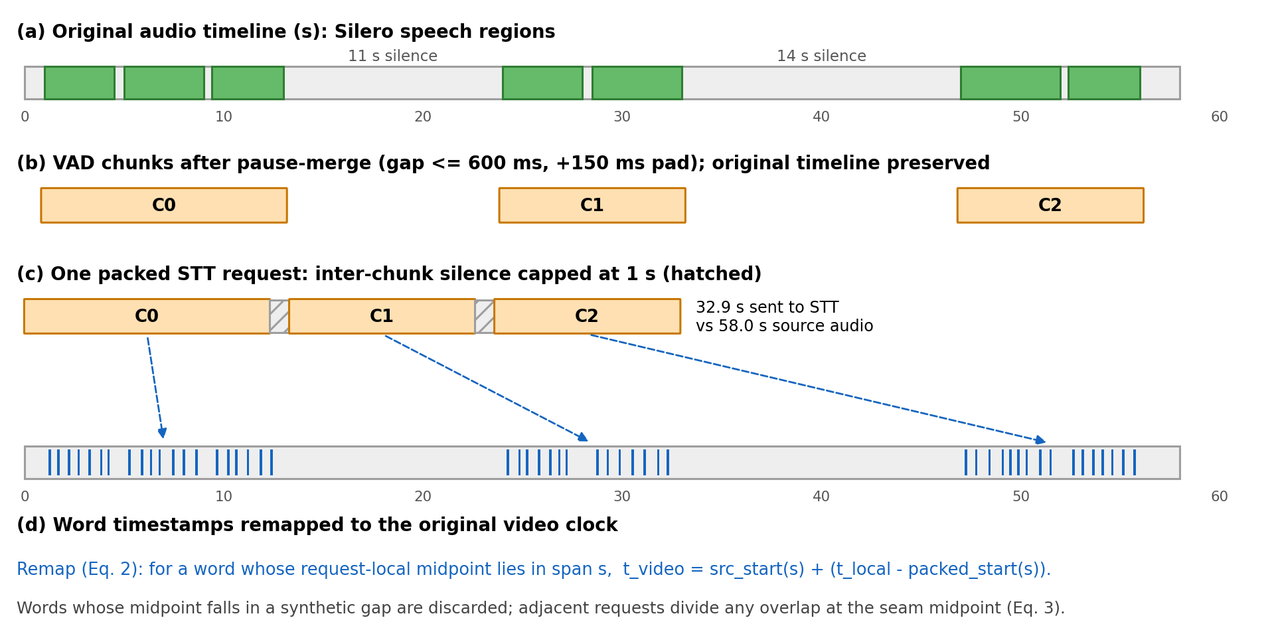
Fig. 2. Silence-compressed packing: speech regions, pause-merged chunks, one packed request with silences capped at 1 s, and words remapped to video time (illustrative).
The ASR model (Whisper-large-v3 [13] on Groq) returns word times local to the request. Each word is assigned to the span σ nearest its midpoint and mapped to the video clock by Eq. (1), where τ is the local time, f = 16 kHz and |σ| the span length:
t = src_start(σ) + clip(f·τ − π_start(σ), 0, |σ|) / f (1)
Words that fall in an inserted gap are kept and attached to the nearest span, because word timings around pauses are imprecise, and start times are made non-decreasing so that the provider's word order survives the final sort. Because the covered-source pointer E is never reset, the source intervals of different requests are disjoint, and a word from request j is kept only if its midpoint lies in the seam-bounded interval between its neighbours. Global de-duplication is deliberately avoided because speakers repeat phrases.

3.5 Quota-Aware, Resumable Transcription
Requests run with bounded parallelism (3 per video). Before each call the worker reserves capacity in shared PostgreSQL counters (requests per minute, audio-seconds per hour and per day). Transient failures are retried with jittered back-off, and a wait longer than 10 s re-enqueues the job instead of holding an instance. Each completed request is checkpointed under (video, sequence, SHA-256 of the audio), so a resumed job pays only for requests not yet transcribed. An empty VAD result or transcript fails the video rather than inventing text.

3.6 Retrieval Units and Indexing
Words on the video clock are merged into chunks that close at 500 characters and never exceed 800, each keeping the start of its first word and the end of its last. Chunks are embedded with all-MiniLM-L6-v2 [14] (384-d, CPU, bundled) and stored in PostgreSQL with a pgvector column and a generated tsvector column with a GIN index. A 3–5 sentence summary is generated from the first 20,000 characters. Chunks and the COMPLETED status are written in one transaction, and all transcript data expires after about 24 h.

3.7 Query Routing and Hybrid Retrieval
Temporal routing. A question containing exactly two timestamps (m:ss or h:mm:ss) is time-anchored. The times are sorted into [t₁, t₂], and every chunk with start ≤ t₂ and end ≥ t₁ is returned in order, bypassing semantic search. Questions with zero, one or more than two timestamps fall through to hybrid retrieval.
Hybrid retrieval. Within one video, a dense list ranks chunks by cosine distance and a lexical list ranks chunks matching any stemmed content word of the question by ts_rank. Each list is truncated to a pool P = max(4k, 20) and the lists are fused by reciprocal rank fusion [10], where a chunk missing from a list receives rank P + 1:
score(d) = 1/(κ + r_sem(d)) + 1/(κ + r_lex(d)), κ = 60 (2)
The top k chunks are returned, with k = 5 for videos up to 10 min, 8 up to 30 min and 12 otherwise. Both lists and the fusion run as one SQL statement scoped by video_id, so a question cannot retrieve another video's content. The lexical query is built from plainto_tsquery, whose terms are re-joined with OR. The original deployment kept the default AND, so a chunk was a lexical candidate only if it contained every term of the question (Section 4.6). The OR form was deployed on 14 Oct 2026 and the candidate list is ordered by ts_rank before truncation.

3.8 Grounded Answer Generation
Each retrieved chunk is prefixed with its [mm:ss–mm:ss] interval, HTML-escaped and placed in <transcript_context> tags. The answer model (gpt-oss-20b on Groq, temperature 0.2, at most 1024 tokens) is told to use only the excerpts, to cite timestamps, to say so when the excerpts are insufficient, and to treat transcript and question as untrusted data. If retrieval returns nothing, a fixed "not found in this video" answer is returned without calling the model.

3.9 Transcript-Grounded Short-Form Clips
The same index drives a clip feature. Suggestion: the chunks are sent as [start–end] text to the answer model with a JSON-only prompt that asks for at most two distinct clips of 20 to 60 s. The server then validates every suggestion outside the model (schema, ends inside the video, 20–60 s) and returns an explicit message if none remains. Rendering: a video allows two free Shorts, reserved under a row lock so duplicate clicks and concurrent instances cannot exceed the allowance, and a repeated request for the same range returns the existing job. A Cloud Tasks worker downloads only the requested section (at most 720p) and FFmpeg produces a 720 × 1280 H.264 clip with a blurred background and burned-in captions, served through a signed URL valid for at most 10 min. Attempt identifiers stop a stale worker from publishing over a newer attempt, failed attempts do not consume the allowance, and clips are deleted after 24 h. Captions: word times are not retained in the index, so each chunk's words are spread evenly over its interval in cues of at most eight words. This is accurate to about the chunk length and is the main known weakness of the feature.

3.10 Deployment, Privacy and Retention
The backend is FastAPI on Firebase Python functions (2 GB, 1 vCPU, no GPU) with a 300 s API timeout and a 900 s worker. Cloud Tasks retries a failed worker up to three times and never reprocesses a completed video. Submissions and questions are rate-limited and protected by reCAPTCHA. Only audio is downloaded, and transcripts, embeddings and question logs expire after about 24 h.

4 Results

4.1 Experimental Setup
Production telemetry. We analysed structured events emitted by the API and worker between 12 September and 10 October 2026 in Google Cloud Logging: stage times, VAD chunk counts, per-request STT completions and failures. Jobs are identified only by random UUIDs, and no transcript, question or video identity was used. The VAD pipeline was rolled out on 22 September, per-request logging was in place from 23 September, and we call 24 September to 10 October the stable period. Because transcripts and metadata are purged after 24 h, durations are not available retrospectively.
Offline benchmark. We replay the production code on 71 public long-form recordings with human transcripts (57.9 h): TED-LIUM 3 talks [15], Rev16 podcasts [13] and Earnings-21 calls [16]. WER was measured on the 10 TED talks with full references (2.4 h) because the ASR budget was limited. The retrieval study uses 143 questions with verbatim answers over 14 recordings, and 20 added questions whose answer is not in the recording. The questions were written with LLM assistance and spot-checked by a human author.

4.2 Operational Reliability
TABLE II
Ingestion Outcomes in Production
Outcome | Whole window (79 jobs) | Stable period (24 jobs)
Completed (fresh ingestion) / served from earlier analysis | 31 / 3 | 12 / 3
Rejected: video longer than the duration limit | 9 | 2
Failed: YouTube download error / bot challenge | 11 / 8 | 2 / 5
Failed in transcription stage / summary | 16 / 1 | 0 / 0

All 16 transcription failures occurred on 22–23 September, on the first three worker revisions of the VAD rollout, and none has occurred since. In the stable period every job whose audio was obtained completed (12 of 12). All 9 failures happened before the AI pipeline started (7 YouTube access errors, 2 duration rejections), so upstream media access, not the speech or retrieval pipeline, is the dominant operational risk.

4.3 Latency and Request Reduction
For the 21 completed VAD-pipeline jobs, end-to-end ingestion took a median of 115.3 s (P90 183.4 s). Stage medians were 37.4 s for audio download, 23.9 s for decode and VAD, 13.8 s for packed transcription, 33.4 s for chunking and embedding, 1.5 s for the summary and 2.4 s for persistence. Transcription is therefore not the bottleneck, and the CPU-bound VAD and embedding stages are the targets for optimisation. Video duration was not retained in the logs of this window, so a real-time factor is not reported.
Thirteen jobs have per-request logs. Without packing each VAD chunk would be one request. With packing these jobs produced 940 chunks but sent only 46 requests, 95.1% fewer (20.4×), with a median of 17 chunks per request (Fig. 3). Under the configured limit of 19 requests per minute, 940 unpacked requests would need at least 49.5 min of request budget against 2.4 min for 46 (derived from the counts and the limit, not measured directly).
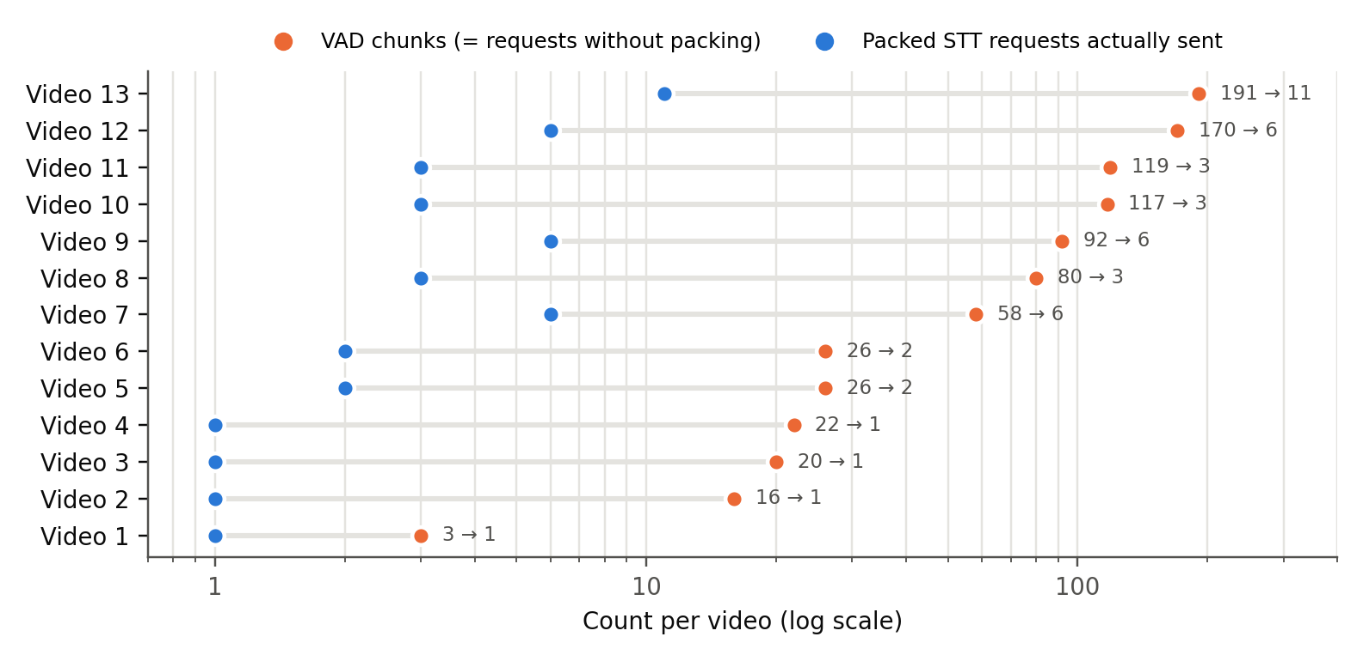
Fig. 3. VAD chunks (one request each without packing) versus packed requests actually sent, per production job (n = 13, log scale).

4.4 Segmentation Strategies
TABLE III
Segmentation Strategies: Requests, WER and Boundary Quality
Strategy | Requests per hour (71 rec.) | Requests (10 talks) | WER | Boundaries inside speech
Fixed 30 s windows | 120.6 | 301 | 3.98% | 84.9%
Fixed 240 s windows | 15.6 | 42 | 3.34% | 84.1%
Packed, original assembly (deployed until 13 Oct) | 15.7 | 43 | 7.63% | 2.4%
Packed, fixed assembly (ours) | 15.7 | 43 | 3.36% | 2.4%

Packing sends about as many requests as fixed 240 s windows and 7.7× fewer than 30 s windows, while 84% of fixed 240 s and 85% of fixed 30 s boundaries land inside speech, against 2.4% (20 of 836) for packed requests. All of those fell in Rev16 podcasts, where Silero split an utterance of about 30 s at a very short internal pause, and 19 of the 20 lie within the 150 ms export padding of a speech onset. Silence compression saves little here: the audio sent is 97.2% of the source duration because these recordings are 85% speech. VAD cost is small (real-time factor 0.0332), and no chunk needed a forced split. With the fixed assembly, packed WER is on par with fixed 240 s windows (95% CI of the difference [-0.22, 0.44] points, packed better on 8 of 10 talks) and significantly better than fixed 30 s windows ([-1.00, -0.12] points, 9 of 10 talks).

4.5 An Assembly Defect Found by the Evaluation
The deployed assembly reached 7.63% WER on the same ASR output, worse than both baselines. Two steps caused it. First, words whose midpoint fell inside an inserted silence were dropped, which removed short function words next to pauses. Second, the final sort by (start, end) reordered words, because the provider sometimes returns non-monotonic word start times (17–36 per talk on four talks), and one misplaced word costs one deletion and one insertion. Concatenating the raw request text without remapping gave 1.1–5.4% WER on those talks, so the loss came from assembly and not from ASR on packed audio. The fix of Section 3.4 lowered WER on all 10 talks, and it is deployed. Word timings from hosted ASR are not reliable enough to define word order.

4.6 Retrieval
TABLE IV
Retrieval Accuracy over Reference Transcripts
Retriever (n = 138) | Hit@1 [95% CI] | Hit@5 | Hit@k (prod. k) | MRR
Lexical only, AND query (original) | 0.029 [0.007, 0.058] | 0.029 | 0.029 | 0.029
Lexical only, OR query | 0.616 [0.529, 0.696] | 0.855 | 0.906 | 0.725
Dense only (MiniLM) | 0.587 [0.507, 0.667] | 0.870 | 0.928 | 0.708
Hybrid RRF, AND (original) | 0.601 [0.522, 0.681] | 0.870 | 0.928 | 0.715
Hybrid RRF, OR (deployed) | 0.638 [0.558, 0.717] | 0.870 | 0.913 | 0.740

Retrieval runs the production components over the reference transcripts, which isolates it from ASR errors. A question counts as answered at rank r if the r-th chunk contains the normalised answer string. The key finding concerns the original lexical branch: plainto_tsquery ANDs every content word, so it matched no chunk for 134 of 138 questions (97%), and the original "hybrid" retriever behaved as a dense retriever (Hit@1 0.601 against 0.587). Re-joining the same terms with OR gives the best Hit@1 (0.638) and MRR (0.740), mainly on long-form recordings, but the differences are not significant at this size (exact McNemar on Hit@1, dense vs RRF-OR: 18 vs 11 discordant, p = 0.26). Hit@k at the production k fell slightly (0.928 to 0.913, not significant), so OR trades a little recall for better top-rank precision. The query also needed an ORDER BY on the lexical candidate list, which the original query lacked and which becomes necessary once OR returns many rows (Fig. 4).
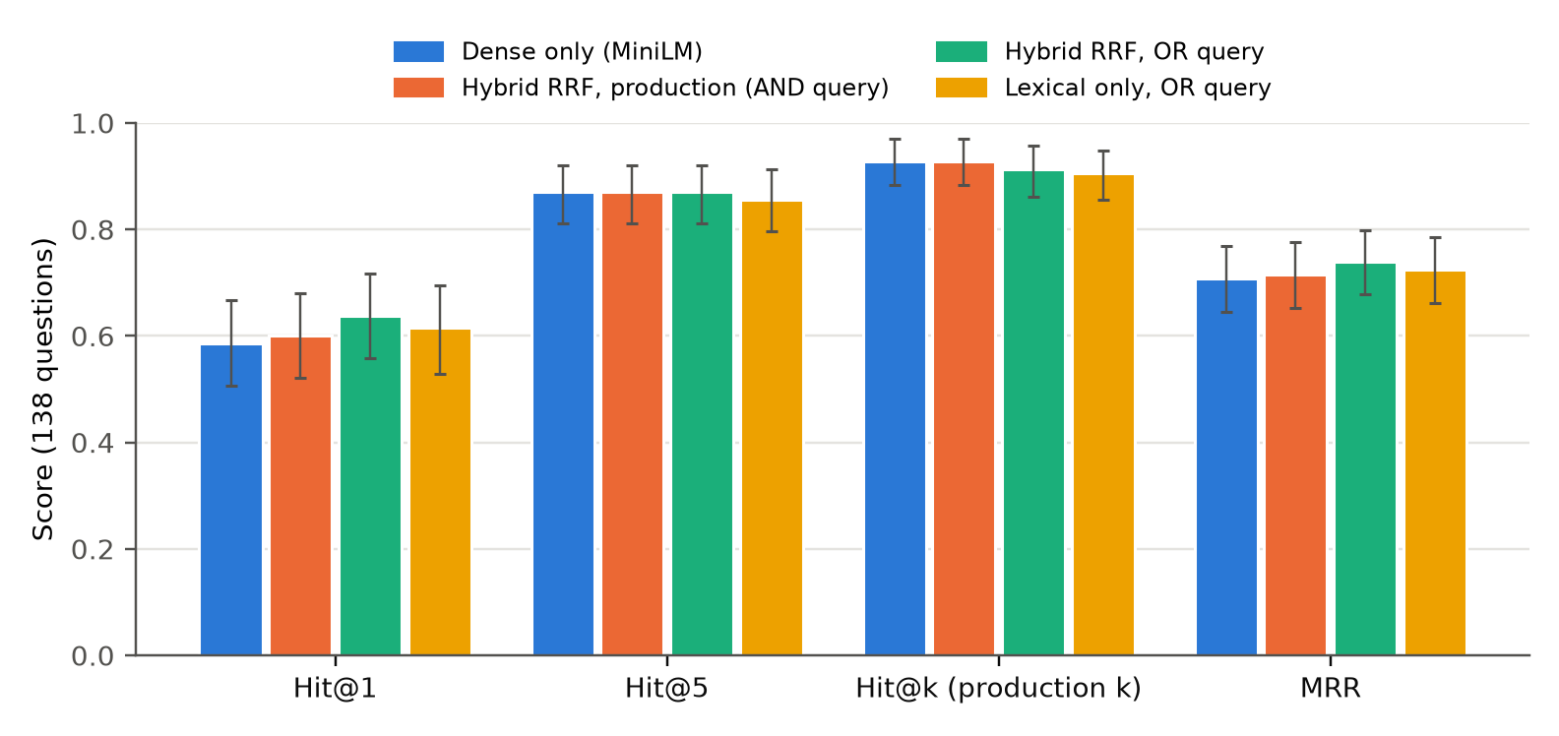
Fig. 4. Retrieval accuracy by system (n = 138, 95% bootstrap confidence intervals).

4.7 End-to-End Answers
TABLE V
End-to-End Answer Outcomes (Original AND Retriever)
Outcome (answerable, n = 138) | Total | Gold chunk in context | Gold chunk not in context
Correct | 124 (89.9%) | 122 | 2
Partially correct | 2 | 1 | 1
Declined ("not in the excerpts") | 11 | 5 | 6
Wrong but grounded in context | 1 | 0 | 1
Invented facts | 0 | – | –

The production retriever, prompt and model produced answers over reference-transcript chunks, graded by an LLM judge and spot-checked by a human author. Chunk timestamps were interpolated from word position, so citation accuracy is not measured, and the answers were generated with the original AND retriever. 89.9% of answerable questions were answered correctly and none contained invented facts. Most failures were retrieval failures: when the gold chunk was outside the top k the model usually declined, as intended. It declined 5 times although the gold chunk was in context, so the prompt is slightly conservative. On the 20 unanswerable questions it declined 19 times and gave one unsupported answer, attaching a fact from the context to the wrong person. Median generation latency was 0.95 s.

4.8 Limitations
The production sample is small (31 fresh completions) and comes from uncontrolled traffic, so it shows feasibility and operating behaviour, not a controlled comparison. WER was measured on 10 TED talks, and conversational audio may behave differently. The questions were LLM-assisted with verbatim answers, which may favour lexical matching, and retrieval and answers were evaluated on reference transcripts, so ASR errors are not included. The offline corpora stand in for YouTube content because redistributable YouTube audio with human transcripts is not available. The assembly defect means production transcripts before 13 Oct 2026 carried about twice the WER of the fixed system. The clip feature is not evaluated: there are no human ratings of suggestions or render statistics, and caption timing is approximate. Lexical search and embeddings are English-only, and the system depends on a hosted ASR/LLM provider and on YouTube access, which caused every stable-period failure.

5 Conclusion and Future Research Directions
This paper presented VidoraAI, a speech-first RAG system for timestamp-grounded question answering over long YouTube videos. Pause-aware segmentation keeps boundaries on natural pauses, and packing sends the chunks to ASR as a few large requests while every word keeps its original-video timestamp. In production, packing cut transcription requests by 95.1%. Offline, it matched the request count and, after an assembly fix, the WER of fixed 240 s windows while almost never cutting inside speech, with little audio saved by silence compression. Our retrieval study showed that AND-semantics full-text search silently turns hybrid retrieval into dense retrieval, and an OR query restores the lexical signal. Future work includes multilingual and code-mixed (Hindi-English) retrieval, cross-encoder re-ranking, visual signals for non-speech content, retrieval across a user's videos, faster CPU inference for VAD and embedding, human evaluation of clip suggestions, and word-level caption timing for Shorts.

References
Verification status. Entries [1]–[4], [6], [7], [9] and [11] were checked against arxiv.org or the publisher page (title, authors, year, volume). [12] is the version pinned in production (6.2.2).
[1] Y. Luo et al., "Video-RAG: Visually-aligned retrieval-augmented long video comprehension," arXiv:2411.13093, 2024.
[2] X. Ren, L. Xu, L. Xia, S. Wang, D. Yin and C. Huang, "VideoRAG: Retrieval-augmented generation with extreme long-context videos," arXiv:2502.01549, 2025.
[3] N. Zeng, H. Hou, F. R. Yu, S. Shi and Y. T. He, "SceneRAG: Scene-level retrieval-augmented generation for video understanding," arXiv:2506.07600, 2025.
[4] S. Shafiq, N. Ejaz, M. A. Shah, R. Kamal, A. Sohail and S. Aslam, "Intra-video temporal-aware RAG: A self-contained framework for video-based question answering," Computers, Materials & Continua, vol. 88, no. 2, art. 96, 2026, doi:10.32604/cmc.2026.081534.
[5] P. Lewis et al., "Retrieval-augmented generation for knowledge-intensive NLP tasks," in Proc. NeurIPS, 2020.
[6] Z. Cao, Y. He, A. Liu, F. Chen, Z. Wang and J. Xie, "TV-RAG: A temporal-aware and semantic entropy-weighted framework for long video retrieval and understanding," arXiv:2512.23483, 2025.
[7] J. Han et al., "RAG meets temporal graphs: Time-sensitive modeling and retrieval for evolving knowledge," arXiv:2510.13590, 2025.
[8] M. Bain, J. Huh, T. Han and A. Zisserman, "WhisperX: Time-accurate speech transcription of long-form audio," in Proc. Interspeech, 2023.
[9] Z. Peng et al., "VibeVoice-ASR technical report," arXiv:2601.18184, 2026.
[10] G. V. Cormack, C. L. A. Clarke and S. Büttcher, "Reciprocal rank fusion outperforms Condorcet and individual rank learning methods," in Proc. ACM SIGIR, 2009.
[11] M. Akarsu, R. K. Karaman and C. Mierbach, "From BM25 to corrective RAG: Benchmarking retrieval strategies for text-and-table documents," arXiv:2604.01733, 2026.
[12] Silero Team, "Silero VAD: pre-trained enterprise-grade voice activity detector," software, v6.2.2, github.com/snakers4/silero-vad, 2026.
[13] A. Radford, J. W. Kim, T. Xu, G. Brockman, C. McLeavey and I. Sutskever, "Robust speech recognition via large-scale weak supervision," in Proc. ICML, 2023.
[14] N. Reimers and I. Gurevych, "Sentence-BERT: Sentence embeddings using Siamese BERT-networks," in Proc. EMNLP-IJCNLP, 2019.
[15] F. Hernandez, V. Nguyen, S. Ghannay, N. Tomashenko and Y. Estève, "TED-LIUM 3: Twice as much data and corpus repartition for experiments on speaker adaptation," in Proc. SPECOM, 2018.
[16] M. Del Rio et al., "Earnings-21: A practical benchmark for ASR in the wild," in Proc. Interspeech, 2021.

A Author Notes (Remove Before Submission)
Status of draft v0.6. Epic-paper layout (US Letter, 0.5" side margins, 10 pt Times New Roman, single column, numbered headings, 4 figures, 1 related-works table, 1 algorithm), condensed from v0.5 (7,458 words) to the length of the Epic paper. v0.5 keeps the full text, including the two extra algorithms and the per-corpus tables. All numbers are generated from measured data files. Page count could not be rendered on this machine, so check it in Word.
# | Item | Needed from
1 | Author block: names are in; affiliation, city and email for both authors are still yellow (one author is the A2R CEO, which covers company permission) | You, last
2 | Optional: real-time factor. Duration telemetry is live, but only 1 video (430 s, 142 s processing, 0.33) was logged by 17 Oct. Add it to Section 4.3 only after enough traffic | Me, once traffic exists
3 | Optional: a systematic literature search (Google Scholar, Semantic Scholar) to widen Section 2 | Me
4 | Commit code changes (assembly fix, telemetry, OR query, test) | You approve; I commit
5 | Revoke the benchmark Groq key | You

