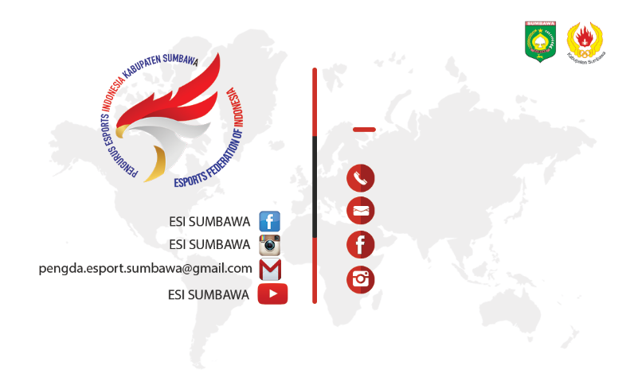

**I Made Widiarta**

0000000001

widiartaimade

widiartaimade@gmail.com

08175731377

widiartaimade

