C LANGUAGE

Introduction:
International Committee designed ALGOL-60, which was failure. Later they designed CPL-Combined Programming Language, which was failure. Then Martin Richards designed BCPL (Basic Combined Programming Language). Due to some reasons it was also a failure. Later by using some features of BCPL, Ken Thomson designed B Language. Due to some reasons it was not popular. Later in the year 1972 Dennis Ritchie adopted the features of 'BCPL','B' language and some features of this own to design the 'C' language. So C language was finally designed at AT & T Bell labs.
C is a popular general purpose programming language. C language has been designed and developed by Dennis Ritchie at Bell Laboratories in 1972. This language is associated closely with UNIX operating system. The source code for UNIX operating system is coded in C. C Programs are efficient, fast and highly portable i.e. C programs written on one computer can be run on another with little or no modifications.

C is a structured language. It is similar in many ways to other structural languages such as Pascal, Fortran etc. A structured language allows variety of programs in small modules. It is easy for debugging, testing, and maintenance if a language is a structured one.

1)What are the features in C Language ?
- C is very Simple language.
- C is very Fast and Efficient language.
- C is structured programming language
- C has 32 built in keywords.
- C has number of set of operators.
- C adopts different types of data types.
- C can converts bits and bytes of data for its easy manipulation.
- Dynamic memory allocation is possible through pointers.
- C language can be used to designed different applications and softwares.

Overview of Compiler and Interpreter
A program is a set of instructions for performing a particular task. These instructions are just like English words. The computer interprets the instructions as a 1’s and 0’s. A program can be written in assembly language as well as high-level language. This written program is called as source program. The source program is to be converted to the machine language, which is called as object program. Either interpreter or compiler will do this activity.

Interpreter:
An interpreter reads only one line of a source program at a time and converts it to object codes. In case of any errors, the same will be indicated instantly. The disadvantage is that it consumes more time for converting a source program to an object program.

Compiler:
A compiler reads the entire program and converts it to the object code. It provides errors not of one line but errors of the entire program. Only error free programs are executed. It consumes little time for converting a source program to an object program.

2)Explain structure of ‘c’ program

Basic Structure of C Program

Every C program contains a number of several building blocks known as functions. Each function of it perform task independently. A function is a subroutine that may consist of one or more statements. A C program may have the following sections

1)Documentation Section
2)Link Section
3)Definition Section
4)Global Declaration section
5)Function main ()
6)Declaration Part
7)Executable Part
8)Sub-Program Section

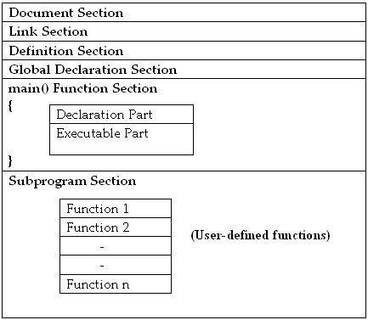

Documentation Section:

The documentation section consists of a set of comment lines giving the name of the program. Comments are provide description of the program which are placed between the delimiters /*………………..*/

Link Section:

The link section provides instructions to the compiler to link functions from the system library i.e. header file. C program depends upon some header files for function definition that are used in program. Each header file by default is extension with .h. The file should be include using #include directive.

Ex: # include <stdio.h>

Definition Section:

The definition section definition defines all symbolic constants.

Global Declaration section:

This section declares some variables that are used in more than one function. These variables are known as global variables. These variables must be declared outside of all the function.

main( ):
Every program written in C language must contain main ( ) function. Empty parenthesis ({ }) after main are necessary. The function main() is the starting point of every ‘C’ program. The execution of the program always begins with the function main(). The program execution starts with the opening brace ’{‘ and ends with the closing brace ‘}’.

Declaration Part:
The declaration part declares the entire variables that are used in executable part. The initializations of variables are also done in this section. The initialization means providing initial value to the variables.

Executable Part:
This part contains the statement following the declaration of the variables. This part contains a set of statements or a single statement. These statements are enclosed between the braces.

Sub-Program Section:
The functions defined by the user are called user-defined functions. These functions are generally defined after the main ( ) function. They can also be defined before main() function. This portion is not compulsory.

Rules of a Program:
A programmer while writing a program should follow the following rules.

- All statements should be written in lower case letters. Upper case letters are only used for symbolic constants.
- Blank spaces may be inserted between the words. It is not used in the case of declaring a variable, keyword, constant and function.
- The programmer can write the statement any where between the two braces following the declaration part.
- The opening and closing braces should be balanced.

Executing A ‘C’ Program

Executing a program written in C involves a series of steps. These are:
- Creating the program

- Compiling the program

- Linking the program with functions that are needed from C library

- Executing the program

Creating the program:
Programs should be written in C Editor. The file with the extension of ‘.c’.

Compiling and Linking of a program:
The source program statements should be translated into object programs which is suitable for execution by the computer. The translation is done after correcting each statement. If there are no errors, it creates another file called “.obj”. After that linking process, in this all other program files and functions together those are required by the program.

Executing the Program:
After the compilation the executable object code will be loaded in the computer’s main memory and the program is executed.

