3) Explain ‘C’ Character set:
The character set are used to form words, numbers and expressions. The characters in ‘C’ are classified in to 4 categories.

They are:
- Letters (A-Z, a-z)
- Digits (0-9)
- White spaces
- Special characters (|, . , $,&,!)

4) Explain ‘C’ tokens:(Important)
The individual elements of a program are called as "Tokens". In a 'C' program the small individual units are known as C tokens.
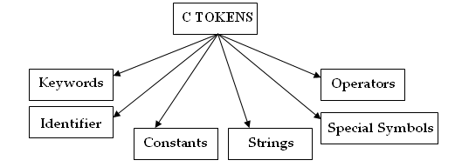

5) Explain ‘C’ keywords:

The C keywords are reserved words by the compiler. All the C keywords have been assigned fixed meaning. The keywords cannot be used as variable names because they have been assigned fixed jobs. The C language has 32 keywords.
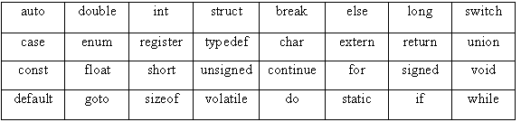

6) Explain ‘C’ Identifiers:

Identifier can be defined as the name of the variable, which holds a value and stores that value in the memory.

Rules for declaring the identifiers:
- The identifier should consists alphabets from a to z and A to Z
- It may consist numerical values from 0 to 9.
- It may consist underscore value.
- The starting character of an identifier must always be an alphabet.

7) Explain ‘C’ Constants:

A constant is a fixed value that cannot be altered during the execution of a program. There are several types of constants in C.

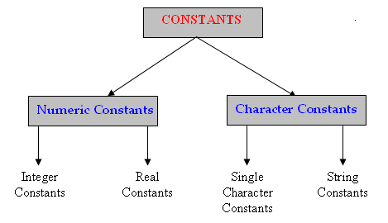

- Integer Constants:
An integer constant refers to a sequence of digits. There are three types of integer’s namely decimal integer, octal integer and hexadecimal integer.

a)Decimal Integers:
Decimal integers consists of set of digits 0 through 9, preceded by an optional – or + sign.
Ex: 10, 20, +30, -15 etc.

b)Octal Integers:
An octal integer constant consists of any combination of digits from the set 0 through 7, with a leading 0.

Ex: 037, 0456, 0, 0551 etc.

c)Hexa Decimal Integers:

A sequence of digits preceded by 0x or 0X is considered as hexa decimal integer. They may also include alphabets ‘A’ to ‘F’ or ‘a’ to ‘f’. The letters ‘A’ to ‘F’ represent the numbers 10 through 15.

Ex: 0x2, 0x9F, 0xbcd etc.

2)Real Constants:
Real constants are often known as floating point constants. The real constants can be written in exponential notation, which contains a fractional part and an exponential part.

Ex: 2.5, 5.521, 2456.123 can be written as 2.45661 X e⁻³

3)Character Constants:
a)Single character constants:
A character constant is a single constant is a single character. They are also represented with a single digit or a single symbol or white space enclosed within a pair of single quote marks.

Ex: ‘a’, ‘A’, ‘8’ etc.

b) String constants:
String constants are sequence of character enclosed within a double quote marks.

Ex: “career”, “welcome” etc.

c)Back slash Character Constants:
C supports some special backslash character constants that are used in output functions.

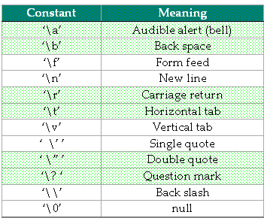

8) Explain about variables:

A variable is a user defined word it has some storage area depends on the data type and its value will be changed during the program execution.

The declaration of a variable is

Syntax:
data_type var1, var2 ... var_n;
Ex:
int a, b, c;

Rules:

- It is a combination of letters and digits.
- The length of the variable is 31 characters. However the length normally more than 8 characters.
- The variable should not be a reserve word.
- Special symbol are not allowed except under score ‘_’
- The first character in the variable must be an alphabet.
- Commas or blank spaces or not allowed with in a variable.
9) Explain about Datatypes:(very important)

A data type represents the type of the variable, means what value that variable will store. All ‘C’ compilers support variety of data types. Generally data is represented using numbers and characters. The number may be integer or real. The different compilers support the different data types.

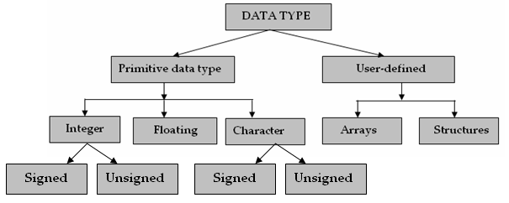

Classification of data types

1. PRIMARY DATA TYPES
- USER DEFINED DATA TYPES

- PRIMARY DATA TYPES:
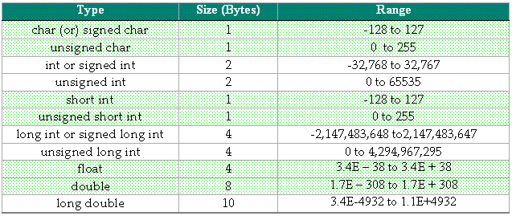

These primary datatypes are also called as simple datatypes or standard datatypes.

These primary data types are divided into 3 categories

a)INTEGRAL TYPES
b)FLOATING TYPES
c)CHARACTER TYPES

a)INTEGRAL DATA TYPES

Integral data types are used to allocate memory for integer values.

signed int – 2bytes -> -32,768 to +32767

unsigned int – 2bytes -> 0 to 65535

Syntax:

Datatype variable; (or) Datatype identifier;

Variable/identifier is a named memory location.

Ex: int a=7;

int, short int, long int are signed datatypes used to store positive values and also negative values.

unsigned int, unsigned short int, unsigned long int types allows only positive values.

These integer datatype can also accepts octal values, hexa decimal values.

Ex:

int a=26; //decimal representation
int a=032; //octal representation
int a=0x1a; //hexa decimal representation

b)Floating point Datatypes

Float, double, Long double are the floating datatypes, which are used to store decimal values.

Float takes 4 bytes of memory and double takes 8 byte s of memory it is capable of representing about twice as much precision as a float. The long double takes 10 bytes of memory.

Ex:
float a;
a = 0.143;

float pi;
double pi_sqr;

pi = 3.1417;
pi_sqr = pi * pi;

c)Character Data Types

Signed char, Unsigned char are the character datatypes.

Signed char – 1 byte -128 to +127
Unsigned char – 1 byte 0 to 255

Signed char is used to store alphabets and unsigned char is used to store unsigned integer value upto 255.

It allocates 1 byte memory for single character and also allocate memory for 1 byte to unsigned integer. In ‘c’ language every character has a decimal value called ASCII(American Standard Code Information Interchange)

Ex:
char ch1 = ‘a’;
unsigned char ch2 = 25;

printf(“%c”,ch1);
printf(“%d”,ch2);

- UserDefined Datatypes:

Structures,unions, typedef are examples to Userdefined datatypes.

The c language provides to create your own names for data types with this typedef keyword.

Ex:
typedef int integer;

integer a, b;

Makes the name integer a synonym for int. it is used same as int.

The typedef declaration does not create a new type in any sense. It adds a new name for the existing type. It makes easy to identify which purpose the variable is used.

10) What are Type Qualifiers? (Important)

Long, short, signed, unsigned are the type qualifiers. They specify special meaning to datatypes.

Ex:
long int, short int, signed int, unsigned int

11) What is Type Casting? (Important)

Convert one variable data type into another type Temporarily is called as Type casting.

Syntax:
(type) variable;

Ex:
int a=10, b=3;
float c;

c = (float)a/b;

printf(“division : %f”,c);

12)Explain ‘C’ LANGUAGE ARCHITECTURE
C API

C LANGUAGE SOURCE PROGRAM
COMPILER/
INTERPRETER

.OBJ FILE (MACHINE CODE)

LINKER

.EXE (NATIVE CODE)

If we develop the program in ‘c’ language. That program was not understand by the system. System understands only machine language. So there is a mediator to translate the Programming language into machine language that is compiler. Compiler takes the program and translates into machine language. If we execute that machine language we have another tool called linker, this linker takes the machine language code and also takes c library files from c API and executes the program and generates executable file(output file).

Whenever we compile the program ‘c’ compiler generates .obj file that is machine code. That machine code doesn’t execute directly. There is another tool linker that executes the machine code and generates .exe file.

13)How many files can generated can ‘C’ program compiled?

Totally 2 files are created when we execute the source program. 1 files is created at compile time that is .obj file(contains machine code) and another file is created at runtime i.e. exe file.

For example if we create the program sample.c it generates sample.obj file at compile time and execution time it creates sample.exe file.

14)What is Initialization?

Declaring the variables with assign the values is called Initialization or definition. Inorder to overcome the garbage values we can initialize the values.

Syntax
<datatype> <variable> = <value>;
Ex:
int a=10;

15)What is Header file in ‘c’?(imp)

Header file is a standard library file which contains the predefined functions that used in many programs. The header file extension is ‘.h’. To load the header file functions in our program we use #include pre processor directive.

16)What is #include?

#include is a preprocessor directive which loads the
given files ( may be header files or user defined files )
at the time of compilation time.

17)What is #define?

‘#define’ is a preprocessor to define symbolic constants and also used to define the macros.

#define is used to define the Constant variable value and it never accepts to change the variable value throughout the program, it is read only variable.

Syntax:

#define <const_variable> <value>
Ex:
#define pi 3.1417

Example:

/* W.A.P TO FIND THE AREA OF CIRCLE */

#include<stdio.h>
#include<conio.h>

#define pi 3.1417

main()
{
float r;
float area;

clrscr();

printf("Enter the radious ");
scanf("%f",&r);

area = pi * r * r;

printf("Area = %f",area);

}

Note:
We can’t change the constant variable values. If we want to modify we use #undef. #undef deallocate the memory of existing constant and allows to redefine the constant

18)What is #undef?

‘#undef’ is a preprocessor directive used to undefine symbolic constants which are already defined

Ex:

#include<stdio.h>
#include<conio.h>

main()
{
#define a 10

clrscr();

printf("a=%d\n",a);

/* a = a + 10; error */

#undef a

#define a 20

printf("a=%d\n",a);

getch();

}

19)What is Macro?(imp)

Macro is nothing but set of instructions. To define the
Macro we used #define. Macro is a function which contains single statement.

Syntax:

#define <macro>(values) <expression>
Eg:
#define cube(r) r*r*r

Example for macro

#include<stdio.h>
#include<conio.h>

main()
{
#define sum(a,b) a+b

int a, b, c;

c = sum(10,20);
printf("%d\n",c); //30

c = sum(60,70);
printf("%d\n",c); //130

c = sum(1,2)*sum(3,4);
printf("%d\n",c); //11 => 1+2*3+4

getch();
}

20)What are preprocessor directives?(imp)

#define, #undef and #include are the preprocessor directives

