**Create an table ‘SAILORS’ with following fields**

|  |  |
| --- | --- |
| **Name** | **Type** |
| SID | NUMBER |
| SNAME | VARCHAR2(20) |
| JORATING | NUMBER |
| AGE | NUMBER |

SQL> create table sailors(sid number primary key,sname varchar2(30),rating number,age number);

Table created.

SQL> insert into sailors values(&sid,'&sname',&rating,&age);

Enter value for sid: 22

Enter value for sname: Dustin

Enter value for rating: 7

Enter value for age: 45

old 1: insert into sailors values(&sid,'&sname',&rating,&age)

new 1: insert into sailors values(22,'Dustin',7,45)

1 row created.

SQL> /

Enter value for sid: 29

Enter value for sname: Brutas

Enter value for rating: 1

Enter value for age: 33

old 1: insert into sailors values(&sid,'&sname',&rating,&age)

new 1: insert into sailors values(29,'Brutas',1,33)

1 row created.

SQL> /

Enter value for sid: 31

Enter value for sname: Lubber

Enter value for rating: 8

Enter value for age: 55

old 1: insert into sailors values(&sid,'&sname',&rating,&age)

new 1: insert into sailors values(31,'Lubber',8,55)

1 row created.

SQL> /

Enter value for sid: 32

Enter value for sname: Andy

Enter value for rating: 8

Enter value for age: 25

old 1: insert into sailors values(&sid,'&sname',&rating,&age)

new 1: insert into sailors values(32,'Andy',8,25)

1 row created.

SQL> /

Enter value for sid: 64

Enter value for sname: Horatio

Enter value for rating: 7

Enter value for age: 35

old 1: insert into sailors values(&sid,'&sname',&rating,&age)

new 1: insert into sailors values(64,'Horatio',7,35)

1 row created.

SQL> /

Enter value for sid: 58

Enter value for sname: Rusty

Enter value for rating: 10

Enter value for age: 35

old 1: insert into sailors values(&sid,'&sname',&rating,&age)

new 1: insert into sailors values(58,'Rusty',10,35)

1 row created.

SQL> /

Enter value for sid: 71

Enter value for sname: Zobra

Enter value for rating: 10

Enter value for age: 16

old 1: insert into sailors values(&sid,'&sname',&rating,&age)

new 1: insert into sailors values(71,'Zobra',10,16)

1 row created.

SQL> /

Enter value for sid: 74

Enter value for sname: Horatio

Enter value for rating: 9

Enter value for age: 35

old 1: insert into sailors values(&sid,'&sname',&rating,&age)

new 1: insert into sailors values(74,'Horatio',9,35)

1 row created.

SQL> /

Enter value for sid: 85

Enter value for sname: Art

Enter value for rating: 3

Enter value for age: 26

old 1: insert into sailors values(&sid,'&sname',&rating,&age)

new 1: insert into sailors values(85,'Art',3,26)

1 row created.

SQL> /

Enter value for sid: 95

Enter value for sname: Bob

Enter value for rating: 3

Enter value for age: 64

old 1: insert into sailors values(&sid,'&sname',&rating,&age)

new 1: insert into sailors values(95,'Bob',3,64)

1 row created.

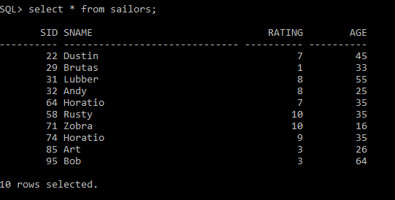

**Create an table ‘BOATS’ with following fields**

|  |  |
| --- | --- |
| **Name** | **Type** |
| BID | NUMBER |
| BNAME | VARCHAR2(20) |
| COLOR | VARCHAR2(20) |

SQL> create table boats(bid number primary key,bname varchar2(30),color varchar2(20));

Table created.

SQL> insert into boats values(&bid,'&bname','&color');

Enter value for bid: 101

Enter value for bname: Interlake

Enter value for color: Blue

old 1: insert into boats values(&bid,'&bname','&color')

new 1: insert into boats values(101,'Interlake','Blue')

1 row created.

SQL> /

Enter value for bid: 102

Enter value for bname: Interlake

Enter value for color: Red

old 1: insert into boats values(&bid,'&bname','&color')

new 1: insert into boats values(102,'Interlake','Red')

1 row created.

SQL> /

Enter value for bid: 103

Enter value for bname: Clipper

Enter value for color: Green

old 1: insert into boats values(&bid,'&bname','&color')

new 1: insert into boats values(103,'Clipper','Green')

1 row created.

SQL> /

Enter value for bid: 104

Enter value for bname: Marine

Enter value for color: Red

old 1: insert into boats values(&bid,'&bname','&color')

new 1: insert into boats values(104,'Marine','Red')

1 row created.

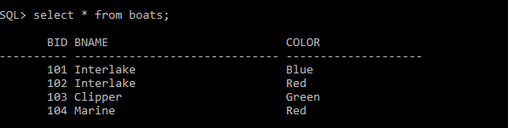

**Create an table ‘RESOURCES’ with following fields**

|  |  |
| --- | --- |
| **Name** | **Type** |
| SID | NUMBER |
| BID | NUMBER |
| DATE | DATE |

SQL> create table reserves(sid int references sailors(sid),bid int references boats(bid),day date);

Table created.

SQL> insert into reserves values(&sid,&bid,'&day');

Enter value for sid: 22

Enter value for bid: 101

Enter value for day: 10-OCT-1998

old 1: insert into reserves values(&sid,&bid,'&day')

new 1: insert into reserves values(22,101,'10-OCT-1998')

1 row created.

SQL> /

Enter value for sid: 22

Enter value for bid: 102

Enter value for day: 10-OCT-1998

old 1: insert into reserves values(&sid,&bid,'&day')

new 1: insert into reserves values(22,102,'10-OCT-1998')

1 row created.

SQL> insert into reserves values(&sid,&bid,'&day');

Enter value for sid: 22

Enter value for bid: 103

Enter value for day: 10-AUG-1998

old 1: insert into reserves values(&sid,&bid,'&day')

new 1: insert into reserves values(22,103,'10-AUG-1998')

1 row created.

SQL> /

Enter value for sid: 22

Enter value for bid: 104

Enter value for day: 10-JUL-1998

old 1: insert into reserves values(&sid,&bid,'&day')

new 1: insert into reserves values(22,104,'10-JUL-1998')

1 row created.

SQL> /

Enter value for sid: 31

Enter value for bid: 102

Enter value for day: 11-OCT-1998

old 1: insert into reserves values(&sid,&bid,'&day')

new 1: insert into reserves values(31,102,'11-OCT-1998')

1 row created.

SQL> /

Enter value for sid: 31

Enter value for bid: 103

Enter value for day: 11-JUN-1998

old 1: insert into reserves values(&sid,&bid,'&day')

new 1: insert into reserves values(31,103,'11-JUN-1998')

1 row created.

SQL> /

Enter value for sid: 31

Enter value for bid: 104

Enter value for day: 11-DEC-1998

old 1: insert into reserves values(&sid,&bid,'&day')

new 1: insert into reserves values(31,104,'11-DEC-1998')

1 row created.

SQL> /

Enter value for sid: 64

Enter value for bid: 101

Enter value for day: 9-MAY-1998

old 1: insert into reserves values(&sid,&bid,'&day')

new 1: insert into reserves values(64,101,'9-MAY-1998')

1 row created.

SQL> /

Enter value for sid: 64

Enter value for bid: 102

Enter value for day: 9-AUG-1998

old 1: insert into reserves values(&sid,&bid,'&day')

new 1: insert into reserves values(64,102,'9-AUG-1998')

1 row created.

SQL> /

Enter value for sid: 74

Enter value for bid: 103

Enter value for day: 9-AUG-1998

old 1: insert into reserves values(&sid,&bid,'&day')

new 1: insert into reserves values(74,103,'9-AUG-1998')

1 row created.

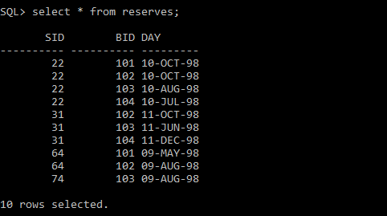

1. Find the names and ages of all sailors

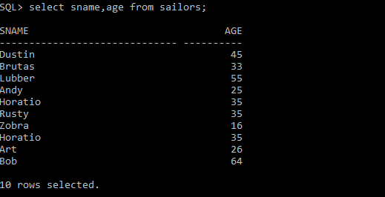

1. Find all information of sailors who have reserved boat number 101.

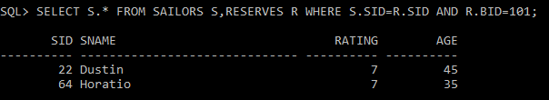

1. Find all sailors with rating above 7

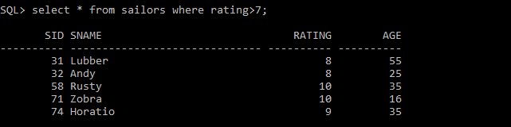

1. Find the names of sailors who have reserved boat no 103

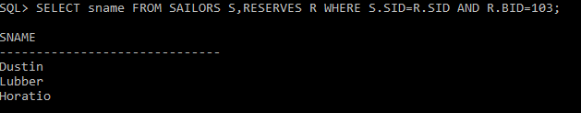

1. Find the names of sailors who have reserved a red boat, and list in the order of age.

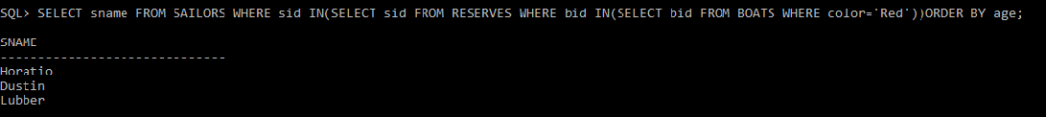

1. Find the names of sailors who have reserved either a red or green boat

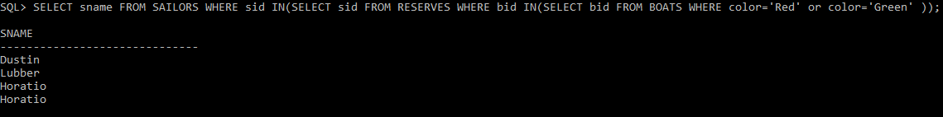

1. Find the colors of boats reserved by “Lubber”.

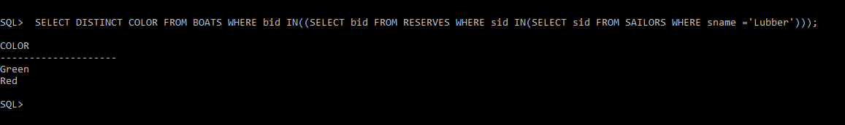

1. Find the names of sailors who have reserved both red and green boats

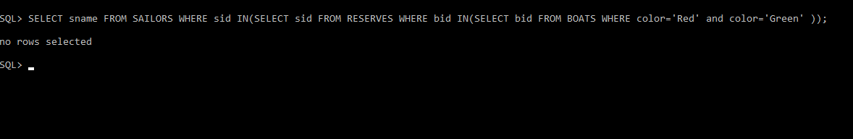

1. Find the names of sailors who have reserved at least one boat
2. Find the ids and names of sailors who have reserved two different boats on the same day.
3. Find the name and the age of the youngest sailor.
4. Find the names and ratings of a sailor whose rating is better than some sailor called

Horatio.

1. Find the names of sailors who have reserved all boats.
2. Count the number of different sailor names.
3. Calculate the average age of all sailors.
4. Find the average age of sailors for each rating level.
5. Find the average age of sailors for each rating level that has at least two sailors.