**Q)Create a table ‘Department’ with following fields.**

|  |  |
| --- | --- |
| **Name** | **Type** |
| Deptno | Number |
| Deptname | Varchar(20) |
| Location | Varchar(20) |

1. **Add column designation to the deprtment table.**

SQL> alter table dpt add (designation varchar2(20));

Table altered.

1. **Insert values into table.**

SQL> insert into dpt values(&deptno,'&deptname','&location','&designation');

Enter value for deptno: 2

Enter value for deptname: sales

Enter value for location: thrissur

Enter value for designation: executive

old 1: insert into dpt values(&deptno,'&deptname','&location','&designation')

new 1: insert into dpt values(2,'sales','thrissur','executive')

1 row created.

SQL> /

Enter value for deptno: 3

Enter value for deptname: production

Enter value for location: trivandrum

Enter value for designation: producer

old 1: insert into dpt values(&deptno,'&deptname','&location','&designation')

new 1: insert into dpt values(3,'production','trivandrum','producer')

1 row created.

SQL> /

Enter value for deptno: 4

Enter value for deptname: it

Enter value for location: kottayam

Enter value for designation: developer

old 1: insert into dpt values(&deptno,'&deptname','&location','&designation')

new 1: insert into dpt values(4,'it','kottayam','developer')

1 row created.

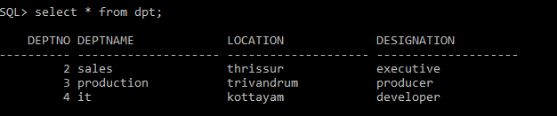

1. **List the record of the department table groupby dept-number.**

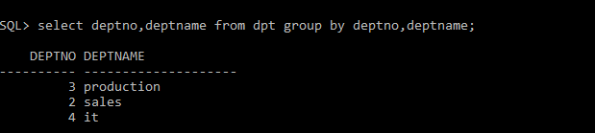

1. **Update the record where dept number is 3.**

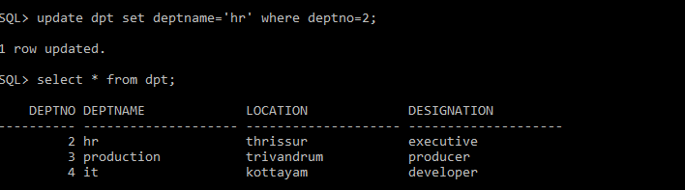

1. **Delete any column from the table.**

SQL> alter table dpt drop(designation);

Table altered.

SQL>