**Q)Create an employee table with following fields.**

|  |  |
| --- | --- |
| **Name** | **Size** |
| EID | NUMBER |
| ENAME | VARCHAR(20) |
| AGE | NUMBER |
| SALARY | NUMBER(10,2) |

SQL> create table emp2(eid number primary key,ename varchar(30),age number,salary number(10,2));

Table created.

SQL> insert into emp2 values(&eid,'&ename',&age,&salary);

Enter value for eid: 201

Enter value for ename: aju

Enter value for age: 25

Enter value for salary: 250000

old 1: insert into emp2 values(&eid,'&ename',&age,&salary)

new 1: insert into emp2 values(201,'aju',25,250000)

1 row created.

SQL> /

Enter value for eid: 202

Enter value for ename: akshara anilkumar

Enter value for age: 24

Enter value for salary: 150000

old 1: insert into emp2 values(&eid,'&ename',&age,&salary)

new 1: insert into emp2 values(202,'akshara anilkumar',24,150000)

1 row created.

SQL> /

Enter value for eid: 203

Enter value for ename: ajay t m

Enter value for age: 24

Enter value for salary: 175000

old 1: insert into emp2 values(&eid,'&ename',&age,&salary)

new 1: insert into emp2 values(203,'ajay t m',24,175000)

1 row created.

SQL> /

Enter value for eid: 204

Enter value for ename: unni mv

Enter value for age: 25

Enter value for salary: 200000

old 1: insert into emp2 values(&eid,'&ename',&age,&salary)

new 1: insert into emp2 values(204,'unni mv',25,200000)

1 row created.

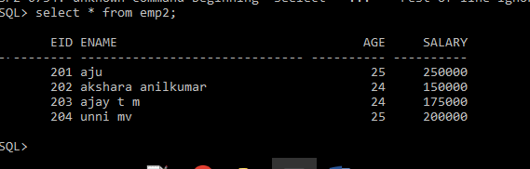

**a)Find the count of employees.**

**SQL> select count(ename)from emp2;**

**COUNT(ENAME)**

**------------**

**4**

**b)Find the maximum age.**



**c)Find the minimum age.**



**d)Find the sum of the salary.**



**e)Find the average of the age.**



**f)Create a view for the age and the name.**





**g)Create a view to store ID,name,Salary.**

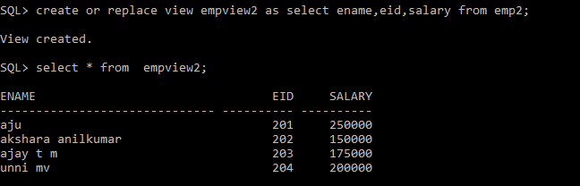

**h)Display name of the employee in ascending order of the Salary.**

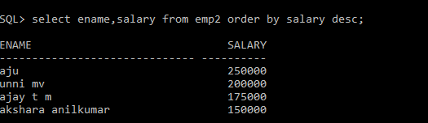

**i)Print the name in ascending order of age.**

