**Q)Create the table with following attributes given below:**

|  |  |
| --- | --- |
| **Name** | **Type** |
| EMP_no | Number |
| EMP_name | Varchar2(20) |
| EMP_job | Varchar2(20) |
| Mgr | Number |
| Sal | Number |

SQL> create table EMP(EMP_NO NUMBER PRIMARY KEY,EMP_NAME VARCHAR2(20),JOB VARCHAR2(20),MGR NUMBER,SAL NUMBER);

Table created.

SQL> DESC EMP;

Name Null? Type

--------------------------------- -------- ----------------------------

EMP_NO NOT NULL NUMBER

EMP_NAME VARCHAR2(20)

JOB VARCHAR2(20)

MGR NUMBER

SAL NUMBER

**a)Add a column commission with domain to the table:**

SQL> ALTER TABLE EMP ADD(COMMISSION NUMBER);

Table altered.

**b)Insert five records into the table:**

SQL> INSERT INTO EMP VALUES(&EMP_NO,'&EMP_NAME','&JOB',&MGR,&SAL,&COMMISSION);

Enter value for emp_no: 1

Enter value for emp_name: AJAY

Enter value for job: CEO

Enter value for mgr: 3

Enter value for sal: 80000

Enter value for commission: 10000

old 1: INSERT INTO EMP VALUES(&EMP_NO,'&EMP_NAME','&JOB',&MGR,&SAL,&COMMISSION)

new 1: INSERT INTO EMP VALUES(1,'AJAY','CEO',3,80000,10000)

1 row created.

SQL> /

Enter value for emp_no: 2

Enter value for emp_name: AKSHARA

Enter value for job: DEVELOPER

Enter value for mgr: 2

Enter value for sal: 50000

Enter value for commission: 5000

old 1: INSERT INTO EMP VALUES(&EMP_NO,'&EMP_NAME','&JOB',&MGR,&SAL,&COMMISSION)

new 1: INSERT INTO EMP VALUES(2,'AKSHARA','DEVELOPER',2,50000,5000)

1 row created.

SQL> /

Enter value for emp_no: 3

Enter value for emp_name: AKSHAY

Enter value for job: DEVELOPER

Enter value for mgr: 2

Enter value for sal: 50000

Enter value for commission: 5000

old 1: INSERT INTO EMP VALUES(&EMP_NO,'&EMP_NAME','&JOB',&MGR,&SAL,&COMMISSION)

new 1: INSERT INTO EMP VALUES(3,'AKSHAY','DEVELOPER',2,50000,5000)

1 row created.

SQL> INSERT INTO EMP VALUES(&EMP_NO,'&EMP_NAME','&JOB',&MGR,&SAL,&COMMISSION);

Enter value for emp_no: 4

Enter value for emp_name: ANANTHAKRISHNAN

Enter value for job: FRONT-END

Enter value for mgr: 2

Enter value for sal: 50000

Enter value for commission: 5000

old 1: INSERT INTO EMP VALUES(&EMP_NO,'&EMP_NAME','&JOB',&MGR,&SAL,&COMMISSION)

new 1: INSERT INTO EMP VALUES(4,'ANANTHAKRISHNAN','FRONT-END',2,50000,5000)

1 row created.

SQL> /

Enter value for emp_no: 5

Enter value for emp_name: KAMALAN

Enter value for job: FRONT-END

Enter value for mgr: 3

Enter value for sal: 50000

Enter value for commission: 5000

old 1: INSERT INTO EMP VALUES(&EMP_NO,'&EMP_NAME','&JOB',&MGR,&SAL,&COMMISSION)

new 1: INSERT INTO EMP VALUES(5,'KAMALAN','FRONT-END',3,50000,5000)

1 row created.

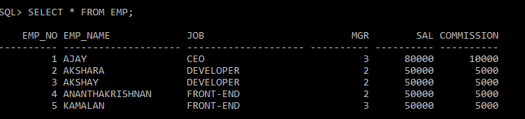

**c)Update the column details of the job:**

UPDATE EMP SET JOB='TRAINEEE' WHERE EMP_NO=5;

Table altered.

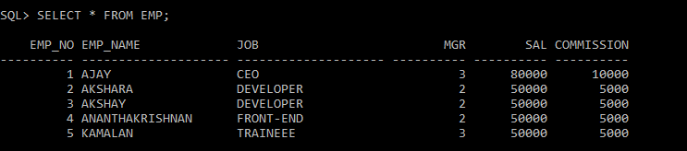

**d)Rename the column of the employee table using the alter:**

SQL> ALTER TABLE EMP RENAME COLUMN MGR TO MANAGER_NO;

Table altered.

**e)Delete the column of the employee whose number is 4:**

SQL> DELETE EMP WHERE EMP_NO=4;

1 row deleted.

