# Table of Contents:

0) Table of contents........................................................................................................................1

1.1) Introduction............................................................................................................................2

1.2) Prereqisites..............................................................................................................................2

1.3) Predicted Outcomes................................................................................................................2

1.4) How to use bootstrap..............................................................................................................3

1.5) Layout.....................................................................................................................................4

1.6) Use Cases...............................................................................................................................5

1.6.1) Media Query..............................................................................................................5

1.6.2) Carousel.....................................................................................................................5

1.6.3) Jumbotron..................................................................................................................6

1.7) Cinclusion...............................................................................................................................6

# Blog Entry

# Bootstrap

## 1.1) Introduction:

Bootstrap is a free and open-source front-end web framework for designing websites and web applications. It contains HTML- and CSS-based design templates for typography, forms, buttons, navigation and other interface components, as well as optional JavaScript extensions. Unlike many web frameworks, it concerns itself with front-end development only.

Simply put, Bootstrap basically provides some CSS files with predefined classes that can be used to modify and customize your webpage.

Starting with version 3.0, Bootstrap adopted a mobile-first design philosophy, emphasizing responsive design by default. This is an approach to web design which makes web pages render well on a variety of devices and window or screen sizes.

Consequently, this framework provides flexibility to the web pages, so that they can render properly on desktop as well as mobile devices with small screens as well. In addition to this, many costomization features are also provided in bootstrap, like navigation bars, carousels, Jumbotron etc. Further it also supports a large number of UI kits like Material Design, Tron etc, which drastically increases the customization options.

The version 4.0 alpha release added Sass and flexbox support.

## 1.2) Prerequisites:

For proper understanding of Bootstrap, a working knowledge of HTML and CSS is important.

If you are familiar with that, all good and you may proceed. Otherwise I suggest that you go through the previous entry of this blog, in which the basics of HTML and CSS are briefly explained.

Once it’s done, we are all set to move forward with the following lessons.

## 1.3) Predicted Outcome:

Once you are done with this lesson, you shoud be proficient enough to make some amazing looking web pages like the one displayed below:

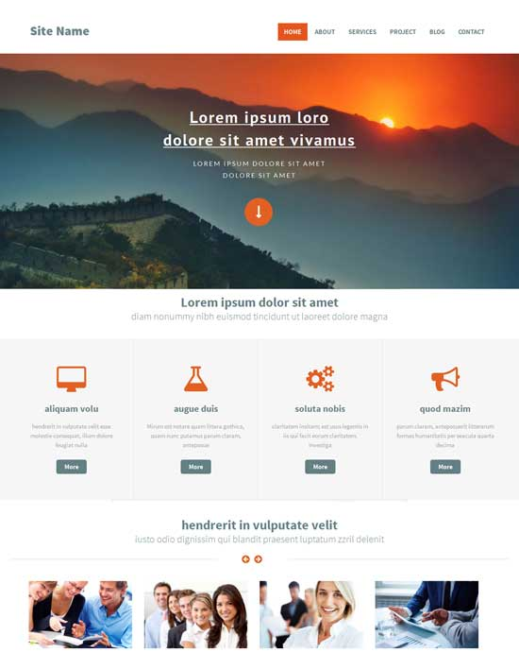

## 

## 1.4) How to use Bootstrap:

There are a number of ways to use bootstrap in your code:

i) Using CDN: This is the easiest way to get Bootstrap features in your web-page. All we need to do is copy the following link in the <head> tag of your HTML document.

<link rel="stylesheet"href="https://maxcdn.bootstrapcdn.com/bootstrap/4.0.0/css/bootstrap.min.css"integrity="sha384-Gn5384xqQ1aoWXA+058RXPxPg6fy4IWvTNh0E263XmFcJlSAwiGgFAW/dAiS6JXm" crossorigin="anonymous">

ii) Another method is to download the CSS files of Bootstrapfrom <https://getbootstrap.com/> and then link them manually in your HTML document

Once you are done with any one of the above, you are godd to use Bootstrap.

## 1.5) Layout:

Bootstrap uses column system to determine the position of content on the page. More precisely, it uses a 12 column system. Once all the 12 columns in a row are used up, the following content is moved to the next row.

Further, we can define container in bootstrap, which, well contain our data. Now, there are two types of containers- normal one: simply called container and a fluid container. Fluid container always takes up the whole width of the webpage.

A container is defined as:

<div class="container">

<div class="row">

<div class="col-sm">

One of three columns

</div>

<div class="col-sm">

One of three columns

</div>

<div class="col-sm">

One of three columns

</div>

</div>

</div>

Here, we define a row. A new row is not introduced as long as this row has some space in it. Also, as three columns are declared here, all the columns introduced are of equal size.

If you want a particular column to have more width than the other one. You can change the class of that column to col-1 to col-12 and the other columns will have an equal width. That's why its so handy to use bootstrap. For eg: this code

<div class="container">

<div class="row">

<div class="col">

1 of 3

</div>

<div class="col-6">

2 of 3 (wider)

</div>

<div class="col">

3 of 3

</div>

</div>

</div>

This will create 3 columns and the

middle will be taking 6 columns.

**1.6) Use Cases:**

1.6.1) Media Query:

Since Bootstrap is developed to be mobile first, we use a handful of media queries to create sensible breakpoints for our layouts and interfaces. These breakpoints are mostly based on minimum view-port widths and allow us to scale up elements as the view-port changes. Bootstrap primarily uses the following media query ranges—or breakpoints—in our source Sass files for our layout, grid system, and components.

// Extra small devices (portrait phones, less than 576px)

// No media query since this is the default in Bootstrap

// Small devices (landscape phones, 576px and up)

@media (min-width: 576px) { ... }

// Medium devices (tablets, 768px and up)

@media (min-width: 768px) { ... }

// Large devices (desktops, 992px and up)

@media (min-width: 992px) { ... }

// Extra large devices (large desktops, 1200px and up)

@media (min-width: 1200px) { ... }

1.6.2) Carousel

The carousel is a slide-show for cycling through a series of content, built with CSS 3D transforms and a bit of JavaScript. It works with a series of images, text, or custom markup. It also includes support for previous/next controls and indicators.

In browsers where the Page visibility API is supported, the carousel will avoid sliding when the web-page is not visible to the user (such as when the browser tab is inactive, the browser window is minimized, etc.).Please be aware that nested carousels are not supported, and carousels are generally not compliant with accessibility standards.

<div id="carouselExampleSlidesOnly" class="carousel slide" data-ride="carousel">

<div class="carousel-inner">

<div class="carousel-item active">

<img class="d-block w-100" src="..." alt="First slide">

</div>

<div class="carousel-item">

<img class="d-block w-100" src="..." alt="Second slide">

</div>

<div class="carousel-item">

<img class="d-block w-100" src="..." alt="Third slide">

</div>

</div>

</div>

1.6.3) Jumbotron :

This tag is used to create hero unit style elements. It’s code goes as follows:

<div class="jumbotron">

<h1 class="display-4">Hello, world!</h1>

<p class="lead">This is a simple hero unit, a simple jumbotron-style component for calling extra attention to featured content or information.</p>

<hr class="my-4">

<p>It uses utility classes for typography and spacing to space content out within the larger container.</p>

<p class="lead">

<a class="btn btn-primary btn-lg" href="#" role="button">Learn more</a>

</p>

</div>

**1.7) Conclusion :**

Bootstrap is a widely used CSS framework. It provides a plethora of customization options that can drastically improve the user interface as well as the user experience of the website.

Go ahead and explore it further.