      

LAN

LAN

TB_1 TB_2 TB_3 TB_4

   TB1: 1 Unity and 1 VNX2, Used for VDM migration, LUN Migration, SANCopy

TB2: 2 Unity, used for block and file replication and VVOL

TB3: 2 Unity, used for recover point

TB4: 1 Unity, used for NDMP and snapshot

  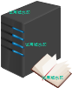 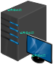

AD NIS LDAP… VMWare SANBlaze Manage Tool

