**DEBIT CARD**

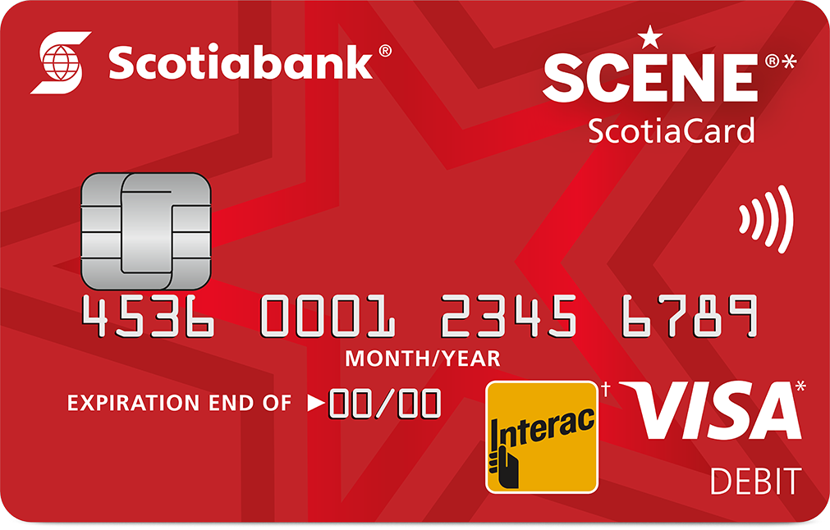

 **Scotiabank Scotiacard**

4521 6983 3698 1425

Anshu Kumari

41463